C4 Information sheets and Activities KS2,3 and 4The Time of Leprosy: 11th Century to 14th Century
This section explains how leprosy became endemic in England by the 11th century, and describes medieval attitudes towards the disease and how sufferers were cared for in religious houses and hospitals.
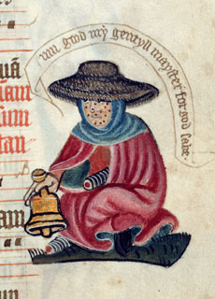
A leper begging for alms from the margins of an English Pontifical c 1425 MS Lansdowne 451, fo 127r© British Library

The Spread of Leprosy
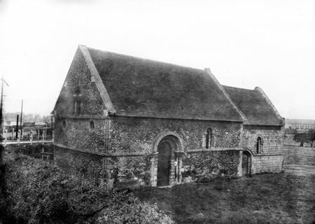
During the medieval period, leprosy's disabling consequences became very visible in all communities across England - rural and urban, rich and poor. Its impact would change both the landscape of the country and the mindset of its people.

Chapel of St Mary Magdalen, Stourbridge near Cambridge
Leprosy had entered England by the 4th century and was a regular feature of life by 1050. Known today as Hansen's disease, in its extreme form it could cause loss of fingers and toes, gangrene, blindness, collapse of the nose, ulcerations, lesions and weakening of the skeletal frame. Today it can be treated by simple anti-biotic drug and has been largely eliminated.

Enduring Purgatory on Earth
Reaction to the disease was complicated. Some people believed it was a punishment for sin, but others saw the suffering of lepers as similar to the suffering of Christ. Because lepers were enduring purgatory on earth, they would go directly to heaven when they died, and were therefore closer to God than other people. Those who cared for them or made charitable donations believed that such good works would reduce their own time in purgatory and accelerate their journey to heaven.
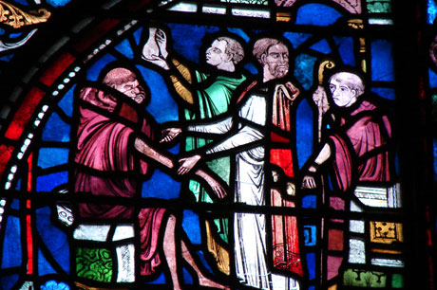
A stained glass depiction of Elias the leprous monk, Trinity Chapel, Canterbury Cathedral © Annaliza Gaber

Leper Houses and Hospitals
The earliest known example of a leper hospital is thought to be St Mary Magdalen in Winchester, Hampshire where burial excavations found evidence of leprosy. The remains were radiocarbon-dated to between 960 and 1030 AD. At least 320 religious houses and hospitals for the care of lepers (known as leper or 'lazar' houses) were established in England between the end of the 11th century and 1350. The houses were usually built on the edge of towns and cities, or if they were in rural areas, near crossroads or major travel routes. Lepers needed to stay in contact with society to beg alms, trade items, and offer services such as praying for the souls of benefactors. There was high demand for places in leper hospitals, and 'leprous brothers and sisters' were often accepted fully into the religious order of the house.
Many of the buildings have decayed or were destroyed during Henry VIII's dissolution of the monasteries in the 1530s. Some remain however, including the oldest, St Nicholas Harbledown in Canterbury, Kent (1070s); St Mary Magdalene in Stourbridge near Cambridge; St Mary & St Margaret in Sprowston, Norwich, Norfolk and the hospital of St Mary the Virgin in Ilford, Greater London. Others survive as ruins or archaeological sites.
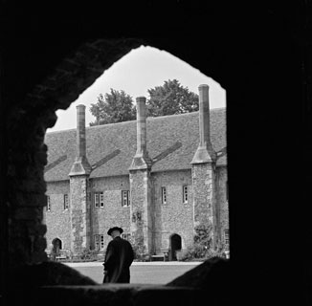
The courtyard and 14th century almshouses at St.Cross Hospital, Winchester. The porch on the right leads to the kitchen and Bretherens Hall.
© English Heritage

Physical and Spiritual Care
Care in religious leper houses centred as much on a person's spiritual needs as on their physical problems. Most hospitals consisted of a group of cottages built around a detached chapel where praying and singing continued throughout the day. Excavations at St Mary Magdalen in Winchester suggest that its chapel had a master's hall attached at right angles, with cells for the inmates built around the inside of the enclosure wall. The existing chapel at Harbledown in Kent has a sloping floor, perhaps so the floor could be washed after the lepers had attended mass.

Life and Work in the Leper Hospital
The emphasis was on cleanliness and wholesome food - clothes were washed twice a week and a varied diet was supplied if possible, often from the house's own fields and livestock. The therapeutic effect of horticultural work and the beauty of nature were recognised - many houses had their own fragrant gardens of flowers and healing herbs, and residents took part in their upkeep.
Many lepers stayed in touch with their family and friends and were allowed to make visits home and receive visitors.

Leprosy in Retreat
Attitudes began to change in the 14th century, particularly after the horrors of the Black Death (1347-1350). Fear of contagion led to greater restriction and isolation, while abusive and corrupt practices increased.
But leprosy was in retreat - possibly due to greater immunity in the population - and many houses fell into disuse or were put to new uses.St Mary Magdalen in Ripon and the hospital of St Margaret and St Sepulchre in Gloucester both became almshouses for the sick and disabled poor. The impact of leprosy lived on - it had brought about an institutional response to disability in the form of buildings and methods of care which would strongly influence future generations.
From Simon Jarrett http://www.english-heritage.org.uk/discover/people-and-places/disability-history/1050-1485/time-of-leprosy/

Activities. KS2
- What was leprosy ?
- What were leprosy’s effect on people
- Where any groups in society protected from getting leprosy?
- Examine the picture of a leper from the English Pontifical 1425
- Describe the picture
- Why do you think the Leper has a bell?
- Why do you think most of their body is covered?
- Look at the stained glass window of Elias the Leporous monk from Canterbury Cathedral.
- Why are others trying to help him?
- What was purgatory and why did people believe lepers were undergoing it?
- Why did many people in the medieval times believe lepers were closer to God?
- Why did Leper houses need to be near the town?

KS3/KS4
- What is Leprosy, what are its effects on people?
- What were the attitudes to people with Leprosy in the Medieval period?
- How did the Church help lepers?
- Why did the number of people with leprosy reduce?
- Examine some of the Leper Houses on the English Heritage website- describe how they worked to support Lepers and how the building were laid out/
- What where the impact of the almshouses and hospitals created in the Medieval period on later provision for sick and disabled people?
- Can you describe how people today might react to a disease or impairment they do not understand?

