

[1]

**E4 Numbers per 1000 and Expenditure New Poor Law 1834 TO 1930**



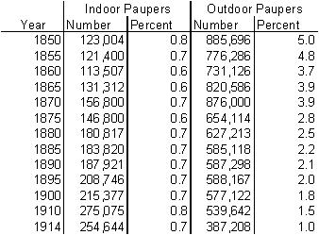

1. From P.Higginbotham 2012 ‘The Workhouse Encylopedia The History Press p257 &258