

**Disability: Leadership, Resistance and Culture**

**We Are Not Objects of Pity**

The Block Telethon Demonstrations

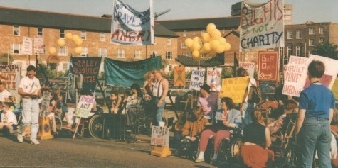

On May 27th 1990 and July 18th 1992 thousands of disabled people gathered outside London Weekend Television Studios on the South bank in London to protest at what they thought were the disgusting patronising portrayals of Disabled people being put out by the ITV charity fundraising “Telethon”. At the time these were the largest demonstrations of Disabled People in the world. Telethon played on the pity of the viewers making Disabled People out to be objects of pity and curiosity, incapable of controlling their lives and always in need of handouts.

On each demonstration disabled artists staged an alternative event that portrayed Disabled People as proud angry and strong. As the Telethon began Disabled People tried to invade the studio.

The demonstrations created shock waves in the media

and amongst the general public who thought wrongly that

Telethon and similar programmes had the support of

the majority of Disabled People.

It also brought about the end of the Telethon, which

was quietly scrapped in 1993.

Before the Block Telethon demonstrations Disabled People were largely seen as passive helpless

recipients of Charity. After the demonstrations

Disabled People began to be seen as active

campaigners for political and social change.

*“I came to the demonstrations because it was the only place in the country I could feel proud of who I was.*

*We’re conditioned to believe that we have to be nice,*

*say please and thank you, but suddenly we’re saying*

*‘we don’t want your crumbs’. I want to shatter the*

*image people have of us.”*

(Disabled activists interviewed during the Block Telethon Demonstrations)

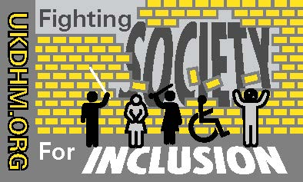



Reproduced with kind permission of the originators