

**Disability: Leadership, Resistance and Culture**

**Ian Stanton –** Natural Born Rebel

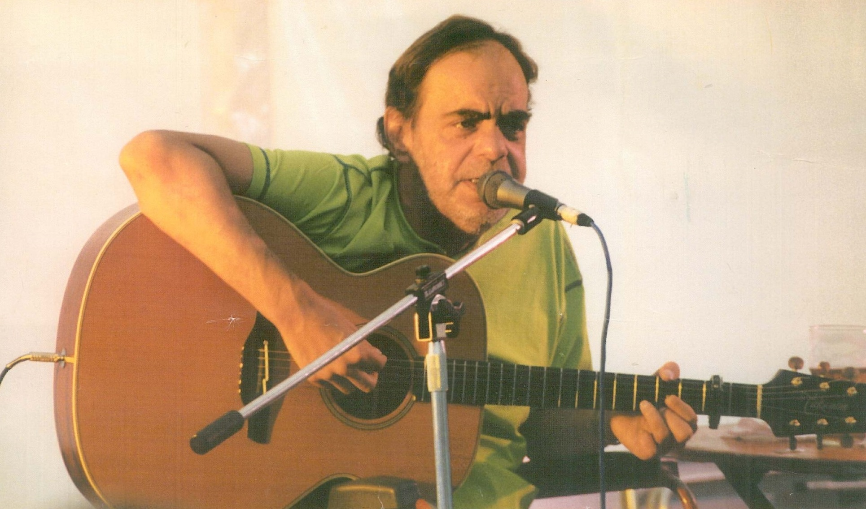

Ian Stanton was born in Oldham in the UK in 1950. By the time of his death in November 1998 he was regarded as one of the foremost singer-songwriters and disabled artists in the world. Using a mixture of music and humour Ian was one of the first to expose the prejudice experienced by disabled people, and many of his songs - such as ‘Tragic but Brave’ and ‘Chip on your Shoulder’- have become anthems of the Disabled People’s Movement. Ian toured all over Europe, Canada, the USA and Britain and was a pioneer bringing songs and art forms highlighting disabled people’s experience to many countries.

Whilst he was attending a day centre or “Glee Club” as he referred to it, he began publishing a subversive magazine which published shocking stories about disabled people’s treatment in the establishment. This came to the attention of the Greater Manchester Coalition of Disabled People who recruited Ian to produce the Coalition Magazine.

This magazine soon became a forum for disabled people to discuss the issues that confronted them and rapidly became required reading for disabled activists across the country and beyond.

Ian’s style on and off the stage was relaxed, friendly and inclusive and these qualities were invaluable to the new disabled people’s movement who without Ian’s wisdom and good-humour may have quickly fallen into quarrelling with itself. His legacy is not just in his songs but in the skill of working together that he passed on. He freely gave his time

to anyone who was committed to equality, disabled and

non-disabled people alike.

Ian recognised the importance of building bridges and alliances across communities, but it is for the major contribution his music made to the Disabled People’s Movement that Ian will always be remembered best.

**<https://www.youtube.com/watch?v=_4r48B0x6qE>**

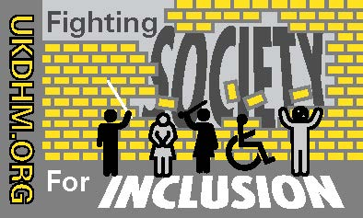



Reproduced with kind permission of the originators