

**Disability: Leadership, Resistance and Culture**

**Jane Campbell**

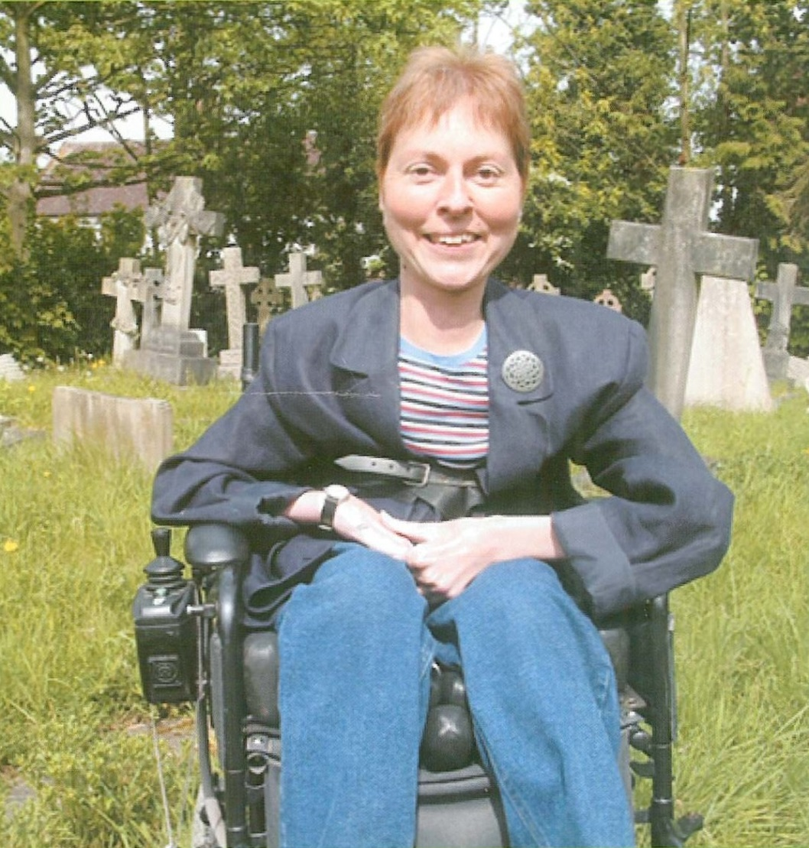**NOT**

**DEAD**

**YET!**

Born in 1959, the doctors told Jane’s mother to take her home and enjoy her while she lived – they predicted she would be dead in a year. As is so often the case the doctors got it wrong and Jane is still very much alive!

At the start of her career Jane found herself the token disabled typist at a major charity for disabled people. It was then that she recognised the need for Disabled People to control their own organisations and not let others represent them in a disempowering way. She joined the Disabled People’s Movement and for five years between 1991 and 1995 she co-chaired the British Council of Disabled People (BCODP). Under Jane’s leadership the fight for comprehensive anti-discrimination legislation won a resounding victory in the form of the Disability Discrimination Act 1995. Jane also campaigned for the introduction of Direct Payments so that Disabled People now have the right to choose and directly pay their personal assistants.

Jane went on to co-found the National Centre for Independent Living. She was appointed a Disability Rights Commissioner in 2000.

Jane has not abandoned her passion for campaigning alongside her sisters and brothers in the movement. Today she is engaged on one of our biggest challenges yet – the right to live. Jane is actively involved in ‘Not Dead Yet’, a group of Disabled People challenging the pro-euthanasia lobby.

She says, “We must put our energy into supporting Disabled People’s inclusion and life, not our death. The campaign to assist our so called voluntary death is dangerous, reinforces our unequal status and makes people like me feel unsafe.”

Jane is still fighting, negotiating, educating and championing the rights of Disabled People.

Jane has been in the House of Lords as a Cross Bench

peer since 2008.





Reproduced with kind permission of the originators