

**Disability: Leadership, Resistance and Culture**

Micheline Mason – Champion of Inclusion

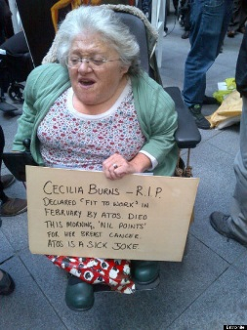

***“Friendship is key. I would argue for inclusive education as young people need to be facilitated to make friendships across the barriers that adults have created. That can’t happen unless they’re all together. All the rest of***

***it is secondary. It was certainly the thing missing from my childhood. You never get over it, not really”.***

Born in 1950 in Kingston, Surrey, Micheline, had home tuition until the age of thirteen when she left home to attend a residential special school in Hampshire. She went to Art college, founded the Liberation Network for Disabled People. When she had her daughter Lucy, also with brittle bones, Micheline founded

the Alliance for Inclusive Education with Richard Rieser. Micheline now campaigns for equality and inclusion in her local area of Tooting.

“When I was born people had no idea that I had an impairment of any sort, but

I in fact had fractures in both my legs. I went home, but every time my parents

tried to pick me up or do anything I was screaming. They took me back to the hospital for x-rays. I feel I can remember the sudden change that happened

when they took the x-rays– it felt to me the world just stepped right back from

me. There was a complete change from thinking I was just an ordinary child to being told that I wasn’t. The shock, the fear, the … everything. We’re also going back to the 1950s when it was worse than it is now, in terms of what people felt or knew about these things”.

TheLiberation Network of Disabled People (LNDP) were influenced by the Women’s Movement. Following their initial

meeting at Lower Shore farm outside Swindon in 1980, they focused on breaking down isolation by finding ways to

communicate with each other whether deaf, blind or physically impaired. Many of the ideas were developed by Micheline Mason and others in their ‘In From the Cold’ magazine. “We brought together leaders of different fragments of a movement.

We challenged the effects of ‘internalised oppression’, recognised by all marginalised groups as the major ‘tool’ of the oppressive society; we challenged the conditioned hatred of ourselves and each other as disabled people; we challenged

the desire to assimilate; we challenged the denial of ‘hidden’ disabilities; we challenged the fierce competition between us; we challenged the inability to champion, appreciate and support each other's achievements or thinking (especially when it challenges our own); we challenged the lack of information & understanding about the issues of other oppressed peoples.“

The LNDP were at the founding meeting of BCODP, leaving at lunchtime not happy with the male dominance and rigid approach. Many of these activists formed organisations that joined BCODP as it grew, but they always formed a different approach within the Disability Movement. The thinking of LNDP helped form the Alliance for Inclusive Education. The

work on self-representation, social model and disability as an oppression was brought together to transform education.

“Lucy was disabled and I knew I didn’t want her to go down the road I’ve been. I was clear that you shouldn’t separate

children from each other. Because the coming together again is so hard or it doesn’t happen. Lots and lots of people

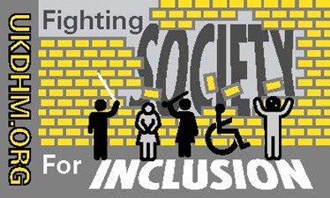never make it and you just live in parallel for the rest of your life. It can’t be good for either side

and it certainly wasn’t going to happen to any child of mine”.

© UKDHM 2019