

**Disability: Leadership, Resistance and Culture**

Mike Oliver – Disability Scholar & Activist

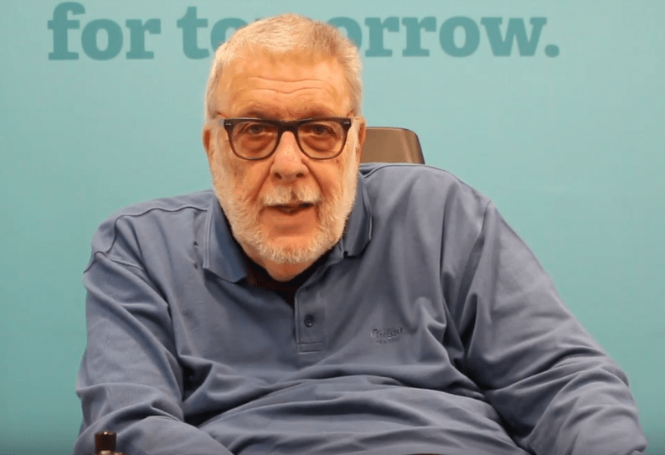

***“I did want to provide an alternative, more optimistic picture that wasn’t about simply seeing disability as purely tragic, disabled people as unemployable and so on,” he recently reflected. “It was about having an optimistic view of what disabled people could achieve if many of the barriers they faced were removed.”***

Michael Oliver (3 February 1945 – 2 March 2019) was a British sociologist, author and disability rights activist. He was the first Professor of Disability Studies in the world. Oliver was born in Kent. He attended grammar school, leaving at 16 to work as a payroll clerk. He broke his neck in 1962 while on holiday, diving into a swimming pool, and was treated at Stoke Mandeville Hospital. He used a wheelchair after his accident.

He returned home after a year of rehabilitation. He worked in adult education at Borstal Prison (a Young Offenders Institution, now HM Prison Rochester) then took a degree in sociology. He started his degree at the University of Reading in 1971. The support arrangements were inadequate and he left after a few weeks. He completed his bachelor's degree at the University of Kent, followed by a Master's, and a doctorate in 1978.

From 1979, he ran a course on Social Work with Disabled People at Kent University. He published a book *Social Work with Disabled People* in 1983.

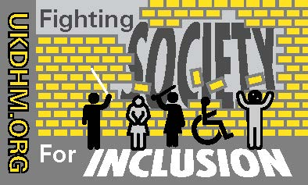Oliver published his book *The Politics of Disablement* in 1990. He became a key advocate of the social model of disability, which he named. This is the idea that much of the inconvenience and difficulty of living with a disability is not an inherent feature of the disability itself, but a failure of society to adapt to the needs of disabled people.

While the distinction between "impairment" and "disability"

had been made by the Union of the Physically Impaired Against Segregation, Oliver coined the term "social model"

to describe this distinction, and popularized it. He also

coined the term "Emancipatory disability studies" meaning

that researchers must not be "parasites" but instead serve

the interests of disabled people.

Mike founded the international Journal Disability and Society and was a pioneer of Disability Studies in universities. He

was an active member of the Spinal Injuries Association and BCODP, taking part in many protest actions.

As an advocate of civil rights for disabled people, Oliver was disappointed in the 1995 Disability Discrimination Act, feeling that it fatally split the disability movement. He was a fierce

critic of the big disability charities, claiming that “disability corporatism” had replaced activism since the 90s.

Growing acceptance of the social model of disability, by

which the individual is regarded as disabled by society and their environment rather than by their own impairment, has been key to the emancipation of disabled people over the

past 40 years.

**https://www.youtube.com/watch?v=NMfvoh-j9qw**

© UKDHM 2019