**Disability: Leadership, Resistance and Culture**



DISABLED LEADERS

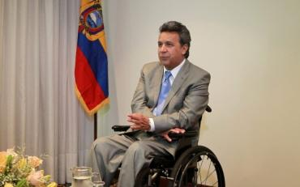 ***“Solidarity—not as charity, but rather as the recognition of others as equals—is the basic pillar for initiating social inclusion.”***

Lenin Moreno is the President of Ecuador. He became paraplegic following a shooting during an attempted robbery, in 1998. He is

the only current head of state to use a wheelchair.

Since being elected Vice President in 2006 Moreno has inspired

and transformed Ecuador into becoming one of the most progressive nations in Latin America in respect of the financial, technical and professional assistance it provides for disabled people.

Lenin Moreno

With support from Cuba and Venezuela at the outset, countries like Guatemala, Uruguay, Chile, and Panama are now following suit.

Moreno was nominated for the 2012 Nobel Peace Prize for his advocacy for disabled people.

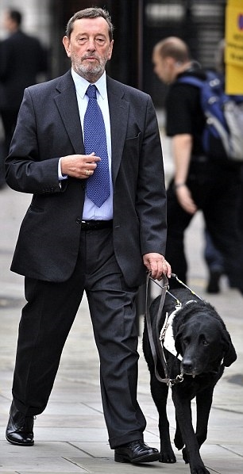

***‘It is not the individual no matter how well placed but the campaigning,***

***the zeal of those building on what comes before, to make the world a better***

***place, who in the end will make that difference’***

David Blunkett is a member of the House of Lords and former Cabinet Minister who served in the Labour government 1997 to 2010.

Blunkett has been blind since birth. He was educated at schools for the blind, but

turned down a course in training to be a piano tuner, insisting on a wider education.

He enrolled at night school for 6 years to get qualifications. He studied politics at

Sheffield University.

Upon graduation he won a seat on Sheffield’s city council, becoming its youngest ever councillor and later its leader. In 1987 he was elected Member of Parliament for

Sheffield Brightside. He became Education Secretary following the 1997

Election, Home Secretary 2001 to 2004, and Secretary of Work and Pensions 2005.

He had responsibility for the Equal Opportunities Commission, establishing the

Disability Rights Commission. He introduced a programme of Inclusive Education.

David Blunkett stepped down as an MP in 2015 and later that year became a Life Peer.

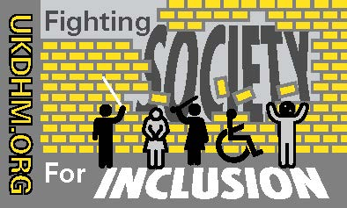

David Blunkett

.

© UKDHM 2019