**Disability: Leadership, Resistance and Culture**



DISABLED LEADERS

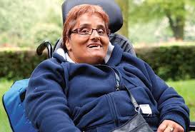

***“The triple oppression of being a black disabled woman should not be overlooked …all the issues affecting disabled women apply to***

***disabled black women. However, the way in which we experience and interpret these issues is likely to differ as the dimensions of race***

***interact to shape our lives.”***

Nasa Begum (1963 – 2011) was a rights campaigner, making an important

contribution to the understanding of the experiences of disabled people, and

campaigned tirelessly for the right to independent living. Her work had a significant

impact on the way that the health service consults with patients. Begum was rare as a senior policy adviser to the Department of Health as a service user herself, having

Nasa Begum

received support for mental ill-health as well as her physical impairement.

Born in Birmingham, Begum was diagnosed with a neurological condition resulting in spine curvature and muscle degeneration. After school, she attended Hereward College in Coventry, at the time for disabled students, which she said compromised her quest for independent living. In 1989

she gained an MA at Warwick University.

She worked at Northampton Welfare Rights Centre, progressing to senior policy and research positions in disability rights. She held research and development posts a prominent organisations over the years. She joined the Social Care Institute for Excellence (SCIE) in 2003 as a principal adviser, helping to set up its first participation strategy with the aim of putting service users and their carers at the heart of service delivery.

Begum worked at the Department of Health. She helped to develop a user-led organisation for disabled people in every health authority. She

joined the board of the National Centre for Independent Living. She presented the Lord Pitt memorial lecture on her joint report with the Race Equality Unit, Doing It for Themselves: Participation and Black and Minority Ethnic Service Users (2006).

Nasa Begum fought all her life for inclusion and equal opportunities for disabled people.

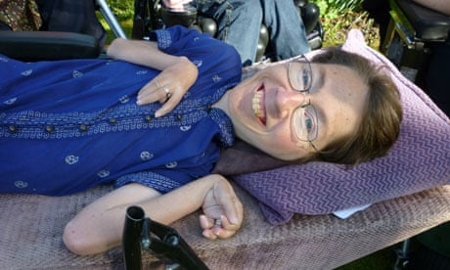

***“If you do not have choice and control over the person who is assisting you, you never have real control over your life. Having PAs enabled me to find out who I am and now enables me***

***to be who I am."***

Rowen Jade (1969 – 2010) was a disability rights leader, pivotal in communicating the views of disabled people to those who determine the policies that affect our lives. As chair of Equality 2025 from 2008 onwards, she was the chief

adviser to the government on disability matters, thus holding a key position in

influencing ministers and civil servants.

Rowen Jade

Jade was born with a severe form of spinal muscular atrophy. Her apparent frailty

Rowen Jade

was part of her power and gave her a unique ability to challenge stereotypes of

disability. She could hardly eat, breathe or move and never weighed more than three stone. Yet she had the physical and mental strength to achieve so much. She attended a mainstream school, where she thrived. At Oxford

Brookes University, she achieved a double first in English and law.

Her first job in disability rights consisted of running empowerment projects for disabled children at the Alliance for Inclusive Education in London.

In Bristol, Jade joined the West of England Centre for Inclusive Living (WECIL), where she pioneered extending this provision to disabled

teenagers. Jade and her partner decided to have their own child, conceived through insemination. Jade was inspired to write, with Michelle

Waites, Bigger Than the Sky (1999), about disabled parenting, to combat prejudice against disabled people becoming parents. She was an

active member of many support and campaigning groups. She was one of the first disabled people to speak out against a change in the law on assisted suicide. In 2006, Jade became a founder member and passionate supporter of Not Dead Yet UK. She asked the question, "Why are

people so keen to help us die, when what we want is support to live with dignity?"

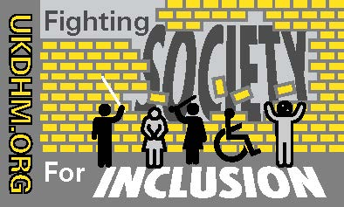

© UKDHM 2019