**Disability: Leadership, Resistance and Culture**



DISABLED LEADERS

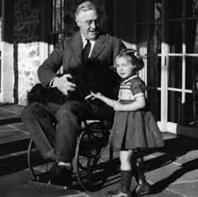

***"I myself have been through this ordeal, (polio) and I am a symbol***

***of what can happen when people with disabilities are strongly***

***supported."***

Franklin Delano Roosevelt (born 1882) was an American statesman and political leader who served as the 32nd president of the United States

from 1933 until his death in 1945.

In 1921 he became paralysed in both legs, using a wheelchair (which he kept concealed) and crutches, but won election to Governor of New York

and 4 times as USA president. He is credited with ending the 1930s Depression with his progressive New Deal and was a great war leader.

FDR believed dealing with his impairment had made him stronger politically.

Franklin D Roosevelt

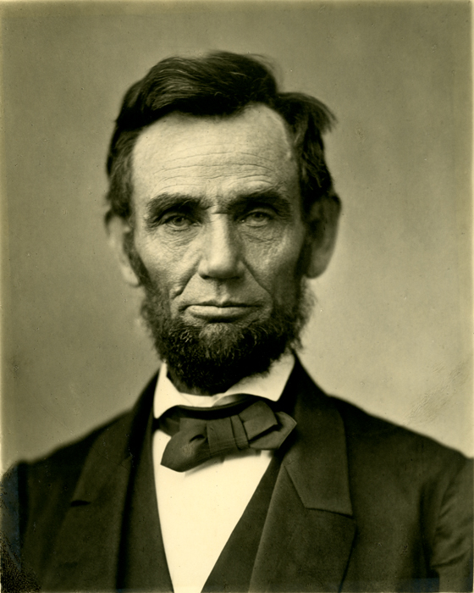 Abraham Lincoln (1809 – 1865) was the 16th President of the United

States. Having had breakdowns and suicidal thoughts, he had clinical depression all his life. He led the country through the American Civil War.

Lincoln grew up in Kentucky where he worked on the land on his father’s holdings, but he preferred reading. He was largely self-taught, studying law and entering the bar in Illinois. The deaths of his mother, sister and later

some of his children pushed him into bouts of melancholia.

Lincoln worked as a lawyer travelling his state for 16 years. Later he ran for the state legislature and congress. He was driven by a deep sense of

equality, that slavery was wrong, which came from his Baptist upbringing. Lincoln initially only wanted to limit the spread of slavery, not abolish it, until

it became a civil war aim to free slaves and recruit them into the Union army. He issued the Emancipation Proclamation, 1863, declaring forever free

slaves within the Confederacy, leading to the 13th Constitutional

Amendment outlawing slavery, 1865.

Lincoln asserted that the nation was born not in 1789, but in 1776,

**"conceived in Liberty, and dedicated to the proposition that all men**

**are created equal".**

Abraham Lincoln

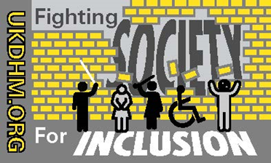

© UKDHM 2019