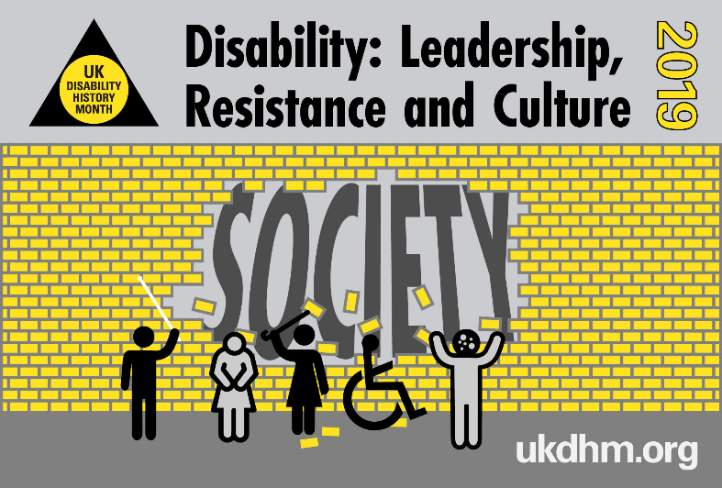
Disability: Leadership, Resistance and Culture. UK Disability History Month 18th Nov-20th Dec 2019

UKDHM 2019 will look at disabled leaders. We will look at their ideas & their struggle to be equal and included. We will look at how the leaders changed the way disability was seen.

We celebrate the lives of disabled people and those who have made these changes possible to improve things for all disabled people.
Even though they have faced barriers, some individual disabled people have become leaders. For example the President of Ecuador, who has a spinal injury and uses a wheelchair, and the writer John Milton who was blind.
However, many disabled people are held back by the world around them and the attitudes of other people.
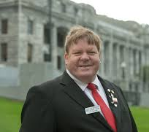
The struggle for an Inclusive world where disabled people have full rights and access continues.

Robert Martin (right) is a man with learning difficulties who represents disabled people on the United Nations Committee.

Our differences have meant that we have often been blamed for the problems in our world. People have thought that we are not as good as those who are not disabled and do not have the same rights in life. This attitude goes back a long way. But disabled people have always tried to fight it. In Germany during the Second World War, disabled people would not get on a bus to the gas chambers. They had to be dragged against their will.

Because of their own feelings about fairness, many disabled people fought for the rights of others.

Suffragettes
Rosa May Billinghurst (below) had polio when she was child. She had to use a 3-wheeled chair, which she moved with her hands.
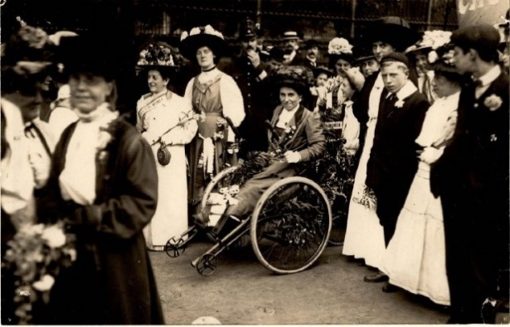
She started the Greenwich branch of the Women’s Social and Political Union. She was a busy protester. She was put into prison many times. She took part in the window smashing in 1912 and other actions. Once when she was arrested she was treated very badly. She was thrown out of her chair. Her arm was also hurt on purpose. Afterwards, the air was taken out of the tyres so she could not move her chair. She was left in the middle of a crowd of rough people.
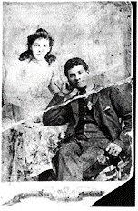
Adelaide Knight (right) needed a stick to walk. She was secretary of the Canning Town branch and one of the main organisers in her area.

The Chartist movement fought for votes for all men. It was the first big political action for the British working class in the 1840s.

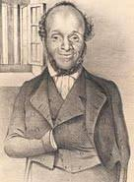
William Cuffay (left), who was a travelling tailor, was one of its leaders. His father was a freed slave. Cuffay’s spine and shins were ‘deformed’ at birth. He was sent to Australia.

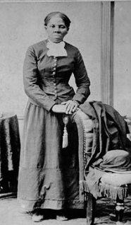

Harriet Tubman (right) was an American Abolitionist. She was born into slavery and wanted to stop it completely. She escaped and then rescued about 70 enslaved people.

She was hit on the head by an overseer and had symptoms of brain injury for the rest of her life. When slavery was over, she went on to fight for votes for women and human rights.

Disabled Political leaders
Franklin Delano Roosevelt (below) was President of the United States from 1933 until his death in 1945. In 1921 he became paralysed in both legs, and had to use a wheelchair and crutches. He still became Governor of New York and 4 times a USA president. He ended the 1930s Depression and was a great war leader.
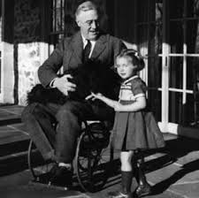

He once said, "I am a symbol of what can happen when people with disabilities are strongly supported."

Henry Fawcett (below) was blinded in a shooting accident in 1858. He was 25. He was brave and determined. He said, “Well it shan’t make any difference in my plans of life!”

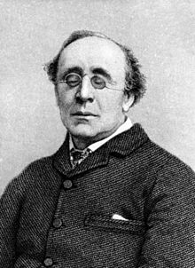
He continued with his education and became an expert on economics. He wrote many important documents and became a Member of Parliament and Minister. He supported lots of important causes. He started parcel post and cheap telegrams.
More recently David Blunkett MP was Secretary of State and Home Secretary.

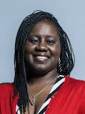
Marsha Chantol de Cordova (right) is a British Labour Party Member of Parliament. She is Shadow Minister for Disabled People. She is registered blind.

In 2017 she said,​ “Living with my visual impairment, I have had to overcome many barriers….my mother… fought tooth and nail to keep me in mainstream education.”

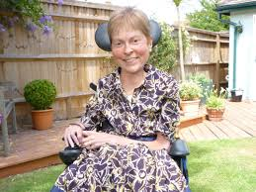
Baroness Jane Campbell (left) has been in the House of Lords 11 years. Jane has spinal muscular dystrophy.

She successfully campaigned for independent living Direct Payments. In 2006 she started Not Dead Yet UK.

Self-Organisation
Over the last 150 years, the improvements in our lives have been shaped by handfuls of individual disabled people. Their thinking and actions challenge how things are. Because of the way the world is run, we are placed as objects of charity. The Disability Movement hits back at this and stands up for itself.

National Association for the Deaf and Dumb was founded by deaf people in 1886. It was a deaf-led British organisation supporting deaf people who use British Sign Language.

It was started because deaf language and education rights were in danger. An international meeting had decided to put a stop to the use of sign languages throughout the world. Deaf teachers would not be employed anymore and sign language would not be used in schools. Instead the Pure Oral System (speaking only) would be used.
The Association successfully fought against this. British Sign Language and the manual alphabet has been used in education more recently.
In 2003 the Labour Government recognised British Sigh Language as an official British language.

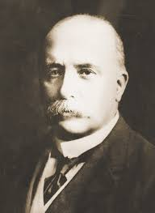
Francis Maginn (right) was born deaf in Ireland in 1861. He was educated in the London Asylum for Deaf and Dumb. He was a teacher at the Margate branch then went to college in the USA. He found that Deaf people were treated better in America. When he came back he spent his life trying to improve the quality of life for Deaf people in the UK.

Dorothy Miles (1931-1993) produced the first British Sign Language/ English Dictionary. She came up with the following signed song. She performed it at a 100th anniversary event of the BDA in 1990.

“The BDA is You and Me”

1880 was a really bad time,
Men got up and said we couldn’t sign,
They told deaf teachers ”Out you get”
But the deaf community wasn’t beaten yet

THE BDA is you and me,
Together we will fight for equality.

The next ten years we schemed and planned,
To save sign language in Britain’s land,
One bold Irishman made the call,
“We must unite and be one for all”.

THE BDA is you and me,
Together we will fight for equality.

In 1890 a small group met,
Up there in Leeds-we will never forget,
Deaf and hearing together that day
They finally formed the BDDA
Justice not Charity
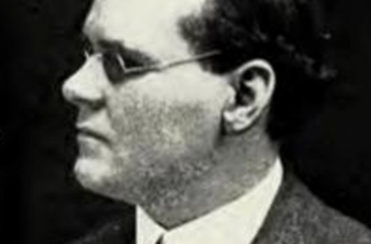
Ben Purse (right) was born in 1874. He was a blind piano tuner. He had lost his sight completely by the age of 13. Because he could not get work he started a new union. It was made up of only blind and partially sighted people. It was called National League of the Blind and it began in 1899.
The group wanted help straight from the government, instead of through charities. He was part of National League of the Blind until the 1920s. Then he started to work with charities to improve blind people lives.

The National League of the Blind joined the Trade Union Congress and the Labour Party at its first general meeting in 1906. They were unhappy about lots of things: they wanted blind students to be taught and trained in regular schools and colleges; blind workers were paid low wages, and they often had to beg for more.
They organised many strikes. One lasted for 6 months.
Groups like the National League of the Blind helped to start the Welfare State. Among other things they wanted a fair pension for people who could not work.

Some blind workers from around England, Scotland and Wales marched to London in April 1920 (below).

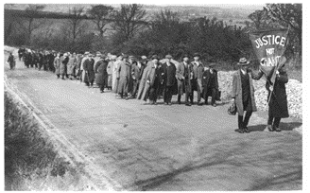
They walked behind a banner that read ‘Justice Not Charity’.
They waited for 5 days to see the Prime Minister. People from London trade unions waited too. The Blind Persons’ Act became law in September 1920.

Post-World War Two
The beginning of the Welfare State actually led to disabled people being more kept apart from non-disabled people. Organisations started by disabled people began to grow.

The transport system was difficult for physically impaired people to use. They needed motor vehicles to be changed so they could drive them.
The Disabled Drivers’ Motor Club was first started by 6 First World War ex-servicemen. They met when they were having their artificial limbs fitted. The group won the right for disabled people to have a driving licence.

Above: a ‘motorised trike’
provided by the Government.

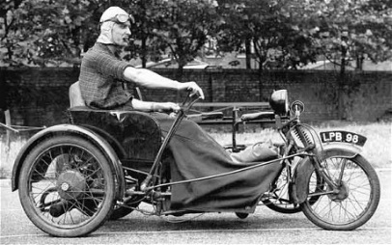
O A “Denny” Denly (right) got polio in 1945, when he was in the Royal Navy. He became paralysed from the waist down. He was given a petrol powered tricycle. In June 1947 he crossed the Swiss Alps on it. His amazing journey was broadcast by the BBC Home Service. Because so many people were interested in this the Invalid Tricycle Association was set up. They joined together with Disabled Drivers’ Motor Club and became the Disabled Drivers’ Association. They brought in the Motability Scheme (1978). It funded disabled people to buy standard cars and have them made user-friendly.

The Disablement Income Group was started in 1965 by 2 housewives called Megan du Boisson (below) and Berit Moore.

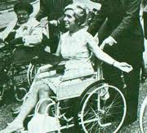
The group fought for a full disability income through the social security system for all disabled people.
At the time, social security payments to disabled people were different depending on why a person was disabled. People injured in war or in the workplace got more support than the "civilian" disabled. In the 1970s new social security benefits were introduced. For example, benefits for housewives and carers.

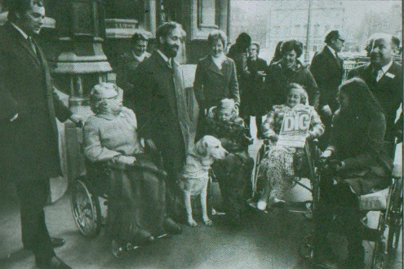
Many people consider Disablement Income Group to be the beginnings of the modern disability movement in the United Kingdom.
They knew that not enough money was a big problem. Megan said, "When I first became ill, I realised that help would be vital at home. We fought for and got a disability pension for housewives who did not work”.
Disablement Income Group changed the Welfare rules and got Attendance Allowance.
They worked with deafened MP Jack Ashley. He worked with Alf Morris MP, whose family had several disabled members. He started the Chronically Sick and Disabled Act, in 1970. It put in place the ‘orange’, now Blue Badge. It also made sure that Local Authorities had to support disabled people living in their own homes. In 1974 Morris became the first Minister for Disabled People. Blue Badges have just been extended to those with Autism.

Rights Not Charity
Paul Hunt (right) had muscular dystrophy. He lived in a Leonard Chesire Home for ‘the Disabled’, called Le Court. In 1972 he started a fight for independent living.

From this grew the Union of Physically Impaired Against Segregation.
Members of this union invented the social model of disability. The model encouraged people not to see disabled people as objects of pity, without rights (like the medical model had done). It showed that the problem was not the disability but the attitude of others and unhelpful surroundings. These things can be removed.
They fought for Civil Rights.
The Equality Act of 2010 showed a real change of culture.
UK activists were a very important part of setting up Disabled People International. They fought for the United Nations Convention on the Rights of Persons with Disabilities in 2006.
178 countries worldwide have agreed to this.

In the 1950s, people with significant physical impairments were put in hospital wards for the long-term sick and elderly. There were too many obstacles for them to live in the community. Disability was seen as their problem. Paul Hunt came to think it was social and physical barriers that were the key issue.

Le Court was set up by Leonard Cheshire. It was his first alternative home for ‘the disabled’. It was relaxed and friendly. However, Local Authorities were paying for places in the growing number of these homes. They began to have stricter management and to medicalise them. The residents at Le Court fought these pressures and were threatened with being sent back to hospital. They produced the important book ‘Stigma: The Experience of Disability’. It looked at their experiences and argued for a different approach to the ‘medical model’, self-representation and control of their lives. This indirectly led to the formation of the Union of the Physically Impaired Against Segregation.

Paul met with Vic Finkelstein (below). Vic had been paralysed following an accident. He was an activist and one of the key thinkers. He developed the idea of disability as a social oppression and put forward the social model.

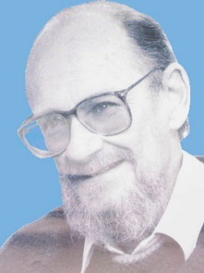
Finklestein played a key part in setting up the British Council of Organisations of Disabled People, who said:

“In our view, it is society which disables physically impaired people. Disability is something imposed on top of our impairments, by the way we are unnecessarily isolated and excluded from… every area of life, such as education, work, mobility, housing, etc.”

The Movement in the UK was to be copied around the world.

Independent Living Centres
Ken and Maggie Davis pioneered independent living by commissioning their own housing scheme in Sutton, Ashfield in the 1970s. Derbyshire Coalition of Disabled People was one of the first to develop. It was supported by the local Council and in consultation with disabled people. These 2 schemes learned much from the struggle at Berkeley USA to set up the first Centre for Independent Living.
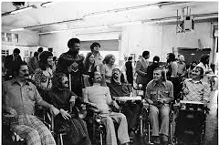
The Berkeley Center for Independent Living (at the University of California) eventually came about because Ed Roberts, with Hale Zukas and Jan McEwan Brown joined forces to make the full academic and social life of the college accessible to all.

In 1972, these students joined community members to create The Center for Independent Living, Inc., based on 3 important points:

- Those who know best the needs of disabled people and how to meet those needs are the disabled people themselves.

- The needs of disabled people can be best met by comprehensive programs which provide a variety of services.

- Disabled people should be integrated fully into their community.
The Center’s services were so successful that today it is the model for roughly 400 independent living centres across the USA, with similar programs in 20 countries.

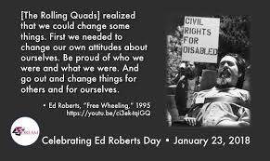
Ed Roberts ‘The Father of Independent Living’ (below) got polio when he was 14 years old. He had control of two fingers and some toes, and needed to sleep in an iron lung.
He went back to high school by phone. He fought to be enrolled at University of California, Berkeley to study political science. Eventually he was given a room on campus and by 1966, 11 other significantly physically impaired students joined Ed.
They fought for funding from Federal government, and for the rights of people with disabilities. They wanted to enforce part of the Rehabilitation Act of 1973 which said that they should not to be excluded, denied anything, or be discriminated against just because of their disability.
As a result of a successful month long occupation, this was passed into law.
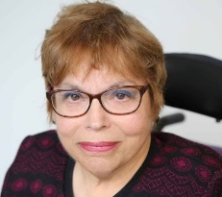
Ed taught at the university and became advisor to the Governor of California. He set up the World Institute of Disability with Judy Heumann (right), who became disabled advisor to Presidents Clinton and Obama.
Developing Movement in UK
The Disability Movement in the UK grew as people came together in local groups. Disabled people wanted to be part of the growth in the economy and they were not. They also wanted to be free of the threat of being put in an institution. They realised that the problems they faced could only be addressed together.

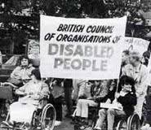
The British Council of Organisations of Disabled People (left) was set up in 1981. This was also International Year of the Disabled.
The Council was made up of national organisations controlled by disabled people. It challenged the existing disability establishment, which was run by charities controlled by the great and the good.
By 1995 it had 300,000 members. When the Disability Discrimination Act became law it wanted full anti-discrimination legislation. It put pressure on the Government and in 2005 they imposed a proactive duty on the public sector to promote disability equality.

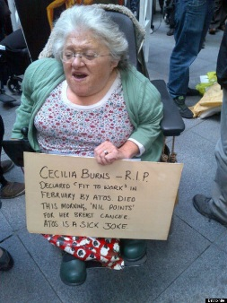
The Liberation Network of Disabled People focused on breaking down isolation by finding ways to communicate with each other whether deaf, blind or physically impaired. Many of the ideas were developed by Micheline Mason (right) and others in their ‘In From the Cold’ magazine.

“We brought together leaders of different fragments of a movement. We challenged the effects of ‘internalised oppression’… the conditioned hatred of ourselves and each other as disabled people… the desire to assimilate… the denial of ‘hidden’ disabilities… the inability to champion, appreciate and support each other's achievements or thinking… the lack of information and understanding about the issues of other oppressed peoples. “Micheline (Jane Campbell & Mike Oliver Disability Politics, 1996).

Selected Principles of Liberation Network of Disabled People
“#To seek to abolish all forms of segregation particularly in education settings and residential institutions

#To seek allies amongst able bodied people (i.e. people who will help us fight for ourselves-not on our behalf)
#To seek complete self-determination and control over our portrayal in the media and to have control over information put out about us.

#To encourage people with disabilities to organise themselves into active groups which will discuss the implications of achieving their rights at international, national and local levels, and will seek to change or influence conditions around them.

#To make allies of, and be allies to, all oppressed groups”.

The thinking of Liberation Network of Disabled People helped later form the Alliance for Inclusive Education. The work on self-representation, social model and disability as an oppression was brought together to transform education.

The Alliance for Integration was set up at a conference called Integration Now in 1990. It was made up of parents who wanted their disabled children in mainstream school, disabled adults, teachers and other educationalists who wanted integration.
Micheline had a disabled child, Lucy, and wanted her included. Micheline had been excluded until the age of 14, when she then attended residential segregated school. She taught them social model thinking. It rescued parents of disabled children who had to put up with medical model approaches, which led to isolation and segregation.
The Conference agreed that the organisation should be led by disabled people, working with friends. Micheline Mason became the Secretary and Richard Rieser, a disabled teacher, became the Chair. The Alliance acted as the hub of a movement of many local struggles all around the country.

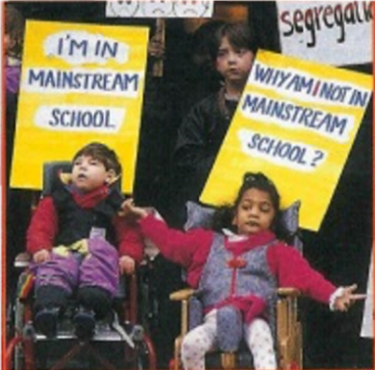
After demonstrations, occupations, court cases and lobbying they managed to change the law so disabled children could not be segregated against their parents’ wishes.

Preethi Manuel went to the High Court about her disabled daughter Zahrah (left) not being included and won. The SEND Act 2001 changed earlier practice and led to a big increase in Inclusion.

Young and Powerful was a group of disabled and non-disabled young people who went to mainstream schools. They campaigned for all children to be included in schools together.

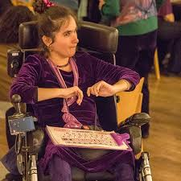
Maresa Mackeith (right) was not being treated fairly at her Comprehensive school. Maresa has cerebral palsy. She cannot talk, but communicates by facilitated communication.
She was put in a separate room on her own. At the end of the 2nd term she wanted to invite some children she had met to her home.
She said, “The teacher refused to give the invitations out saying ’they are not ready to come to your house’. I asked the Young and Powerful group for help”.
When they got to County Hall the Director did not want to see them, but eventually he agreed to look into her case. When he met them again his attitude had completely changed. “He said it was worse than we had said and I could choose any school in Nottinghamshire to go to”.
Maresa moved to a new school in Yr. 9. She got the assistance she needed. She gained GCSEs, A levels and a university degree.
She said, “To me that education was a lifeline... I wanted access to knowledge… and to learn amongst others. Communication and Education are Human Rights and disabled people are human. Now I do a combination of writing and talks in education and other settings to try to persuade the world that we must include everyone in the action of living.”

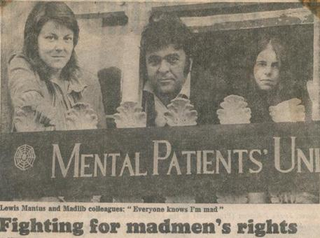
Mental Health Survivors’ Movement
From the 1970s this movement grew alongside the development of the Disability Movement. A huge variety of groups flourished, as a result of a large closure programme of mental hospitals and the growth of ‘care in the community’. They led to user-centred ways of providing support to people with mental health problems.

In March 1973, about 100 people met to discuss forming a Mental Patients Union (above right). Most people were patients or ex-patients, and most lived in London. It turned out that this was not the first Mental Patients’ Union.
The national Mental Patients Union was formed with full membership reserved for patients and ex-patients.
Peter Campbell said, "We proclaim the dignity of society's so-called mental patients. We challenge repressive psychiatric practice and its ill-defined concepts of 'mental illness”.

Race and Mental Health
David ‘Rocky’ Bennett (below) is one of a long line of Caribbean and Black men with mental health issues, who have died in police custody or the high end of the mental health system.

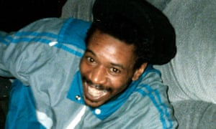
There is an imbalance with this group 3 to 5 times more likely to have severe mental illness/ schizophrenia. Black men with mental health issues are twice as likely as white men to commit suicide. They are disproportionately detained under the Mental Health Act.
Racism was a problem in the Survivors Movement in 70s-80s and it still is in the NHS. An effective Black Survivors’ Movement is needed. The Disability Movement also needs to remedy its poor record on intersectional equality.

People with Learning Difficulty
Coming out of a past of exclusion and forced locking up, people with Learning Difficulties fought against the label of ‘mental handicap’ and biased IQ testing.
People First National was formed by self-advocates in the 1980s. Many people were only just returning to the outside world to live in the community, because a large closure programme of long stay mental hospital was under way.
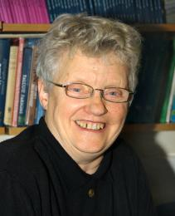
Mabel Cooper (left) was institutionalised at 3 weeks old until she was in her 30s. Upon her release, Mabel became an active campaigner for people with learning disabilities and was awarded an Honorary Degree from the Open University in recognition of her work.
Gary Bourlet was another founder of People First and a self-advocate. More recently Gary has founded the Learning Disability Alliance. It has equal numbers of self-advocates, families and organisations on its board.
DAN (Disabled People’s Direct Action Network) formed after a successful action of 1500 activists that blocked ITV Telethon and stopped it in 1992.
Telethon was a television show that raised money for charity. Disabled people felt that the language used and the images shown were demeaning. They portrayed disabled people as objects of pity.

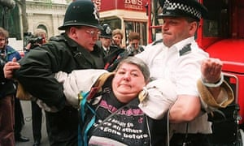
DAN activists went on to fight for accessible transport by chaining themselves to buses and trains (right). The effect was to bring forward the date when all new buses had to be accessible. In London this was 20 years before the legislative date.

Disabled People Against the Cuts.
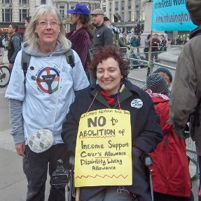
Government cuts since 2010 have affected disabled people more than any other group in society.
Disabled People Against the Cuts was started by Linda Burnip and Debbie Jolly (left).
The action group organised protests against benefit cuts, the ending of the Independent Living Fund, the Welfare Reform Act, and the Bedroom Tax amongst other issues (below).
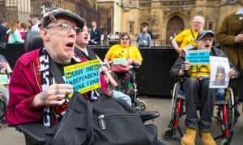

They later initiated a complaint to the United Nations. This was investigated and the UN found “grave and systematic violations of disabled people’s human rights in the UK”.
They called Government policy a human catastrophe.

Our movement needs more than ever to go back to the insights contained here.
We need a strong grass roots democratic cross impairment disability movement, combining with our allies to expose and critique the discrimination and prejudice that undermines our human rights.

Trade Unions now have sections for disabled members and the Labour Party has changed its rules to ensure proper representation of disabled people at every level. Both are committed to a social model approach.

We still need to find new ways of struggling for Inclusive structures and Equality.

There needs to be a recognition that on paper and in law we have made progress, but that our experience of the deeply ingrained oppression towards all disabled people requires us to be directly and collectively involved in a changing of society and the world.

We can make a start by challenging the growth of exclusions, segregated education, and attacks on the livelihoods of disabled people through welfare reform.

Richard Rieser Coordinator UKDHM
rlrieser@gmail.com
www.ukdhm.org
Printing of the broad sheet supported by Unison

