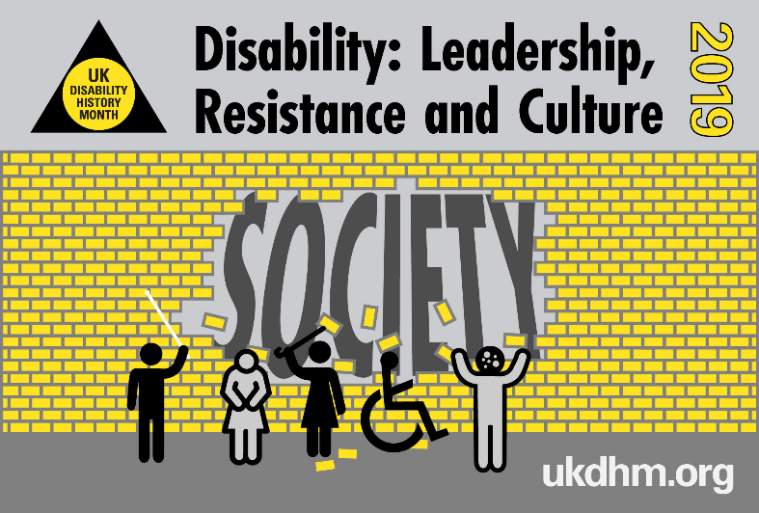
Disability: Leadership, Resistance and Culture. UK Disability History Month 18th Nov-20th Dec 2019

This year we focus on disabled individual leaders and leaders of social movements, their thinking & struggle for acceptance and equality. We examine how the leaders of the Disabled People’s and the Mental Health Survivors’ Movement changed the way disability was seen, moving from a personal individual medical problem to a socially created oppression and human rights issue. This was achieved using the social model of disability from 1970 to the present. We examine earlier examples of individual and collective resistance to the oppression disabled people have faced at work, in education, in their local community and the collective strength of disabled people in the Disability Movement for fairness, equality and a life worth living. We trace the change in thinking about disability both in organisations and society. We celebrate the lives of disabled people and those who have made these changes possible. Our website will have a range of articles, videos and pictures about different struggles for our rights www.ukdhm.org Disabled People have throughout history been treated as other, different. We are pitied, reviled, venerated or seen as objects of curiosity or fun with less value than non-disabled peers.
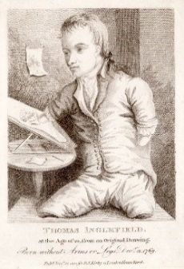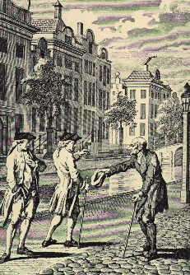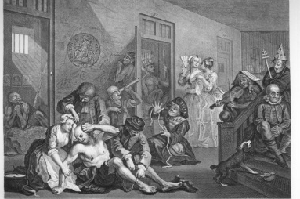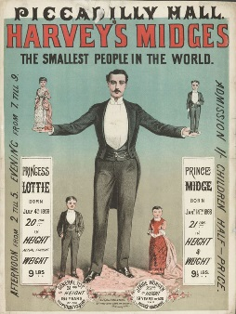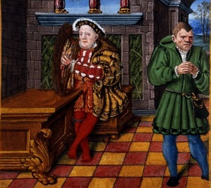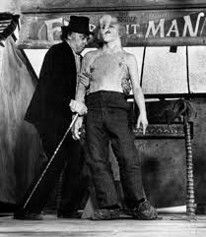
Sometimes self-mockery as fool, clown or freak was the only way to live. [Left to right, Thomas Inglefield-limbless artist 1769; C18th street beggar; Visit to Bedlam, Hogarth; Freak Show –‘midgets’1880s; Henry VIII with disabled jester; Elephant Man on display.] People with physical, sensory or mental impairments have either tried to pass as non-disabled or where the visibility of their impairment and the social reaction to it, disablement, has made this impossible, they have resisted or colluded with dominant stereotypes. In most cases a combination of these. Seeking to overcome the disadvantages by extra effort and the insights gained has led to some individual disabled people becoming leaders. To quote a medieval German saying “The Cripple Always Leads the Dance” (cripple should now not be used). Just consider the wide range of disabled people who have risen to be leaders in their chosen field, despite the barriers. Many have not because of obstacles of attitude, organisation and environment.
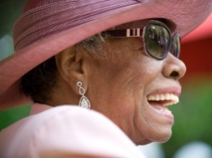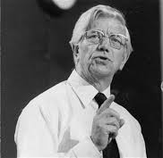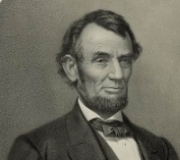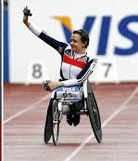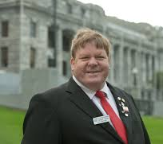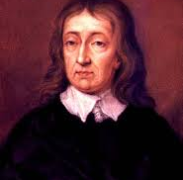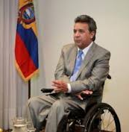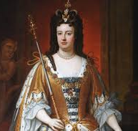
Maya Angelou Jack Ashley MP Abraham Lincoln Baroness Tanni Robert Martin John Milton Lenin Moreno Queen Anne
Author Parliamentarian President USA Grey Thompson Self Advocate UN Paradise Lost Pres. Ecuador British Queen
Selective Mutism Deafened Depression Paralympian/Politician Learning Disability Blind Author Spinal Injury Immune Disorder

Our ‘otherness’ has led us to being scapegoated and wrongly blamed for society’s ills. Underlying this are deep cultural and religious beliefs about our inferiority or unworthiness to life. But even in the most extreme situations there has been resistance. During the Nazi Euthanasia programme to eliminate disabled people, they resisted. [The German Government acknowledges 270,000 were murdered during the T4 programme 1939-1945.] At Absberg, residents of the Abbey run by the Catholic Church for disabled people, refused to get on the bus taking them to the gas chambers. They were dragged and carried by force on to the bus and their resistance put to shame the nuns’ and local people’s helplessness as they stood by.

Other social movements attracted disabled people prepared to fight for political rights out of their own sense of justice.
Suffragettes
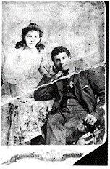
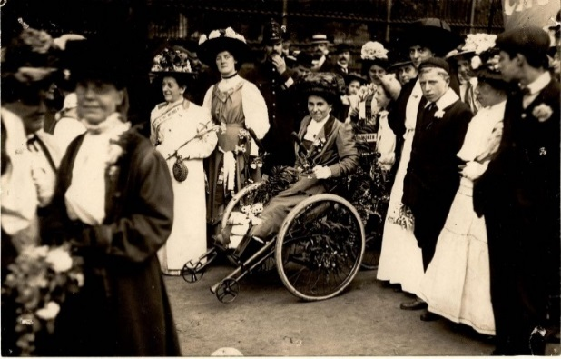
Rosa May Billinghurst used a hand-propelled tricycle after a childhood case of polio. She founded the Greenwich WSPU branch (1910) took part in the window smashing campaign (1912) and was thrown into Holloway Prison on multiple occasions. In 1910, Billinghurst was one of 159 women arrested at a demonstration outside the House of Commons. Afterwards she recalled: "At first the police threw me out of the machine on to the ground in a very brutal manner. Secondly when on the machine again they tried to push me along with my arms twisted behind me in a very painful position. Thirdly they took me down a side road and left me in the middle of a hooligan crowd, first taking all the valves out of the wheels and pocketing them so that I could not move the machine." Another disabled suffragette, Adelaide Knight, walked using a stick. Knight became secretary of the WSPU’s Canning Town branch (1906). She was part of a mixed race family. (Knight married a Jamaican man in 1894.) Among the working class women’s movement, she was hugely significant and she was one of the key organisers in her area.

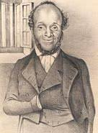
The Chartist movement for universal male votes was the first mass political movement of the British working class. One of its leaders, William Cuffay, was born in 1788 in Chatham. His father, a freed slave from St. Kitts, was a cook on a warship. Cuffay, whose spine and shins were ‘deformed’ at birth, became a traveling tailor in his late teens and remained in that trade. 3 million signatures were gathered to the Charter. In 1848, Cuffay was arrested on the information of police spies, for conspiring to levy war against the Queen. He was probably aware of the plot but not a supporter of it. His bearing in court was very dignified - he objected to being tried by a middle class jury, and to the evidence against him, which was gathered by police spies known to be dishonest. He was sentenced to life transportation to Tasmania.
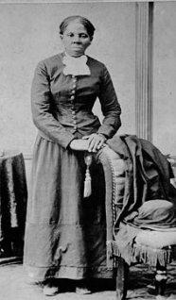
Harriet Tubman was an American Abolitionist and political activist. Born into slavery, Tubman escaped and made some 13 missions to rescue approximately 70 enslaved people, using the network of anti-slavery activists and safe houses known as the Underground Railroad. Tubman was hit on the head by an overseer and for the rest of her life had symptoms of brain injury. After abolition she went on to fight for women’s suffrage and human rights.

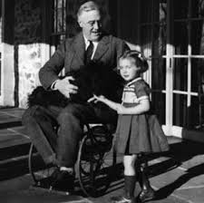
Disabled Political leaders. Franklin Delano Roosevelt (FDR) was an American statesman and political leader who served as the 32nd president of the United States from 1933 until his death in 1945. In 1921 he became paralysed in both legs, using a wheelchair (which he kept concealed) and crutches, but won election to Governor of New York and 4 times as USA president. He is credited with ending the 1930s Depression with his progressive New Deal and was a great war leader. Speaking at a rally in Rochester New York "I myself have been through this ordeal, (polio) and I am a symbol of what can happen when people with disabilities are strongly supported." FDR believed dealing with his impairment had made him stronger politically.

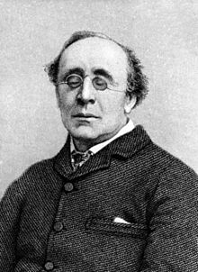
Henry Fawcett in 1858, aged 25, was blinded in a shooting accident. Courage and determination were to be the hallmarks of his career and he declared, “Well it shan’t make any difference in my plans of life!” He continued with his studies, especially in economics. In 1863, Henry Fawcett published his Manual of Political Economy as Professor of Political Economy at Cambridge. He made himself a recognised authority on economics, his works on which include The Economic Position of the British Labourer (1865) and Labour and Wages. He was elected Liberal MP (1865 to 1884) for Brighton and then Hackney. He advocated votes for women and the abolition of religious tests at universities. He supported social reforms for factory and agricultural workers. Re-elected for Brighton (1868) he joined a group of radicals, became a conspicuous critic of the Liberal Government and eventually alienated himself from the Party. Reconciled in 1880 he became Postmaster General, establishing parcel post and cheap telegrams.
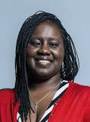
Marsha Chantol de Cordova (born 1976) is a British Labour Party politician, who was elected as the Member of Parliament for Battersea at the 2017 general election. She defeated the Conservative Minister Jane Ellison. She was appointed Shadow Minister for Disabled People. De Cordova has Nystagmus and is registered blind. Most recently, de Cordova worked at leading sight loss charity Thomas Pocklington Trust, as Director of Engagement and Advocacy. De Cordova was a Labour Party councillor for the Larkhall ward on Lambeth Council and an active Unite the union rep. “Living with my visual impairment, I have had to overcome many barriers, but I want to give a special thanks to my mum, who is here today. She made sure that I had a brilliant state education. When I was at primary school, the headteacher thought that it would be better if I was sent to a special school, but my mother was having none of that and fought tooth and nail to keep me in mainstream education. I can safely say that I would not be the woman I am today, or an elected Member of Parliament, had it not been for her.” Maiden speech 2017.​

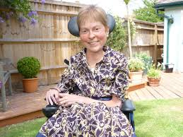
Baroness Jane Campbell has been in the House of Lords 11 years. Jane has spinal muscular dystrophy. How did she get interested in disability politics? ‘I went to university gaining a first class degree and masters and got a job at the charity RADAR. They sacked me because I could not type fast enough. I was invited to one of the first meetings of BCODP by Frances Hasler. I had steered away from disabled people because of my internalised oppression. When I heard Vic Finklestein and Mike Oliver explaining the ‘social model’ it suddenly transformed how I thought. I was interested in independent living. John Evans explained how he received Direct Payments. I wanted this in Kingston and a new Director of Social Services agreed so Ann MacFarland and I were the first 2 disabled people to get this. Then we campaigned to get a Bill through Parliament. It took 6 years and now any disabled person can have Direct Payments from their Council. I had a series of leadership jobs and eventually was made a Peer, but everything I do is guided by Nothing About Us Without Us’. When she gets flu, the hospital does not want to resuscitate her. So makes sure someone is with her. Our lives are still seen as not worth living. She started ‘Not Dead Yet.’

Self-Organisation. Over the last 150 years, the radical history of disabled people leading to improvements in the conditions of our existence has been shaped by handfuls of individual disabled people, their thinking and movements which challenge the status quo. This status quo is shaped by the system’s requirements for employment, profitability and needs of an increasingly globalised market of capitalism, mediated by humanitarian and charitable impulses, which place us as objects of charity. This is countered by self-advocacy and the thinking of the Disability Movement.
National Association for the Deaf and Dumb (NADD) was founded by deaf people (1886) replaced by British Deaf and Dumb Association (1890). In 1971 it became the British Deaf Association (BDA), a deaf-led British organisation advocating for deaf people who use British Sign Language. The creation of the NADD was in response to the perceived threats to their language and education rights which had arisen after the Milan Conference of 1880. This international eugenicist inspired congress, where the majority of those attending were hearing teachers of deaf children, had passed a resolution banning the use of sign languages throughout the world. The participants had returned to their home countries, determined to eradicate both the employment of Deaf Teachers and the use of sign language in schools. A Royal Commission on the education of deaf children was launched (1889). It failed to consult deaf people and supported the establishment of the Pure Oral System with the banning of sign language. In response, the magazine Deaf Mute encouraged deaf people to unite in defence of their own interests. Prior to this, from the advent of Sign Language (1780s), there had been a renaissance with Deaf Schools using Sign Language and Deaf Teachers. Since losing to Pure Oral, the BDA has consistently argued for a Total Communication position for Deaf Education including BSL and the manual alphabet, which is now recognised as educationally the right approach.
In 1889, the NADD ceased to exist, so 4 deaf men, including James Paul, Francis Maginn and George Healey, arranged a meeting (January1890) at St. Saviour's Church for the Deaf, Oxford Street, called the "National Conference of Adult Deaf and Dumb Missions and Associations". Many of the leaders of the movement were Deaf Missionaries charged with bringing God to the Deaf. The conference considered the forming of a national society to "elevate the education and social status of the Deaf and Dumb in the United Kingdom", resulting in the formation of the British Deaf and Dumb Association (BDDA) in Leeds (July 1890). The BDDA deleted the world "Dumb" from its title (1971). The BDDA fought with a network of Deaf Clubs to keep Deaf culture and language alive. It wasn't until the 1970s that schools began to look again at accepting sign language. Its resurgence and acceptance by the general public resulted in Deaf leaders slowly returning to the forefront, starting with Jack Young the first Deaf chair (1983) and Jeff Mc Whinney the first Deaf chief executive (mid 1990s). The BDA became a deaf-led organisation and mainly campaigned for the recognition of sign language. In 2003 the Labour Government recognised BSL as an official British language.
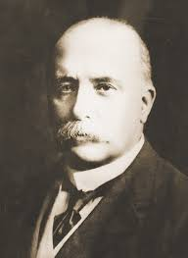
Francis Maginn (1861-1918) was born deaf in Ireland and educated in the London Asylum for Deaf and Dumb in Old Kent Road. He became a pupil-teacher at the Margate branch before going to the USA to the forerunner of Galludet College. He formed the view that Deaf people in America had better status and opportunities to achieve higher levels of attainment. Returning after 3 years he realised that the British approach to deafness was one of injustice, and he devoted his life’s work to improve the quality of life for Deaf people in the UK. Maginn had argued the new Association should only be for Deaf people (which he lost) and that the name ’Dumb’ should not be used because of negative meanings, (which he also lost).
Dorothy Miles (1931-1993) who had produced the first BSL/English Dictionary, devised the following signed song and performed it at the Centenary Conference of the BDA in Brighton in 1990.

The BDA has been making and collecting films of its members signing since 1931. This is included in the collection. www.sharedeafarchive.org

“The BDA is You and Me”

1880 was a really bad time,
Men got up and said we couldn’t sign,
They told deaf teachers ”Out you get”
But the deaf community wasn’t beaten yet
Chorus
THE BDA is you and me,
Together we will fight for equality.

The next ten years we schemed and planned,
To save sign language in Britain’s land,
One bold Irishman made the call,
“We must unite and be one for all”.
Chorus
In 1890 a small group met,
Up there in Leeds-we will never forget,
Deaf and hearing together that day
They finally formed the BDDA
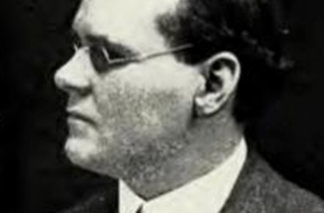
Justice not Charity. Ben Purse, born in 1874, was a blind piano tuner who had trained at Henshaw’s Blind Asylum, Old Trafford. Purse had lost his sight completely by the age of 13. After failing to get work Purse decided to form a radical organisation of only blind and partially sighted people. Purse and the newly formed National League of the Blind (1899) argued the need for an entitlement to direct state aid and the abolition of all charities. Purse was a strong advocate of self-representation, using parliamentary and direct action, arguing a trade union was required in order to represent workers who were being exploited in private industry and in the charity sector. Ben stayed connected to NLB until 1920s, then moved away from the NLBs radical aims, wishing to work with charities to improve the lot of blind people. Ben’s dream of a minimum wage was only introduced 48 years after his death in 1954.

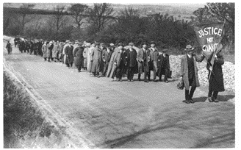
The National League of the Blind of Great Britain and Ireland (founded in 1894) joined the TUC (1902) and the Labour Party at its first Conference (1906), which endorsed the NLB policies, including education and training for blind students in mainstream institutions. Conditions in the charity workshops for blind workers were notorious for their excessively low wages. Workers often had to beg to augment their meagre incomes. They organised many strikes, one for 6 months in Bristol, 1912. Organisations such as the NLB and its influence in the TUC and Labour Party helped frame the Beveridge Report and the instigation of the Welfare State. As well as collective bargaining for workers in charitable foundation workshops, the League campaigned for the state to take over responsibility for employing blind people and for a decent pension for those who could not work. 74 blind workers from Scotland and north east England travelled to Leeds, setting off on 5th April 1920. 60 workers from Ireland and the north west left Manchester and 37 from the south west departed from Newport. They marched behind a banner reading ‘Justice not Charity’, the marchers reaching Trafalgar Square on 25 April, supported by London trade union branches. They then waited five days to see Prime Minister Lloyd George. The Blind Persons’ Act became law (September 1920). Despite the huge propaganda success of the march, the law was less prescriptive than the League had wanted. A further march was organised in 1933.

Just after the First World War there was an uprising of militancy with the Disabled Soldiers and Sailors Association and many trade unions engaging in direct action. In the 1920s this was replaced by an increase in philanthropy, with the forming of the British Legion and an increased role for St Dunstan’s for Blind Veterans UK, founded in 1915 by Sir Arthur Pearson, owner of Daily Express, to provide rehabilitation, training and lifelong support to those blinded in the First World War.

Post-World War Two. The introduction of the Welfare State ironically led to an increase in segregated provision for disabled people in long stay mental deficiency hospitals, asylums, care homes, with a rapid growth of segregated education. The 1944 Act was based on selection by ability for Grammar, Secondary Modern and Technical schools, with increased selection for disability with 14 new categories of special schools. This was matched by a growth and increased professionalism of special educators and rehabilitation professionals. In the modern age, where many disabled people are feeling isolated and marginalised by government cuts, ruthless examination by the benefits system, large-scale closure of support services and demonization by the popular press, some might argue that the innocent and caring community spirit of post-war Britain was a relatively better place to be. Economically times were harsher, there were less opportunities and attitudes were paternalistic, but at least there was a sense of optimism and progress. Self-directed organisations evolved such as Disabled Driver's Association and the campaigning groups of the 1960s like Disablement Income Group (DIG) and later the Association of Disabled Professionals and the Spinal injuries Association.

The transport system was inaccessible. Physically impaired people relied on adapted motor vehicles and later the ‘invacar’ or ‘motorised triks’ provided by Government. The Disabled Drivers’ Motor Club (DDMC) was originally formed by 6 First World War ex-servicemen who met while having artificial limbs fitted at St Mary’s Hospital, Roehampton. The first official meeting was in April 1922, when it was decided that membership should be open to all disabled drivers of cars and cycle cars. In the 1920s and early 1930s the DDMC took an active role in shaping public and parliamentary opinion regarding disabled drivers. The DDMC won the right for disabled people to hold a driving licence, and by the end of the 30s was officially recognised by the Minister of Transport as the representative organisation for disabled drivers.
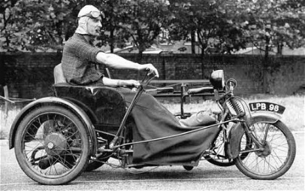
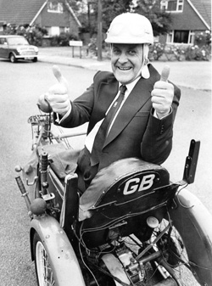
Having contracted polio and becoming paralysed from the waist down while serving in the Royal Navy in 1945, O A Denly (Denny) was issued with a petrol powered Argson tricycle with a maximum speed of 30mph. In June 1947 he crossed the Swiss Alps on it, and in August the same year listeners to the BBC Home Service were enthralled by a broadcast about his extraordinary expedition. So much interest was aroused from the radio broadcast that an article appeared in Motorcycle Magazine to float the idea of an association, and in 1948 the Invalid Tricycle Association was formed. The main activities revolved around rallies and excursions and travel. The association also focused on mutual help and support for its members. These two organisations both run by disabled people, merged to form the Disabled Drivers’ Association and successfully brought in the replacement of the ‘Invacar’ by the Motability Scheme (1978) which funded disabled people to buy standard cars and have them adapted. The Chronically Sick and Disabled Person’s Act was the first law that referred to access to buildings, as a result of the work of Denny Denly, who in the 1960s was the country’s only access officer.

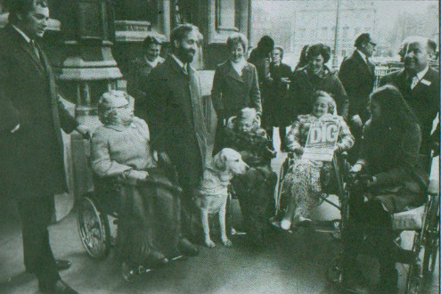
The Disablement Income Group was a British disability pressure group formed in 1965 in Godalming, Surrey. It is considered the first pan-impairment pressure group in Britain, and was created to campaign for the introduction of a full disability income through the social security system for all disabled people. DIG was founded in 1965 by 2 middle class housewives, Megan du Boisson and Berit Moore. At the time, social security payments to disabled people depended on the cause of impairment. People injured in war or in the workplace were entitled to significantly more support than the "civilian" disabled. DIG's campaigns brought disability to the attention of the general public. Other events such as the thalidomide scandal led to the creation of a series of new social security benefits in the 1970s. These included benefits for housewives and carers who had previously been excluded. DIG is significant as it was formed by disabled people, so many consider DIG to represent the beginnings of the modern disability movement in the United Kingdom.
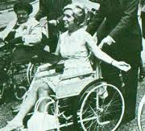
Megan du Boisson developed multiple sclerosis 6 years previously. "The fear was always there at one time. I had to get it into the open and face it. If you can do this then you can turn fear into something hopeful and creative." In creating DIG, Megan du Boisson offered hope to others like her. Instead of campaigning for more welfare or better facilities—worthy but vague causes—DIG picked on the core of the problem, lack of money. "When I first became ill, I realised that help would be vital at home. I stopped to think what would happen if my husband couldn't afford it. Obviously, there must be some State benefit for people like me. I found out that there is nothing, for the housewife is the only adult left outside any form of social security in respect of sickness and disability”. DIG changed the Welfare rules and got the Attendance Allowance established. Megan died in a car crash in 1969, but others active in DIG such as Peter Large and Mary Greaves went on campaigning and worked with deafened MP Jack Ashley. Ashley used lip reading and a palantypist to communicate. He worked with Alf Morris MP, whose family had several disabled members and who instigated the Chronically Sick and Disabled Act, 1970 which introduced the ‘orange’, now Blue Badge and many requirements on Local Authorities to support disabled people living in their own homes (some of which have been eroded under austerity measures). In 1974 Morris became first Minister for Disabled People.
Rights not Charity. In 1972 Paul Hunt, a physically impaired inhabitant of a Leonard Cheshire Home for ’the Disabled’, wrote a letter to the Guardian asking if others would join him in challenging this ’latter day workhouse’ and in fighting for their right to live independently. “..I am proposing the formation of a consumer group to put forward nationally the views of actual and potential residents of these successors to the workhouse. We hope in particular to formulate and publicise plans for alternative kinds of care”.
From this grew the Union of Physically Impaired against Segregation, UPIAS. It was members of UPIAS who developed the social model of disability, which challenged the current orthodoxy of viewing disabled people through the lens of their impairment, as objects of pity, without agency or rights. In place of this ‘medical model’ was brought forward the social model, which viewed the barriers beyond the person as disabling those with impairments. The barriers of attitude, organisation and environment are socially created and so can be removed, where the political will exists. UPIAS led to the British Council of Disabled People in 1980, which included those with intellectual impairments. They campaigned for Civil Rights. Many attempts and Direct Action through DAN and the Disability Arts Movement (see UKDHM 2017) led to a change of culture, the weak Disability Discrimination Act 1995 and the stronger Equality Act 2010. UK activists were key in setting up Disabled People International which campaigned for the United Nations Convention on the Rights of Persons with Disabilities 2006. 178 countries worldwide have ratified this.
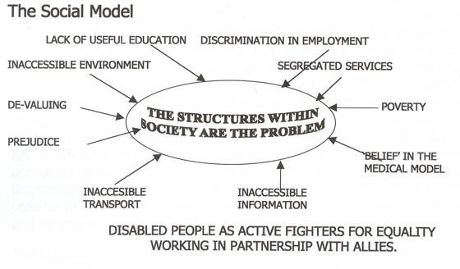
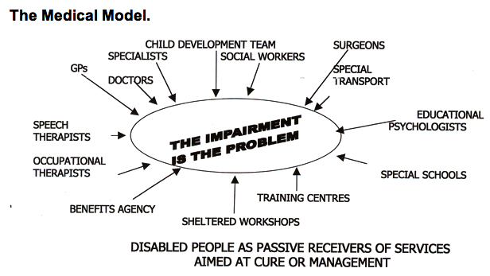

There is still lack of implementation, rooted in negative attitudes and stereotypes of disabled people. Our history shows disabled people in all areas have achieved and become leaders of progressive change at all levels.
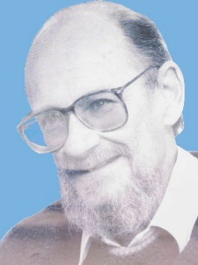
In the 1950s, those with significant physical impairments were placed in hospital wards for the chronically sick and elderly, as there were too many obstacles for them to live in the community. Their problem was seen as their impairment, but Paul Hunt came to think it was disability, being the social and physical barriers to integration, that was the key problem. These barriers were underlain by deep and age old prejudicial oppressive attitudes and thinking. Le Court was set up by Leonard Cheshire as his first alternative home for ‘the disabled’. There was an easy-going attitude, a democratic residents’ committee controlling a publication ‘Cheshire Smile’ and a film making unit. However, as Local Authorities were paying for places at the growing number of these homes, they began to have stricter management and to medicalise these institutions. At Le Court, Paul and the other residents resisted these pressures collectively over a long period, even being threatened with expulsion back to hospital. They produced the important book ‘Stigma. The experience of disability’(1966), analysing their experiences and arguing for a different approach to the ‘medical model’, self-representation and control of their lives. This indirectly led to the formation of the Union of the Physically Impaired Against Segregation (UPIAS). Paul had married Judy and moved to an adapted home . A good resource is ‘No Limits’ by Judy Hunt (2019) which recounts the historical transformations for physically disabled people from institutional care to independent living, drawing on Paul’s journal and papers and interviewing the dwindling number of his contemporaries. https://www.gmcdp.com/no-limits

Paul and Judy met with Vic Finkelstein and his wife. Vic had been imprisoned in South Africa for Anti-Apartheid activity after he was paralysed. Vic was one of the key thinkers, attributed with developing the idea of disability as a social oppression and positing the social model. In an article before his death Finklestein says that this thinking relied on insights from the struggle for race equality in South Africa. UPIAS went on to recruit disability activists from across the UK and formulated the Fundamental Principles of Disability. This led to the setting up of the British Council of Organisations of Disabled People in which Finklestein played a key part.
“In our view, it is society which disables physically impaired people. Disability is something imposed on top of our impairments, by the way we are unnecessarily isolated and excluded from full participation in society. Disabled people are therefore an oppressed group in society. It follows from this analysis that having low incomes..is only one aspect of our oppression. It is a consequence of our isolation and segregation, in every area of life, such as education, work, mobility, housing, etc.”

The Movement in the UK was to be replicated around the world. In 1980, 200 disabled people had withdrawn from a Rehabilitation International Conference in Winnipeg and under the leadership of Henry Enns agreed to set up national representative councils in their countries. In 1981 DPI was born and Vic was one of the three 3 reps.

Independent Living Centres. Ken and Maggie Davis, two leading members of UPIAS, pioneered independent living, by commissioning their own housing scheme at Grove Road in Sutton in Ashfield. They moved in 1976 after buying the land, working with architects and bringing in adapted fittings from Sweden. Derbyshire Coalition of Disabled People was one of the first to develop, locally supported by the Council and building on the duties of Councils to consult with disabled people, following the 1970 Act. The comrades in Derbyshire and Hampshire, led by John Evans who studied 4 CILs in the USA, learned much from the struggle at Berkeley to set up the first Centre for Independent Living.
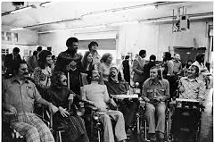
The Berkeley Center for Independent Living emerged from the movement of the 1960s as a powerful social catalyst at the University of California. Ed Roberts, Hale Zukas, and Jan McEwan Brown joined forces to make the full academic and social life of the college accessible to all. In 1972, these students joined community members to incorporate as The Center for Independent Living, Inc., based on 3 prinicples:- 1.Those who know best the needs of disabled people and how to meet those needs are the disabled people themselves. 2.The needs of disabled people can be met most effectively by comprehensive programs which provide a variety of services.3. Disabled people should be integrated fully into their community. The CIL’s peer-based services were so successful that today it is the model for roughly 400 independent living centres across the USA, with similar programs in 20 countries. In the UK in the early 1970s these CILs, controlled by disabled people, were providing political leadership and practical support for those who wanted more choice and control over their lives.
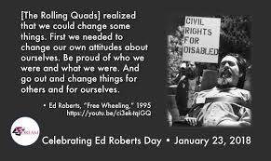
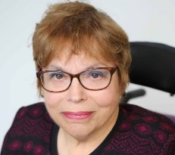
Ed Roberts ‘The Father of Independent Living’ contracted polio when he was 14 years old, after 18 months in hospital he was quadriplegic and needed to sleep in an iron lung. He had control of two fingers and some toes. He went back to high school by phone. His mother, Zona convinced him to go in person and challenge the negative view he had of himself. He fought to be enrolled at University of California, Berkeley to study political science. Eventually he was given a room at Cowell hospital on campus, 1962. By 1966, 11 other significantly physically impaired students joined Ed. They fought for funding from Federal government and recognition of the CIL. With his Masters, Ed taught at the University. He and his peers demonstrated to enforce section 504 of the Rehabilitation Act of 1973, which stated that people with disabilities should not be excluded from activities, denied the right to receive benefits, or be discriminated against from any program using Federal financial assistance, solely because of their disability. For 28 days, activists occupied the offices of the Carter Secretary of Health, Education and Welfare building located in San Francisco. The Nixon administration passed it into law as a result. 1976-1983 Ed was advisor to Jerry Browne, Governor of California. With Judy Heumann, who became disabled advisor to Presidents Clinton and Obama, he set up the World Institute of Disability. Married with a son, Ed died of cardiac arrest in 1995.
Developing Movement in UK. In the 1960s and early 1970s there was a massive infrastructure of complex, confusing and dependency-creating services and the existence of passive and disempowered disabled people. How did the Disability Movement develop? Coming together in local groups and beginning to organise around particular issues had a consciousness raising effect which forced disabled people to consider some of the wider issues. There were the groups mentioned above, but Paul and Vic felt that groups like DIG did not go far enough. Disabled people wanted to be part of the growth in the economy and were not. They also wanted to be free of the threat of being put in an institution. There was a growing realisation that the problems disabled people faced could only be addressed collectively. UPIAS was male dominated and to develop thinking was only open to disabled people. Many of the group were from institutions so it operated under strict confidentiality to prevent harassment from staff. Micheline Mason was not attracted to this. ‘What I wanted, and initiated, was a coming together of “leaders” of different fragments of disabled people's struggles, to have a “safe haven” in which to think, plan and strategise collectively.’

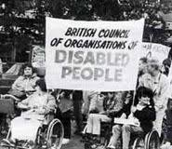
The British Council of Organisations of Disabled People was formally set up in 1981 with 7 founding national organisations run by disabled people. It challenged the existing disability establishment, run by charities controlled by the great and the good. The stimulus of the International Year of the Disabled, 1981 and the need to send delegates to the newly forming Disabled People International in Singapore were both strong stimulants to the organisation. After a rocky road for finance and many schisms, by 1995 BCODP represented 110 organisations, national and local, run by disabled people, with a membership of 300,000 disabled people. The division between the ‘of’ and ‘for’ organisations re-emerged when the Rights Now Coalition split over whether the meagre provisions of the Disability Discrimination Act(1995) were adequate. Disabled led organisations viewed the DDA as a pale shadow of the comprehensive anti-discrimination legislation they wanted. Pressure from BCODP led the incoming 1997 Labour Government to strengthen the legislation (2001), including education and in 2005 they imposed a proactive duty on the public sector to promote disability equality. After 2005 the strength of the Disability Movement and BCODP dissipated. (This became UK Disabled People’s Council, now closed.) Reclaiming Our Futures Alliance (ROFA) is now seeking to fill the vacuum.

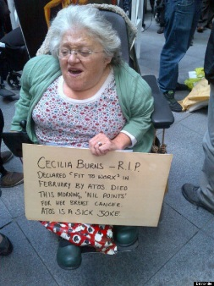
The Liberation Network of Disabled People (LNDP) were more influenced by the Women’s Movement. Following their initial meeting at Lower Shore farm outside Swindon in 1980, they focused on breaking down isolation by finding ways to communicate with each other whether deaf, blind or physically impaired. Many of the ideas were developed by Micheline Mason and others in their ‘In From the Cold’ magazine. “We brought together leaders of different fragments of a movement. We challenged the effects of ‘internalised oppression’, recognised by all marginalised groups as the major ‘tool’ of the oppressive society; we challenged the conditioned hatred of ourselves and each other as disabled people; we challenged the desire to assimilate; we challenged the denial of ‘hidden’ disabilities; we challenged the fierce competition between us; we challenged the inability to champion, appreciate and support each other's achievements or thinking (especially when it challenges our own); we challenged the lack of information and understanding about the issues of other oppressed peoples. “ Micheline ( Jane Campbell & Mike Oliver Disability Politics,1996)
Selected Principles of LNDP
“ #To seek to abolish all forms of segregation particularly in education settings and residential institutions
#To seek allies amongst able bodied people (i.e. people who will help us fight for ourselves-not on our behalf)
#To seek complete self-determination and control over our representation in the media and to have control over information put out about us. #To encourage people with disabilities to organise themselves into active groups which will discuss the implications of achieving their rights at international, national and local levels, and will seek to change or influence conditions around them. #To make allies of, and be allies to, all oppressed groups”. The LNDP were at the founding meeting of BCODP, but left at lunchtime not happy with the male dominance and rigid approach. Later many of these activists formed organisations that joined BCODP as it grew, but they always formed a different approach within the Disability Movement. The thinking of LNDP helped later form the Alliance for Inclusive Education. The work on self-representation, social model and disability as an oppression was brought together to transform education.

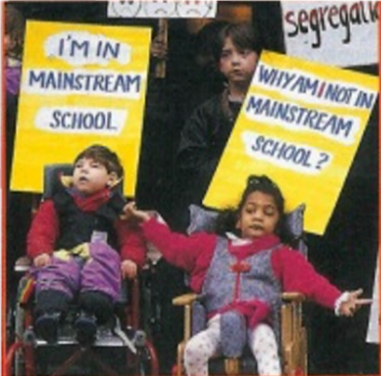
The Alliance for Integration (later Inclusion Education ALLFIE) was set up at a conference called Integration Now in 1990, with parents who wanted their disabled children in mainstream school and not segregated, disabled adults many of whom had gone to segregated schools, teachers and other educationalists who wanted integration. A group of parents took the 1981 Education Act at its word and wanted their disabled children educated alongside their non-disabled peers, but had run into barriers. Micheline had a disabled child, Lucy, and wanted her included as Micheline had been excluded until 14, then attending residential segregated school. Micheline taught them social model thinking. Just as the social model had liberated disabled people it also liberated parents of disabled children who were being subjected to medical model approaches leading to isolation and segregation. The Conference agreed that the organisation should be led by disabled people, with the collaboration of allies so the goal could be achieved. In this respect it was different to many other organisations which were exclusively made up of disabled people. Micheline Mason became the Secretary and Richard Rieser, a disabled teacher, became the Chair. The Alliance acted as the hub of a movement of many local struggles all round the country. After demonstrations ( See 26th May 1998 www.vimeo168475477 ), occupations, court cases and lobbying they managed to change the law so disabled children could not be segregated against their parents’ wishes. Preethi Manuel went to the High Court about her disabled daughter Zahrah not being included and won. The SEND Act 2001 changed previous practice and led to a big increase in Inclusion, though education funding cuts and high stakes testing and academies have recently put this into reverse.
Young and Powerful (1997-2002) was a group of disabled and non-disabled young people who went to mainstream schools. They campaigned for all children to be included in schools together, supported by the Alliance for Inclusive Education, but they made their own decisions, with residential get together and actions.
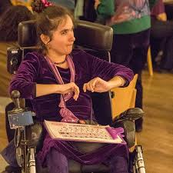
Maresa Mackeith was not being treated fairly or allowed contact with other children at her Comprehensive school. Maresa has cerebral palsy. She cannot talk, but communicates by facilitated communication. Maresa was put in a separate room on her own. At the end of the 2nd term she wanted to invite some children she had met to her home. “The teacher refused to give the invitations out saying ’they are not ready to come to your house’. I asked the Young and Powerful group for help”. When they got to County Hall the Director did not want to see them, but they made a lot of noise, had TV cameras with them, so he saw them. Eventually he agreed to investigate and said they should come back to see him at the next school holiday. When he met them again his attitude had completely changed. “He said it was worse than we had said and I could chose any school in Nottinghamshire to go to”. Maresa moved to a new school in Yr. 9. They took seriously what she and her family were asking for: a chance to take part in ordinary lessons. “I got the assistance I needed and began to flourish with a circle of friends. I loved the learning and felt satisfied and stretched. Two years later I got 6 GCSEs and went on to do ‘A’ levels at a further education college and eventually got a university degree in English. To me that education was a lifeline because, at last, I could do what I knew I could. I need assistance for everything except thinking so I wanted to express my thinking. I wanted access to knowledge to stretch that thinking and to learn amongst others. Communication and Education are Human Rights and disabled people are human. Now I do a combination of writing and talks in education and other settings to try to persuade the world that we must include everyone in the action of living.”

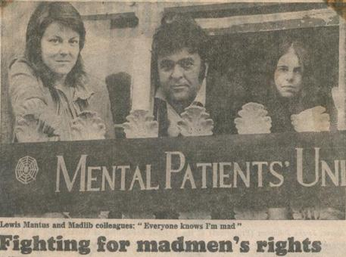
Mental Health Survivors’ Movement. Parallel to the development of the Disability Movement this developed from the 1970s. A huge diversity of groups flourished, stimulated by a large closure programme of mental hospitals and the growth of ‘care in the community’. They led to advocacy, crisis cards and crisis houses - user-centred ways of providing support to people with mental health problems - were developed and pioneered in the 1970s and 1980s, by politically radical individuals with personal experience of incarceration within the mental health system. Many of the management committee members were heavily involved in so-called "mad politics" back in the 1960s to 80s. The group included Andrew Roberts, a member of the Hackney MPU; Frank Bangay, a member of Protection of the Rights of Mental Patients in Therapy, formed in 1976 (becoming the Campaign Against Psychiatric Oppression, 1985) and of the radical action group Mad Pride (1990s); and Peter Campbell, a founder member of Survivors Speak Out, a national networking group formed in 1986 for mental health service users. There was a wariness between this movement and the Disability Movement in the 1970s-1990s, some in the survivor’s movement did not see themselves as disabled just different. The UN Convention on the Rights of Persons with Disabilities which covers Mental Health System Survivors, alongside all other disabled people, is breaking down some of the inter group barriers.

About 100 people met to discuss forming a Mental Patients Union in the evening of Wednesday 21st March 1973, at Paddington Day Hospital. The majority were patients or ex- patients. Most lived in London. It turned out that this was not the first Mental Patients’ Union. People came who had previously formed the Scottish Union of Mental Patients and in Oxford and a message was received from another group in Leeds. The national Mental Patients Union was formed with full membership reserved for patients and ex-patients. "We proclaim the dignity of society's so-called mental patients. We challenge repressive psychiatric practice and its ill-defined concepts of 'mental illness”. Peter Campbell "There is a perception of the survivor movement as a few radical mental health professionals with some semi-empowered activists in their train. That isn't how it was," he says. "Even in the early 90s, nobody in the statutory services gave a damn about advance directives or advocacy - the assumption is that these things have happened through the guidance of right-minded professionals. But they had to be fought for. A lot of it was about working against the mental health system and fighting to get organisations like Mind and Rethink behind us”. https://libcom.org/history/mental-patients-union-1973
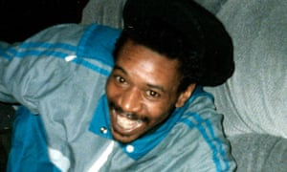
Race and Mental Health. David ‘Rocky’ Bennett is one of a long line of Caribbean and Black men with mental health issues who have died in police custody or the high end of the mental health system. There is a disparity with this group 3 to 5 times more likely to have severe mental illness/schizophrenia. Black men with mental health issues are twice as likely as white men to commit suicide. They are disproportionately (5x their number in the population) detained under the Mental Health Act. Racism was a problem in the Survivors Movement in 70s-80s and despite a much more liberal approach throughout the Mental Health System, it still is in NHS. “BME communities, particularly African, Caribbean and Muslim people, are still perceived either as a menace to society or victims of their own misfortune in terms of culture, faith and identity. We are still perceived as being obsessed about racism or having a chip on our shoulder when it comes to any mention of discrimination. Racism and Islamophobia are either a figment of our imaginations or we are just basically mad, bad and dangerous”. Patrick Vernon, Afiya Trust. Yet high rates of school exclusion, unemployment, involvement in drugs and the criminal justice system are creating the problem. An effective Black Survivors’ Movement is needed. The Disability Movement also needs to remedy its poor record on intersectional equality.
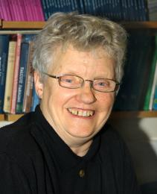
People with Learning Difficulty. Coming out of a past of exclusion and forced incarceration under the eugenicist inspired Mental Deficiency Act (1913), People with Learning Difficulties fought against the label of ‘mental handicap’ and biased IQ testing. Earlier in the long stay hospitals there was a culture of resistance, often expressed in songs, solidarity and challenging the rigid sex segregation by illicit relationships. People First National was formed by self-advocates in the 1980s, many of whom were only just returning to the outside world to live in the community, as a large closure programme of long stay mental hospital was under way. Mabel Cooper was institutionalised at 3 weeks old until she was in her 30s. Upon her release, Mabel became an active campaigner for people with learning disabilities and was awarded an Honorary Degree from the Open University (2010) in recognition of her work. “I'm more confident since I've been in the People First group. You do what you want to do and not get anybody else to do something for you. I was chairperson for quite a long time, but it's just the same as anybody else. You just help the people what can't do it for themselves”. Gary Bourlet was another founder of People First and a self-advocate. More recently Gary has founded the Learning Disability Alliance with equal numbers of self- advocates, families and organisations on its board.
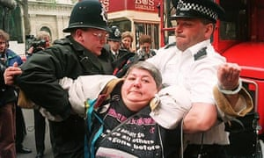
DAN (Disabled People’s Direct Action Network) formed after a successful action of 1500 activists that blocked ITV Telethon and stopped it in 1992. Telethon was a television show that raised money for charity. Disabled people felt that the language used, the images shown were demeaning, and portrayed disabled people as objects of pity. After this success DAN organised 3 national actions a year, using non-violent direct action over the lack of a parliament adopting the Disability Discrimination Act, 17 attempts before successful. DAN activists went on to fight for accessible transport by chaining themselves to buses and trains. The effect was to bring forward the date when all new buses had to be accessible. In London this was 20 years before the legislative date. Barbara Lisicki was one of the main organisers with Alan Holdsworth. They learned from ADAPT in the USA, trained all those who turned up. To start with the police did not know what to do, but then more were arrested. The public even though disrupted, were very sympathetic and we got a lot of media coverage. See Channel 4 film Desperate DAN https://youtu.be/ngkx8ASyWaY By 2010 DAN was no longer active.
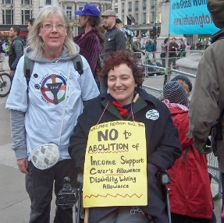
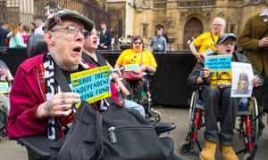
Disabled People Against the Cuts (DPAC). The incoming Coalition and then Tory Governments from 2010 were committed to austerity measures, which fell on disabled people more than any other group in society. DPAC started organising against benefit cuts, the ending of the Independent Living Fund, the Welfare Reform Act, the Bedroom Tax and a host of other measures. Linda Burnip and Debbie Jolly were the founders. DPAC was formed by a group of disabled people after the 3rd October 2010 mass protest against cuts in Birmingham, England. This was the first mass protest against the austerity cuts and their impact on disabled people. It was led by disabled people under the name of The Disabled Peoples’ Protest. DPAC later initiated a complaint to the United Nations CRPD Committee. This was investigated and the UN found “grave and systematic violations of disabled people’s human rights in the UK”. They called Government policy a human catastrophe.

Our movement needs more than ever to go back to the insights contained here. We need a strong bottom up democratic cross impairment disability movement, combining with our allies to expose and critique the discrimination and prejudice that undermines our human rights. Trade Unions now have sections for disabled members and the Labour Party has changed its rules to ensure proper representation of disabled people at every level. Both are committed to a social model approach. We still need to find new ways of struggling for Inclusive structures and Equality. There needs to be a recognition that on paper and in law we have made progress, but that our experience of the deeply ingrained oppression towards all disabled people requires us to be directly and collectively involved in a transformation of society and the world. We can make a start by challenging the growth of exclusions, segregated education and attacks on the livelihoods of disabled people through welfare reform. Richard Rieser Coordinator UKDHM rlrieser@gmail.com www.ukdhm.org Printing of the broad sheet supported by Unison

