

**Disability: Leadership, Resistance and Culture**

Vic Finkelstein **–** Building a Movement

Vic Finkelstein became a wheelchair user in 1954 after receiving a spinal injury on the sports field while at school in South Africa. He was arrested in Johannesburg in 1966 and faced torture, 180 days solitary confinement, and three months imprisonment for his anti-apartheid activities. He left South Africa in 1968 as a political exile after his release and State banning.

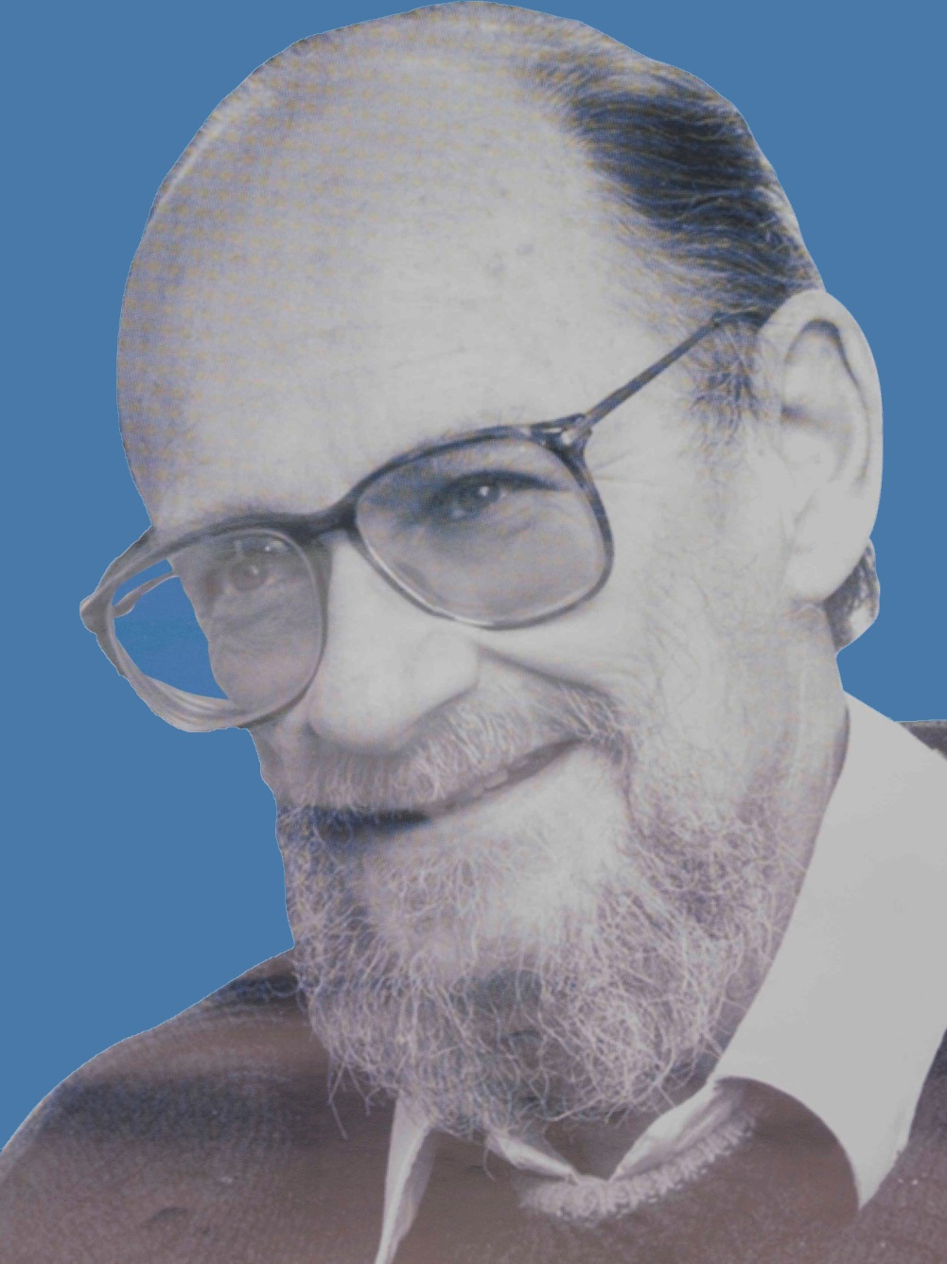In the UK Vic was to emerge as an ardent human rights campaigner and a leading light in the development of the Disabled People’s Movement at a time when disabled people had no say in the decision making processes affecting their lives. Vic and other like-minded disabled people championed a new emancipatory movement that set out to challenge the incarceration of disabled people in de-humanising institutions where they were afforded little or no rights.

Vic was a founding member of The Union of the Physically Impaired Against Segregation, set up in 1974. Vic and the other members of UPIAS promoted a new way of thinking about disability that said a world constructed only for able-bodied people unfairly excluded disabled people and forced them to be dependent. This view led to demands for greater inclusion and the rise of a growing number of organisations of disabled people, and eventually to the setting up of The British Council of Organisations of Disabled People (of which Vic was the first Chair in 1981).

During this time he was also involved in the movement of Disabled People Against Apartheid and together with his late wife helped produce much of the DPPA’s literature. In

1975 he joined the Open University where he later became chair of the UK’s first course in ‘disability studies’.

Later he turned his attention to the world of Disability Arts

and helped set up the London Disability Arts Forum in 1985, created to promote the newly emerging notion that disabled people have their own distinct cultural identity born out of a shared experience of discrimination and a celebration of difference.

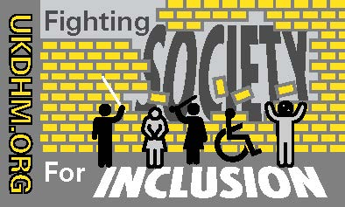



Reproduced with kind permission of the originators