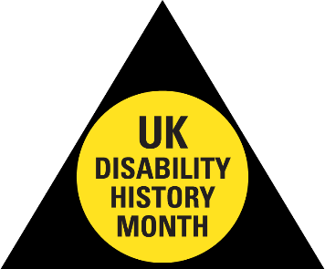
CELEBRATING OUR LIVES
CHALLENGING DISABLISM
ACHIEVEING EQUALITY

DISABILITY HISTORY MONTH LAUNCH
Monday 25 November 2019, 12.00pm – 2.00pm

Nottingham Council House
Old Market Square, Nottingham NG1 2DT

- Richard Rieser, UK DHM coordinator
- the origins of DHM and DHM today

- Charlotte Throssel, CEO Disability Support Nottingham - her work to support Disabled people & her personal disability journey
(inc some strong language!)

- My Sight Notts Choir

- Maresa Mackeith, local poet

- In the presence of the Lord Mayor and Sheriff of Nottingham

To book please contact:
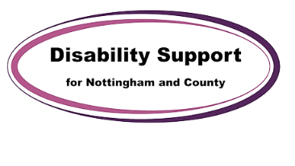
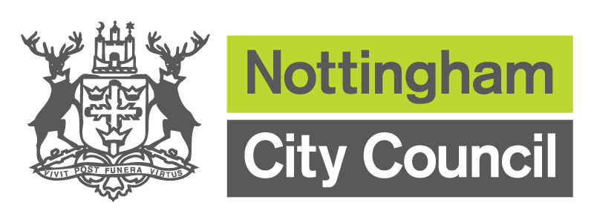
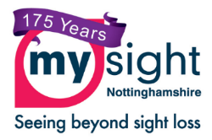
Annette.Molyneux@nottinghamcity. gov.uk / 0115 8762533

