Reports

THE PECULIARLY BRITISH CHARITABLE MINDSET IN A PANDEMIC
Peter Beresford and Mark HarrisonMay 26, 2020
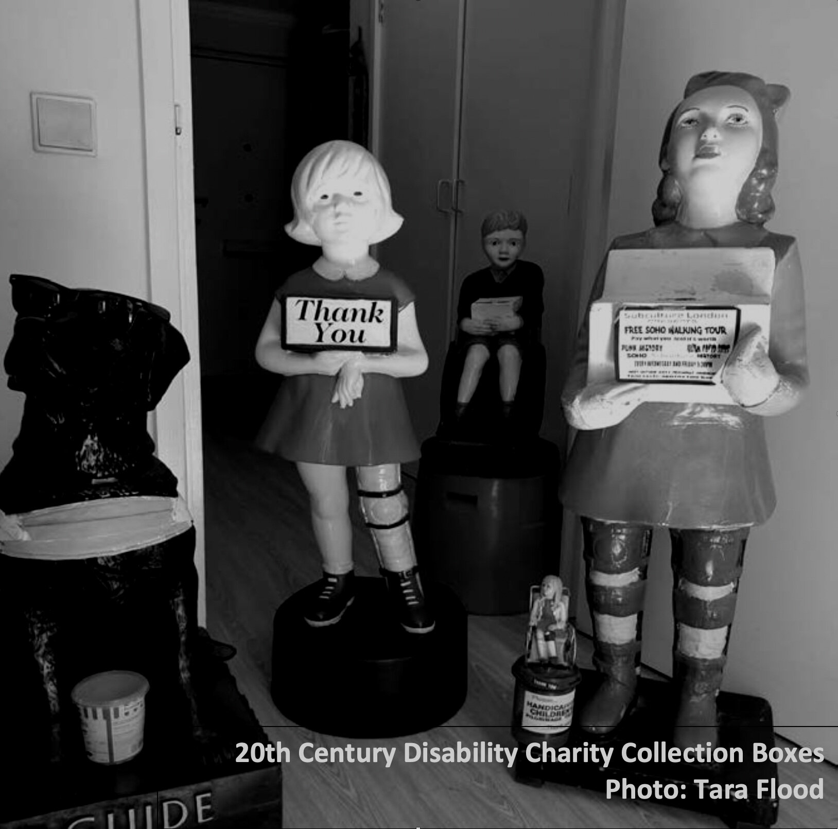
THE ORIGINAL NHS CARD sent out to citizens states that the NHS is not a charity. It is worth quoting from the front of that NHS card:
“It will provide you with all medical, dental and nursing care. Everyone — rich or poor, man, woman or child — can use it or any part of it. There are no charges, except for a few special items. There are no insurance qualifications. But it is not a ‘charity’.”
The huge response to Captain Tom Moore walking round his garden raising £30+ million for the NHS shows how embedded charitable giving and the NHS has become in the British mindset. We argue that charity is the other side of the capitalist exploitation coin and Covid-19 has exposed the very British notion of charity. Henning Wehn, the comedian of German heritage, has a meme on social media saying “We don’t do charity in Germany. We pay taxes. Charity is a failure of governments’ responsibilities.”

VE Day was a reminder that the establishment of the NHS and the creation of the welfare state was a blow to the capitalist class at the end of the Second World War. It was a tactical retreat by them to save their system. Two main factors combined - the Soviet advance to the borders of western Europe and British soldiers returning from war determined that they weren’t going to endure the hardship imposed on their fathers and families after the sacrifices made in the First World War.
The rich feared this would mean revolution and that they would lose everything, and that had to be avoided at all costs. This retreat, however, was only temporary, lasting into the 1960s and early 1970s. The following decades have seen the ruling class attempting to roll back the gains won, starting with Heath and Thatcher but often assisted by Labour leaders and the trade union bureaucracy. Leaders like Blair saw their interests being served, not by advancing public services and closing inequality, but by ‘freeing the market’, privatising public services, shrinking the state and returning the wealth gap between rich and poor back to pre-war and now Victorian levels.
The NHS has a complicated relationship with charity. While services like opticians now sit mainly outside the NHS in the private sector, significant areas of activity are ‘outsourced’ to the charitable sector like end-of-life, hospice and non-medical cancer care. Then you have the global charitable brand that is Great Ormond St Children’s Hospital which is a huge money raising operation appealing to the public’s emotional tie to sick children. All these things undermine the rights-based and universal aspects of the NHS.
Charity and philanthropy are embedded in the British system and psyche. This is an important part of keeping order and knowing your place. By othering portions of the population and segregating them into the deserving and undeserving groups, this can be weaponised against people fighting for equality, human rights and justice. It is the ideological side of the privatisation coin.
Charity in the form of foodbanks is becoming an acceptable part of the welfare state. Mutual aid can be solidarity but can also be patronising and demeaning where the causes of poverty are left unaddressed in favour of charity handouts from the ‘haves’ to the ‘have nots’. People on the left are in danger of colluding with the normalising of food poverty and slave wages in the gig economy, which have contributed to a significant section of the population being dependent on foodbank handouts. It is important mutual aid groups step up the fight for rights and socialism alongside ensuring the populations made vulnerable by this political as well as virus-created crisis don’t starve. Food banks often reflect the poor law attitudes they grew out of - patronising users, restricting the number of times people can return and offering the left-overs of a rich society, instead of truly challenging the DWP and its arbitrary and cruel benefits system.
Capitalism cannot and will not meet the most basic needs of the population - food, shelter, family life, mental health, etc. To collude with this at the expense of fighting for rights and socialism is to side with the oppressors. There is a route through mutual aid and community social action to do both, but this has to focus on solidarity, reciprocity and building a movement that can address the causes as well as the symptoms.

Clement Atlee summed this up beautifully: “Charity is a cold grey loveless thing. If a rich man wants to help the poor, he should pay his taxes gladly, not dole out money at a whim.”
The disability rights movement was forged in a struggle against the big national charities that segregated and imprisoned disabled people in institutions, often in remote rural locations - and this still continues in some cases. Central to this fight against organisations led by non-disabled people speaking and acting for disabled people has been the slogan ‘Nothing About Us Without Us’. When the charity fundraising Telethons first emerged, disabled people held protests outside and invaded TV studios to challenge the notion that they were to be pitied or were charity cases. The slogans developed in this campaign were ‘Rights Not Charity’ and ‘Piss On Pity’.
The charity mindset goes deep and disabled people are still often defined using negative and pitiful images and language in advertising campaigns to raise money for disability and other charities. The current Covid-19 pandemic has demonstrated that this othering and demeaning is still alive and well. The discourse is often framed around disabled people being vulnerable and a vulnerable group.
The reality is that disabled people are made vulnerable not by their impairments but by the barriers and discrimination society constructs to make disabled lives unequal. By defining disabled people as vulnerable per se it removes both voice and agency and relegates them to passive victims who need to be ‘looked after’ by charities. It is revealing that the current Minister for Disabled people, Justin Tomlinson, has during Covid-19 failed to meet with representatives of disabled people’s organisations (DPOs) but has found the time to meet with the Disability Charities Consortium.
In the neo-liberal world of Cameron’s coalition government the slogan ‘Big Society’ was developed to promote charitable giving and receiving as a cover for slashing funding to state services. This saw charities competing with each other and commercial businesses for government contracts, as the state was shrunk to unsustainable levels. Charities became big businesses with hundred million pound turnovers and CEOs earning six figure salaries.
Meanwhile disabled people were excluded from this game. User-led DPOs had their funding slashed and many closed down as a result. Interestingly, Scope, formally known as The Spastics Society, has recently sold off all its services to the private sector and now brands itself as the disability equality charity — moving to exclude and take over from the authentic and democratically accountable voice of disabled-person-led DPOs.
The other half of the charity con here is the way Johnson’s government has used and abused volunteering during the pandemic. Remember the 750,000 volunteers, and then the increasing number of stories about people being ready to help but with nothing for them to do, no protective clothing available and then the bigged-up O2 Nightingale Hospital having to close for want of staff?
There is enormous goodwill that operates in societies like ours where people want to contribute their time and skills as part of their sense of civic involvement and mutuality. Thus have developed great community innovations like the heritage railway and canal movements, befriending schemes and bereavement support. Sadly the Tory reality of volunteering is more often using it as a substitute for paid employment and taking advantage of people’s altruism. So far, anyway, the signs are that it is the local, community based volunteering arrangements that are coming up trumps, not the high profile centralised ones or those operated by big charities.
We now know a lot about what makes for good volunteering and it demands a lot more than some quick spin from a politician uncertain how to respond to a large-scale emergency or to fill the gaps resulting from constant cutting of the public service infrastructure. There are principles for good practice and constraints that need to be recognised because of the demographics of volunteers.
According to the Institute of Volunteering Research at the University of East Anglia:
“While the public response has been tremendous, there is a lack of collaboration between national and local approaches leading to people not knowing what they can do to help their communities. Millions of volunteers are currently themselves directly and indirectly affected by Covid-19 and among them many can no longer volunteer. In some cases the organisations who involve them have had to stand them down or they are at increased risk of severe illness.”
Volunteering may be headline grabbing but it’s no panacea. Nor is it necessarily the cheap option. It costs to organise and administer volunteers effectively and it is now recognised as good practice that expenses should be met, and some token payment may need to be made if volunteering is to be truly inclusive.
But Johnson’s government has shown where its heart really lies. Volunteering may look good and keep the voters busy, but anything more than that and it turns to its natural allies, the for-profit outsourcing sector. Having at last got some sort of testing system for Covid-19 underway, it is the likes of Serco, Boots, and Sodexo, the private equity organisations it truly feels comfortable with, that have been recruited to run testing centres, using low paid unskilled casual workers to do so.
All in all the Johnson response to the crisis of a new pandemic is a worrying mish-mash of old anti-state thinking that takes no account of the brave new insights available both from 21st century user-led organisations and grassroots voluntary action — based on a commitment to life enhancing mutual aid instead of crude cost-cutting.

PETER BERESFORD AND MARK HARRISON
Mark Harrison is director of Social Action Solutions, and Senior Research Fellow in Social Action at the University of Suffolk.
Peter Beresford is co-chair of Shaping OurLives, the disabled people's and service users’ organisation and network, and Professor of Citizen Participation at the University of Essex.
https://labourbriefing.org/blog/2020/5/26/the-peculiarly-british-charitable-mindset-in-a-pandemic

