Activity: Vicky Lucas

Vicky Lucas
Read the following excerpt from ‘the Guardian’ newspaper and discuss it in your group. Imagine that Vicky comes to your class.

“…The importance of finding a way of coping with disfigurement is imperative for people like Vicky Lucas, 21, whose condition cannot be treated effectively. She was born with cherubism, a very rare childhood disease that enlarges the jawbone and makes the eyes protuberant.

Lucas’ symptoms became severe as she entered her teens. “Children and sometimes adults, too, would call me ‘Desperate Dan’, ‘Popeye’ and ‘alien’. When I went to secondary school I was bullied a lot and the girl who had been my best friend turned against me. She used to draw pictures of my face in class.”

Lucas was helped to develop skills she needed to deal with such behaviour and – equally important – to value her self by the charity Changing Faces, which supports people with facial deformities…

Lucas says: “They helped me to see that I was wanting to change my face to please other people. But why should I have to do that or hide away? I’m now finishing a degree at college in media studies. I have very good friends and although I certainly won’t pretend it’s always great being as I am I don’t see the cherubism blighting my life.”….” (“The Guardian”, 27.6.2000)

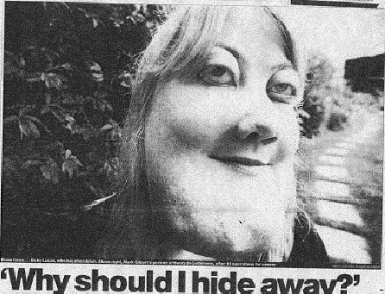

- How would you ensure that Vicky is completely included in the learning environment?

- How is Vicky’s experience different to Harry Maher’s? What difference in attitude would her difference in experience engender?

- What issues would be involved in Vicky’s inclusion

- For you?
- For other students?
- For your organisation?

How would you deal with these?

- How would you ensure that Vicky is treated well by other students in the class?

Suggestions for promoting full inclusion for Vicky

1. Assume that Vicky has already developed coping strategies for meeting new people. She is currently doing a degree in media studies and is therefore used to studying and being in a classroom. You should do all the usual group building exercises and ensure that people have opportunities to talk about them-selves and develop friendships in the classroom. The more you demonstrate an acceptance of everyone in your classroom, the more your students will reflect your practice. If you notice that any students (including Vicky) are becoming isolated you will need to look at the group dynamics and adjust your practice to ensure that everyone is included (e.g. weekly ice-breakers, deliberately matching students for pair-work and group work; making sure that everyone in the class knows everyone else’s name; introducing new students as they join; giving everyone a chance to answer and take part in discussions in a structured way, etc).

2. Vicky’s experience is different from Harry’s in that she has had a mainstream education and has expectations of being active in the world and in an educational setting. She is likely to have a far more assertive attitude towards life than Harry has. She has learned that negative reactions to her impairment are other people’s problems and she is not willing to hide or live her life less fully than anyone else. She has a measure of self-confidence that Harry is unlikely to have.

3. (a) Initial shock or horror at Vicky’s appearance may be an issue for you. You may feel curious about her impairment and want to ask questions about it. You may imagine that Vicky is less able to understand your subject (because many people equate physical appearance with intelligence). You may believe that people who look like Vicky shouldn’t be in mainstream education for their own protection.
(b) mostly the same as (a).

- Get to know Vicky as a person and encourage and enable your students to do the same.
- Any negative feelings you have towards disabled people can be challenged and worked on by attending disability equality courses.
- Do not put Vicky on the spot by asking her about her impairment unless she volunteers information.
- Develop curriculum activities on inclusion and social justice in order to address the issues with your students.
- Ask the class at your first meeting if there are any access needs that you need to know about and offer people a chance to either inform the whole class or to talk to you privately (in tutorials, or at break times). Make it clear that disabled people are welcome in your classroom and that you will do your best to meet their access requirements.
- Listen carefully to Vicky and to other students.

(c) Similar reactions to (a) and (b). Vicky may have a hard time in the corridors and canteen by being stared at and whispered about. It is important to remember that she deals with these sort of reactions on a daily basis and is unlikely to be fazed by it. However, that does not mean that she will not require any support from you or others in the class. A college that has inclusion training, a good equally opportunities policy and a policy of challenging disablist remarks will be better placed to support Vicky in her right to be accepted.

4. Devise a group contract to ensure that all your students are aware of and have agreed to standards of acceptable behaviour towards each other. Talk with the group about their lives in a completely non-judgemental way. Ensure that everyone is listened to respectfully. Ensure that Vicky is included in all class activities and that she is paired with different people so that she can make friends. Encourage her to choose who she wants to work with. Ensure that everyone’s achievements are acknowledged and celebrated. Sit with your group at break time and make sure that Vicky is included in the conversation, direct questions towards her. Model complete respect for Vicky and everyone else in your class - your students will copy the example.

[Developed by C. O’Mahony]

