Making Sense of Disability: What causes people to be disabled and what causes their impairment
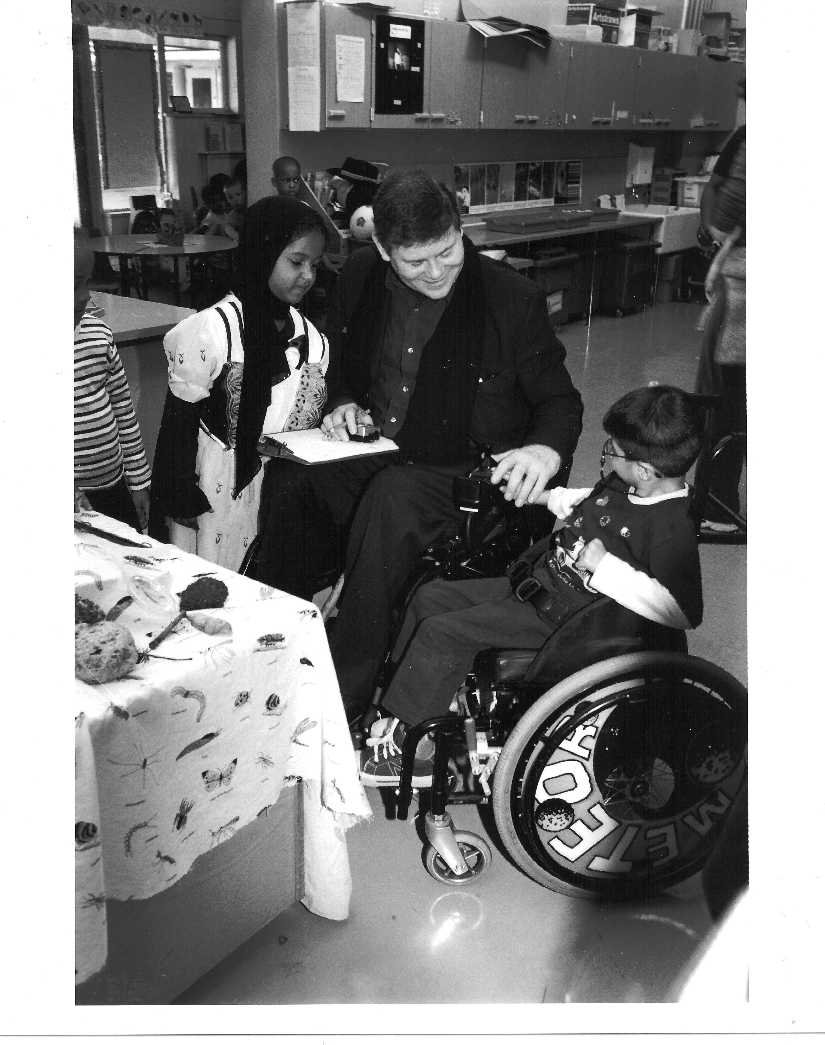Richard is a teacher who uses a wheelchair because he had polio as a small child. This effected his walking and later he has become unsteady on his feet and has hurt himself falling over. What were the barriers to Richard as he was growing up and became an adult? What were the barriers at school and in adult life? What were the solutions to these barriers? Write or draw barrier top of box. Write or Draw Solution to that barrier in bottom of the box.

