Let’s storm Parliament! The punks who risked their lives to fix ableist Britain
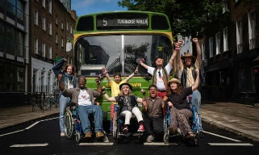
Then Barbara Met Alan. Photograph: Samuel Dore/BBC/Dragonfly Film & Television Productions Ltd
They chained themselves to buses, threw themselves in traffic and brought London to a standstill – until the powers that be could ignore them no more. Now, their fight is being brought to life … and it’s truly groundbreaking TV
Lucy Webster
Fri 11 Mar 2022 13.00 GMT

You probably don’t know what happened when Barbara met Alan, but you should. Barbara Lisicki – the UK’s first disabled female comic – and Alan Holdsworth – AKA musician Johnny Crescendo – were two rebellious, punk-inspired performers on the 1980s cabaret scene when they met, fell in love and changed the course of civil rights history. The couple were the force behind the disabled people’s Direct Action Network (DAN), which successfully convinced the Conservative government to pass the Disability Discrimination Act in 1995. It was a landmark bill, the first of its kind in the UK.
So when it came to televising the story, a landmark approach was also required. “There’s never been a story about disability told like this onscreen before,” says Ruth Madeley, who plays Lisicki in the new BBC drama Then Barbara Met Alan. “There was one moment when we were filming, we had hundreds of disabled people on set, and it was one of the most surreal moments of my career. I thought: ‘Why does this feel different?’ It’s because I’ve never been surrounded by so many disabled actors and creatives in one space. It felt so incredible.”
Madeley (who played Rosie Lyons in Russell T Davies’s Years and Years) is joined by Arthur Hughes (Help, The Innocents) as Holdsworth in a one-off drama with groundbreaking authenticity. The tale of how the pair went from having post-cabaret sex in a London hotel room to changing the course of history doesn’t just feature disabled talent in front of the camera – they’re also the creative force behind it.
“I just remember thinking this cannot be – I will not let this be – the only time I feel like this on set,” says Madeley, of a production that had 16 disabled crew members and 13 of the real-life members of DAN as part of its 55 disabled supporting artists (plus a main cast with 17 disabled actors out of 24). “It felt really revolutionary. It shouldn’t have felt that way. But it did because it happens so rarely.”
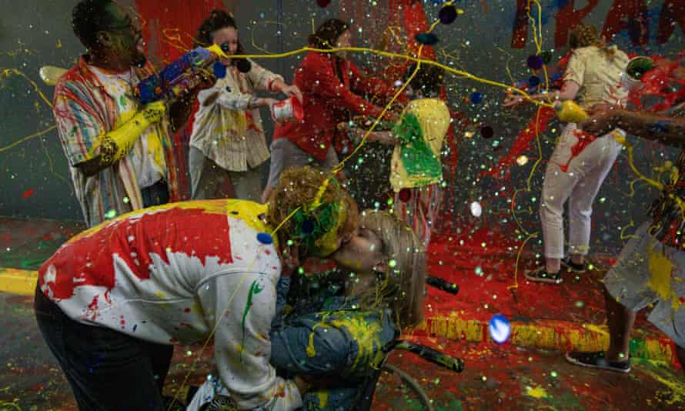
Making a splash … Arthur Hughes and Ruth Madeley in Then Barbara Met Alan. Photograph: Samuel Dore/BBC/Dragonfly Film & Television Productions Ltd
On the surface, it is a relatively simple civil rights story, in the same vein as Pride or Made in Dagenham – a tale of oppressed people banding together to create social change. But it is not solemn or sad. Instead, it is driven by Alan and Barbara having such a punk-ish sense of mischief that one of their iconic slogans was the phrase “Piss on pity”. They sing while they struggle. And the fun they have along the way is infectious – we’re shown two people who live life with full conviction and at full speed. “It was so empowering. It was fun. It was real,” says Hughes. “It did feel like a watershed for this type of film being made.”
We see Alan, Barbara and their disabled comrades begin with a joyful invasion of a bus station to daub “transport for all” across a wall while having a paint fight – only to end up shouting through megaphones atop police vans, handcuffing themselves to public transport and being repeatedly arrested in their quest for accessible buses, the end of ITV’s “pity-porn” annual charity Telethon, and the eventual codifying of disability rights in law. We also witness the opposition they faced, from a government that thought mandating accessibility would be too much of a burden for businesses, and from the non-disabled activists who wanted DAN to be less radical, with DAN finally having to storm the Houses of Parliament to make their point.
The drama uses historical protest footage to remind us that disabled people were not given rights by some benevolent society, but had to prise them out of institutions steeped in ableism. Wheelchair users threw themselves in front of traffic to block roads, manacled themselves to vehicles and were hoisted from their chairs by police. Given the brutal consequences this had for some protesters, commemorating this is especially important. Some got sick. Others died (“because of what they put their bodies through on these protests,” says Madeley), and the names of many of those who made such sacrifices are now forgotten. The sight of hundreds of disabled people descending on a maddeningly inaccessible Parliament is one of the most moving scenes in the show, reminding us of the power of a group fuelled by righteous anger.
Yet beneath the riotous action, the drama makes a revolutionary decision to be, above all, a love story. Crucially, a disabled love story – something completely ordinary but somehow still a societal taboo. With the couple eventually torn apart by their differences over how to pursue their political goals, the fact it is not a fairytale with a made-for-TV ending makes it all the more compelling. Instead, it is raw, sexy, thrilling and heartbreaking. In other words, it is real life.
For both Madeley and Hughes, this is what drew them to the characters – and what they are most passionate about. “Take everything else away and you’ve got these two characters who are so strong and magnetic and fiery that you automatically want to learn more about them,” says Madeley.
“I’ve been very lucky to have played a love story on screen in the past, but this was next-level stuff. To show these two characters, who both had disabilities, fight and laugh and kiss and make love and have children … There’s so much that disabled actors and disabled characters don’t get to do on screen. We did it all.”
Bafta-winning screenwriter Jack Thorne, who co-wrote the script with the actor Genevieve Barr, credits the production company Dragonfly with putting Alan and Barbara’s relationship at the heart of the show: “We were brought the story by [executive producer] Tom Pullen and Richard Bond [managing director], who had a really simple and glorious pitch – they changed the world but in doing so destroyed their relationship. Two arcs that dovetail – you can’t hope for more as a writer,” he says. “But they’re people too, and while we felt the burden of telling the story of DAN, capturing their truth was most important.”
That truth makes the wider story more emotionally resonant. The audience are desperately rooting for DAN to win against their powerful foes, but the more visceral rooting is for Alan and Barbara – for them to face down their demons and heal their relationship. The knowing look they share when the law is finally changed conveys it all: love, loss, sacrifice and the profound sense of comfort found only in the people who really know what you have been through. Madeley has described the depth of their partnership as a gift: “You’re there to make people feel things … And this film does it in spades.”
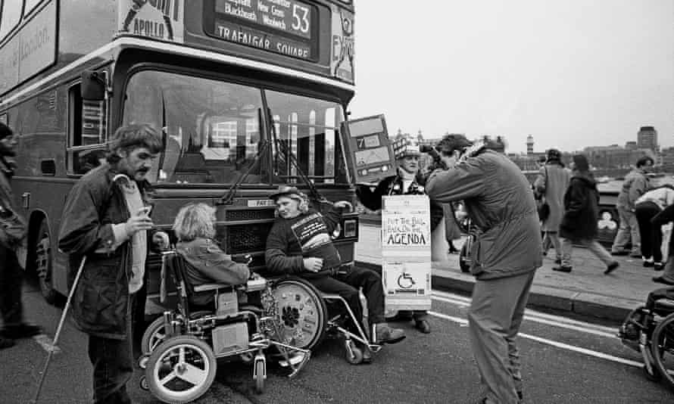
Fare play … A DAN protest about access to public transport in 1995. Photograph: GP Essex/Alamy
The importance of not just showing disabled love on screen, but more broadly, showing disabled characters as rounded, full people is something essential to Madeley and Hughes. Particularly given that disabled characters are often secondary parts – the best friend, the brother, the lonely girl the hero takes to the prom instead of his actual love interest. “This is a story about two civil rights leaders,” says Hughes, “but they weren’t just that. They were parents, musicians, comedians, entertainers, friends. There’s so much more.”
One scene springs to mind: Barbara and Alan hosting friends to hate-watch the Telethon. There’s banter, friendship, disagreement, frustration. Tensions are high but so is determination. “These guys were angry and wanted rights but they did it with big hearts and such style,” says Genevieve Barr. She says the characters’ inherent unconventionality allowed the writers to play with form. The drama could have got tangled up trying to explain history through hammy dialogue, but instead happily bulldozes the fourth wall and has Barbara speak directly to the audience, guiding them through the narrative.
“The story lent itself to a way of telling, and a way of doing, things differently,” says Barr. “And I hope it does push people to look at things differently – the spaces around them and the people who inhabit them.”
The stars and writers believe that all the ways this drama is different – its fully disabled crew, its disabled love story – will allow audiences to see that change is possible. They can choose to be part of Barbara and Alan’s legacy, joining the fight for better accessibility in our physical world and richer, more diverse narratives in our culture. Let’s hope the drama spurs viewers to unpack the boxes disabled people are put in, and see us in our complexities: determined, flawed, feisty, scared. And that they’re left with that memorable DAN slogan ringing in their ears: it’s time to piss on pity.
Then Barbara Met Alan is on BBC Two on 21 March
https://www.theguardian.com/tv-and-radio/2022/mar/11/then-barbara-met-alan-lets-storm-parliament-the-punks-who-risked-their-lives-to-fix-ableist-britain?CMP=Share_iOSApp_Other&fbclid=IwAR2UNO51BH2QZvi-8xpVi8q_wyiSjDgBP6avp2razXhXEoWIJ5wgdH4B10o

