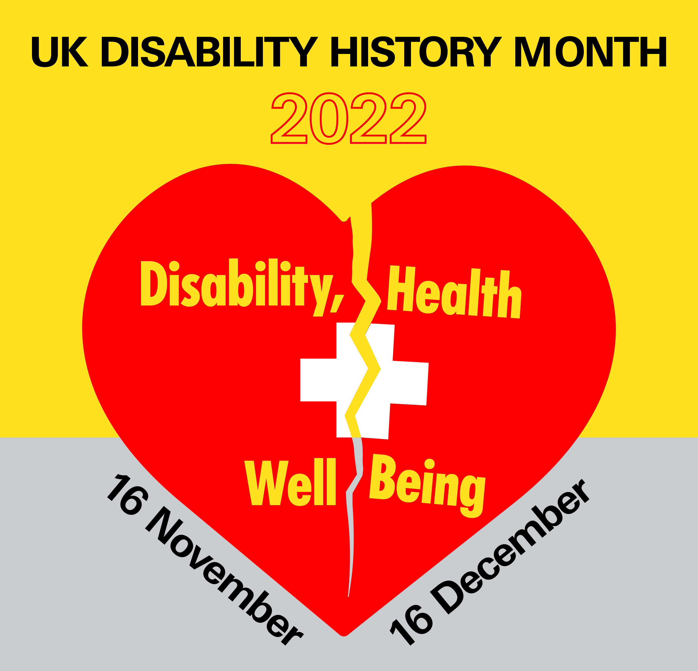
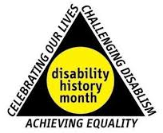
United Kingdom Disability History Month 2022 Disability, Health and Well Being Broadsheet
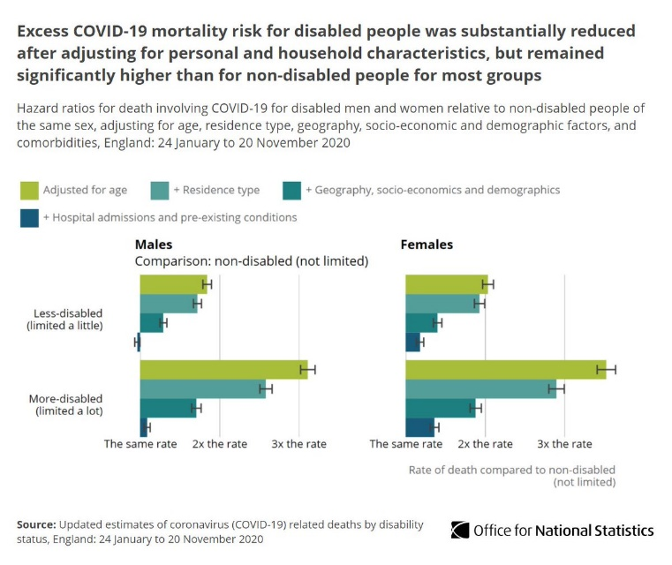
The Covid Pandemic demonstrated across the UK and around the world just how fragile are the Rights that Disabled People have secured for themselves and how easily we become expendable. "Death rates involving coronavirus (COVID-19) decreased for both disabled and non-disabled people between second and third waves of the pandemic. However, today's analysis shows a continued elevated risk of COVID-19 mortality in disabled people compared with non-disabled people, which remains largely unchanged across the three waves of the pandemic. No single factor explains this elevated risk and this analysis suggests it is down to a range of disadvantages experienced
Excess Covid Deaths for Disabled People after adjustment ONS
by disabled people" Julie Stanbridge, Deputy Director Health and Life Events, Office for National Statistics. March 2022. This study, based on those identified as disabled in the 2011 census, gave death rates for ‘more disabled women’ as 3.8 times higher than ‘non-disabled women’ and for ‘less disabled women’ 2 x higher than ‘non-disabled women’ across all 3 waves. For men 3.1 x higher for ‘more disabled men’ than ‘non-disabled men’ and for men identified as ‘less disabled’ the death rate was still 1.9 x higher than ‘non-disabled men’ across all 3 waves. All these rates are likely to be under-estimates because of a 9 or10 year gap in census data and many more people would have been identified as disabled in the intervening years.
At the heart of this appalling state of affairs is that we, as disabled people, are only conditionally seen as human. Our rights whether we live in institutions, care homes or independently in our own homes and the community, can be ridden over by politicians, medical professionals or the population in general, judging the world by ableist standards and practising deeply entrenched disabilist responses. Where we are counted in a disaggregated way we find disabled people were not protected and had by far the highest preventable death rate, especially in group homes and institutions which undermine our right to Independent Living. We have been given the label of ‘vulnerable’, rather than being viewed as at greater risk of infection, disease and death, without proactive social measures being directed at ensuring our right to life, health and wellbeing.
However, in Wales, where 68% of Covid fatalities were amongst disabled people because of the obsession with a medical model approach to disability, the barriers that compromise our health, now and in the past, are not identified and acted upon. We are held responsible for our conditions rather than providing us with the support and health care we need. But the Government faced up to the situation with a disabled person led enquiry and the possibility of real change addressing our disadvantage has become a possibility with the acceptance by Government of the centrality of the Social Model of Disability and linked approaches to include disabled people.
Young people with Learning Difficulties were at the sharp end with up to 30x the death rate for non-disabled population (Covid (ONS).Some of the key reasons identified for this appalling position are lack of support:- to be registered with a GP, to understand the hygiene rules of preventing transmission of the virus and to accommodate the traumatic loss of routine, activities and contact with family and carers that was hard to understand and to cope with. Crises of war and pandemic create Mental Health Issues and impairment e.g. at least 400,000 people with long Covid now come under the Equality Act definition of Disability. Despite the Government rhetoric, support and services for those with mental health have not improved.
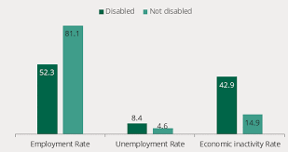
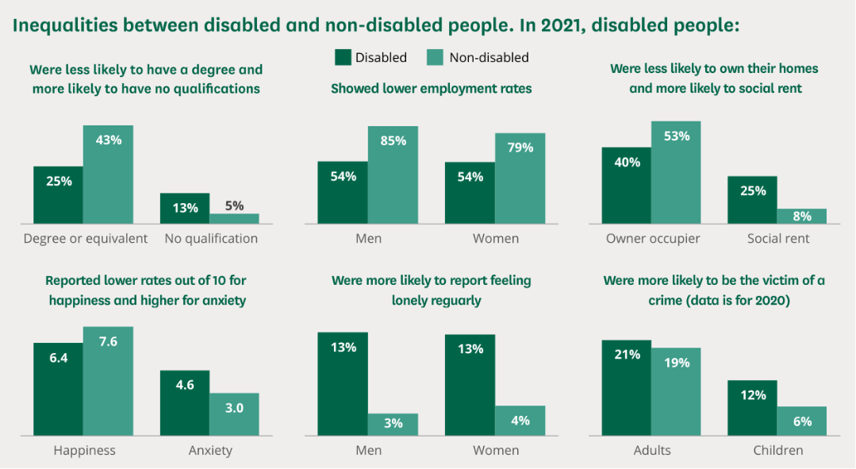
Fundamental thinking for disabled people in the UK has been the understanding that our disadvantages are not caused by our impairment or medical condition, for which we may need medical and social support, but by the barriers of attitude, environment and organisation in society that disadvantage us systematically. (House of Commons Library. See Below)
The years of austerity for disabled people destroyed our wellbeing, arose from deeply held perceptions of our unworthiness rooted in the past history of our oppression.
UKDHM will examine the history of welfare from disabled people’s point of view and provide examples of how this denial of human rights can and will be reversed.
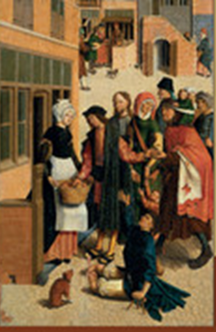
Most of western thought, including the Renaissance and the Age of Enlightenment up to present, was based on the thinking of Greek philosophers such as Socrates, Plato and foremost Aristotle and on Biblical thought including giving charity to the less fortunate (left).
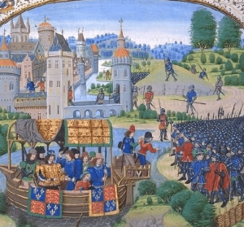
Aristotle's contribution to the Western intellectual tradition is unparalleled. Founding formal logic and the science of biology—he also produced work of the highest order across the full breadth of disciplines already in place: ethics, metaphysics, psychology, physics, economics, rhetoric, and dozens more. We have learned a great deal about the world in the nearly two and a half millennia since Aristotle lived. Within Aristotle’s surviving works, littered among the myriad insights that continue to inspire philosophers today, are hundreds of claims we now know are simply false. Most are forgivable, but the most infamous example is Aristotle’s claim that “from the hour of their birth, some are marked out for subjection, others to rule” (Pol. I.5, 1054a22-23). Aristotle does not simply endorse natural slavery; he expends significant effort arguing that it is “both expedient and right” (1054a18). Aristotle begins his argument for natural slavery by observing that some human beings are simply incapable of engaging in successful practical reasoning. This thinking can and has been many times extended to various concepts of personhood in a disabling manner that have over many centuries denied justice, equality and human rights for all, especially disabled people. Only with the United Nations Convention on the Rights of Persons with Disabilities has this link been finally broken.
Much of what happened to disabled people was often coincidental to other measures & legislation that provided poor relief or early welfare. Following the Peasants revolt of 1381 reacting to unfair taxes, which had greatly worried the King and Feudal Lords, Richard II enacted the Statute of Cambridge 1388 to control the movement of peasants with strong punishment. Previously, the plague had deciminated the population with up to 40% being wiped out.
This gave those labourers who survived greater labour power, often going on the ‘tramp’ to maximise earnings. Previously the Statue of Labourers 1351 introduced by Edward III, tried to control labourers with draconian measures. As there was still great fear of ‘beggars’ or vagabonds the 1388 Statute was introduced.
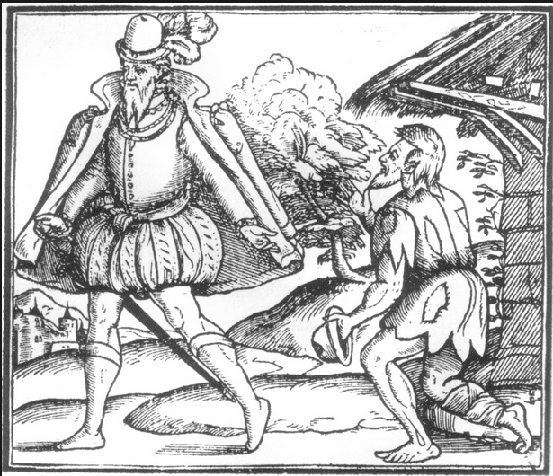
- It concerned Labourers, Servants and Beggars.
- The Statute strengthened the powers of the Justices of the Peace to impose and administer the law.
- It distinguished between the “sturdy beggars” capable of work and the “impotent beggars” ( includes disabled people) i.e. those incapacitated by age or infirmity. A distinction that has operated right up until allocation of benefits in the present day, or as often characterised, the moralistic difference between the worthy and unworthy poor.
- It forbade servants to move out of their ‘Hundred’ (this was the administrative area of the time and may have consisted of several Manors and related Manorial lands) without legal authorisation. This meant that roaming around the countryside in search of work, was no longer allowed and allocated responsibility to the leaders of a particular ‘Hundred’. It introduced a formal geographic basis for accountability for the poor which would be delegated down in time to the Parish.
- Each ‘Hundred’ was made responsible for housing and keeping its own paupers, but made no special provision for maintaining the sick poor.
For the next two centuries the aged and infirm depended upon pure charity for survival. The monasteries and the church communities were supposed to administer the charity required. In reality that performance was patchy. Christians, especially in Monasteries, were undertaking the seven-corporal works of mercy-deeds aimed to remove the worries and distress of those in need in accordance with their religious teachings;-feed the hungry, give drink to the thirsty, welcome the stranger, clothe the naked, visit and care for the sick, visit the prisoner and bury the dead.
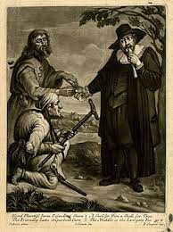
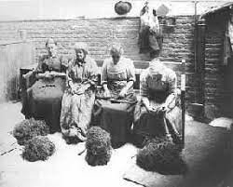
Elizabethan Poor Laws After the Reformation, England was a very different country. The monasteries could be many things to the people, they were a spiritual place, a school, a hospital and a provider of care to the poor and destitute. Without them to provide care and comfort, people suffered terribly & something had to be done. A series of Poor Laws passed during the reign of Elizabeth I played a very important role in the country’s welfare but none had the impact needed to resolve the problems of the poor on their own. Each one built on the other and they were vital as the poor relief system moved from a private welfare to a public welfare system, where responsibility for the poor lay with communities. In 1590s, inflation, a 50% drop in wages and a series of poor harvests led to famine conditions. Whereas people had, in the past, turned to the monasteries for help, since their dissolution, there was little charitable support to be had. Parliament, fearing civil unrest, decided to make the parish responsible for administering a system of compulsory poor relief through the Poor Law Act of 1601. Every parish (15,000 in England) had to appoint overseers who collected a property tax and provided Out Relief to old people, widows with children and the infirm (disabled people). Some casual benefit was paid out to young males who were too ill to work, had become unemployed or had to work in parish Poor Houses (precursors of the workhouses).

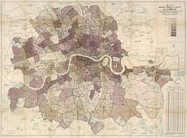
The Poor Law Amendment Act 1834 amended what was known as the ‘Old Poor Law‘ and reflected concerns about the mob, the burden of a growing population and a spiralling cost of poor relief under the Old Poor Law. A Royal Commission recommended one of the most important and draconian pieces of legislation. The Act adopted an approach that was to make poverty less attractive, difficult to believe in hindsight that this could be seen as attractive! Conversely those in power would, as can be seen today, have seen it as an important incentive not to be in poverty at all but to be gainfully employed. Relief was restricted largely to administration via entry into the Workhouses, what had been known as ‘Outdoor Relief’ was now severely restricted. Even entry into the Workhouse was subject to a form of means testing that only allowed the severest of cases to be admitted. Parishes were organised into Poor Law Unions, which were run by elected Boards of Guardians. These Boards were supervised by the Poor Law Commission based in London. The principle architect of the scheme was Edwin Chadwick who had led work and report of the same year on the Old poor Law. Chadwick had Utilitarian sympathies and these were enshrined in this harsh administration. He had designed the system of Workhouses to be, in his own words, ‘uninviting places of wholesome restraint’. By the 1860s until the end of the system in 1948 the majority population of workhouses were not the unemployed or ‘work shy’, but old and disabled people who also had to live under the harsh conditions. Dickens works were erudite social documents of the times and illustrations of how tough life was for the poor during his lifetime and this period.
Liberal Reforms 1906-1914 Some researchers such as Charles Booth (left) conducted studies to find out the causes of poverty. They discovered that the causes were low pay, unemployment, large families, illness/disability, old age– not laziness (as today). The effects of poverty were damaging to society (the health problems due to malnutrition, weak and sick children, crime etc.) In 1906 to 1914 the Liberal Government passed reforms to help reduce poverty. Basic social welfare service had been created which greatly improved the conditions for poorer people in British society. A new unified Germany several decades before had introduced general social welfare to prevent Revolution and with the rise of mass trade unionism in 1890s, the Liberals were similarly concerned. To pay for this social reform the Liberals increased the taxes on the rich.
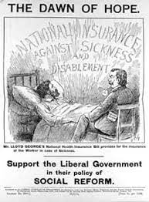
The reforms aimed to help the following people:
1. Reforms for the Young: free school meals, free medical inspections at school and later free treatment up to & those under 12 banned from begging and not sent to adult prisons.
2. Old Age pension from age 70.
3. Reforms for the sick: all manual workers and people in low-paid jobs had to join National Insurance scheme (Act 1911). The employee, the employer and the state contributed money to the scheme. Provided compulsory health insurance for workers earning under £160 per year if ill, an employee was paid 10 shillings (for up to 13 weeks) then 5 shillings for an additional 13 weeks. Workers in the scheme could have free medical care, especially for injuries during their work. Those not working were excluded, especially disabled people and were still often in the workhouses. Disabled people not working relied on families, charity, the workhouse or starved. Charity was also the UK Government response to the over two million disabled men who returned from the First World War. The land ‘Fit for Heroes’ did not emerge, as the 1920s and 30s led to mass unemployment and destitution.
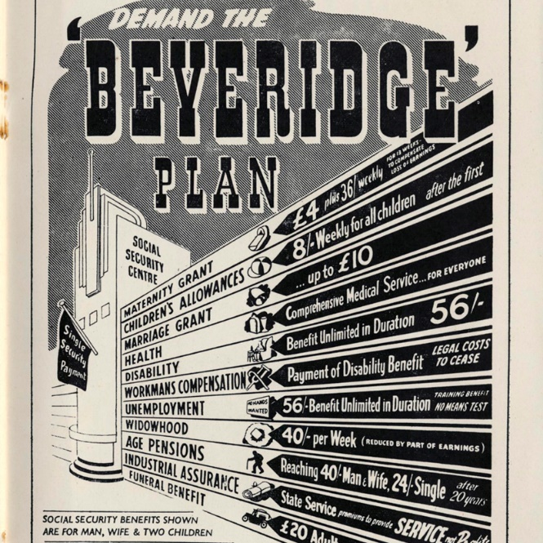
Beveridge and Welfare State The introduction of the Labour Government’s Welfare state of 1945-51 should have included disabled people, but apart from those on war pensions, some supplementary benefits and those who had accrued sufficient National Insurance through work, disabled people were largely left out, with numbers in asylums, institutions and long stay care homes rising. Payments and provision for disabled people were woefully inadequate. Beveridge, the moralistic and patrician social reformer and his influential Report (1942) reflected the mood during the 2nd World War that there had to be something better for the mass of people after the War. They should not have to rely on a means test but make contributions under national insurance and progressive taxation. Fiona Williams (1989) has critiqued the Labour Government’s implementation of the Welfare State, as sexist, relying as it did on married women to provide care, child care and not supporting single mothers effectively. She also points out its racist approach with its reliance on contributory benefits built up over time which penalised newly arrived post-war workers from Commonwealth countries. UKDHM must add that the conception was disabilist and it has taken a struggle by disabled people over the intervening years to get established the ideas of disability equality, incapacity benefits, direct payments, independent living, closing long stay institutions and community care, Disability Living Allowance (now Personal Independence Payments). Now we see them as targets of the so-called austerity measures of subsequent Governments since the 2008.

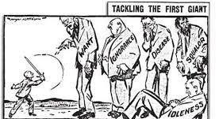
The National Assistance Act 1948 formally abolished the Poor Law system that had existed since the reign of Elizabeth I, and established a social safety net for those who did not pay national insurance contributions (such as the homeless, the physically handicapped, and unmarried mothers) and were therefore left uncovered by the National Insurance Act 1946 . "Assistance will be available to meet all needs which are not covered by insurance. It must meet those needs adequately up to subsistence level, but it must be felt to be something less desirable than insurance benefit; otherwise the insured persons get nothing for their contributions.” The rate for a married couple before the new service was launched, for instance, was 31 shillings (£1.55) a week, and 40 shillings (£2.00) a week when the new service was introduced, together with an allowance for rent. "In most cases where the applicant was a householder, the rent allowance was the actual rent paid." Under Section 29 of the Act, the power was granted to local authorities to promote the welfare of physically handicapped individuals but was not implemented in the main other than care homes. The social needs of those with mental conditions were to be the responsibility of mental health departments which, being part of the new National Health Service, were to provide its services to all those who needed it, regardless of ability to pay. The struggle for disabled people for decent benefits, independent living and closing institutions was fully covered in UKDHM 2019 Leadership, Resistance and Culture see Broadsheet

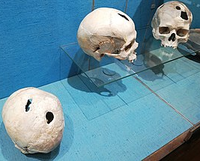
The treatment of those with mental conditions, both learning difficulty and madness (mental health issues) has a related but very different history
A distinction was made between ‘mental deficiency’-‘idiots’, ‘imbeciles’ and ‘feeble minded’ who had cognitive impairment and those who had ordinary cognition but then developed ‘madness’, mainly melancholia or mania, and other conditions of the brain/mind. They were usually treated differently though at times they were contained in similar institutions. Roy Porter in his ‘Madness A Brief History’ (2002) says Madness is as old as human kind.
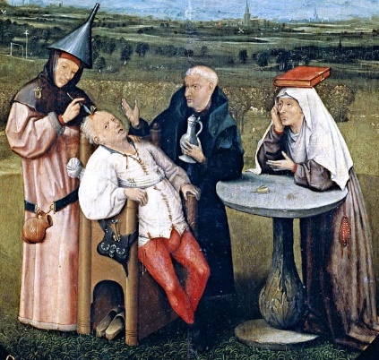
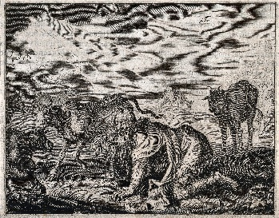
‘Archaeologists have unearthed skulls datable back to 5000 BC which have been trepanned-small round holes. The subject was probably thought to be possessed by devils which the holes allowed to escape.’(Above: Bronze Age trepanned skulls, France). The practice continued into the Middle Ages (Bosch, right). The world over, madness was understood as divine or demonic possession which were embodied in Mesopotamian and Egyptian medicine. Madness figured as a fate or punishment in early religious myths or fables. In Deuteronomy (6.5) ‘The Lord will smite thee with madness’ or Nebuchadnezzar (left) reduced by the Lord to bestial madness. Wild disturbance of speech and behaviour were generally imputed to supernatural powers.

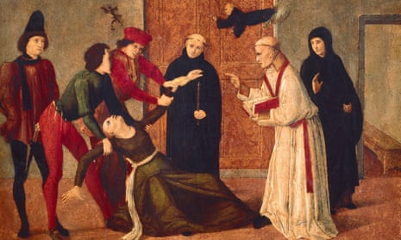
By the time of Hippocrates (c.470-375 BC) the sacred disease, Epilepsy, seen as supernatural possession was ‘ no more divine nor more sacred than other diseases, but had natural causes from which it originates like other afflictions’. So rational and naturalistic thinking about madness was developed in the Greco-Roman period and subsequently sat alongside Christian inspired conceptions of good, sin and satanic possession through witch hunts and exorcism. So in his Anatomy of Melancholy (1621) Robert Burton identified the Tempter (Satan) as the true author of despair and suicide. The bloody excesses of witch hunts with more than 200,000 people, mainly women, being executed eventually led to sceptism about demonical possession in medical circles. For example, in 1603, physician Edward Jorden was summoned to testify in the case of Elizbeth Jackson, arraigned for bewitching Mary Glover (a 14 year old girl with symptoms of epilepsy) and wrote a book explaining his testimony entitled:
‘A Brief Discourse of a Disease Called the Suffocation of the Mother.

Written upon the occasion which
Melancholy and Mania at gates of Bedlam Hospital
hath beene of late taken thereby, to suspect possession off an evil spirit, or some such like supernatural power. Wherein is declared that divers strange actions and passions of the body of man, which in the common opinion are imputed to the Devil, have their true natural causes and do accompany the disease.’ The natural causes he suggested relying on medical science from Galan were wrong, being vapours arising from the womb and spreading to the extremities, but it was a material explanation.
Medicine in the Age of Enlightenment reached back to the elitist male philosophers of the Greek city states and Hippocrates who strongly advocated that ‘human life, in sickness and in health, was to be understood in naturalistic terms’. ‘ Men ought to know that from the brain, and from the brain alone, arise our pleasures, joys, laughter and jests, as well as our sorrows, pains, griefs and tears.’ 2000 years earlier the naturalistic explanations Hippocrates had developed of illness, based on clinical evidence, in terms of ‘humours’( basic juices or fluids) were also adopted. These crucial vitality sustaining juices were blood, choler (yellow bile), phlegm (pale) and melancholy (black bile). These with their different attributes and impacts on humans provided endless plausible and indispensable explanations, so long as science had little direct access to what went on beneath the skin or in the head. So for mental health excesses both of blood and yellow bile (being too cold and dry), resulted in lowness, melancholy or depression. Those whose blood was polluted with toxins could have mania and be subject to blood-letting. Raving mad people could be put on diluting and cooling diets. This leads to mania and melancholy being seen as opposites being hot and cold, wet and dry, ‘red’ and ‘black’ conditions respectively.
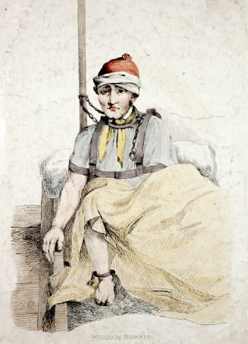
Most people who were mad for a long period were seen as the responsibility of their family and kept indoors or for those who could afford it lodged with small privately run ‘madhouses’(about 50 by 1800), which took care of them and were licenced after 1800. Some people who were very dangerous or behaved outrageously were locked away in early asylums for lunatics. The earliest in UK was Bedlam taking patients from C14th. To start with asylums were meant to be progressive, protecting ‘mad’ people from abuse and mal- treatment but overtime they developed punitive methods. There was pressure from the Crown in England to declare insane or idiotic those who were different and who owned estates. These would then revert to the Crown. Many neighbours and relatives did not want their Estates forfeited and so minimised their symptoms. Unreason in itself did not in C18th lead to incarceration. There was a lot of stigma attached as far as families were concerned with claims of ‘bad stock’. Many destitute people or paupers ended up in the workhouse or paupers’ asylums where conditions were bad.
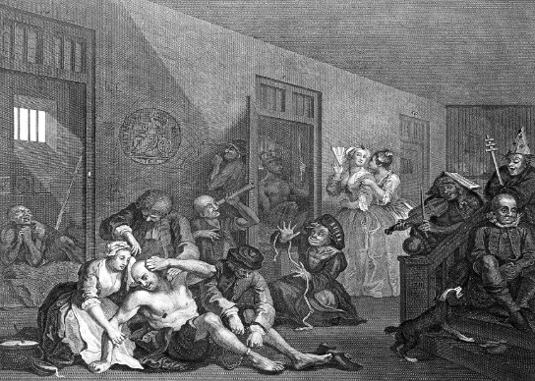
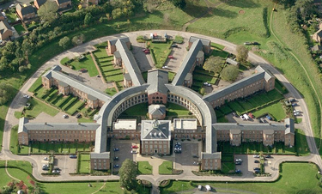
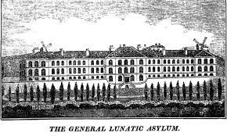
In 1808, an Act of Parliament permitting the use of public funds was passed but not until 1845 was the provision of such county asylums made mandatory. Restraint was used widely in early asylums for the apparent safety of the patient and of others, but it was dangerous and demeaning. In 1829 William Scrivinger, a patient at Lincoln Asylum, was found dead from strangulation after being strapped to his bed in a straitjacket and left overnight without supervision. The incident persuaded the authorities at Lincoln to abolish all physical restraints and implement a non-restraint system. Their system was very influential in 1800s asylum reform, and indicative of a wider change in attitude towards mental illness and the care of mentally ill people. The growing complexity of industrial society and the increased pressure of time and a fashion for conformity led to the big push to segregation.
Hogarth Madhouse, Rakes Progress 1735
Devon Asylum 1845
Nottinghamshire Asylum 1812
to

1902

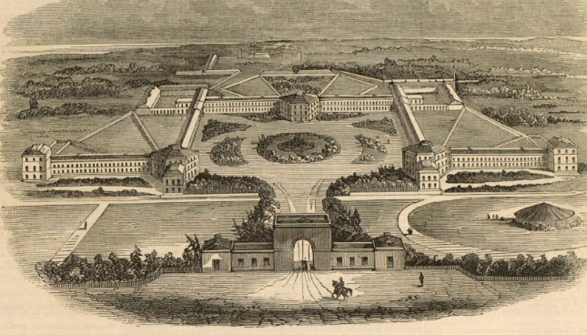
As Harriet Martineau, a social reformer observed. “In pauper asylums we see chains and strait-waistcoats, three or four half-naked creatures thrust into a chamber filled with straw, to exasperate each other with their clamour and attempts at violence; or else gibbering in idleness or moping in solitude.” Pressure from the likes of

Martineau, Pinel (a French alienist psychiatrist) who pioneered a more humane approach to the insane) and
Hamwell, Middx. 1835 run on a Moral basis
Samuel Tuke, superintendent of the Retreat in York, who pioneered a ‘Moral approach’ without restraint, led to the setting up of the County Asylums. These were often designed with gardens, spacious grounds, farms and breweries, bakeries, laundries and workshops to be self-sufficient. Treating inmates as people paid dividends in terms of recovery. As the century wore on with many more people placed by magistrates in these asylums, restraint and tough regimes came back into use. A consequence of having so many captive subjects and the increasing medicalisation of Asylums led to much theorising, false science and invasive treatments such as electric shock, surgical procedures and increasing use of drugs. Psychiatry as a burgeoning science owed much to the Asylum. The tendency to set up asylums and other institutions for the lunatic, mentally deficient or epileptic took off across Europe and North America from around 1850.

People with Learning Difficulty in C18th and C19th
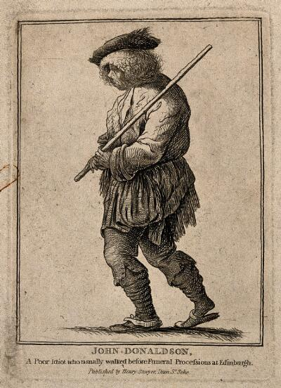
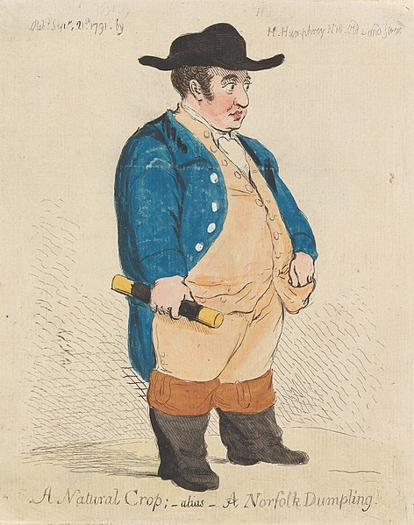
Simon Jarrett in his book Those They Called Idiots examines how this group of people were treated from 1700. Those with Learning Difficulty or Intellectual Impairments it appears were accepted and living I the community up until the end of C18th.The fashion for institutions from the 1850s, followed by the Eugenicist inspired Mental Deficiency Act (1913) sealed their fate for 150 years. Those called ‘idiots’, ‘imbeciles’ and ‘feeble minded’(‘morons’ in USA) were members of families, neighbourly and employment networks and were loved, protected and accepted by those who knew them throughout the C18th and early C19th. Communities seemed to adapt to people rather than people having to adapt to the community. There were times when they were ridiculed, bullied, abused, despised and loathed but Jarrett has identified evidence of countervailing response of protection, love and acceptance. Evidence is amassed from civil and criminal courtrooms, joke books, slang dictionaries, novels, arts and caricature of C18th to illustrate his thesis. Through this analysis it is shown that ‘idiots’ were an undeniable and pervasive presence throughout the century. A lack of intelligence was not a barrier to belonging. The ‘dim-witted’ could be seen as having other virtues-of reliability, steadfastness, honesty and loyalty. Physically, they could even be objects of desire, for their fabled compensatory bodily gifts. Strange but included into the pattern of everyday existence in C18th and early C19th.
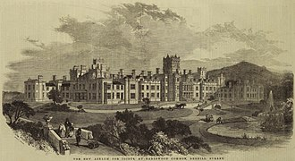
The pressure to segregate and incarcerate the insane was also impacting on those with learning difficulty as ‘idiots’ and ‘imbeciles’ including many with conditions such as Down’s Syndrome were locked away. Langdon Down was the first superintendent at Royal Earlswood Hospital for those with the condition he named, where he developed his racist theories of them being genetic throw-backs to an inferior race. The idea was they could be educated, trained and live a comfortable life protected from society.

The pernicious ideas of Social Darwinism and Eugenics saw most ills in society placed at the door of those thought to be morally and mentally deficient with the bizarre idea that they would weaken the population. Francis Galton, Darwin’s cousin, thought of applying the mechanisms of Darwin’s Evolution theory to Human society to ‘improve the breed’ and became a powerful force in the last part of the C19th and the first part C20th.
Changes that led to the Great Incarceration of People with Learning Difficulties The acceptance of the C18th and previously, changed in two phases leading to an increasingly harsh environment and growth in segregation. The upsurge of the French Revolution rattled the British ruling class and this satirical cartoon by Gillray, in 1795, captures the concern. ‘The Republican Attack’ on the King’s coach appears to be led by the lower orders and some appear to have the characteristics of ‘idiots’ or ‘simpletons’. Indeed Edmund Burke in rebutting the Revolution warns “ If people move and operate outside their allotted social role they would destroy the social order”. Equally proponents of Equality, Liberty and Fraternity such as Tom Paine and William Godwin in their idealised characterisation of all men (only men) even ‘a clod from the valley’ would with education, advance to the highest levels of civilisation though both campaigners for meritocracy are silent on the role
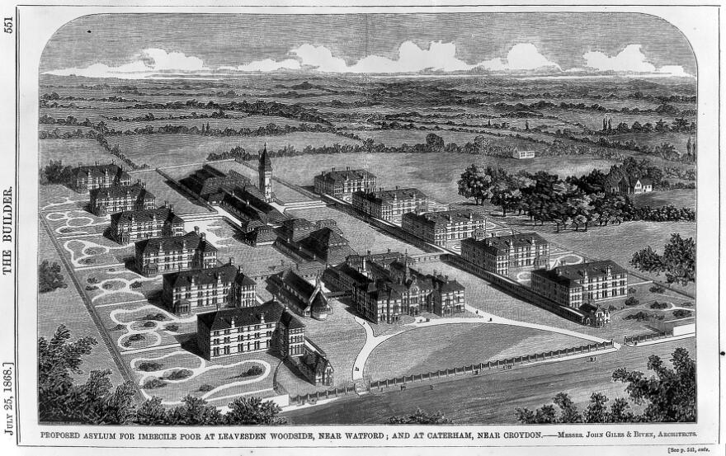
of people with learning difficulties. Mary Wollstonecroft argued against Burke but also was the first to assert Women’s and Girls’ Rights & Feminism. Generally, fear of the mob forced much greater social control such as the 1834 Poor Law and much tougher sentencing and placement in institutions in the period up to 1850/60. ‘This view of threat was reinforced by evangelists like Hannah More who saw the weak mind no longer as a God given misfortune. Instead, it was a degenerate threat at the heart of the moral universe, a conduit through which sin, destruction and blasphemy could undermine Christian faith. If the dull-witted could not learn to read especially the Bible this located the ‘idiot’ outside the human sphere, lacking the will or capacity to determine their own fate.’ This all culminated in an increase of the ‘idiot’ population of workhouses and asylums, but as the unsuitability of this became apparent an escalating programme of creating asylums for ‘idiots’ and ‘imbeciles’ began. The first purpose-built asylum specialised for idiots was completed in 1863 at Earlswood, to be followed by a number of others to include Caterham in Surrey and Leavesden in Herts. Imbecile Asylums opened in 1870, each with 1560 beds (right).

The second phase of increasing harshness in the treatment of people with Learning Difficulties came from 1870 onwards. Developments in developmental biology initiated by later works by Darwin created a scientific interest in looking for throw-backs to earlier links to animal evolution and quite falsely attributed features found amongst people with learning difficulties such as head shape, cognition and bodily form, such as hairiness, to this link. At the same time, the growth in the ‘mentally deficient’ population of insane asylums, workhouses and the growing number of specific asylums for them led to much more interest in classifying and ways (usually wrong) to understand the phenomena. Increasingly this became the preserve of the medical professions that had a plentiful supply of subjects. The 1886 Idiots’ Act had established legislation specifically to address the problem of ‘idiocy’ and enabled certification as distinct to ‘lunatics’ and allowed local rates to be used for building specialist mental deficiency facilities.

Francis Galton, in his 1869 Hereditary Genius: An Inquiry into Its Laws and Consequences argued for a hereditary principle of human development. He speculated if by careful selection farmers and botanists could breed strong animals and plants ’could not the race of men be similarly improved?’ In his later work in 1883 Inquiries into Human Faculty and Development he introduced the term Eugenics. This argued for ‘a national policy of social engineering to increase the number of people with the necessary mental intelligence to meet the challenges of a complex, newly industrialised and economically globalised society’. [This section draws heavily on Simon Jarrett’s Those They Called Idiots Ch.7 &Ch.8].
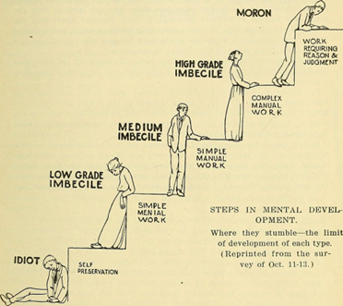
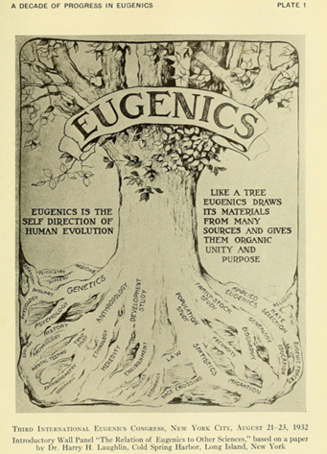
This involved promoting differential birth rates, increasing the rates of gifted young middle and upper classes and reducing or stopping births of the feckless lower class. Parallel developments in the UK & United States meant by the 1890s most people classified as ‘Idiots’ or ‘Imbeciles’ had already been institutionalised. The growing Eugenicist movement was now obsessed with the next group of mentally deficient people-the bottom 10% who could pass as non-disabled but were morally weak and did not have sufficient intelligence to function-the ‘moron ‘in the USA and ‘feeble-minded’ in the UK . This was the group that were criminal, beggars, prostitutes and mothers of illegitimate children mainly living in poverty who were weakening the nation and needed to be stopped from breeding or locked away in sex segregated institutions. The fact that this was a product of capitalism escaped the Eugenicists.This movement had plenty of influential supporters and cultural icons such as H.G.Wells, D.H.Lawrence, Beatrice and Sidney Webb. They did not have an objective way of proving what they were saying. The Intelligence test was developed in France by Alfred Binet (1904). William Stern in Germany developed the Intelligence Quotient. Goddard in US popularised this work. This pseudo-science was not tested for errors, instead conveniently those labelled as ‘idiots’ scored 0-25, those labelled as ‘imbeciles’ scored 26-50 and those labelled ‘moron or feeble minded’ scored 51-70. The cultural biases, the environment of those tested and the efficacy of pulling out one set of attributes in what is now recognised as multiple intelligence, were not questioned. The clamour of ‘this danger in our midst’ led to a Royal Commission (1904-1908) which, with prominent Eugenicists on it, argued for state regulation -supervision, guardianship and institutionalisation. There was a protracted debate about whether sterilisation should be introduced. It was in 32 US States, but not in the UK. Instead the 1913 Mental Deficiency Act was passed with all 41 Labour MPs, voting for, as well as Liberals (the Government) with only some Conservatives and Josiah Wedgewood (Liberal) making 150 speeches against from the point that all humans had inviolable rights. In the end it went through, 358 to 15 MPs. Ironically, the 1st World War led to many of those classed as ‘mentally deficient’ having to carry out factory war work, only afterwards to be placed for life in institutions on the say of two doctors. Eugenics was the opposite of Scientific Method.
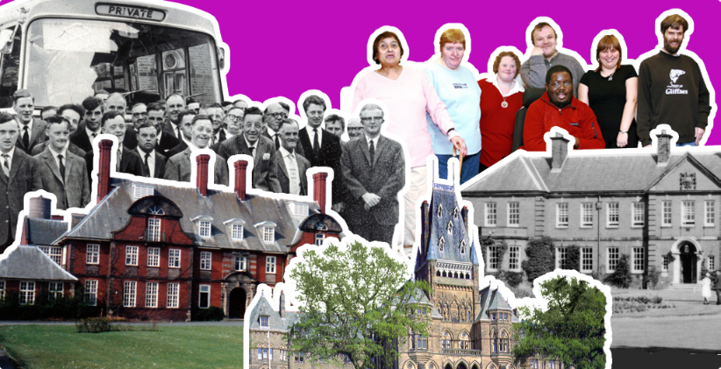
Lancashire Learning Disability Institutions: A people’s History Project. Picturing old inmates and modern people with Learning Difficulties living independent lives.Lancashire Learning Disability InstitutionsA people’s history of institutional life

The closure of these institutions with ‘care in the community’ was only mooted after many human rights abuses and scandals in the Mental Health Act in 1959, which had brought the mad and mentally deficient together. However, the more than 200,000 inhabiting these institutions as part of the NHS would have to wait until the 1980s/90s to be released to live in the community with support. By the early 1990s nearly all were living in the community with social service and NHS support. See Mabel Cooper’s Story (above) and resources from the Open University to work with schools and college students on this history.
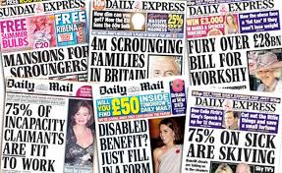
Austerity The financial crisis of 2008 was the harbinger of austerity , but with the election of the Tory Government of 2010, austerity measures predominantly impacted on disabled people with 42 separate measures. This was a political choice because we have seen from the furlough support in 2019-2021 Government can increase as well as decrease funding. To make these reductions palatable, Ministers encouraged the media to attack the wellbeing of disabled people as ‘Scroungers’, living on ‘Benefit Street’.
Lies in the Press. Less than 1% actually are cheats according to House of Commons Library

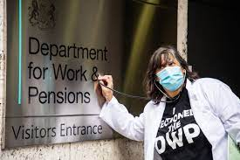
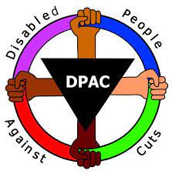
This led to three-fold increase in hate crime towards disabled people. An extra 335,000 people died than expected as a result of austerity measures between 2012 to 2019, the majority disabled people. It is estimated there was an increase in suicide and mental health difficulties for disabled people, due to benefit cuts. One study found 590 extra suicides in 2010-/13 from reassessment of Work Capability. The DWP admits to 69 suicides, but the true figure will be much greater as many as 10,000 activists estimate. Dolly Sen, a mental health survivor, a disabled filmmaker, artist, researcher and campaigner ran a project Broken Hearts where she laid siege to the DWP (Department of Work and Pensions) with family of the dead and campaigners and went on to Section the DWP [A legal measure used for ‘mad’ people who are danger to themselves and others, where they are locked up]. Dolly’s own experience as a Survivor motivates her to campaign and challenge. Here she is seeking to humanise the DWP.
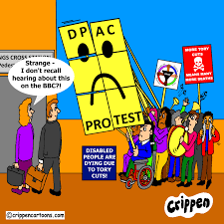
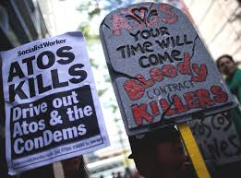
DPAC In 2010 there was no national Disabled People’s Organisation capable of challenging the scale and depth of these cut-backs so a grass roots organisation Disabled People Against the Cuts was formed by 7 activists, after an anti-austerity demonstration in Birmingham at the Tory Party Conference in October 2010. Using social media, demos and stunts DPAC spread very quickly. They were effective in getting the multi-national ATOS to drop their contract with the DWP to reassess disability benefits. The National Independent Living Fund closure went to High Court Appeals, the draconian measures adopted by DWP in transitioning over 4 million people from Disability Living Allowance to Personal Independence Payment (a non-means tested benefit for the extra cost of being a disabled person) has resulted in more than 70% winning their appeals and an increase in the numbers claiming benefit. However, 100,000 people lost their Motability cars.
Linda Burnip, one of the leaders of DPAC was the first person to use the UNCRPD Optional Protocol to take a Government to the Disability Committee in Geneva. After three years of investigation they produced a highly critical report accusing the UK Government of ‘Grave and Systematic Violations of Disabled People’s Rights’ and requiring them to report to the committee annually about improvements. There have not been improvements and now it appears that Disabled People will have to pay for the damage to the economy caused by Brexit, Covid-19, the Ukraine War and escalating commodity prices. One simple solution would be the full incorporation of the UN Convention on the Rights of Persons with Disabilities into UK Law. This would make unlawful many of the cuts of the UK Government.
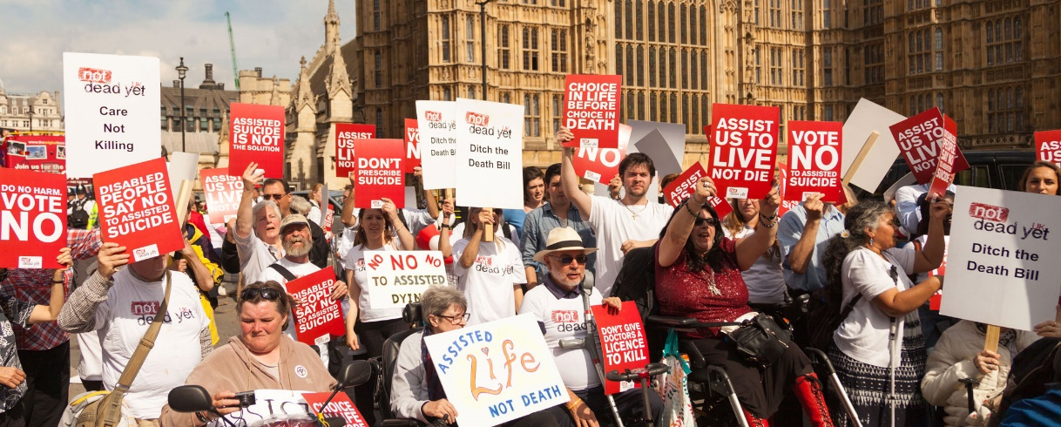
For over 120 years we, as disabled people, have learned that we need our own organisations where we control the demands we make, based on our lived experience and mediated by our understanding of how we are treated in Society. In 1920 three marches organised by the Trade Union the National League of the Blind marched on London from South Wales, Leeds and Manchester. They marched for decent conditions and pay in the workshops in which they were employed. They marched under the slogan ‘Justice not Charity’. They did not get all they wanted but got some of it in an Act of Parliament after meeting the Prime Minister Lloyd George. More recently since 1960s, Disabled People in the UK have organised themselves around the principle of self-representation and the ‘Social Model’ in which it is the barriers that people with impairments face that disabled us. To find out more of how the Disability Movement developed in the UK read A Brief History of the Disabled People’s Self Organisation.
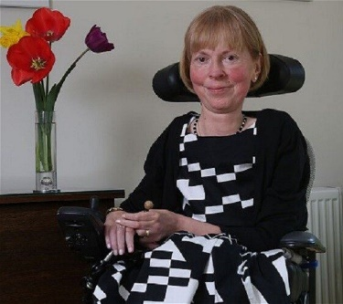
Not Dead Yet One of our key demands is the right to stay alive and get what we need to enjoy our lives. The founder, Baroness Jane Campbell (right) says “Not Dead Yet UK campaign against changing the current law on assisted suicide. I founded the organisation in 2004 we felt that it would simply feed into society’s commonly held belief that many sick and disabled people suffer unbearably and their lives are tragic and consequently not worth living. And this is constantly endorsed by the media. They believe as a consequence, assisting us to die, alternatives, such as investing in palliative care, and support for living would come, secondary, it would be much easier and cheaper to help us to die rather than live”. Many non-disabled people who acquire an impairment are shocked when they become disabled both by the sense of personal loss and finding out all the barriers that are still our everyday obstacles to the good life. The lack of accessible homes, transport, communications, the prejudice that prevents us getting a decent job or accessing education and the negative attitudes, abuse and hate crime we experience. Some of these things have improved over time but many remain major obstacles. People who have lived a non-disabled life are so shocked by the reduction in the quality of their life that they argue for euthanasia and assisted suicide. To change the Law to allow this, opens the door for our non-voluntary euthanasia as studies in the states and countries have shown, many are pressured to end their lives. We have to continually struggle against those who wish to for this slippery slope, ignoring history and the forced deaths of 250,000 disabled people experienced in Nazi Germany.
Dr.Miro Griffiths told the All Party Parliamentary Group on Disability in Oregon where assisted suicide has been legal since 1999, if you look at the data from 1999 to 2020 it is an 807% increase in the number of people choosing to die through assisted suicide. And when we look at the reasons why people choose to do this, we see emphasis placed on the burden on families and caregivers being cited, we see issues around the ability to participate in enjoyable activities, and the fear and the concerns around isolation.
One of the most basic indicators of wellbeing is to feel safe in our homes The fire at Grenfell Tower was horrendous and showed up Local Authority and Governments disregard for human life by allowing cost saving flammable cladding to be affixed to many tall buildings. Despite assurances to remove it from social housing and leaseholder properties the process is painfully slow. The fire led to 72 people losing their lives, including 15 of Grenfell’s 37 disabled residents, on the night of 14 June 2017. Georgie Hulme and Sarah Rennie, co-founders of Claddag, have told the Home Office in a legal letter of the “upset, outrage and betrayal” by the Home Office decision to reject the Grenfell Inquiry’s recommendation that all owners and managers of high-rise residential buildings should be legally required to prepare a personal emergency evacuation plan (PEEP) for all residents who may find it difficult to “self-evacuate”. In June 2022 the Home Office said its decision was taken on the grounds of “practicality”, “proportionality” and “safety”. Hulme said: “An evacuation plan is not a big ask and the fact that the Home Office is blocking this is an outrageous act of discrimination. Their focus on ‘proportionality’ shows a total disregard for those who died, survivors and bereaved. We know that over 40 per cent of those who died were disabled & none of them had evacuation plans. How many disabled deaths would be an acceptable amount for the Home Office to consider proportionate to warrant action? We are being framed as a costly hindrance to the taxpayer and a physical obstacle to non-disabled people trying to evacuate. This is despite producing no evidence of either”. The Chief Fire Officer for London said it was “neither morally nor legally justifiable” to tell non-disabled residents living in higher risk tower blocks in London that they must evacuate in an emergency, while leaving disabled residents in their flats to be rescued by firefighters.
People with Leaning Difficulty Disabled activists have spoken out over “absolutely shocking” figures which show that younger people with learning difficulties in England were more than 30 times more likely to die from coronavirus than non-disabled people of the same age. Andrew Lee (pictured, left), director of People First (Self Advocacy), said he was “alarmed and appalled” by the figures. ‘I’m concerned how little attention our politicians have given to this health inequality. He believed that some deaths could have been avoided. People First was also concerned that people with learning difficulties will be at the bottom of the list for access to vaccination. The figures published on 12 November 2020 are a shocking indication of the health inequalities we face and hope that we can all work together to make sure that the rates of death for people with learning difficulties are significantly reduced.’ (Disability News Service).Part of the reason for the higher death rates, according to Public Health England, is that people with learning difficulties are more likely to have underlying conditions such as obesity and diabetes, or to be more ‘vulnerable’ to respiratory infections and he also said they may have found it more difficult to recognise symptoms of COVID-19, or to follow government advice on testing, self-isolation, social distancing and infection prevention and control. Andrew thinks this is due in the main to the lack of self-advocacy, Government not listening to self-advocates and not funding their organisation.
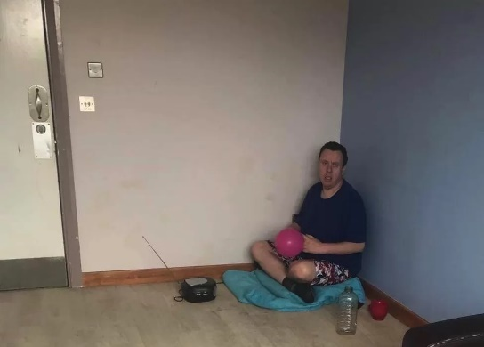
Close ATUs The keeping of people with Learning Difficulties and Autism in Assessment and Treatment Units (ATUs) for long periods, is another scandal which self-advocates and parents are fighting. More than 100 have been kept for over 20 years in these establishments out of the nearly 2000 patients. Tony Hickmott’s parents sought legal means to end his 20 year stay in a special hospital more than 2 hours drive from where they live. Mr Devine, a whistle blower, who worked at the ATU said only Mr Hickmott's basic needs were met. "Almost like an animal, he was fed, watered and cleaned. If anything happened beyond that, wonderful, but if it didn't, then it was still okay." (December 2021) The NHS said they are working with local Authority Commissioners to find a solution and that the number of people with a learning disability or autism who were in a mental health inpatient setting had reduced by 28% since March 2015.
Abuse and violence at the private hospital Whorlton Hall, funded by NHS where 6 staff were arrested for abusing patients following a BBC Panorama programme, should not have happened following the very similar Winterbourne View scandal in 2014. The promised changes have not occurred with the ‘patients’ not coming back to community based supported living, in line with Article 19 of the UNCRPD-Independent Living. The main reason is the £270 million cuts to social service budgets imposed by Government Austerity measures.

So how are we doing on Disabled People’s Health and Well Being? The answer is not well. A cynic might believe another way of reducing public expenditure might be elimination of costly disabled people by classifying us as ‘vulnerable’ and then not tackling the risks we face from Covid; our loss of benefit, pushing an increasing number to suicide, still keeping us in institutions against our will rather than supporting us to live in the community, general lack of care in high rise buildings and potential fire risks, allowing numerous debates on assisted suicide to get the public in favour of voluntary euthanasia and most importantly, not fully implementing our human rights by failing to incorporate into UK Law the United Nations Convention on the Rights of Persons with Disabilities.

Despite some improvements, disabled people are often not viewed as fully human. The history of our oppressive treatment and negative portrayal has led to us being seen as less than: suitable cases for pity, charity and sympathy. We do not want this. We want our full human rights and we need our allies in our struggle for equality to champion the removing of barriers that disadvantage us as disabled people. Our impairments are not our main problems. Other people’s attitudes and practices are. Support UKDHM to bring about this long overdue change.

People’s History Museum in Manchester are launching an exhibition to coincide with UKDHM called Nothing About Us Without Us. They employed four community curators, who identify as disabled people, to help put the exhibition together. It runs for 11 months from 16 November 2022 to 16 October 2023. (right - one of exhibits, Help the Normals collection can by Dolly Sen, 2012).

Support UKDHM in your community, workplace, school or college. Let us know your events. Mail rlrieser@gmail.com There are more resources, this Broadsheet in different formats and films of the launch and interviews with speakers and activities for schools and colleges on our website www.ukdhm.org

