Man who couldn’t read until 18 becomes Cambridge’s youngest-ever black professor
Comment
Emma BrazellThursday 23 Feb 2023 12:45 pm
Share
31.1kSHARES
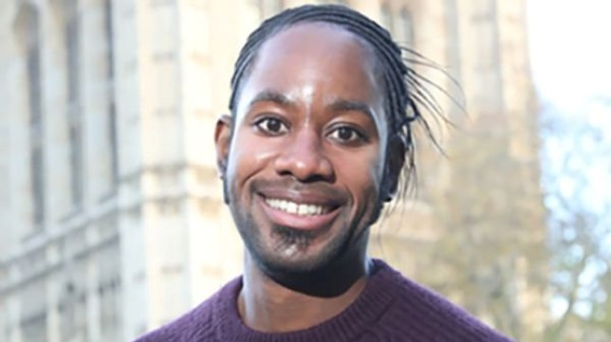
Professor Jason Arday, 37, has shared his incredible journey (Picture: University of Cambridge Faculty/ SWNS)
A man who couldn’t read or write until he was 18 is about to become Cambridge University’s youngest-ever black professor.
Professor Jason Arday was told he would likely spend his adult life in assisted living after being diagnosed with autism and remaining speechless until he was 11.
The 37-year-old, from Clapham in London, spent years getting ‘violently rejected’ when he first started writing academically.
Now, he is now an acclaimed professor who will take up one of the most prestigious professorship posts in the world – professor of sociology of education at Cambridge.
He will be one of just five black professors at the institution and one of 155 black university professors in the UK from a total of 23,000.
‘My work focuses primarily on how we can open doors to more people from disadvantaged backgrounds and truly democratise higher education’, he has said.
‘Hopefully being in a place like Cambridge will provide me with the leverage to lead that agenda nationally and globally.’
Professor Arday was diagnosed with global developmental delay when he was a child, but says that didn’t make him question the world around him any less.
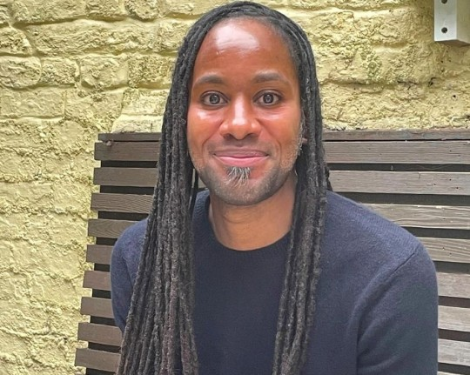
He is hoping to inspire people from under-represented backgrounds into higher education (Picture: University of Cambridge Faculty/ SWNS)
He says he remembers thinking ‘Why are some people homeless? Why is there war?’ as a youngster.
‘I remember thinking if I don’t make it as a football player or a professional snooker player, then I want to save the world’, he added.
After learning to read and write as a teenager, he became a PE teacher, which gave him an insight into the systemic inequalities that children can face in education.
He knew he wanted to study further, but felt lost as he had no guidance on how to create his own path.
Aged 27, he wrote on his bedroom wall at his parents’ house: ‘One day I will work at Oxford or Cambridge.’
He remembers his college mentor, Sandro Sandi, telling him, ‘I think you can do this – I think we can take on the world and win’.
This was the first time he ‘really believed in himself’ and he became ‘determined and focused’ after this talk.
Still working as a PE teacher during the day, he wrote papers and studied by night.

‘When I started writing academic papers, I had no idea what I was doing’, he said.
‘I did not have a mentor and no one ever showed me how to write. Everything I submitted got violently rejected.
‘The peer review process was so cruel, it was almost funny, but I treated it as a learning experience and, perversely, began to enjoy it.’
After years of relentless hard work, Professor Arday has two master’s degrees and a PhD in educational studies.
He has had roles at the University of Glasgow and the University of Durham, and is an adjunct professor at the Nelson Mandela University.
Looking back at his inspiring story, he says he knows ‘this is what I meant to do’.
He will start at the University of Cambridge on March 6 as Professor of Sociology of Education in the Faculty of Education.

