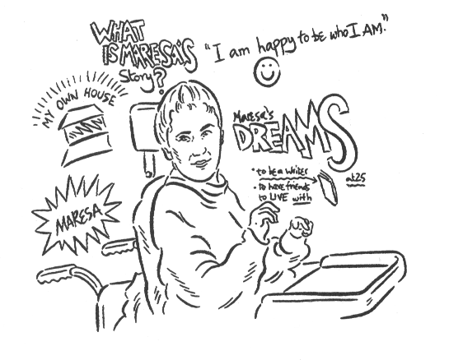
Maresa’s Story

My name is Maresa and I live in Nottingham. I have an impairment which affects the circuits in my brain and leads to uncontrollable movement and muscle spasms. I can’t talk using my mouth, but I communicate by using my Light Writer, a keyboard that illuminates words and sentences and speaks the words I spell out.

When I was small I started out at Special School. It was frustrating because people didn’t know how much I understood or how to help me communicate. Then when I was nine I started going to ordinary Junior School one day a week. At first it was great. I had an assistant who was learning to help me communicate. But I got depressed because I missed so much. I did make some good friends, but when I left it all crumbled.

When I was 11, I got a place at a Secondary Comprehensive School. I was so excited. We bought the uniform, and I had a new pair of glasses. But on the first day, the Head said I couldn’t start because the special toilets weren’t built. It made me feel awful. When I did start it was just in the mornings. The lessons were good, but most of the time I was in the Special Needs Room with people who didn’t know how to ‘talk’ to me. Then at the end of the second term I started full time.

I decided I wanted to invite some kids home, so I wrote some notes to them, and my mum wrote a note to the teacher to ask her to give them out.

The teacher wrote back saying she wouldn’t give them out because the kids weren’t ready to come to my house. So I asked the Young and Powerful group for help.

Young and Powerful is a group of disabled and non-disabled young people who go to mainstream schools. They support each other and campaign for all children to be included in schools together. They’re supported by the Alliance for Inclusive Education, but they decide what they are going to do.

We got together in the summer holidays and decided to organise a demonstration to ask the Director of Education in Nottingham to change things. We discussed our plans, what we wanted to say and sent a press release to the local paper and TV.

When we arrived at County Hall we were led straight into a big room. The Director of Education was very stern and didn’t seem to listen much. He said he didn’t have the power to change things without an investigation. So we agreed to meet again in a month.

The evening after our meeting we were on the radio five times, there were two pieces on TV news and we made the front page of the Nottingham Post too.

A month later, we met again. At first the Director of Education said he couldn’t do anything and we felt very disappointed. Something had to happen, and it did! Halfway through the meeting Katie Caryer, another member of Young and Powerful, gave him a heart-felt message on her talker:

“Please…just…make…it…better…for…Maresa…not fantastic…but… better…”

That’s when the real negotiation began.

In the end we didn’t get all we asked for, but they did agree I should never be without someone who can communicate with me and that my timetable would be rewritten with help from my mum.

Now I have started at another Comprehensive School, with my own personal assistants. It has been so much better, and I am doing GCSEs in 2001. A group of Year 10 girls have also volunteered to be a part of my ‘Circle of Friends.’ It’s brilliant because now we can go out and talk together without adults around.

(The girls all worked out their own circle of friends and realised how isolated Maresa was. They all decided that they needed to learn to enable Maresa to communicate.)

I think all kids need to be together, and then they can learn from each other. Schools need to change, to be kinder to kids who need a lot of help or get tired. When will people realise that all kids are worth thinking about? Both disabled and non-disabled kids need help of different kinds, not just help with work.
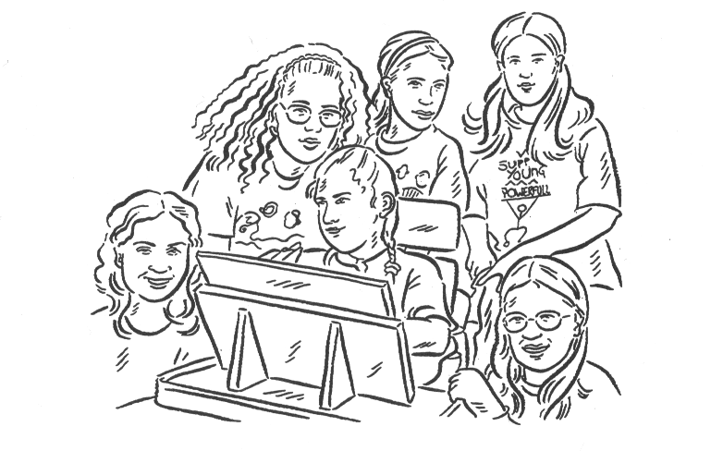

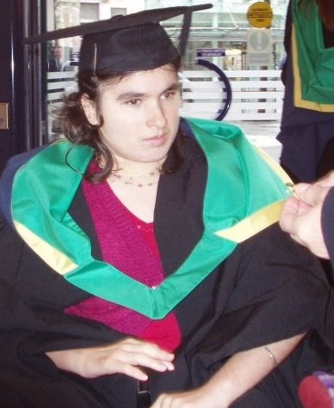
Postscript: Maressa sat her exams at the Secondary School with her communicator. She was given 6 times longer by the exam board to communicate her answers to her communicator who then wrote them down. She was exhausted at the end but got the best GCSE results achieved at the school. Maressa then when to FE College, but asked as a reasonabled adjustment that instead of sitting long ands exhausting exams she could write three long essays. This was agreed by the college, exam board and the University Maressa wanted to attend.. She achieved high marks but before going to University asked for a year off. When she finally got on the courser-English. Maressa asked for another adjustment. She said her main barriers is time to communicate ands so wanted to do the 3 year course ion 4 years. The Nottingham Trent University agreed and 4 years latter Maressa got a 2.1 degree. Now Maressa is an activist with Quiet Riot(a group for
t he rights of non-verbal people; A Poet and a journalist https://youtu.be/OlIPYe8sAwI?t=10

https://ukdhm.org/v2/wp-content/uploads/2016/11/UKDHM-2016_Poems_02.pdf

