Out of Sight Children and Experience of Disability 1900-1950

(By Steve Humphries and Pamela Gordon; published by Northcote House 1992 for Channel 4 series). The following extracts are taken from this interesting oral history book.
Background
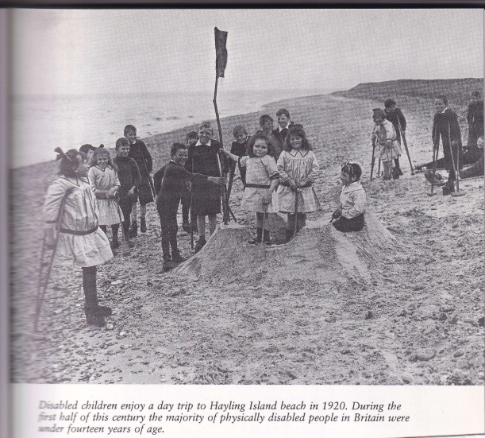
In the early half of the century, most disabled people were children. There were around 50,000 children with physical disabilities, the vast majority of whom were from working-class homes. Many came from the poorest families in the slums, for much physical impairment was a consequence of severe deprivation and hardship. This close association between poverty and disability in the minds of charities and government officials helped fuel extremely hostile attitudes towards them. Many of the prejudices made about the undeserving poor by middle class reformers were heaped upon them. They were part of the 'great unwashed,’ who were ignorant, immoral and feeble-minded. In short they needed to be saved from themselves and from their families. One of the main aims was to instil in them a discipline which would prevent them from begging, living on poor-law handouts and becoming a public nuisance.
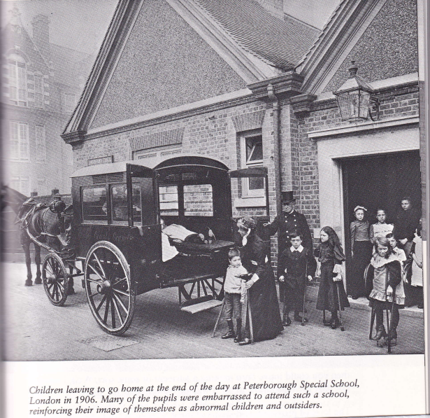
Stereotypes which closely linked moral and physical 'degeneracy' were strongly reinforced in the early part of the century by the new and fashionable science of Eugenics. Eugenicists often represented disabled people as helpless, ignorant or insane. They claimed that mental and physical disability was a heredity problem passed on through so called 'defective' families. This 'bad stock' was thought to be undermining the strength and efficiency of the British race because people with disability were reproducing at a much faster rate than the able-bodied. This reproduction of the 'unfit' was thought to be one of the main causes of the poverty, unemployment, criminality, alcoholism and idleness which preoccupied many Edwardian social reformers.
The Eugenicist solution was to prevent disabled people from reproducing, or at least dramatically reduce their rate of reproduction thereby maintaining racial purity. Eugenicist ideas strongly influenced the passing of the Mental Defectives Act 1913, which gave local authorities far-reaching powers to place people having sex outside marriage into institutions. The most vulnerable to victimisation under this legislation were disabled people and young men and women with learning difficulties. Many found themselves classified as moral imbeciles and were locked away in long-stay mental handicap hospitals, sometimes for the rest of their lives. In such institutions sex segregation was strictly enforced.
From the mid-nineteenth century onwards, there had been a growing emphasis in British society on the importance of masculinity, physical strength, fitness, athleticism and sport - what has come to be called 'Muscular Christianity'. These values were stressed in schools and immensely influential. Uniformed youth movements like the Boys Brigade and the Boy Scouts - it was all part of the new ideology of imperialism with its great pride in the supremacy of the British army and navy and the power of the empire. Failure to live up to this mythical stereotype often caused great shame and suffering to the parents of disabled children.
100,000 or more disabled children were enrolled in state primary schools in 1920s and 1930s. Those the Authorities identified were sent to special schools and institutions.
Thousands of disabled boys and girls spent long periods of their childhood as hospital patients. Here the enforcement of strict institutional discipline and the mistaken belief in the complete immobilisation of some patients meant that occasionally children were not allowed to move at all from their beds.
Before the last war, disabled people formed an underclass neglected by society and denied opportunities in the world of work. The training they received in institutions - and the workshops attached to them - prepared them for a lowly role in life. They were trained to enter into a very narrow range of occupations. As 'apprentices' they were often paid nothing for their labour, or at most pocket money, yet their wares were often sold for profit.
The fact that many of the institutions of the day were reliant on public donations added to the justification for creating a false public image of the kind of life children had to live inside them. It was particularly parents who were seen as dangerous, and great effort was put into preventing their children telling them what was really happening to them.

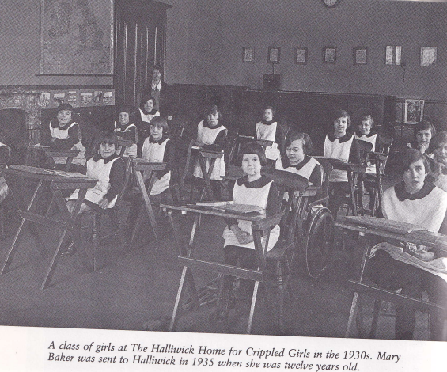
Mary Baker, Halliwick Home for Crippled Girls, 1930s
Mary was 12 years old when she was sent to Halliwick. She had a dislocated hip. As a result she walked with a limp. Mary’s father had been injured in 1st World War and when her mother died she and her brothers were sent to the workhouse in Wimborne, Dorset and from there she was sent to Halliwick, a Church of England Institution.
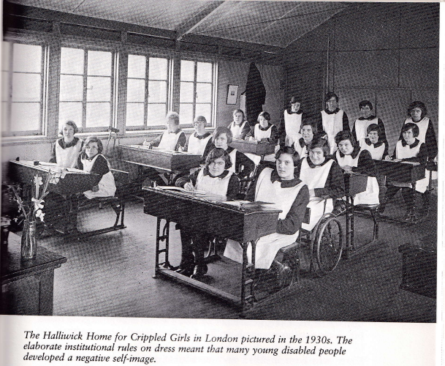
"When I first arrived at Halliwick, the nurse took me into this bathroom and she stripped me off completely. She cut my hair short, right above the ears. And then I was deloused with powder of some description. Then they put me in a bath and scrubbed me down with carbolic soap. It was very degrading to me and I felt as though the end of the world had come. I didn't know what to do, had no idea what I was going to do. But it was a huge and it was lonely, the place. And I felt really lost, and I thought, 'what am I going to do with no one to love me?’ The next morning you were given a number and you had to remember it. My number was twenty-nine and when I got up and went to wash, my towel and flannel had my number on them Twenty-nine - was engraved on all my hairbrushes and things with a red-hot poker-like thing. Everything I owned had a marking of twenty-nine so I can never forget that number and if matron wanted you, she just called you by your number. We never had names we were just numbers there."
“ The most places we felt lonely was in our bedrooms, in the dormitories, because we all used to chat about the thing we’d lost, our mothers, our fathers and our brothers and sisters. We all used to cry and wondered when we would see them again...At times I used to read stories to the other girls in the room because some didn’t know how to read. But we had to be careful not to get caught, it was all so disciplined. There was no love there at all…Sometimes we had high jinks as well, we used to pillow fight and all the things girls do…And if matron did catch any of us we all stuck up for each other.”
“One of the main things about the place was religion. In the week we used to go to chapel before we went to school for our hymns and once later in the day. We went to church three times on Sunday.”
"When we were in the classroom, we used to write home every week. After we had written a letter the headmistress passed them all on to the matron so she could read them and she used to cross off what we weren't supposed to put in. We had to put it that we lived it there, and everybody was happy, and everything that was really lies. We couldn't put any of our true feelings into a letter. If we had written anything bad about the place, they were bought back to us and we had to write them again, leaving out those bad things. Then they were sent back to the matron and sealed down and sent off. I used to write to my father and to my grandmother. And I used to get letters back saying they were so thrilled that I was so happy, but my letters were all lies."
“In 1938 I began my training in needlework after schooling was finished. I was not keen on it. The needlework we did started very plain, then all sorts of stitching and buttonholes. If we passed, we could go onto something more elaborate. It was mainly underclothes of silk or satin…. I think they went to orders from London shops…And I always used to wish that I could wear some of those clothes that we made…We still. Had to wear our awful uniform. We were taught needlework and nothing else. This was all disabled people were allowed to do. We weren’t allowed to put our minds to anything else, because they thought we weren’t fit to do it”
- Jean Hollamby, Tite Street Children's Hospital, 1928 – 1933, to be 'treated' for cerebral palsy
"I was in the hospital for five years and every week my mum used to visit me, but she wasn't allowed in the ward, not once in all that time. She just looked in through the window in the ward door and waved at me like all the other parents. That was really upsetting, much more upsetting than if we had had proper visits. She used to leave me presents to have when she'd gone home but of course it wasn't like seeing her properly. All year we would look forward to the garden fete in the summer so then we could be with our mum's properly for an hour or ....” -
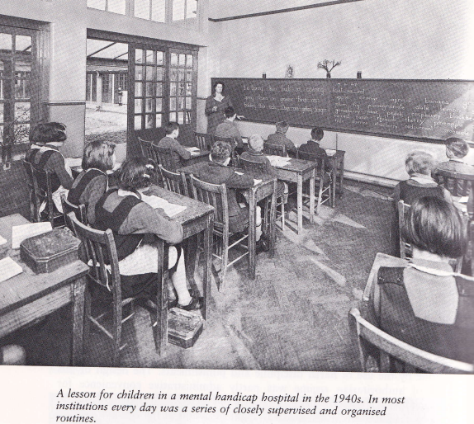
Evelyn King, Mental Handicap Hospital
In 1951 at the age of five Evelyn King admitted to one of the largest mental handicap hospitals in the North of England. Sher had cerebral palsy which prevented her from walking or speaking more than a few words. After failing the intelligence test administered by doctors she was diagnosed as ‘an imbecile’ who was unfit to be educated. Evelyn had no learning issues, just difficulty speaking.
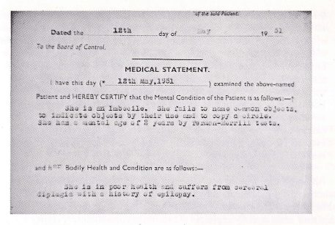
“When I first came I was a baby in a wheelchair. I never used to walk and I couldn’t talk, And I weren’t happy as a girl ‘cos it was a bit miserable. On the villa we played dominoes, ludo and snap cards and I played jigsaws and did sewing. I used to get a bit bored and I used to look out of the window and dream about me poor mum and dad-‘cos I never used to go home and I missed all that…Then later I started school but I only had school in the morning…And the staff were very strict.. Just had to keep your mouth shut. But we used to get punished and everything...When we used to scrub the floors, when we were naughty , all day long. Used to be locked in our rooms. I couldn’t use a knife and fork in them days, just a spoon and if I spilt something like tea, they used to get a cloth and make me wipe it up. I used to say ‘I’m Sorry I did it on accident’. But the still made you wipe it up…Sometimes they would say @If you do that again, you won’t see your mother or father again. I won’t have this’. So we had to be careful what we say to them.
"Years ago we daren't talk to the boys. Oh no, we had to keep away from them. Girls used to be on one side and boys on the other. If we talked to the boys you could get into real trouble. I did get frightened to get into trouble for what I say to the boys, so I just kept my mouth shut." -
Muriel Faulkner, contracted polio in 1904
"They kept you where people couldn't see you. They kept you out of sight." –

Susan Miller, hospitalised with polio in 1921 (at the age of one) to 1942
"From the age of five to 13, I was encased in a plaster cast, rather like an Egyptian mummy in the children's ward of the Royal Sea Bathing Hospital in Margate. Whenever the little girl in the next bed to me wanted to play dollies, I undid the straps that were meant to keep my arms still and joined in with the game. But if the nurse ever saw us, and she mostly did, she thundered down the ward, yelled at me, put me back in my little coffin and tied my arms and hands down with bandages to the sides of the bed really tight. It was like being crucified flat. There were so many times when I wanted to play and talk and I would wriggle and accidentally break bits off the cast. And this would mean that I had to be re-plastered. The nurses got really furious and they would quite often wheel me, bed and all, into the cold, wet bathroom as a punishment. I had to cry myself to sleep to the sound of the dripping tap."
Betty Holland, LA school for crippled children, 1920's
Betty had polio when she was 9 months old in 1913. She lived in Camberwell London. The daughter of a printer.
“There was nothing that I could do when I got home from school because I couldn’t get out well enough to play on our street like the rest of them. I did used to go to the Cripples Parlour. It was a king of a club set up in an old church hall and it was every Monday. It was only for children with handicaps. It wasn’t bad I suppose but you could only sit there , quite boring and play dominoes and cards, maybe have a chat. It was the name that got me. Cripples Parlour. As if that was the only place I was fit for and couldn’t have fun anywhere else. I used to hate going in there if people were looking because of them shouting out names to you and laughing at you for going to a place with a name like that”
"I went to a school for handicapped children. I could read a bit when I went there but we just had baby lessons at that school. Very basic things like the ABC and adding up two numbers. They treated you like imbeciles. Dressmaking was the main subject, well, needlework. It was all we learnt. We used to sit for hours stitching. I never knew what good it was going to do me in life, to get a job and that. I hated it and so I was no good at all at sewing. First you had to learn how to do a buttonhole. You had to sit there and do those until you were perfect then you could move onto a garment of some sort. Well 1 never got past the buttonhole at all. I was on buttonholes for years".
Earnest Williams, Birmingham Blind Institution, 1920's
Earnest was born in 1915 the son of an agricultural labourer who eked out a living for his family in Herefordshire. “Being a blind boy I was spoilt compared to brother and sister. Extra spoonful’s of honey…I had a pair of spectacles once, but I lost them and they could not be replaced. They were more expensive than shoes. The main concern was the business of living.”
Although Ernest was very helpful to his father in agricultural labouring- milking cows and helping calves be born, when he was eleven in 1926 he was sent to St Helen’s Institution for the Blind in Swansea.
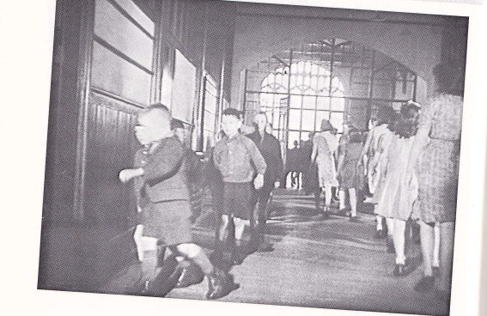
“ We had to go to Sunday school every Sunday and we’d file in crocodiles with a line of boys next to a line of girls. One girl shouted out ‘Earnest touched my knickers’. I bumped into her accidentally, but I hadn’t done anything to her. That was it . I was reported and there was an unholy row. The next morning I was reprimanded in front of the whole school in the hall. I was called out to the front and the headmistress said ‘ You’re worse than the beasts in the field, isn’t it boy?’. They were going to thrash me, but then a member of staff called out ‘Put him away until he cleanses himself’. I was locked in the sick room for four days. I was angry and did not say sorry as I felt wrongly treated. . I still hadn’t confessed but they said that Lord Jesus Christ had taken me into his heart.”
"At the end of my educational life at 16, I simply, the next day went into the workshops. It had been decided that I would go into boot and shoe making and repairing. I was to be trained then sent back to my little village where I had come from, there to have a wooden shed adjacent to my cottage home which would be my workshop. And so it was. The system allowed for three years to become qualified to decently sole and heel a pair of shoes it was not uncommon to take weeks over a simple task. People asked if I wasn't bored to death but the truth of the matter is that we were psychologically adapted to the acceptance of one's lot."
Dennis Boucher, Yorkshire Institute for the Deaf.
Dennis was sent there in 1935 when he was aged 7. The Deaf schools all rejected Sign Language and taught by the oral method, but the children learned it from each other in the playground.
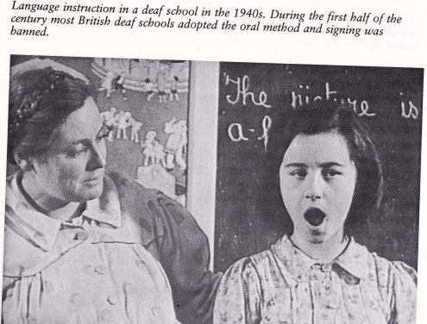
“ When I first came to school not many children could sign. They just used ‘F’ for father and ‘M’ for mother. They didn’t know the alphabet at all. They didn’t know any signing. I could sign because my older brothers came home and taught me when they went to Leeds school….I carried on teaching signs like mother, father, brother, sister-I taught them all those3. And they all found it very interesting and enjoyed it…It spread round the whole little school.”
“When I was about thirteen or fourteen at my school the boys were always hungry. Anyway, the prefect, he used to make me and three or four others go scrumping apples and pears. There were loads of trees next to the school. So we used to crawl at night, when it was quite dark, come right into the orchard and pinch all the apples and fill our pockets… Then he’d make us give them all up and the prefect would hand them out. We secretly kept some back for ourselves. When we got back to our rooms and eat all these apples and pear. The next morning, God, my stomach… But we would be back there the next night”
Dennis first met Hazel at the Yorkshire Residential Institution in the 1930s. Mixing of the sexes was forbidden, but the secretly met.
“There was a big wall in the playground separating the boys from the girls and so if I wanted to speak to Hazel or meet up and have a little kiss and a cuddle I would ask one of the lads to stand so I could stand on his shoulders and look over the wall and sign to Hazel.” They later married.
Ted Williams arrival at Manchester Road School for the Blind in Sheffield 1923.
“ The first day you got there, you changed into the school uniform and your clothes were put in the wardroom. Add insult to injury, we were dumped with a number. Mine was 43, prisoner Forty-Three sort of thing, and I kept that number for seven solid years solid. ..All my clothing, all my possessions, what few I had anyway, I discovered there was a big number forty-three. We had to line up for everything in our convict numbered sequence. I was homesick. The first night I just laid and cowered under the sheets…My home wasn’t much to crack about. We lived in a slum area of Sheffield. But I remember when the dictate came from the council saying that I had to go to Manchester Road School, I didn’t want to go.”
“The rules about silence in the school were terrific, they were out of this world. Say at meal-time, five minutes before a meal time, the teacher would come up to the playroom and blow a whistle…We all lined up and marched in absolute dead silence from the playroom- we didn’t walk in a relaxed way- it was a semi-goose stepping march. If you accidently walked a bit faster and bumped into someone and giggled, that was 50 lines ‘I must not talk in line’.
“ The sex segregation at the Blind school was something terrific. We would go back to school in January and we weren’t supposed to talk to any girls until July. Now there were fifty odd boys and thirty odd girls and if ever accidentally, we had some sort of contact with a girl, we were actually punished. I myself had the cane for accidentally putting my hand out and feeling at a girl’s back more or less to find out who was in front of me in the queue.”

Ted Williams, Sharrow Lane Workshops, 1930s
"On the day that I left school I was told that I was going into the mat shop and that was that. There was no choice at all. We had twenty odd looms in our mat shop at the workshops, big thundering great things they were. And the common run of the mat maker was that you stood winding yarn round a steel rod and thumping the big heavy baton down and bang the rows up together. We did that then hour after hour, year after year, lifetime after lifetime." –
Gerald Turner, Loxley House, Home for Crippled Boys, 1942
Gerald was born in 1931 with cerebral palsy. He lived in the mining village of Rawmarsh near Rotherham with his parents, three brothers and sister. He was sent to Loxley House when he was 10 in 1942.
“ There would be real fisticuffs , especially from my sister if ever someone started to make fun of me. My brothers and her stuck by me in our village when I was little. They used to take me out to play games so I could join in…I couldn’t walk then, so sometimes it was difficult for them to get me very far in the old pushchair because you didn’t have proper wheelchairs then. In then evenings quite often my brother get me on his back and we would go to the cinema to see a picture”.
"We went out to school three times a week. I really enjoyed it there. It was exciting learning new things because I had never been able to go to school before and I was ten by then, so I really did want to learn. They taught us how to write a bit with chalk and to draw, just simple things to start us off like. But as soon as we got back to the home the matron would knock anything we had learnt out of us. It seemed like she didn't think we ought to be allowed to learn. She wouldn't let us have any books. And if you was caught reading you got a crack behind the car and the book would be torn up in front of our eyes. Mother and dad didn't know anything about all this going on and when they came to visit me they used to bring me books and comics. They were really pleased that I was going to school at last. Course they didn't know that as soon as they left the matron took all the new books off me and ripped them up.
And when we weren’t at school we weren’t allowed to do anything except sit around all day until we were put to bed, sometimes at 4pm….We were scared of being hit more and we were too weak to run away. I had only just learned to walk. But I would have run if I could have!”
Florence Aulph,12, who had an impairment in one leg was sent in 1913 from her Banardos Home near Newcastle to Canada. Many disabled children were kept in orphanages and the workhouse. Nobody even told her mother. Around 90,000 were exported to Canada up to the 1920s for cheap labour and some were disabled.
“ We went down to the docks by four horses, where the big ship was waiting. We were three weeks crossing and most of us were dreadfully sick all the way…We landed in Quebec and we then had to go down the St Lawrence Seaway in a smaller boat to a children’s home in Peterborough. There were hundred boys and 100 girls. They had all our names down and they asked us ‘Where would you like to live, in the city or out on a farm?’ in a book and they took a couple of us in the room at a time and asked ’Where would you like to live, in the city or on a farm/’ And stupid me said, ‘On a farm’. I did everything the hard way…And the first place I went to was Hagersville. It was called a foster home , just me and two little boys and they were good to me. I went to school while there for just one year, as I did so want to pass my entrance into high school. And that’s as far as I got. ..I was there 3 years and then suddenly one day I was picked up, no reason and was sent to Fergus. It was a dreadful place. I had a life of hell there. The man had a vicious temper and he used to beat me up if I forgot something or didn’t do it right. You see I was the hired man and the housemaid too. I worked my heart and soul out there for three dollars a month. It kept me in something to wear on my feet that was all.”
- End
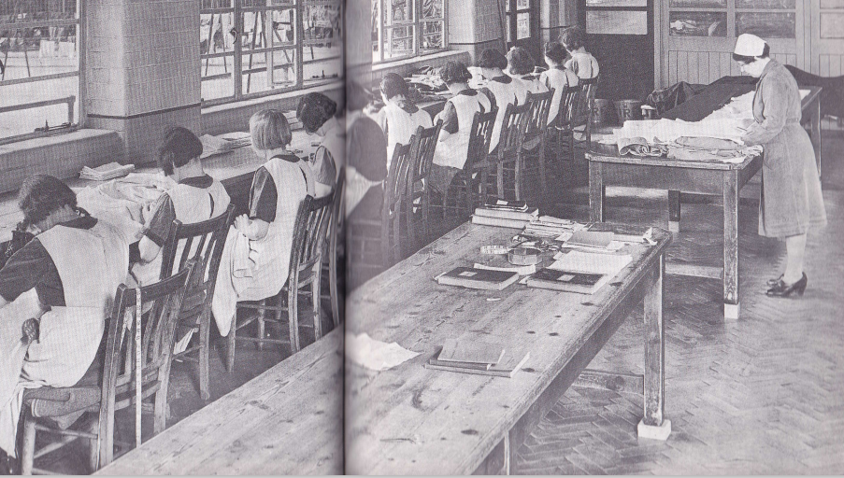
Long Stay Hospital Sowing Room

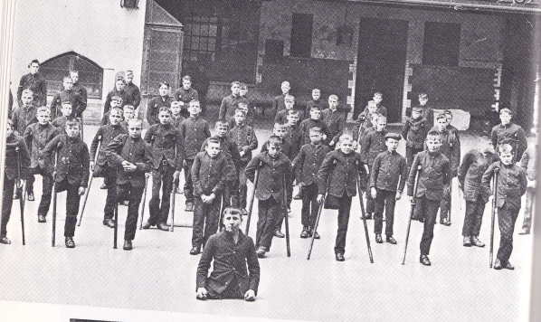
Banardos in East End of London

