UKDHM Broadsheet 2023 (with Alt Text for visuals)
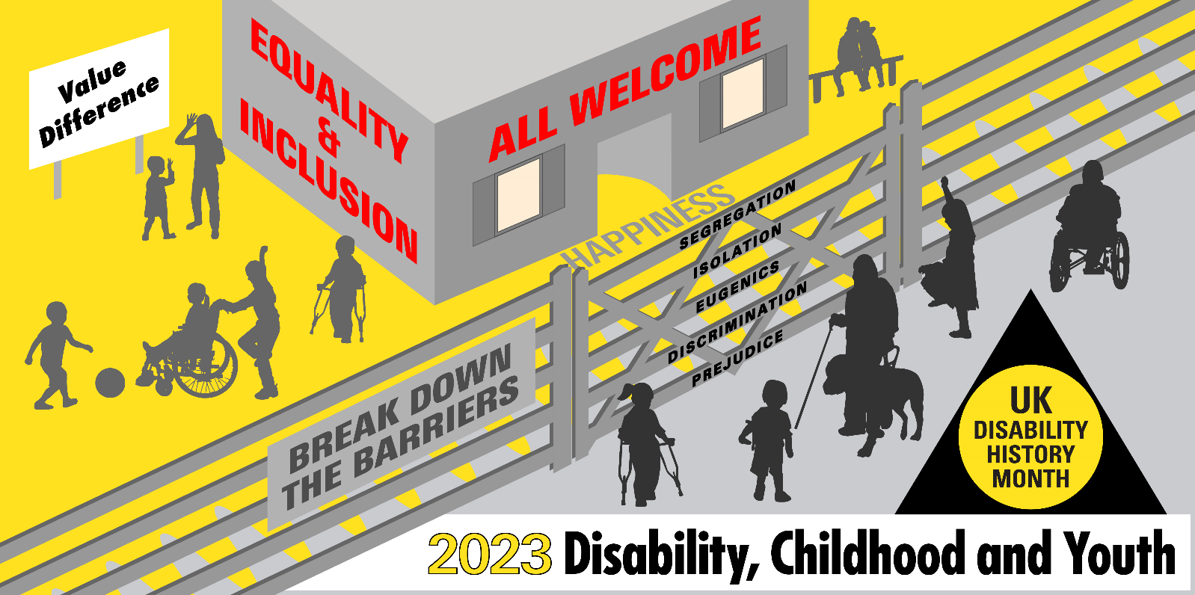
Disabled children (aged 8-17) are clear about what they want for a better world: as they told the Children’s Commissioner in England in March 2023 (a representative sample of 3,593)
o To be understood, seen and heard;
o To benefit from a fantastic, ambitious education in mainstream school where possible and support at school when they need it;
o For all activities and services to be accessible;
o To receive high-quality care locally and quickly;
o To be free from harassment and discrimination;
o For transitions to be smooth and prepare them for adulthood;
o For services to see them as part of a family, and to take a whole family approach.
After many years of cuts, austerity and failure to effectively implement the Equality Act, in the UK today voices of disabled young people are still marginalised, there is increasing segregation in schools, a lack of access and support in the community and failure to provide families of disabled children with the support they need. Their aspirations are not being met.
Taking a longer historical view, the cruelty, isolation, segregation of the workhouse, institution, asylums and residential schools of the 200 years to 1980 has largely been banished. But the ideas of otherness, prejudicial thinking, under valuing remains. Gains in medicine and welfare have banished or minimised many of the childhood impairments that dominated the C19th and first part of C20th. Only to be replaced by a new range of impairing conditions, such as learning difficulties, neuro-diversity and mental health issues that can lead to just as damaging disabling barriers, discriminations and practices.
Efforts of the Disabled People’s Movement in the UK in the last 50 years has led to the state increasingly accepting a ‘social model’ approach to disability, putting the focus on the barriers in environment, attitudes and culture, communication, access and organisation that people with a multitude of impairments face, resulting in their disablement. In doing this they challenge the individualistic /medical approach to disability that in various forms does still dominate the life of disabled people.
Since 2006, the United Nations Declaration on the Rights of Persons with Disabilities has broadened the ‘social model’ perspective into enforceable human rights. Although ratified in the UK (though not incorporated into British Law) and in most countries of the world, the implementation of this rights’ based approach remains a dream, yet to be fulfilled. For disabled people economic, social and cultural disadvantage, isolation, harassment and exclusion remain far too common in post austerity, post Covid UK.
The UNCRPD Committee heavily criticised the UK Government seven years ago in 2016 finding grave and systematic violations of their treaty obligations. This disregard seems to be continuing as at a special session of the Committee in August 2023 to see how things had improved, the UK Government decided not to attend.
In the UK children and young people born with or acquiring various long-term conditions or impairments are still predominantly viewed through the lens of their medical diagnosis/label, as in ‘deficit’ compared to ‘normal’ non-disabled children and young people. The concept of Special Educational Needs (SEN), rather than the Disability Right to Inclusion predominates. SEN and related medical assessments determine the resources provided to the disabled child or young person in an increasingly dysfunctional and inefficient and oppressive Education System. SEN resources are increasingly the sticking plaster of a failing system.
There are conflicting numbers and proportion of disabled children from different data sources. Special Educational Needs in England January 2023. The latest annual DFE survey identifies in all English schools 9,073,832 pupils up to age 16. 4.3% have a statutory Education Health and Care Plan (EHCP) 289,171. 13% require SEN School Support 1,183,384. That is 17.3%, many of whom could also count as disabled under the Equality Act definition. The Census 2021 found 6% of children aged 0 to 14 (590,908) were limited a little or a lot in their day-to-day activities by long-term physical or mental health conditions or illnesses. The 2021-22 Family Resource Survey found 11% (0 to 19) and the most common impairment type was social or behavioural impairments, with half reporting this. This was followed by a mental health impairment at 30%, then a learning impairment at 26%. In Census for UK 2021 there were 1.9 million disabled young people aged 0 to 24.50% reporting Social/Behavioural Impairments and 30% Mental Health.
The History of Disabled People, especially Disabled Children and Young People over the last 300 years provides a long oppressive shadow of being ostracised, marginalised, ridiculed and dismissed that obstructs our aspiration and rights. We shall unpack this history to make clear the changes we need.
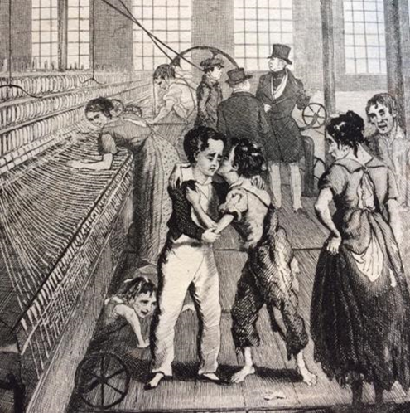
Child Labour, Industrial Revolution and Impairment
Although child labour was common in pre-industrial times, children would generally help their parents with the farming or cottage crafts. By the late C18th children were specially employed at the factories and mines and as chimney sweeps, often working long hours in dangerous jobs for low pay e.g. in England and Scotland in 1788, two-thirds of the workers in 143 water-powered cotton mills were described as children. Many acquired life-long impairments, but if they could they kept working, as conditions and subsistence in the work house was worse.
“At the age of six I became a piecer … each piecing requires three or four rubs, over a space of three or four inches; and the continual friction of the hand rubbing the piecing upon the coarse wrapper wears off the skin, and causes the finger to bleed. The position in which the piecer stands to his work is with the right foot forward, and his right side facing the frame. In this position he continues during the day, with his hands, feet, and eyes constantly in motion … the chief weight of his body rests upon his right knee, which is almost always the first joint to give way … my evenings were spent in preparing for the following day – in rubbing my knees, ankles, elbows, and wrists with oil, etc. I went to bed, to cry myself to sleep.” William Dodd Kendal, 1841.
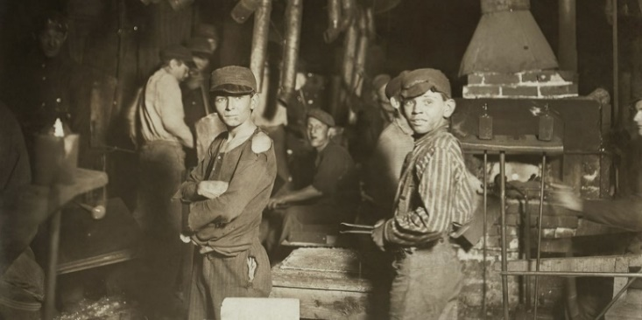
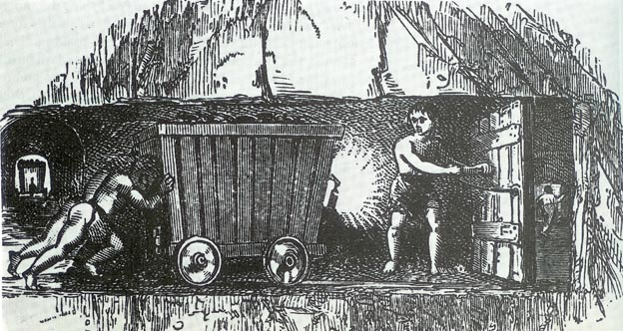

Joseph Hebergam of Huddersfield was 17 years old when he spoke to the Parliamentary Sadler committee about his disability. He had started working as a worsted spinner aged 7, a highly-strenuous job that eventually took a toll on his body. He points out that he was compelled to continue working, otherwise he would have lost his job.
Below details his responses (in italics) to various questions posed to him by members of the Parliamentary Committee,1832
“How long was it before the labour took effect on your health?”
– “Half a year”.
“And did it at length begin to affect your limbs?”
– “When I had worked about half a year, a weakness fell into my knees and ankles; it continued, and it has got worse and worse.”
“Was that weakness attended with very great pain, and the sense of extreme fatigue?” – “Yes.”
“Had you to work as often as you could under these circumstances?”– “Yes.”
“Otherwise no allowance would have been made to you by the occupier of the mill?” – “No.”
‘Disabled people’s role in the workplace is interwoven with the exploitation of industrial capitalism. Nonetheless, John and other disabled people were resilient, had agency and were integral to the workforce and the emerging trade union movement’. Gill Crawshaw
By the 1830s, the determination within Parliament to regulate factory conditions had strengthened. Campaigners did not hesitate to compare the treatment of mill-workers, including children, with that of slaves. From 1819 a series of Factory Acts were introduced banning night-time employment of children, limiting their hours of work and stopping those below the age of 9 working in mills. The first Commissioners were also set up to control practices which in subsequent legislation spread to other industries, including mines. Weavers had been working in factories or mills, amongst the tremendous din of power-looms, since the early part of the 19th century. Unsurprisingly, deafness was common. A century later, it was considered an occupational hazard, the workers took it for granted. And the government and employers did little to protect mill workers’ hearing until the late C20th. “The noise of the looms was so loud that they learned to communicate with signs and to lip read. None of the weavers I spoke to had been given ear protection; as a consequence they were now suffering from work related hearing loss in their later years.”

From Elizabethan times there had been a parish local tax to support the old, ill and ‘infirm’ (an old word for disabled), which gave some support to the destitute. Most people were tied to the land and children stayed with their families and were seen as little adults more than as separate children. Children of landed gentry and aristocracy were prepared for leading roles being very sex specific. For lower orders, boys at puberty were apprenticed to craftsmen or girls developed domestic skills and became servants. For the lowest orders of labourers, whole families including their children would work.

As the Industrial Revolution and the growth of trade capitalism took off, many were forced off the land by Enclosures and came to the towns to find work. Throughout the late C18th and C19th life was cruel with little support, especially for disabled children whose families often could not afford to support them. A harsh morality matched the harshness of the time and increasingly those who were less fortunate under the growing laissez faire social attitudes were held accountable for their own misfortune.

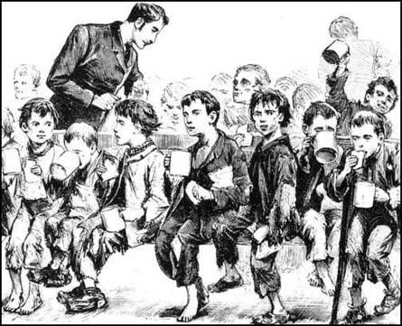
Workhouses and Disabled Children 1834 Poor Law created the workhouse structure, under the philosophy that only those willing to enter the unpleasant and liberty-reducing workhouses were poor enough to deserve aid. Those who entered the workhouse system were confined for twenty-four hours a day, separated from their children, parents, and spouses, and subject to rigorous discipline and arduous labour. In the five years after the Act, some 350 new workhouses were built at a distance of roughly 20 miles from each other, with a further 200 constructed before the end of the century.
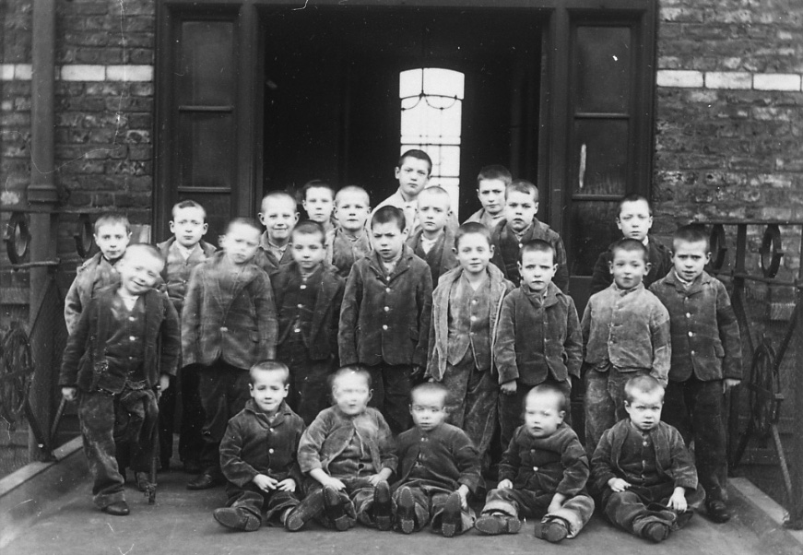
The workhouse life was designed to be less desirable than the life of the lowest paid independent worker, so that resources would not be too greatly taxed. Because of this, very few non-disabled people chose to enter the workhouse system; the large majority of inmates were aged, ‘infirm’, or children. By 1860, old and ‘infirm’ including children predominated. As there was no relief in the community anymore, many disabled people had no choice but to seek shelter and bare minimum subsistence in the workhouse. Children under 7 and boys and girls aged 7-15 , men and women, old and disabled were all kept separate. The main idea behind this was to stop them breeding. The able-bodied poor avoided the new workhouses, so many were soon housing the old, the sick, the mentally ill and those with physical or learning disabilities who could not work.
In 1835 the Birmingham workhouse built wards specifically for 'insane' residents. The Leicester workhouse segregated 'idiots and lunatics', providing specialised nursing attendants. By 1837 more than 8,000 'idiots and lunatics' were under the care of parishes. Workhouse staff struggled to care for them.
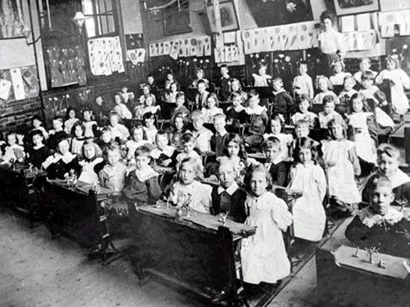
In 1837, Assistant Poor Law Commissioner, James Phillips Kay, argued that pauper children maintained in workhouses were dependent ‘not as a consequence of their errors, but of their misfortunes’, subsequently children were one of the few groups of paupers to warrant widespread pity for their condition. However, because of their association with pauper adults, it was felt that these children were not only ‘inefficiently trained’ but were ‘actually nurtured in vice’, and many of them would inevitably grow up to be ‘thieves or prostitutes or paupers’. This thinking led to children in the workhouse being offered at least 3 hours education -reading, writing and arithmetic, though later writing was stopped as ‘they had no need of it’. In his 1836 report to the Poor Law Commission, Edward Tufnell had felt that the improvements in the care of pauper children following the 1834 act was one of the ‘most pleasing and popular’ results of the new legislation. These were known as ragged schools (left) and they provided better education than for poor children not living in the workhouse until the Foster Education Act of 1870 introduced education for all.
The late 19th century was not a good place for a child. One in seven infants died in England and Wales, and even more would later be killed operating dangerous machinery or getting stuck up a chimney, before Acts of Parliament were brought in to prohibit child labour. And in Victorian London’s East End, where Thomas Barnardo set up his first home for boys in 1870, there was also post-Industrial Revolution overcrowding, filth, poverty and disease to contend with. Poor children suffered from rickets, curved spines, respiratory diseases, inherited syphilis and a variety of ‘deformities’.
But Barnardo prided himself on welcoming children of all abilities and health into his care. In 1877, he wrote: “Given the destitution and when accompanied by disease, deformity or ill-health…. We will render assistance.” He disapproved of segregation between non-disabled and disabled children, declaring instead that all young people could benefit from integration. “Unkindness to these little unfortunates from the other boys or girls,” he wrote, “is a thing quite unknown to us.”
Barnardo believed that “the presence of a child maimed for life, or marked by some serious deformity, draws out only kind deeds and gentle thoughts from the roughest boys and wildest girls”. Later when Thomas and his wife had a child Marjorie with Downs Syndrome they included her in everything.
“Knowing the reality of the world around them, however, he also made sure disabled children learnt marketable trades. The boys practised tailoring; the girls learnt embroidery. At Barnardo’s school for deaf, blind and disabled girls in Hackney, the children also wove Persian rugs, sewed tapestries and hand-painted lace.”
Kate McLoughlin (1889) was born in 1882 in Nottingham, and was admitted to Barnardo’s at the age of seven by the local vicar. Her father had been in prison several times and was in jail at the time. The family of five lived in one room which the local vicar described as, ‘the most utter squalor and filth’. It was ‘the very worst home’ he knew in his parish. Kate’s mother battled alcoholism, and while she was out drinking, her first child drowned in a bucket of water, and another was seriously burnt. When Kate was just a baby, she fell out of her mother’s arms, and subsequently suffered hip disease and ‘deformity’. After care and training in the homes, she went into domestic service in 1905.

Alfred Smith was born in 1875 in the town of Rugeley, Staffordshire. His father died of diabetes nine years later, leaving seven children. His mother was unable to work due to abscesses on her legs and was receiving parish relief. Alfred had his right leg amputated when he was just 13. Two years later, he was admitted to the homes, and received an apprenticeship in the Tailors workshop. In 1895, he was working as a tailor in Surrey.

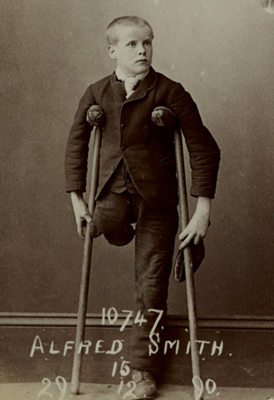
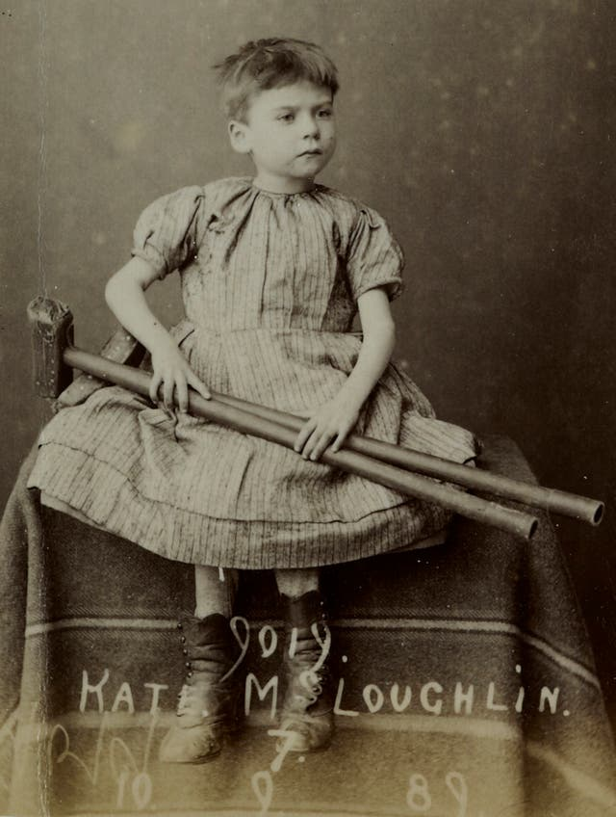

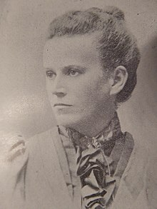
Education The first schools for disabled children were established for deaf and blind children in Europe and USA in the late C18th and early C19th. These were run on a voluntary and charity model. Later a number of schools were set up by pioneering parents, churches and philanthropists. However, the vast majority of children from labouring and working class backgrounds did not go to school. ‘Since the advent of compulsory state education in 1870 most disabled children, often through neglect or lack of government money but sometimes through parental choice and the schemes of education authorities, have received their education in mainstream day schools’ writes Ted Cole in his 1989 Children with Special Needs Apart or A Part. This is true but it did not prevent many children being segregated by their impairment in day and residential schools and being subject to a ridged life-style, discipline and to appalling abuse and neglect. The education and welfare of disabled children was also subject to moralist and social Darwinist campaigners.
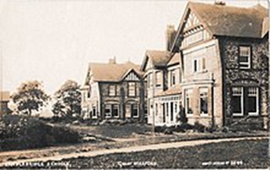
Many in power would have viewed Mary Dendy as a social reformer, but she was an ideologue and a leading member of the British Eugenics movement that were convinced of an enemy within, caused by feeble mindedness who should be stopped from breeding as Churchill believed to ‘maintain the British Race’. Dendy and a few others had agitated using false science and Social Darwinism to get a Royal Commission and then an Act of Parliament:1913 Mental Deficiency Act. Recently it has been argued that this agitation was as much motivated by fear of the working class and women not being controlled by men, as eugenics. Visiting board schools as a member of the Manchester School Board from 1896, Mary Dendy was struck by the ‘outcast’ children in the school playgrounds and those unable to make use of the education on offer. After personally inspecting nearly 40,000 children, she pressed the board for day special schools and became a driving force in the establishment of the residential Sandlebridge Schools for the Permanent Care of the Feeble-minded. Opened in 1902 under the aegis of the Lancashire and Cheshire Society for the Permanent Care of the Feeble-minded, Sandlebridge was the first institution of importance to be certified under the Elementary Education (Defective and Epileptic Children) Act, 1899. The children in these institutions progressed onto Sandlebridge Hospital where there were still nearly 400 incarcerated in 1947.
Other prominent educationalists such as Sir Cyril Burt, first consultant psychologist of London County Council led to mass IQ testing, setting up more segregated schools than any other area in response to the Mental Deficiency Act. Burt as a member of the Spens Committee shaping post second world war came out with the Tripartite system and the 11-Plus on Burt’s insistence. He was so keen to prove a genetic link of low intelligence, poverty and criminality that he falsified his results on twins.
Medical Doctors not known for their expertise in education became the arbitrators, firstly assuming children with physical and mental impairments were sick and secondly that their false IQ tests measured something that was not changeable. As Patricia Potts has said “The influence of doctors in special education can be illuminated by tracing their early involvement in state funded provision for children with physical and mental impairments. Doctors defined and classified disabilities; their categories became the non-educational basis for educational legislation and provision; they assessed the children referred for separate schooling; they inspected the special schools; they drafted educational policy documents as School Medical Officers within the Board of Education”.
This is clear in legislation such as the 1921 Education Act which consolidates previous acts recognizing 5 categories (blind, deaf, mentally defective, physically defective and epileptics). These children must be certified and provided for only in special schools and certified classes. The 1944 Education Act requires education according to age, aptitude and ability (as in 2014 Children and Families Act), but special educational treatment can take place in ordinary as well as special schools. However, the 1945 Regulations still named 11 types of special schools for different medical diagnosis.
Between 1900 and 1945, up to half a million children had a physical disability or sensory impairment, mainly due to poverty and disease. There were no vaccinations, and many working class families couldn't afford specialist equipment or treatment.
Everyone now had the right to education. Schools for 'crippled', blind and deaf children could be harsh but there were some new approaches. Progressive 'sunshine homes' looked after blind children, and 'open air' schools were believed to improve children's health. Disabled children were trained for low-skilled work, but most people thought they would never find a job.
The Oral History book and Channel 4 series Out of Sight collected survivors’ views.
Mary Baker, Halliwick Home for Crippled Girls, 1930s Mary was 12 years old when she was sent to Halliwick. She had a dislocated hip. As a result she walked with a limp. Mary’s father had been injured in 1st World War and when her mother died she and her brothers were sent to the workhouse in Wimborne, Dorset. From there she was sent to Halliwick, a Church of England Institution.
"When I first arrived at Halliwick, the nurse took me into this bathroom and she stripped me off completely. She cut my hair short, right above the ears. And then I was deloused with powder of some description. Then they put me in a bath and scrubbed me down with carbolic soap. It was very degrading to me and I felt as though the end of the world had come. I had no idea what I was going to do. But it was huge and it was lonely, the place. And I felt really lost, and I thought, 'what am I going to do with no one to love me?’ The next morning you were given a number and you had to remember it. My number was twenty-nine and when I got up and went to wash, my towel and flannel had my number on them Twenty-nine - was engraved on all my hairbrushes and things with a red-hot poker-like thing. Everything I owned had a marking of twenty-nine so I can never forget that number and if matron wanted you, she just called you by your number. We never had names we were just numbers there."
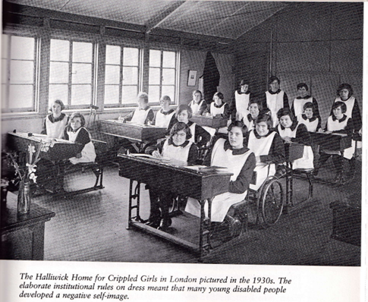
“ The most places we felt lonely was in our bedrooms, in the dormitories, because we all used to chat about the thing we’d lost, our mothers, our fathers and our brothers and sisters. We all used to cry and wondered when we would see them again...At times I used to read stories to the other girls in the room because some didn’t know how to read. But we had to be careful not to get caught, it was all so disciplined. There was no love there at all…Sometimes we had high jinks as well, we used to pillow fight and all the things girls do…And if matron did catch any of us we all stuck up for each other.”
Ernest Williams, Birmingham Blind Institution, 1920's
Ernest was born in 1915, the son of an agricultural labourer who eked out a living for his family in Herefordshire. “Being a blind boy, I was spoilt compared to brother and sister. Extra spoonful’s of honey…I had a pair of spectacles once, but I lost them and they could not be replaced. They were more expensive than shoes. The main concern was the business of living.”
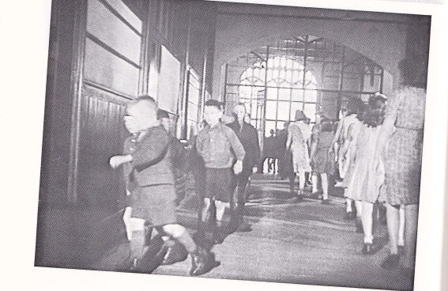
Although Ernest was very helpful to his father in agricultural labouring, milking cows and helping calves be born, when he was eleven in 1926 he was sent to St Helen’s Institution for the Blind in Swansea. “ We had to go to Sunday school every Sunday and we’d file in crocodiles with a line of boys next to a line of girls. One girl shouted out ‘Ernest touched my knickers’. I bumped into her accidentally, but I hadn’t done anything to her. That was it . I was reported and there was an unholy row. The next morning I was reprimanded in front of the whole school in the hall. I was called out to the front and the headmistress said ‘ You’re worse than the beasts in the field, isn’t it boy?’. They were going to thrash me, but then a member of staff called out ‘Put him away until he cleanses himself’. I was locked in the sick room for four days. I was angry and did not say sorry as I felt wrongly treated. I still hadn’t confessed but they said that Lord Jesus Christ had taken me into his heart.”
Dennis Boucher, Yorkshire Institute for the Deaf Dennis was sent there in 1935 when he was aged 7. The Deaf schools all rejected Sign Language and taught by the oral method, but the children learned it from each other in the playground.
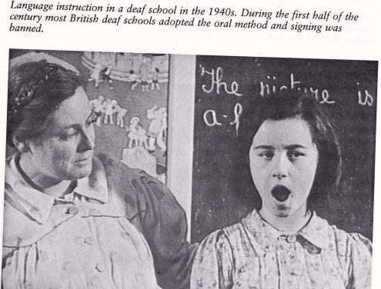
“ When I first came to school not many children could sign. They just used ‘F’ for father and ‘M’ for mother. They didn’t know the alphabet at all. They didn’t know any signing. I could sign because my older brothers came home and taught me when they went to Leeds school….I carried on teaching signs like mother, father, brother, sister-I taught them all . And they all found it very interesting and enjoyed it…It spread round the whole little school.”
“When I was about thirteen or fourteen at my school the boys were always hungry. Anyway, the prefect, he used to make me and three or four others go scrumping apples and pears. There were loads of trees next to the school. So we used to crawl at night, when it was quite dark, come right into the orchard and pinch all the apples and fill our pockets… Then he’d make us give them all up and the prefect would hand them out. We secretly kept some back for ourselves. When we got back to our rooms and ate all these apples and pear. The next morning, God, my stomach… But we would be back there the next night.” Dennis first met Hazel at the Yorkshire Residential Institution in the 1930s. Mixing of the sexes was forbidden, but the secretly met.
“There was a big wall in the playground separating the boys from the girls and so if I wanted to speak to Hazel or meet up and have a little kiss and a cuddle I would ask one of the lads to stand so I could stand on his shoulders and look over the wall and sign to Hazel.” They later married.
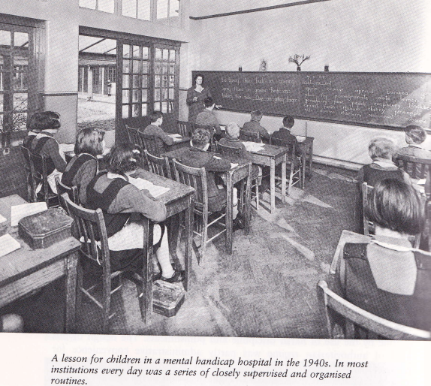
Evelyn King, Mental Handicap Hospital In 1951 at the age of five Evelyn King was admitted to one of the largest mental handicap hospitals in the North of England. She had cerebral palsy which prevented her from walking or speaking more than a few words. After failing the intelligence test administered by doctors she was diagnosed as ‘an imbecile’ who was unfit to be educated. Evelyn had no learning issues, just difficulty speaking.
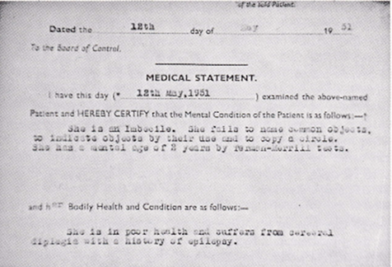
“When I first came I was a baby in a wheelchair. I never used to walk and I couldn’t talk, And I weren’t happy as a girl ‘cos it was a bit miserable. On the villa we played dominoes, ludo and snap cards and I played jigsaws and did sewing. I used to get a bit bored and I used to look out of the window and dream about me poor mum and dad-‘cos I never used to go home and I missed all that…Then later I started school but I only had school in the morning…And the staff were very strict.. Just had to keep your mouth shut. But we used to get punished and everything...When we used to scrub the floors, when we were naughty , all day long. Used to be locked in our rooms. I couldn’t use a knife and fork in them days, just a spoon and if I spilt something like tea, they used to get a cloth and make me wipe it up. I used to say ‘I’m sorry I did it on accident’. But they still made you wipe it up.”
A Further source of the views of disabled people on their schooling in 1960s/70s is Old School Ties Programme 1
Another Oral History Project How was School from the Alliance for Inclusive Education looked at Disabled People’s experience of education over the last 100 years through the telling of memories. It is only in the last 40 years that disabled people have had an opportunity to learn alongside their non-disabled peers in mainstream education settings. In the first half of the 20th Century disabled children and young people were routinely sent to residential institutions, often many miles from their families and communities. Some of these institutions provided an educational element, but the focus was often on ‘fixing’ the disabled child rather than embracing them. This approach was driven by the traditional Medical Model of Disability which identifies the person with their impairment/health condition as the problem, rather than the society we live in that creates barriers to disabled people participating as equal citizens.
Mark Lynes was born in 1971 in Birmingham. He attended a local special school from age four to sixteen and then went to a residential special college in Shropshire. “The building – the campus was quite strange because at that time you had Wilson Stuart Special School that took physical disabilities. Then you had Braidwood School that took deaf people. And then you had Princess Smith School that took blind and partially sighted students. So, not only were you segregated from – and again, you think this is okay when you’re there. But not only were you segregated from able bodied people but you were segregated from deaf and partially sighted and blind kids as well.”
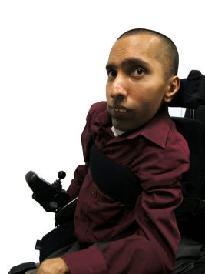
“I realised that school was very useful to me in a lot of ways, but in an awful lot of ways it was a waste of time, because it actually gave me no background to life at all. When I left and went to college and started taking some of the same stuff they did, then I started to realise what an impact my education had had on my life, really, in a negative way. Which made me very angry and it made me very sad as well, because I loved school but I couldn’t love it after that, if you see what I mean. So, it almost took those memories I’ve already talked to you about away, because I realised what they didn’t give me compared to what they would have given other people my own age. So, it really took my childhood memories away.”
Ajay was born in India in 1977. He attended a special school in East London from the age of five to sixteen and then went on to a mainstream sixth form college and university.
“At school we weren't taught sex education, not much anyway, and very vaguely, so when you turned kind of you know, young teenagers you don't really know what's going on, so you have to wait 'til you find out from your friends, I mean we were taught stuff but very, very vague.”
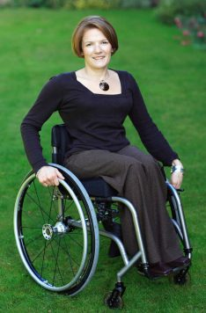
Helen was born in 1969 in Surrey. She attended mainstream primary and secondary schools, going on to University from her Grammar school.
“My understanding is that we are aiming for inclusive education and in my opinion that's absolutely as it should be, we shouldn't be segregating Society at all. I do a lot of work in the field of graduate recruitment now. Particularly, talking to some of the people who are responsible for attracting disabled students into universities, and indeed the disability managers at universities, they all talk about the fact that when they are talking to school children, actually it's not the children that they need to target, it's the parents and the teachers, because they're still giving the messages of, 'Children like you can't go to universities like that’.”
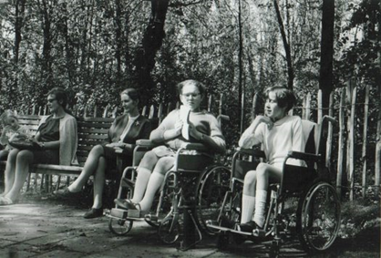
Alice was born in 1957 in Buckinghamshire. She went to mainstream primary schools and moved to a residential special school with her sister for her secondary education. “When I left school, I swore never to have anything to do with any disabled people ever again, apart from my friends of course, because they were alright, they weren't really disabled people. And so I didn't for a long time mix with other disabled people except my friends. I think more importantly, was this kind of 'You have got to strive to be more normal than the normal' ethos that arose from old Florry's that until I discovered the Social Model at the age of about thirty-three, I was being 'normal', and actually being normal as a disabled person is an incredibly stressful thing to do, so what was that about? Fifteen years, post leaving school, busy being normal, and being told that people didn't think of me as a disabled person and thinking that was the nicest thing they could say about me, and that I think was far more important than any other consideration.”

Ann Torode was born in 1943 in Dulwich, London. She was sent to a special primary school, then known as an 'educationally sub-normal' school until her mother won a battle to have her moved to her local mainstream primary school. From there Ann went on to a girls' grammar school and afterwards to university.

They did nothing whatsoever.
“There was a dinner lady in the playground, on duty and she watched these girls, every playtime they circled me and chanted and sang. Punchinella was one of the songs. I can’t remember it, but they just chanted and said things to me and I withdrew from my body and went up, which is a very bad thing to learn to do and I just thought, 'Well you can’t affect me, you can’t get to me, I’m not going to let you get to me'. And mum came to the school one time and said, 'Can I speak to all the classes because I want to talk to them about what’s happening' and she did and she told all the children in each class about the teasing and to stop it, but it made no difference whatsoever. There was no support from the staff? No, no.”

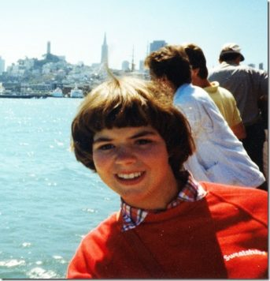
Simone Aspis was born in 1969 in Dollis Hill, London. She went to a residential special school in Cheshire from the age of four until sixteen. From there she went on to college and then university. “And then at the age of thirteen I wrote to the Secretary of State asking to get me out of school because nobody else wanted to get me out of the special school. So I think at that point my mum and dad did send me to an educational psychologist to see whether I might be able to be reintegrated back into mainstream education. And there the educational psychologist basically wrote to say that if I came home that I would be – that I would irritate people who had quicker brains than myself.”

“I worked at the BBC for ‘From The Edge’ for a number of years, decided, you know what, I’m fed up with watching everyone else change the world, I want to get out there and do it myself. So I first – I got into activism – working with People First which is an organisation run by people with learning difficulties and I was a parliamentary campaigns worker there, ‘cause what really annoyed me was disabled people didn’t have rights, you know.”

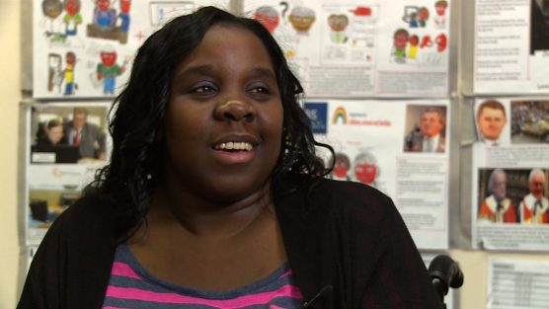
Joanne Wacha was born in 1984 in Harrow, London. Joanne attended local mainstream primary and secondary schools and also spent time in hospital, attending the hospital school, after becoming ill at the age of thirteen. After school she went on to a local sixth form college, then a residential special college and then on to university.
“There was talk about me going to a boarding school but that would be away from my home and my mum point-blank said, ‘No way, she is going to stay home with me and learn – have her education here in Harrow.’ And I’m so glad she made that decision because I probably wouldn’t know my littlest sister Rachel who was six months when I was ill as well as I do now.” There are many more stories of post war ‘special education’ and its largely negative impact.
Photo
Number of disabled children educated separately in England 1897-2023-from Government Statistics
Date | Nos. of children
1897 | 4,739
1909 | 17,600
1914 | 28,511
1919 | 34,478
1929 | 49,487
1939 | 59,768
1947 | 40,252
1955 | 51,558
1965 | 70,334
1967 | 78,256
1977 | 135,261
1987 | 107,126
1994 | 104,431
2001 | 111,500
2006 | 111,980
2008 | 122.,820
2010 | 117,880
2016 | 137,725
2020 | 166,334
2023 | *191,040
*All EHCP Plans in Special, Independent Schs.& Alternate Provision including SEN Support
Special education is based on medical model diagnosis of the child’s impairment to distinguish how different they are from normal children. The Warnock Report and subsequent 1981 Education Act allowed for the integration of disabled children in mainstream provided they could do what ‘normal children did, they would not interfere with their efficient education and there were appropriate resources. To allow for some support a statutory statementing process was established to make provision. The history of doctors and later psychologists dominating this process of selection, often informed by eugenicist notions of children having fixed ability which could be measured by tests, is still a dominant ideology within the English Education system. This has led to a deficit approach to disabled children based on what they cannot do rather than what they can do. The table to the left shows the general trend to segregation of disabled children and young people to education in separate locations away from their non-disabled peers. This is particularly strange as the 1981 Education Act, 1996 Education Act and Part 3 of 2014 Children and Families Act, 2001 Disability Discrimination Act and the Equality Act 2010 all support the development of mainstreaming and what is now known as inclusive education.
Growth in Segregation The tendency to increase segregated education is linked to the lack of mainstream teacher and support staff capacity, failure to effectively tackle disablist bullying, narrowing and raising the level of the curriculum, loss of continuous assessment, cuts in education budgets, structural reform of schools such as the Academies Programme and reduction in Local Authority specialist support teams. The growth of neurodiversity and mental health issues mixed with increased competition and impoverishment parallels the growth of stress for young people. When this is matched with behaviourist rather than person centre approaches, based on relationships building and emotional intelligence, this leads to increased levels of suspension and exclusion, especially for disabled young people intersecting with racism towards those from a Black and Ethnic Minority background.
Looking at the table, the big surge in numbers from 1967 to 1977 came about from the 1970 Education Act, which for the first time created universality of education, abolishing education sub-normality schools and junior training centres, replacing with Learning Difficulty schools. The drops from 1977 to 1994/2001/06 were caused by the impetus for mainstreaming given by 1981 Act and New Labour’s policy of inclusive education (1997 to 2006). By 2008 Labour had reversed this policy and the massive growth since is largely down to Tory policies
In addition, though most parents start off wanting their disabled children included into their local nursery and school, the failure to meet their child’s needs brought about by the above factors, leads to them becoming refugees from the mainstream. This process is ‘bankrupting’ the Higher Needs Budget, as parents utilise their statutory rights to seek special and independent provision.
What is needed is a National Inclusive Education Strategy as the United Nations UNCRPD Committee had recommended. This would be in line with Article 24 of the United Nations Convention on the Rights of Persons with Disabilities and General Comment No.4 which explains how to implement such a system.
Traditional thinking about disabled people. History, religion and culture are important in understanding how negative attitudes have developed. These can together create thinking which denies disabled people access and equality, leading to unfair and unequal treatment and exclusion. Stigma can be blaming impairments on the actions of the parents, being signifiers of evil or seen as punishment by deities. Stereotypes are still very common, viewing disabled people as inferior, pitiable or pathetic; incapable of education or work; a burden on society; comical or the butt of jokes; incapable of family life and having adult relations. These lead to the widespread denial of the human rights of disabled people. Effectively challenging such thinking and providing practical alternatives based on equality and human rights is essential, especially in the school curriculum and training teachers.
Medical or Individual thinking. Advances in medical science, disease, accident prevention and improvements in health are all vital in dealing with impairment- the loss of physical or mental functioning, but should never be confused with the empowerment and equality of disabled people. Medical, educational, community, social workers, health and rehabilitation professionals need to recognise that the empowerment of disabled people, their human rights are always paramount. The UN Convention on the Rights of Persons with Disabilities is based on a paradigm shift moving away from the traditional/ medical approach to a Social Model / Human Rights Approach.
Social Model and Inclusion focusses on removing barriers to presence, participation, achievement and friendships e.g. barriers of attitude, communication, environment and organisation. The Human Rights approach to inclusion. Inclusion involves a process of systemic reform embodying changes and modifications in content, teaching methods, approaches, structures and strategies in education, to overcome barriers with a vision serving to provide all students of the relevant age range with an equitable and participatory learning experience and environment that best corresponds to their requirements and preferences. Placing disabled students within mainstream classes without accompanying structural changes to, organisation, curriculum, teaching and learning strategies, does not constitute inclusion. Furthermore, integration does not automatically guarantee the transition from segregation to inclusion.
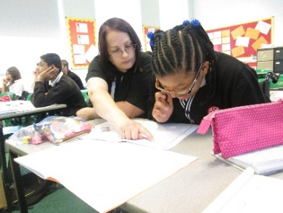
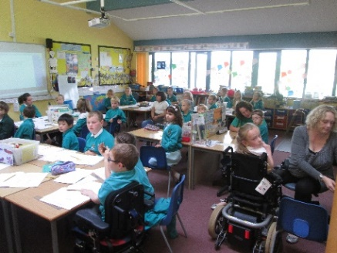
Despite the rise in segregation and the policy reasons given on the previous page, there are still hundreds of mainstream schools with inclusive practice and we know this is the dream of most disabled children and young people. Emersons Green Primary School, South Gloucestershire https://youtu.be/w4B4CGopmZw
Wroxham Primary School, Hertfordshire https://youtu.be/NL-Y9L3U6gY
Priestnall Secondary School , Stockport https://youtu.be/ggMUiQ58-xk
EastLea Secondary School , Newham https://youtu.be/cAAoWGi3AKk There are 40 more schools filmed as part of the Reasonable Adjustment Project in 2003/04 (RAP). Two coheads of a Nottingham Primary school who only retired last July, talking about what made their school inclusive is worth listening to. In England the current position on inclusive education is harder. Twenty years ago in the RAP project we found that mainstream schools successful at inclusion of disabled students had the following (See Table below):-

Vision and values based on an inclusive ethos.

A ‘can do’ attitude from all staff.

A pro-active approach to identifying barriers and finding practical solutions.

Strong collaborative relationships with students and parents.

A meaningful voice for students.

A positive approach to challenging behaviour.

Strong leadership by senior management and governors.

Effective staff training and development.

The use of expertise from outside the school/college.

Building disability into resourcing arrangements.

A sensitive approach to meeting the impairment specific needs of students.
Regular critical review and evaluation;-
- at student level,
- at departmental level,
- at school/college level.

The availablity of role models and positive images of disability.
In the Inclusion Movement we should be engaging with the Government Change Programme locally and emphasising:-
- Local groups of teachers, parents, disabled people and disabled young people should engage with these processes and argue for what we know works, to enhance good inclusive practice.
- We need to keep pressing that all partners are much more aware of the Equality Act and its implications for Disability Equality and intersectionality. This includes insisting the Access Planning Duty is fully implemented.
- Create much more awareness of good inclusive mainstream practice developing around the world and the link to Article 24 of the UNCRPPD.
Not re-invent the wheel but learn from the many studies and recording of good inclusive practice in English schools over the last 30 years e.g. the 2006 Reasonable Adjustment Project

It is ironic that a Conservative Government that came to power with David Cameron committed to rid the education system of the ‘bias to inclusion’ has been so successful, that it now has to come up with a whole range of measures to reduce reliance on expensive independent schools, reduce numbers in special schools and work on ways of improving inclusive practice in mainstream schools for budgetary reasons! What they and potential Governments need to realise is that inclusive values and equality have to be at the heart of the state education system and many of their policy folies that hinder this must be got rid of.

Other failures for disabled children and young people that need to be rectified.
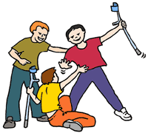
- Disabilist Harassment and bullying on the streets, at school and on social media, ‘Mate’ crime-where young disabled people are exploited for their benefits are still big issues. Building confidence for young disabled people by empowering them, teaching them the history of oppression and ensuring all non-disabled peers understand the roots of this prejudice and that it is a hate crime.
Anti Bullying Alliance

- Isolation, loneliness and unhappiness . The impact of low level harassment, social exclusion and segregation often means young disabled people do not have friends and relationships. This is particularly true for those who are neurodiverse or have Learning Difficulty. All those who work with young disabled people whether health or social workers, teachers, lecturers or employers should encourage the use of person centred planning tools and their inclusion in social activities taking their lead from the disabled person. Inclusive Solutions.

- Disability Equality Training for staff in Education, Health and other public sector services on nerodiversity and learning difficulties. This should be co-delivered by individuals with first hand experience of living with the impairment. The untimely death of Oliver McGowan, who was neurodiverse and against his and his parents wishes was given the wrong drugs, was ruled by an Inquiry as a preventable killing. Paula his mother got 100,000 signed petition to Parliament which led to an ammendment to the Care Act 2022. This has led to mandatory Oliver McGowan training for all health professionals often delivered by self advocates who have Autism and/or have learning difficulties. Such training should be developed and extended across education.
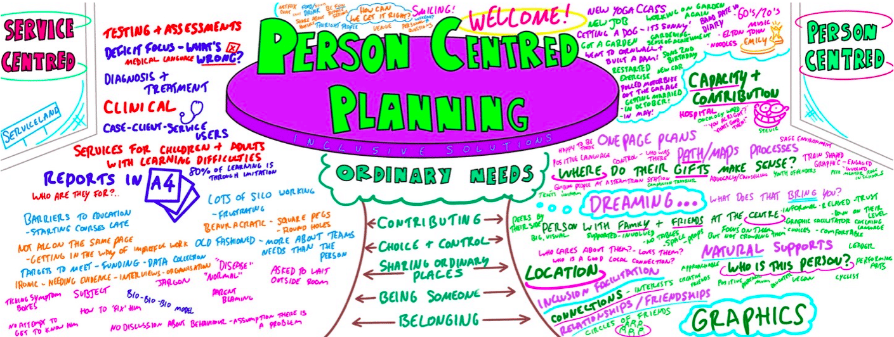
4. Lack of policy and law implementatrion. All public bodies, those funded from the public purse, are under a Duty (sec 149 of the Equality Act) to have due regard to promoting Disability Equality by:-
(a) eliminating discrimination, harassment, victimisation and any other conduct that is prohibited by or under this Act; (b) advancing equality of opportunity between persons who share a relevant protected characteristic and persons who do not share it; (c) fostering good relations between persons who share a relevant protected characteristic and persons who do not share it.
In addition all service providers including transport, all educational providers, arts and leisure venues and employers have a legal duty to provide reasonable adjustments to disabled people. This is an anticipatory duty for all, except employers meaning, they must review their provisions, criteria and practices to ensure they do not place disabled people at a substanial disadvantage. The problem is the above statutes are more ignored than implemented. We need the Equality and Human Rights Commission to have far more enforcement powers and for all young disabled people to learn their rights.
Regardless of where they are educated all disabled pupils and students have an entitlement to know what their disability rights are!
“The EHRC has stressed the danger of a continuing failure by the UK and Welsh governments to make necessary reforms, including to address problems with the welfare system, poor engagement with disabled people and their organisations in many parts of the UK, and inadequate public services for disabled people, leaving them at a higher risk of poverty, abuse and poor health.” Equality and Human Rights Commission.

6. Continious exposure to sterotypes of disability and impairment in toys, literature, computer games, films, TV and negative language leads to low self esteem and internalised oppression. Challenged by including
Don’t Use
“Spaz
Mong
Thlid
Thick
Idiot
Freak
Dumb
Lame
Nutter
Victim
Sufferer”
in the curriculum, critiquing it and the media and Disability Equality Training.
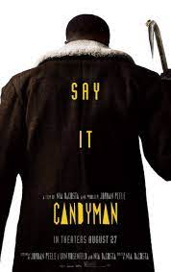
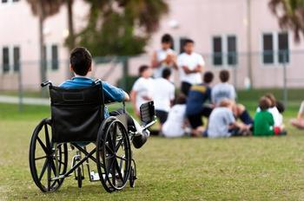
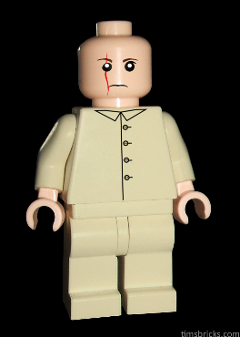
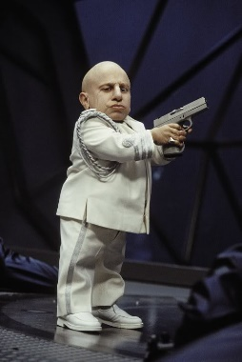

Lego Bloefeld
James Bond
Villain
Vengeful
Candy Man
Left Out/Isolated
Mini Me
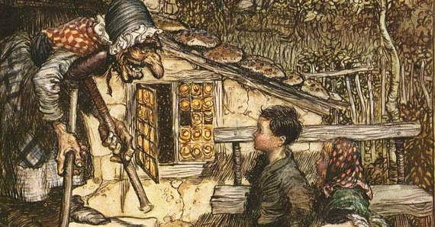
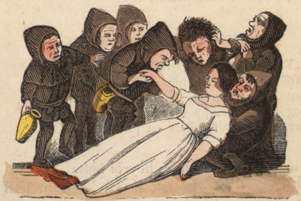

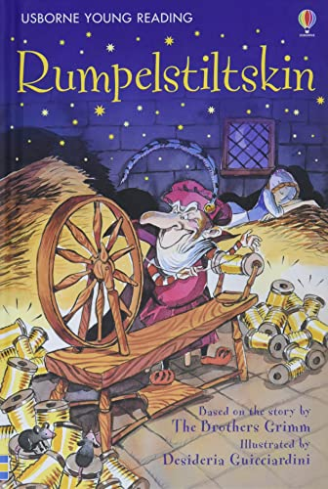
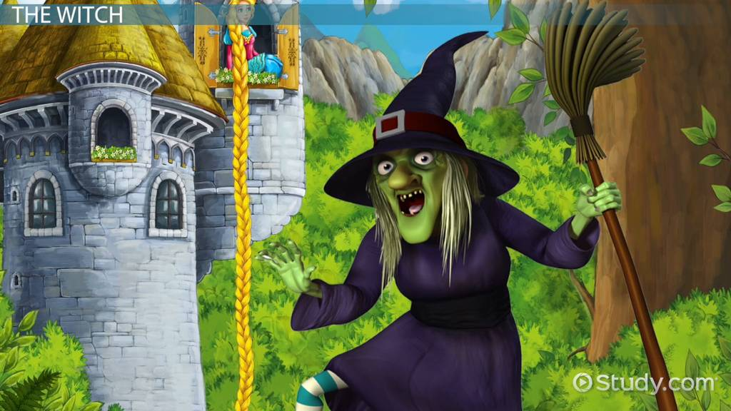
Witch in Hansel & Gretel
Dwarf Throwing
Snow White and 7 Dwarves Isolated
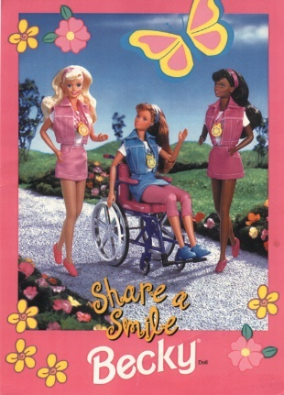
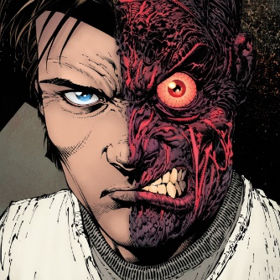
Two Face in Batman Forever
Rumpelstiltskin- Malign
Patronising and Sexist
Blind Witch in Rapunzel
STEREOTYPES Pitiable, Laughable/Ridicule, Burden, Evil, Useless, Asexual, Perpetual child, Objects of violence, Atmosphere or a curio, Your own worst Enemy. Challenge them.

7. Higher Education Disabled people are almost three times more likely than non-disabled people to have no qualifications at all. Only 25% of disabled people aged 21 to 64 have a degree compared to just over 40% of their non-disabled peers. Only 29% of disabled students receive the Disabled Students Allowance which undergraduate and postgraduate students can receive up to £25,575 a year to pay for specialist equipment or non-medical helpers, for example a British Sign Language (BSL) interpreter, a note taker or additional travel costs incurred as a result of a disability.
Dan Rowley, 22, from the Isle of Wight, has Ehlers-Danlos Syndrome and Fibromyalgia causing chronic pain, fatigue and dislocations. He originally went to a university in the Midlands,but problems with inaccessibility meant he was forced to drop out. His university was concerned that any assistive equipment (e.g. kitchen equipment with special grips, kitchen stools, and grab rails,) might be stolen. They only allowed a shower stool as others couldn’t see it and there would have been significant injury risk without it. He eventually completed his degree through the Open University.
Sophia Keaveney, 18, from Greenwich, London, was an A-Level student who wanted to become a diagnostic radiographer, after receiving treatment for a grade four brain tumour aged 15. She was studying chemistry and maths, but acquired brain trauma has left her in the lower second percentile for processing speed, leading King’s College Hospital doctors to recommend Sophia undertakes her exams in an open-book format. This would mean having additional information in the exam, such as an adapted textbook to support Sophia’s brain injury and processing. Sophia’s memory cannot be improved just by revision or repetition due to the nature of her brain injury, meaning approved adjustments like keyword sheets or extra time will not suffice. “We started talking about my reasonable adjustments the summer before I went into sixth form,”. “And it was only two weeks ago we finally got given a plan with nothing we asked for.” “They’re giving 100% extra time and coloured paper, but you can’t finish an exam if you don’t have the information you need. I spent my summer making reference materials for them to approve as an adjustment, but they never got back to us.”
Laurie Brown, graduated from the university last year. He felt he had been let down by his tutors who, he says, did not understand his disability. He has Asperger syndrome, an autism spectrum disorder, started at Sheffield in 2017. His appointment to get a learning support plan was booked in for a few weeks after the start of term but by that point the problems were already overwhelming. He said: “I was being told stuff in class like ‘If you don’t learn these characters by week three then it’s too late’. “In the classes they would pick people to do exercises and I would feel like I was having a panic attack in class whenever my name was called,” Laurie said. Because of his difficulties with the course, he was told he should change subjects - a move which meant giving up on his long-held dream of studying abroad.
There continue to be a rise in the number of disabled Higher Education students from 9.5% in 2010 to 19% in 2022 . The growth is largely down to more students reporting neuro diversity and mental health issues. There are continuing reports of UK Universities not meeting their obligations on Support Plans, failing to make reasonable adjustments to the buildings, providing accessible course material and many students report bullying and harassment from faculty.
Seld advocacy groups like Disabled Students UK and National Union of Students are campaigning hard on the above issues.
8.Parents of disabled children part of the problem are part of the solution?
Many parents of disabled children have over the years recognised they have a choice between accepting what the medical/Special education establishment says of their children which has often confined them to isolation/segregation and limited life- chances. Some have championed their children’s human rights, fought for their equality and their inclusive education. Others like the parent 70 years ago who set up Scope (previously the Spastic Society) or Mencap or more recently the National Autism Society fought for their disabled children to go to school, special schools they set up as the education system could or would not meet their needs. All the major advances in inclusive education on the ground came from parents fighting for their child’s rights to be included. An organisation Parents for Inclusion was formed in the 1980s by parents who wanted inclusion for their disabled children and disabled activists, a fusion which led to an entirely new perspective, so that parents became allies in their children’s struggle. For lack of funding after 30 years forced to close. Parents for Inclusion’s mission statement says :
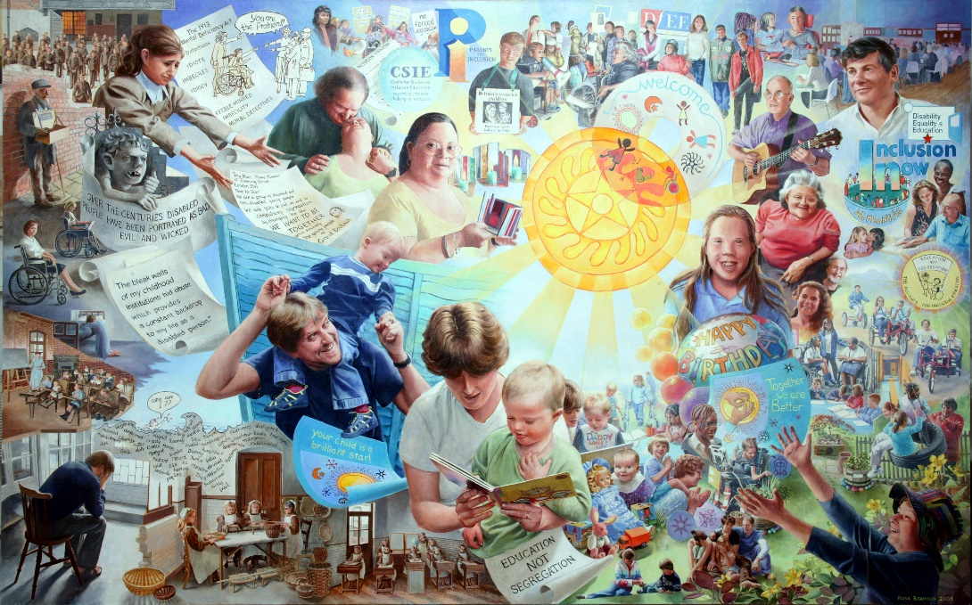
“We believe that it is physical and social barriers that stop disabled children from being included, rather than disabled children themselves. Children often have little power to ask for what they want. They say they want to be able to make friends and be involved in their local community. They want to be able to get out and about, meet new people, enjoy their leisure time and go to their local school.”
Many of these parents have joined disabled campaigners in the UK to challenge a new threat to inclusion from the UK Government – its determination to remove the ‘bias to inclusion’. As many have already said, the bias is all the other way if one wants to choose mainstream education for one’s disabled child. We need new generations of parents to understand the message of the Inclusion Movement and struggle for their child’s human rights and inclusion as their good allies.
Portrait of a Movement. Rosa Branson, 2010 201

9.Developing Disabled Youth Leaders
RIP: STARS was a Project run by the Alliance for Inclusive Education for Young Disabled Leaders in the East Midlands with 5 workshops for 17 to 25 year olds, in 2020.
These are some of the things we learnt and now want to share with other Disabled Young people:
- Your personal story matters – what you have experienced has shaped who you are.
- Get political, learn about disability activism, learn about current fights being led by disabled people.
- Learn about your rights as a young person and as a disabled person.
- Learn about the social model of disability – it will change your life forever. There are lots of YouTube videos on the social model.
- Get in touch with a disabled person led organisation and find out what they are doing and ask to attend one of their meetings to see what it is about.
- Finally: Don’t let anyone make assumptions about what you can or can’t do.
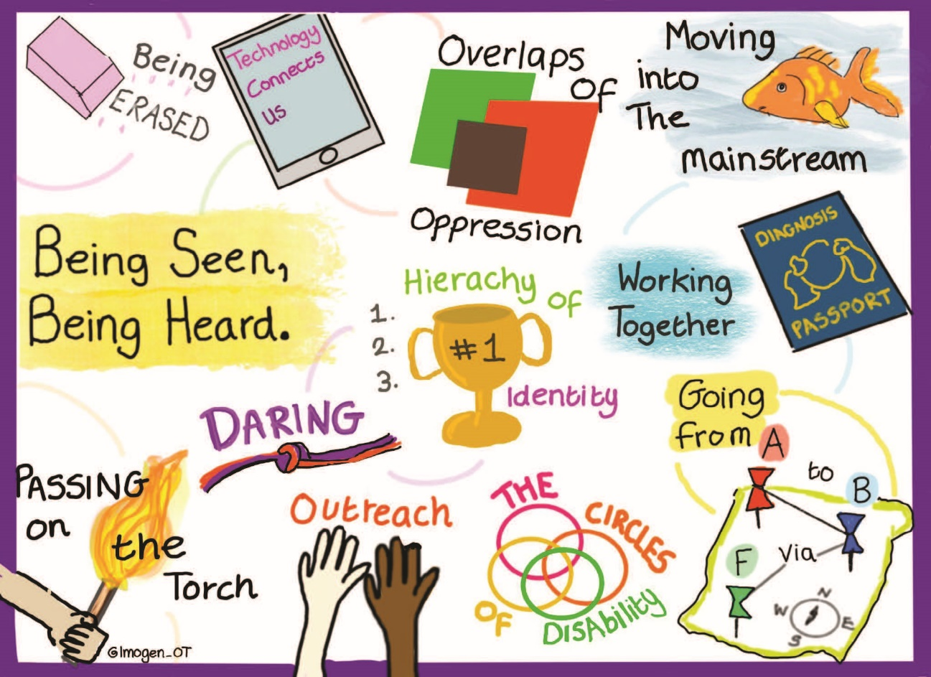

Disability Activism in Europe: Young Disabled Activist's Views and Experiences is a research project that forges new understandings of disability activism, politics, and the resistance practices of young disabled activists across Europe. The project runs from October 2020 until March 2024. the University of Leeds and the Leverhulme Trust. It is led by Dr Miro Griffiths. It is the first study to investigate the contemporary position of young disabled activists engaged in activism and social movements across Europe.
It will offer insight into young disabled activist's contributions to disability politics, the barriers limiting their participation, and their vision for the future of disability activism. It is co-funded by It will make original contributions to the fields of Disability Studies, Social Movement Studies, Youth Studies, and the Sociology of Resistance. Of particular note, it provides a still rare investigation into disabled people's social activism.

.

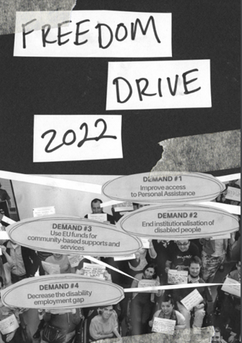
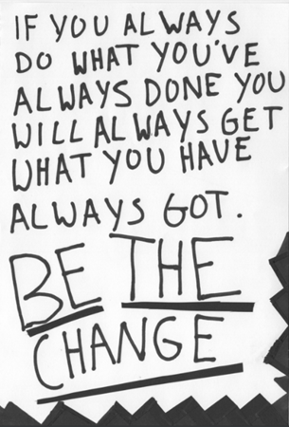
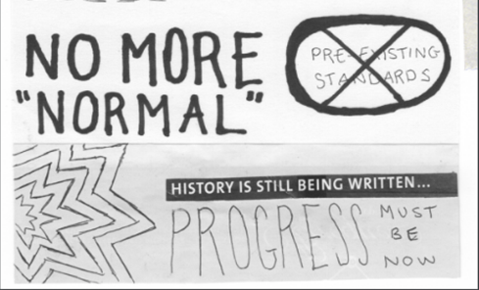

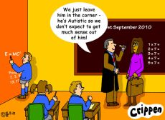
https://disabilityactivism.leeds.ac.uk/getting-involved-in-the-research-2/zine-disability-activism-in-europe/
What is to be done?
Get rid of the normal. Value difference.
Remove all barriers. Full access and communication.
Enforce Disability Equality Law.
Challenge disability hate crime and bullying. Get rid of Disablism.
Fund Inclusive Education properly in nurseries, schools, colleges and universities.
Support our independent living, meaningful relationships and having fun.
Meaningful and adequate livelihood and/or employment for all.
Empower disabled children and young people and their peers to challenge the oppression they face.
Recruit parents, teachers, social workers, health workers etc. to be allies in our struggle for equality.
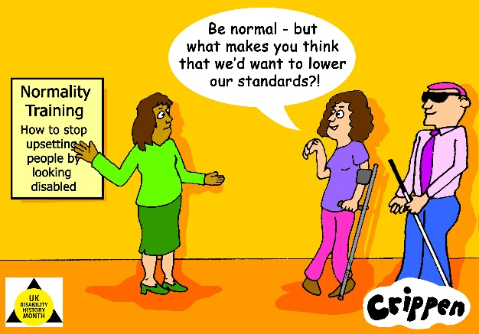
Fully Implement the UNCRPD - Nothing About Us Without Us.
United Kingdom Disability History Month
Website https://ukdhm.org
Coordinator Richard Rieser rlrieser@ukdhm.org 0207 359 2855

