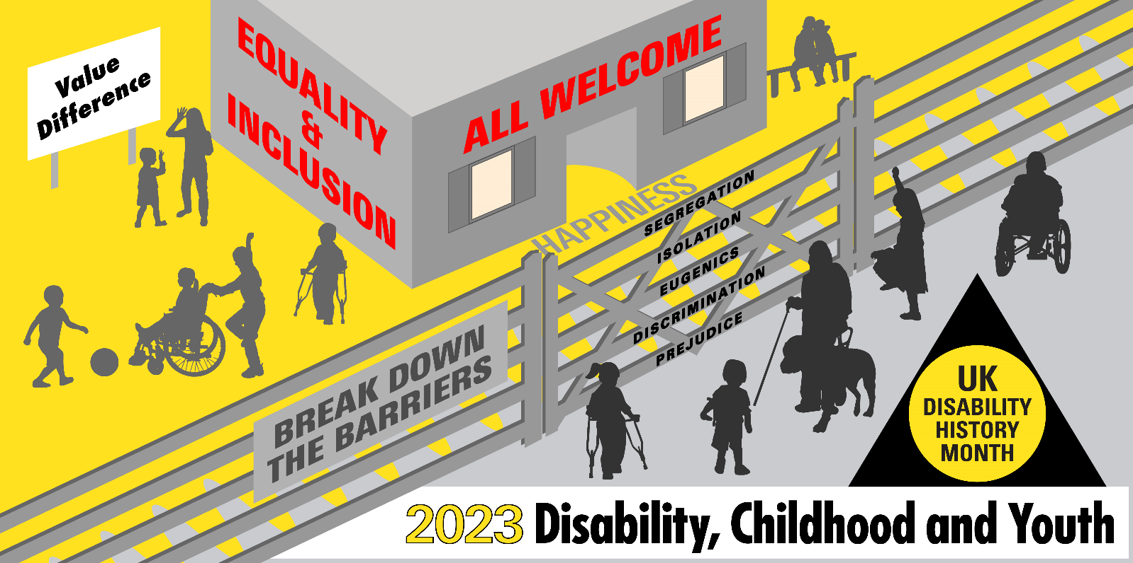
UKDHM Broadsheet 2023 (with Alt Text for visuals)

Disabled children (aged 8-17) are clear about what they want for a better world: as they told the Children’s Commissioner in England in March 2023 (a representative sample of 3,593)
* To be understood, seen and heard;
* To benefit from a fantastic, ambitious education in mainstream school where possible and support at school when they need it;
* For all activities and services to be accessible;
* To receive high-quality care locally and quickly;
* To be free from harassment and discrimination;
* For transitions to be smooth and prepare them for adulthood;
* For services to see them as part of a family, and to take a whole family approach.
Their aspirations are not being met.
Taking a longer historical view, the cruelty, isolation, segregation of the workhouse, institution, asylums and residential schools of the 200 years to 1980 has largely been banished. But the ideas of otherness, prejudicial thinking, under-valuing remains. Gains in medicine and welfare have banished or minimised many of the childhood impairments that dominated the C19th and first part of C20th. Only to be replaced by a new range of impairing conditions, such as learning difficulties, neuro-diversity and mental health issues that can lead to just as damaging disabling barriers, discriminations and practices.
Efforts of the Disabled People’s Movement in the UK in the last 50 years has led to the state increasingly accepting a ‘social model’ approach to disability, challenging the individualistic/ medical approach to disability that in various forms does still dominate the life of disabled people.
Since 2006, the United Nations Declaration on the Rights of Persons with Disabilities has broadened the ‘social model’ perspective into enforceable human rights. Unfortunately, the implementation of this rights-based approach remains a dream, yet to be fulfilled. For disabled people economic, social and cultural disadvantage, isolation, harassment and exclusion remain far too common.
In the UK children and young people born with or acquiring various long-term conditions or impairments are still mostly viewed through the lens of their medical diagnosis/ label, as in ‘deficit’ compared to ‘normal’ non-disabled children and young people. There is still a concept of Special Educational Needs (SEN), rather than the Disability Right to Inclusion. SEN and related medical assessments determine the resources provided to the disabled child or young person. SEN resources are increasingly the sticking plaster of a failing system.
There are conflicting numbers and proportion of disabled children from different data sources. Special Educational Needs in England January 2023. The latest annual DFE survey identifies in all English schools 9,073,832 pupils up to age 16. 4.3% have a statutory Education Health and Care Plan (EHCP) 289,171. 13% require SEN School Support 1,183,384. That is 17.3%, many of whom could also count as disabled under the Equality Act definition. The Census 2021 found 6% of children aged 0 to 14 (590,908) were limited a little or a lot in their day-to-day activities by long-term physical or mental health conditions or illnesses. The 2021-22 Family Resource Survey found 11% (0 to 19) and the most common impairment type was social or behavioural impairments, with half reporting this. This was followed by a mental health impairment at 30%, then a learning impairment at 26%. In Census for UK 2021 there were 1.9 million disabled young people aged 0 to 24.50% reporting Social/Behavioural Impairments and 30% Mental Health.
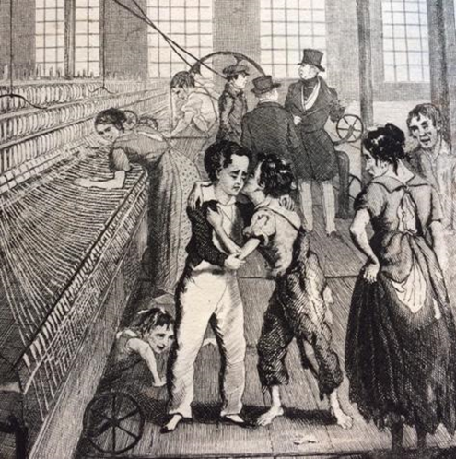

The History of Disabled People, especially Disabled Children and Young People over the last 300 years, provides a long shadow of being excluded and made to feel unimportant that obstructs our desires and rights. We shall unpack this history to make clear the changes we need.

Child Labour, Industrial Revolution and Impairment
By the late C18th children were specially employed at the factories and mines and as chimney sweeps, often working long hours in dangerous jobs, acquiring life-long impairments.
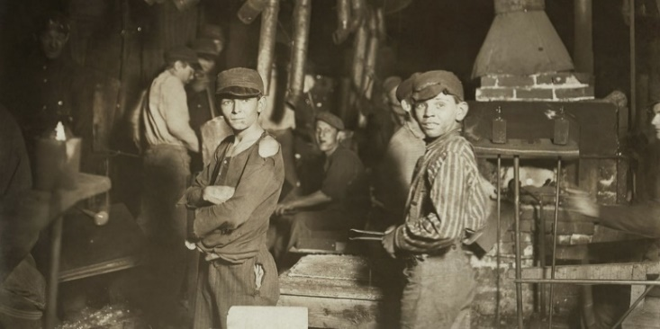
“At the age of six I became a piecer … each piecing requires three or four rubs, over a space of three or four inches; and the continual friction of the hand rubbing the piecing upon the coarse wrapper wears off the skin, and causes the finger to bleed. The position in which the piecer stands to his work is with the right foot forward, and his right side facing the frame. In this position he continues during the day, with his hands, feet, and eyes constantly in motion … the chief weight of his body rests upon his right knee, which is almost always the first joint to give way … my evenings were spent in preparing for the following day – in rubbing my knees, ankles, elbows, and wrists with oil, etc. I went to bed, to cry myself to sleep.” William Dodd Kendal, 1841.
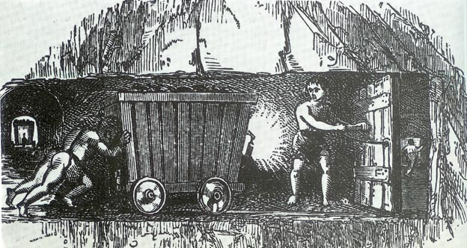

Joseph Hebergam of Huddersfield was 17 years old when he spoke to the Parliamentary Sadler committee about his disability. He had started working as a worsted spinner aged 7, a highly-strenuous job that eventually took a toll on his body.
Below details his responses (in italics) to various questions posed to him by members of the Parliamentary Committee,1832
“How long was it before the labour took effect on your health?”
– “Half a year”.
“And did it at length begin to affect your limbs?”
– “When I had worked about half a year, a weakness fell into my knees and ankles; it continued, and it has got worse and worse.”
“Was that weakness attended with very great pain, and the sense of extreme fatigue?” – “Yes.”
“Had you to work as often as you could under these circumstances?”– “Yes.”
“Otherwise no allowance would have been made to you by the occupier of the mill?” – “No.”

‘Disabled people’s role in the workplace is interwoven with the exploitation of industrial capitalism. Nonetheless, John and other disabled people were resilient, and were integral to the workforce and the emerging trade union movement’. Gill Crawshaw
By the 1830s, Factory Acts were introduced and the first Commissioners were set up to control practices and improve conditions.

From Elizabethan times there had been a parish local tax to support the old, ill and ‘infirm’ (an old word for disabled), which gave some support to the destitute. Most people were tied to the land, children stayed with their families and were seen as little adults more than as separate children.

As the Industrial Revolution and the growth of trade capitalism took off, many were forced off the land by Enclosures and came to the towns to find work. Throughout the late C18th and C19th life was cruel with little support, especially for disabled children whose families often could not afford to support them.

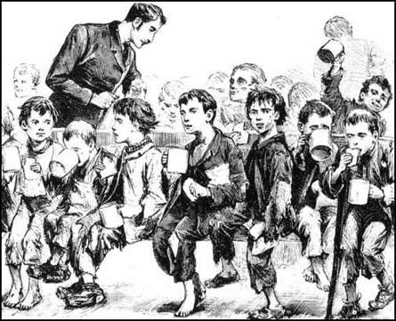
Workhouses and Disabled Children
1834 Poor Law created the workhouse structure. There were many workhouses and conditions were harsh.
By 1860, most people in the workhouse were old and ‘infirm’, including children. As there was no relief in the community anymore, many disabled people had no choice but to seek shelter and bare minimum subsistence in the workhouse. The able-bodied poor avoided the new workhouses, so many were soon housing the old, the sick, the mentally ill and those with physical or learning disabilities who could not work.
In 1835 the Birmingham workhouse built wards specifically for 'insane' residents. The Leicester workhouse segregated 'idiots and lunatics', providing specialised nursing attendants. By 1837 more than 8,000 'idiots and lunatics' were under the care of parishes. Workhouse staff struggled to care for them.
The late 19th century was not a good place for a child. One in seven infants died in England and Wales, and even more would later be killed operating dangerous machinery or getting stuck up a chimney, before Acts of Parliament were brought in to prohibit child labour. And in Victorian London’s East End, where Thomas Barnardo set up his first home for boys in 1870, there was also post-Industrial Revolution overcrowding, filth, poverty and disease to contend with. Poor children suffered from rickets, curved spines, respiratory diseases, inherited syphilis and a variety of ‘deformities’.
But Barnardo prided himself on welcoming children of all abilities and health into his care. In 1877, he wrote: “Given the destitution and when accompanied by disease, deformity or ill-health…. We will render assistance.” He disapproved of segregation between non-disabled and disabled children, and said that all young people could benefit from integration. “Unkindness to these little unfortunates from the other boys or girls,” he wrote, “is a thing quite unknown to us.”
Barnardo believed that “the presence of a child maimed for life, or marked by some serious deformity, draws out only kind deeds and gentle thoughts from the roughest boys and wildest girls”. Later when Thomas and his wife had a child Marjorie with Downs Syndrome they included her in everything.
“Knowing the reality of the world around them, however, he also made sure disabled children learnt useful trades. The boys practised tailoring; the girls learnt embroidery.
Kate McLoughlin (1889) was born in 1882 in Nottingham, and was admitted to Barnardo’s at the age of 7 by the local vicar. Her father had been in prison several times and was in jail at the time. The family of 5 lived in one room. Kate’s mother battled alcoholism, and while she was out drinking, her first child drowned in a bucket of water, and another was seriously burnt. When Kate was just a baby, she fell out of her mother’s arms, and subsequently suffered hip disease and ‘deformity’. After care and training in the homes, she went into domestic service in 1905.

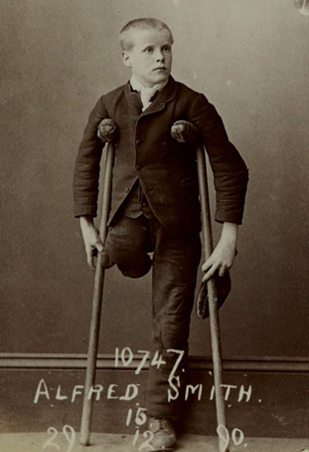
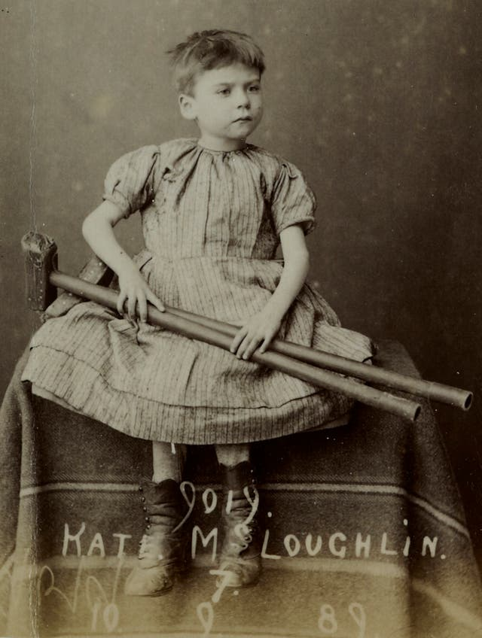

Alfred Smith was born in 1875 in the town of Rugeley, Staffordshire. His father died of diabetes 9 years later, leaving 7 children. His mother was unable to work due to abscesses on her legs and was receiving parish relief. Alfred had his right leg amputated when he was just 13. 2 years later, he was admitted to the homes, and received an apprenticeship in the Tailors workshop. In 1895, he was working as a tailor in Surrey.

Education
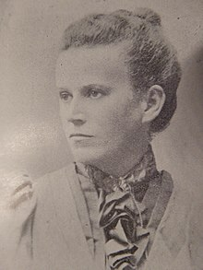
The first schools for disabled children were established for deaf and blind children in Europe and USA in the late C18th and early C19th. These were run on a voluntary and charity model. Later a number of schools were set up by pioneering parents, churches and philanthropists. ‘Since the advent of compulsory state education in 1870 most disabled children, often through neglect or lack of government money but sometimes through parental choice and the schemes of education authorities, have received their education in mainstream day schools’ writes Ted Cole in his 1989 Children with Special Needs Apart or A Part. This is true but it did not prevent many children being segregated by their impairment in schools and being subject to a rigid life-style, discipline, and to appalling abuse and neglect. The education and welfare of disabled children was also subject to moralist and social Darwinist campaigners.
Mary Dendy was a leading member of the British Eugenics movement. Dendy and a few others used false science and Social Darwinism to get a Royal Commission and then an Act of Parliament: 1913 Mental Deficiency Act. Visiting board schools as a member of the Manchester School Board from 1896, Mary Dendy was struck by the ‘outcast’ children in the school playgrounds and those unable to make use of the education on offer. After personally inspecting nearly 40,000 children, she pressed the board for day special schools and became a driving force in the establishment of the residential Sandlebridge Schools for the Permanent Care of the Feeble-minded. Opened in 1902, Sandlebridge was the first institution of importance to be certified under the Elementary Education (Defective and Epileptic Children) Act, 1899. The children in these institutions went onto Sandlebridge Hospital, where there were still nearly 400 in 1947.
Other prominent educationalists like Sir Cyril Burt, first consultant psychologist of London County Council, led to mass IQ testing and setting up more segregated schools than any other area in response to the Mental Deficiency Act.
Medical Doctors not known for their expertise in education enabled this, firstly assuming children with physical and mental impairments were sick and secondly that their false IQ tests measured something that was not changeable.
This is clear in laws such as the 1921 Education Act which combines previous acts recognizing 5 categories (blind, deaf, mentally defective, physically defective and epileptics). These children must be certified and provided for only in special schools and certified classes. The 1944 Education Act requires education according to age, aptitude and ability (as in 2014 Children and Families Act), but special educational treatment can take place in ordinary as well as special schools. However, the 1945 Regulations still named 11 types of special schools for different medical diagnosis.
Between 1900 and 1945, up to half a million children had a physical disability or sensory impairment, mainly due to poverty and disease. There were no vaccinations, and many working class families couldn't afford specialist equipment or treatment.
Everyone now had the right to education. Schools for 'crippled', blind and deaf children could be harsh but there were some new approaches. Progressive 'sunshine homes' looked after blind children, and 'open air' schools were believed to improve children's health. Disabled children were trained for low-skilled work, but most people thought they would never find a job.
The Oral History book and Channel 4 series Out of Sight collected survivors’ views:
Mary Baker, Halliwick Home for Crippled Girls, 1930s Mary was 12 years old when she was sent to Halliwick. She had a dislocated hip, so she walked with a limp. Mary’s father had been injured in 1st World War and when her mother died she and her brothers were sent to the workhouse in Wimborne, Dorset. From there she was sent to Halliwick, a Church of England Institution.
Ernest Williams, Birmingham Blind Institution, 1920's
Ernest was born in 1915, the blind son of an agricultural labourer who eked out a living for his family in Herefordshire.
Although Ernest was very helpful to his father in agricultural labouring, milking cows and helping calves be born, when he was eleven in 1926 he was sent to St Helen’s Institution for the Blind in Swansea.
Dennis Boucher, Yorkshire Institute for the Deaf Dennis was sent there in 1935 when he was aged 7. The Deaf schools all rejected Sign Language and taught by the oral method, but the children learned it from each other in the playground.
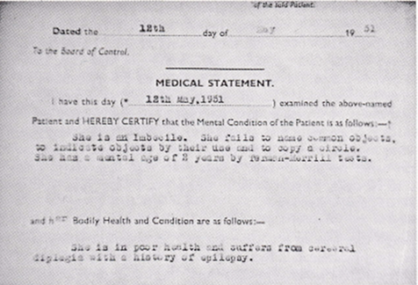
Evelyn King, Mental Handicap Hospital In 1951 at the age of five Evelyn King was admitted to one of the largest mental handicap hospitals in the North of England. She had cerebral palsy which prevented her from walking or speaking more than a few words. After failing the intelligence test administered by doctors she was diagnosed as ‘an imbecile’ who was unfit to be educated. Evelyn had no learning issues, just difficulty speaking.
A Further source of the views of disabled people on their schooling in 1960s/70s is Old School Ties Programme 1
Another Oral History Project How was School from the Alliance for Inclusive Education looked at Disabled People’s experience of education over the last 100 years through the telling of memories. It is only in the last 40 years that disabled people have had a chance to learn alongside their non-disabled peers in mainstream education settings. In the first half of the 20th Century disabled children and young people were routinely sent to residential institutions, often many miles from their families and communities. Some of these institutions provided an educational element, but the focus was often on ‘fixing’ the disabled child rather than embracing them. This approach was driven by the traditional Medical Model of Disability, which identifies the person with their impairment/health condition as the problem rather than the society we live in that creates barriers to disabled people taking part as equal citizens.
Mark Lynes was born in 1971 in Birmingham. He attended a local special school from age four to sixteen and then went to a residential special college in Shropshire. “The building – the campus was quite strange because at that time you had Wilson Stuart Special School that took physical disabilities. Then you had Braidwood School that took deaf people. And then you had Princess Smith School that took blind and partially sighted students. So, not only were you segregated from – and again, you think this is okay when you’re there - but not only were you segregated from able bodied people but you were segregated from deaf and partially sighted and blind kids as well.”
“I realised that school was very useful to me in a lot of ways, but in an awful lot of ways it was a waste of time, because it actually gave me no background to life at all…. it almost took those memories I’ve already talked to you about away, because I realised what they didn’t give me compared to what they would have given other people my own age.”
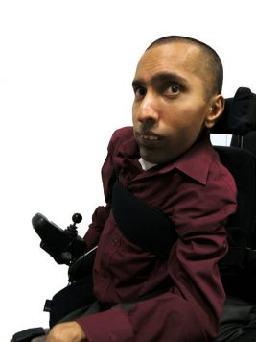
Ajay was born in India in 1977. He attended a special school in East London from the age of five to sixteen and then went on to a mainstream sixth form college and university.
“At school we weren't taught sex education, not much anyway, and very vaguely, so when you turned kind of you know, young teenagers you don't really know what's going on, so you have to wait 'til you find out from your friends, I mean we were taught stuff but very, very vague.”
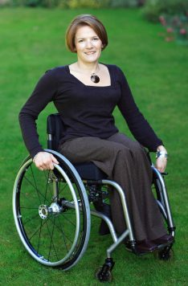
Helen was born in 1969 in Surrey. She attended mainstream primary and secondary schools, going on to University from her Grammar school.
“My understanding is that we are aiming for inclusive education and in my opinion that's absolutely as it should be, we shouldn't be segregating Society at all. I do a lot of work in the field of graduate recruitment now. Particularly, talking to some of the people who are responsible for attracting disabled students into universities, and indeed the disability managers at universities, they all talk about the fact that when they are talking to school children, actually it's not the children that they need to target, it's the parents and the teachers, because they're still giving the messages of, 'Children like you can't go to universities like that’.”
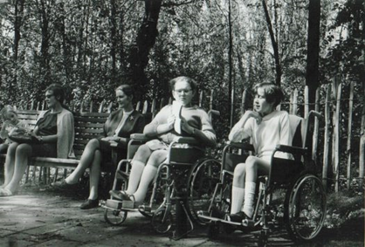
Alice was born in 1957 in Buckinghamshire. She went to mainstream primary schools and moved to a residential special school with her sister for her secondary education. “When I left school, I swore never to have anything to do with any disabled people ever again, apart from my friends of course, because they were alright, they weren't really disabled people. And so I didn't for a long time mix with other disabled people except my friends. I think more importantly, was this kind of 'You have got to strive to be more normal than the normal' ethos that arose from old Florry's that until I discovered the Social Model at the age of about thirty-three, I was being 'normal', and actually being normal as a disabled person is an incredibly stressful thing to do, so what was that about? Fifteen years, post leaving school, busy being normal, and being told that people didn't think of me as a disabled person and thinking that was the nicest thing they could say about me, and that I think was far more important than any other consideration.”

Ann Torode was born in 1943 in Dulwich, London. She was sent to a special primary school, then known as an 'educationally sub-normal' school until her mother won a battle to have her moved to her local mainstream primary school. From there Ann went on to a girls' grammar school and afterwards to university.

They did nothing whatsoever.
“There was a dinner lady in the playground, on duty and she watched these girls, every playtime they circled me and chanted and sang. Punchinella was one of the songs. I can’t remember it, but they just chanted and said things to me and I withdrew from my body and went up, which is a very bad thing to learn to do and I just thought, 'Well you can’t affect me, you can’t get to me, I’m not going to let you get to me'. And mum came to the school one time and said, 'Can I speak to all the classes because I want to talk to them about what’s happening' and she did and she told all the children in each class about the teasing and to stop it, but it made no difference whatsoever. There was no support from the staff? No, no.”

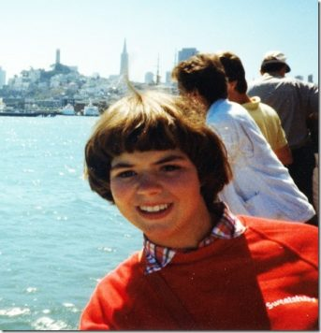
Simone Aspis was born in 1969 in Dollis Hill, London. She went to a residential special school in Cheshire from the age of four until sixteen. From there she went on to college and then university. “And then at the age of thirteen I wrote to the Secretary of State asking to get me out of school because nobody else wanted to get me out of the special school. So I think at that point my mum and dad did send me to an educational psychologist to see whether I might be able to be reintegrated back into mainstream education. And there the educational psychologist basically wrote to say that if I came home that I would be – that I would irritate people who had quicker brains than myself.”

“I worked at the BBC for ‘From The Edge’ for a number of years, decided, you know what, I’m fed up with watching everyone else change the world, I want to get out there and do it myself. So I first – I got into activism – working with People First which is an organisation run by people with learning difficulties and I was a parliamentary campaigns worker there, ‘cause what really annoyed me was disabled people didn’t have rights, you know.”

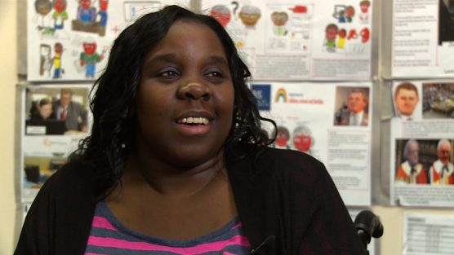
Joanne Wacha was born in 1984 in Harrow, London. Joanne attended local mainstream primary and secondary schools and also spent time in hospital, attending the hospital school, after becoming ill at the age of thirteen. After school she went on to a local sixth form college, then a residential special college and then on to university.
“There was talk about me going to a boarding school but that would be away from my home and my mum point-blank said, ‘No way, she is going to stay home with me and learn – have her education here in Harrow.’ And I’m so glad she made that decision…” There are many more stories of post war ‘special education’ and its largely negative impact.
Special education is based on medical model diagnosis of the child’s impairment to distinguish how different they are from normal children. The Warnock Report and subsequent 1981 Education Act allowed for the integration of disabled children in mainstream, provided they could do what ‘normal children did, they would not interfere with their efficient education and there were appropriate resources. To allow for some support a statementing process was established to make provision.
The history of doctors and later psychologists dominating this process of selection, often informed by eugenicist notions of children having fixed ability which could be measured by tests, is still a dominant ideology within the English Education system.
This has led to a deficit approach to disabled children based on what they cannot do rather than what they can do.
Number of disabled children educated separately in England 1897-2023-from Government Statistics
Date | Nos. of children
1897 | 4,739
1909 | 17,600
1914 | 28,511
1919 | 34,478
1929 | 49,487
1939 | 59,768
1947 | 40,252
1955 | 51,558
1965 | 70,334
1967 | 78,256
1977 | 135,261
1987 | 107,126
1994 | 104,431
2001 | 111,500
2006 | 111,980
2008 | 122.,820
2010 | 117,880
2016 | 137,725
2020 | 166,334
2023 | *191,040
*All EHCP Plans in Special, Independent Schs.& Alternate Provision including SEN Support
The table to the left shows the general trend to segregation of disabled children and young people to education in separate locations away from their non-disabled peers. This is particularly strange as the 1981 Education Act, 1996 Education Act and Part 3 of 2014 Children and Families Act, 2001 Disability Discrimination Act and the Equality Act 2010 all support the development of mainstreaming and what is now known as inclusive education.
Growth in Segregation
The tendency to increase segregated education is linked to the lack of mainstream teacher and support staff capacity, failure to effectively tackle disablist bullying, narrowing and raising the level of the curriculum, loss of continuous assessment, cuts in education budgets, structural reform of schools such as the Academies Programme and reduction in Local Authority specialist support teams.
Looking at the table, the big surge in numbers from 1967 to 1977 came about from the 1970 Education Act, which for the first time created universality of education, abolishing education sub-normality schools and junior training centres, replacing with Learning Difficulty schools. The drops from 1977 to 1994/2001/06 were caused by mainstreaming by the 1981 Act and New Labour’s policy of inclusive education (1997 to 2006). By 2008 Labour had reversed this policy and the massive growth since is largely down to Tory policies.

What is needed is a National Inclusive Education Strategy, as the United Nations UNCRPD Committee had recommended. This would be in line with Article 24 of the United Nations Convention on the Rights of Persons with Disabilities and General Comment No.4 which explains how to implement such a system.
Traditional thinking about disabled people.
History, religion and culture are important in understanding how negative attitudes have developed. These can together create thinking which denies disabled people access and equality, leading to unfair and unequal treatment and exclusion. Stereotypes are still very common, viewing disabled people as inferior, pitiable or pathetic; incapable of education or work; a burden on society; comical or the butt of jokes; incapable of family life and having adult relations. These lead to the widespread denial of the human rights of disabled people.

Medical or Individual thinking.
Advances in medical science, disease, accident prevention and improvements in health are all vital in dealing with impairment - the loss of physical or mental functioning - but should never be confused with the empowerment and equality of disabled people. Medical, educational, community, social workers, health and rehabilitation professionals need to recognise that the empowerment of disabled people, their human rights, are always paramount. The UN Convention on the Rights of Persons with Disabilities is based on moving away from the traditional/ medical approach to a Social Model / Human Rights Approach.

Social Model and Inclusion focuses on removing barriers. The Human Rights approach to inclusion. Inclusion involves a process of complete reform, making changes in content, teaching methods, approaches, structures and plans in education, to overcome barriers with a view to provide all students with an equal learning experience and an environment that suits their needs and desires. Placing disabled students within mainstream classes without the right changes to organisation, curriculum, teaching and learning is not inclusion. Integration does not automatically guarantee the move from segregation to inclusion.
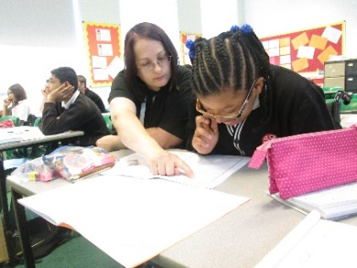
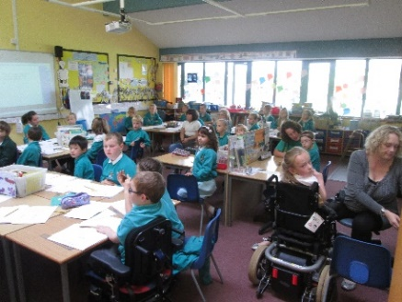
Despite the rise in segregation there are still hundreds of mainstream schools with inclusive practice and we know this is the dream of most disabled children and young people.

Emersons Green Primary School, South Gloucestershire https://youtu.be/w4B4CGopmZw
Wroxham Primary School, Hertfordshire https://youtu.be/NL-Y9L3U6gY
Priestnall Secondary School , Stockport https://youtu.be/ggMUiQ58-xk
EastLea Secondary School , Newham https://youtu.be/cAAoWGi3AKk
There are 40 more schools filmed as part of the Reasonable Adjustment Project in 2003/04 (RAP). Two coheads of a Nottingham Primary school who only retired last July, talking about what made their school inclusive is worth listening to. In England the current position on inclusive education is harder. Twenty years ago in the RAP project we found that mainstream schools successful at inclusion of disabled students had the following (See Table below):-

Vision and values based on an inclusive ethos.

A ‘can do’ attitude from all staff.

A pro-active approach to identifying barriers and finding practical solutions.

Strong collaborative relationships with students and parents.

A meaningful voice for students.

A positive approach to challenging behaviour.

Strong leadership by senior management and governors.

Effective staff training and development.

The use of expertise from outside the school/college.

Building disability into resourcing arrangements.

A sensitive approach to meeting the impairment specific needs of students.
Regular critical review and evaluation;-
- at student level,
- at departmental level,
- at school/college level.

The availability of role models and positive images of disability.

In the Inclusion Movement we should be engaging with the Government Change Programme locally and emphasising:-
- Local groups of teachers, parents, disabled people and disabled young people should engage with these processes and argue for what we know works, to enhance good inclusive practice.
- We need to keep pressing that all partners are much more aware of the Equality Act and its implications for Disability Equality and intersectionality. This includes insisting the Access Planning Duty is fully implemented.
- Create much more awareness of good inclusive mainstream practice developing around the world and the link to Article 24 of the UNCRPD.
Not re-invent the wheel but learn from the many studies and recording of good inclusive practice in English schools over the last 30 years e.g. the 2006 Reasonable Adjustment Project

It is ironic that a Conservative Government that came to power with David Cameron committed to rid the education system of the ‘bias to inclusion’ has been so successful, that it now has to come up with a whole range of measures to reduce reliance on expensive independent schools, reduce numbers in special schools and work on ways of improving inclusive practice in mainstream schools for budgetary reasons! What they and potential Governments need to realise is that inclusive values and equality have to be at the heart of the state education system and many of their policy folies that hinder this must be got rid of.

Other failures for disabled children and young people that need to be rectified.
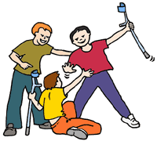
- Disablist Harassment and bullying on the streets, at school and on social media, ‘Mate’ crime-where young disabled people are exploited for their benefits are still big issues. Building confidence for young disabled people by empowering them, teaching them the history of oppression and ensuring all non-disabled peers understand the roots of this prejudice and that it is a hate crime.
Anti Bullying Alliance

- Isolation, loneliness and unhappiness . The impact of low level harassment, social exclusion and segregation often means young disabled people do not have friends and relationships. This is particularly true for those who are neurodiverse or have Learning Difficulty. All those who work with young disabled people should encourage the use of person centred planning tools and their inclusion in social activities, taking their lead from the disabled person. Inclusive Solutions.

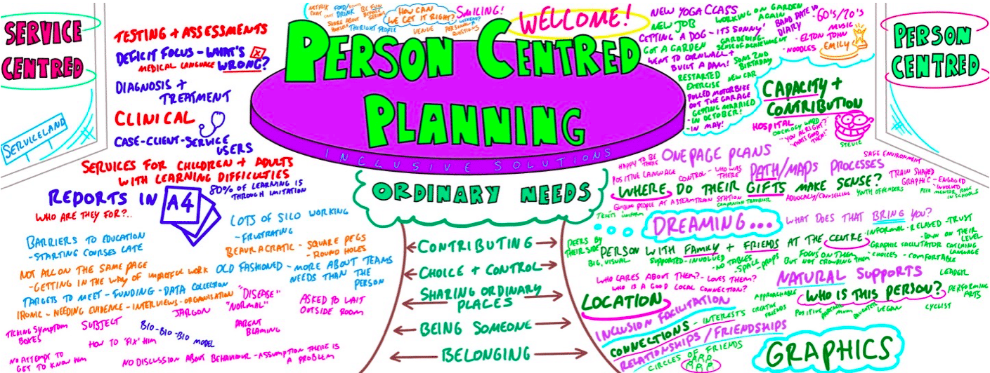
- Disability Equality Training for staff in Education, Health and other public sector services on nerodiversity and learning difficulties. This should be co-delivered by individuals with first hand experience of living with the impairment. The untimely death of Oliver McGowan was ruled by an Inquiry as a preventable killing. His mother got a 100,000 signed petition to Parliament which led to an ammendment to the Care Act 2022. Oliver McGowan training is now delivered to all health professionals, often by self advocates who have Autism and/or have learning difficulties. Such training should be developed and extended across education.

4. Lack of policy and law implementatrion. All public bodies, those funded from the public purse, are under a Duty (sec 149 of the Equality Act) to have due regard to promoting Disability Equality by:-
(a) getting rid of discrimination, harassment, victimisation etc (b) advancing equal opportunity between persons who share a relevant protected characteristic and persons who do not share it; (c) fostering good relations between persons who share a relevant protected characteristic and persons who do not share it.
In addition all service providers - transport, education, arts and leisure venues, and employers - have a legal duty to provide reasonable adjustments to disabled people. The problem is the above rules are more ignored than implemented. We need the Equality and Human Rights Commission to have far more enforcement powers and for all young disabled people to learn their rights.

5. Regardless of where they are educated all disabled pupils and students have an entitlement to know what their disability rights are!
“The EHRC has stressed the danger of a continuing failure by the UK and Welsh governments to make necessary reforms, including to address problems with the welfare system, poor engagement with disabled people and their organisations in many parts of the UK, and inadequate public services for disabled people, leaving them at a higher risk of poverty, abuse and poor health.” Equality and Human Rights Commission.

6. Continious exposure to sterotypes of disability and impairment in toys, literature, computer games, films, TV and negative language leads to low self esteem and internalised oppression. Challenged by including in the curriculum, critiquing it and the media and Disability Equality Training.

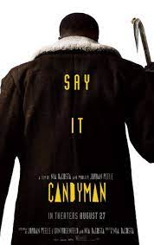
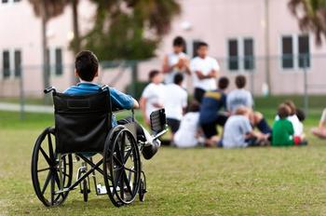
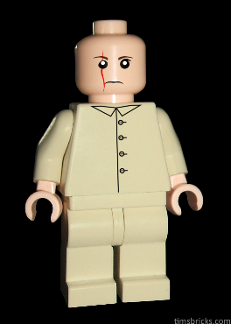
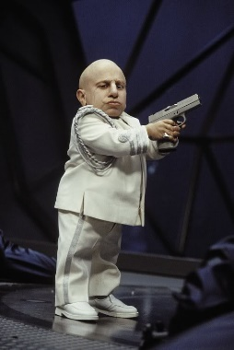
Don’t Use
“Spaz
Mong
Thlid
Thick
Idiot
Freak
Dumb
Lame
Nutter
Victim
Sufferer”

Vengeful
Candy Man
Left Out/Isolated
Lego Bloefeld
James Bond
Villain
Mini Me
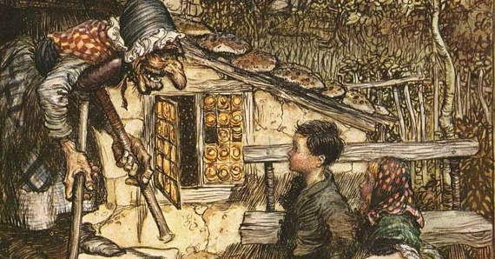
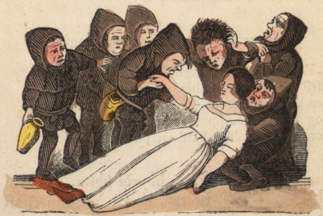
Snow White and 7 Dwarves Isolated
Dwarf Throwing
Witch in Hansel & Gretel

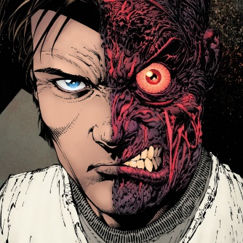
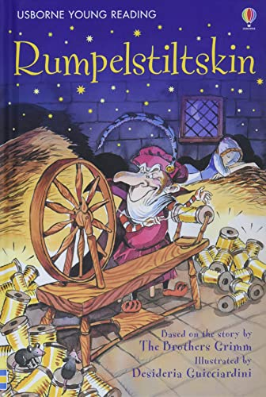
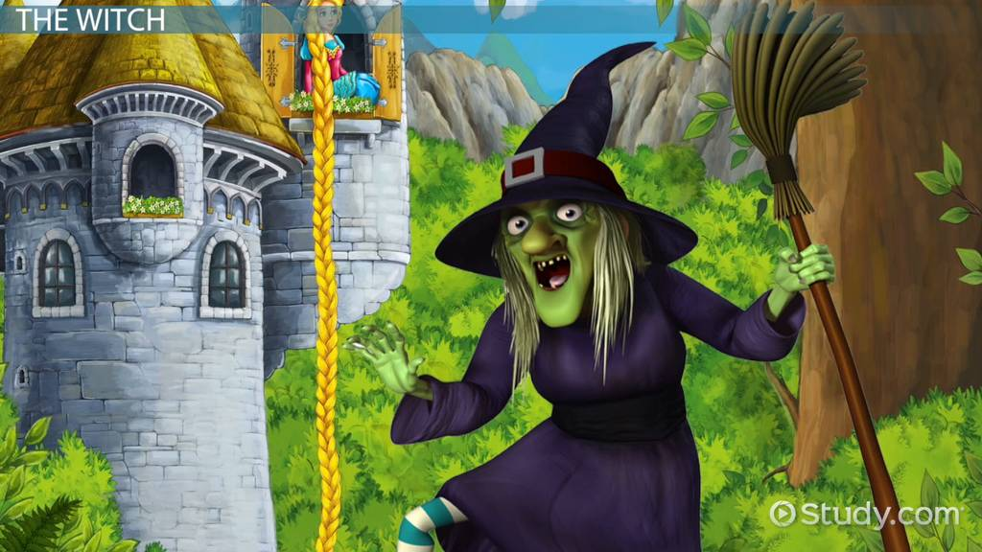
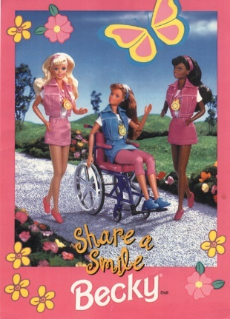
Two Face in Batman Forever
Blind Witch in Rapunzel
Rumpelstiltskin- Malign
Patronising and Sexist
STEREOTYPES Pitiable, Laughable/Ridicule, Burden, Evil, Useless, Asexual, Perpetual child, Objects of violence, Atmosphere or a curio, Your own worst Enemy. Challenge them.

7. Higher Education
Disabled people are almost three times more likely than non-disabled people to have no qualifications at all. Only 25% of disabled people aged 21 to 64 have a degree compared to just over 40% of their non-disabled peers. Only 29% of disabled students receive the Disabled Students Allowance which undergraduate and postgraduate students can receive up to £25,575 a year to pay for specialist equipment or non-medical helpers, for example a British Sign Language (BSL) interpreter, a note taker or additional travel costs incurred as a result of a disability.

Dan Rowley, 22, from the Isle of Wight, has Ehlers-Danlos Syndrome and Fibromyalgia. He originally went to a university in the Midlands, but problems with inaccessibility meant he was forced to drop out. His university was concerned that any assistive equipment might be stolen. He eventually completed his degree through the Open University.
Sophia Keaveney, 18, from Greenwich, London, was an A-Level student who wanted to become a diagnostic radiographer, after receiving treatment for a grade four brain tumour aged 15. The brain trauma has left her in the lower second percentile for processing speed. After a long time, a reasonable adjustments plan was given, but it did not contain anything that she had asked for.
Laurie Brown, graduated from university last year. He felt he had been let down by his tutors who, he says, did not understand his disability. He has Asperger syndrome, an autism spectrum disorder. Because of his difficulties with the course, he was told he should change subjects - a move which meant giving up on his long-held dream of studying abroad.
There continues to be a rise in the number of disabled Higher Education students from 9.5% in 2010 to 19% in 2022. The growth is largely down to more students reporting neuro diversity and mental health issues. There are continuing reports of UK Universities not meeting their obligations on Support Plans, failing to make reasonable adjustments to the buildings, providing accessible course material and many students report bullying and harassment from faculty.
Self-advocacy groups like Disabled Students UK and National Union of Students are campaigning hard on the above issues.
8. Parents of disabled children part of the problem or part of the solution? Many parents of disabled children have over the years recognised they have a choice between accepting what the medical/Special education establishment says of their children which has often confined them to isolation/segregation and limited life-chances.
Some have championed their children’s human rights, fought for their equality and their inclusive education. Others, like the parent 70 years ago who set up Scope (previously the Spastic Society) or Mencap or more recently the National Autism Society fought for their disabled children to go to school, special schools they set up as the education system could or would not meet their needs. All the major advances in inclusive education on the ground came from parents fighting for their child’s rights to be included.
An organisation Parents for Inclusion was formed in the 1980s by parents who wanted inclusion for their disabled children and disabled activists, which led to a new perspective, so that parents became allies in their children’s struggle. For lack of funding after 30 years forced to close. Parents for Inclusion’s mission statement says:
“We believe that it is physical and social barriers that stop disabled children from being included, rather than disabled children themselves. Children often have little power to ask for what they want. They say they want to be able to make friends and be involved in their local community. They want to be able to get out and about, meet new people, enjoy their leisure time and go to their local school.”
We need new generations of parents to understand the message of the Inclusion Movement and struggle for their child’s human rights and inclusion as their good allies.

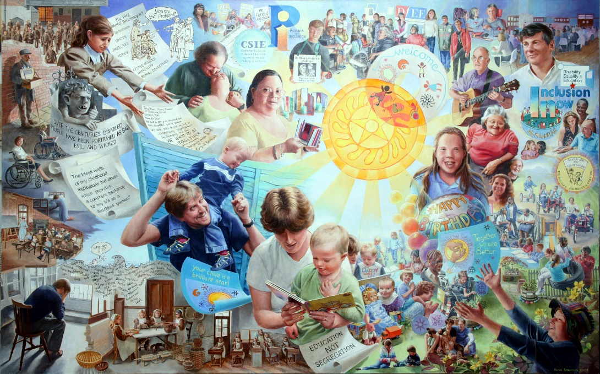
Portrait of a Movement. Rosa Branson, 2010 201

9. Developing Disabled Youth Leaders
RIP: STARS was a Project run by the Alliance for Inclusive Education for Young Disabled Leaders in the East Midlands with 5 workshops for 17 to 25 year olds, in 2020.

These are some of the things we learnt and now want to share with other Disabled Young people:

- Your personal story matters – what you have experienced has shaped who you are.
- Get political, learn about disability activism, learn about current fights being led by disabled people.
- Learn about your rights as a young person and as a disabled person.
- Learn about the social model of disability – it will change your life forever. There are lots of YouTube videos on the social model.
- Get in touch with a disabled person led organisation and find out what they are doing and ask to attend one of their meetings to see what it is about.
- Finally: Don’t let anyone make assumptions about what you can or can’t do.
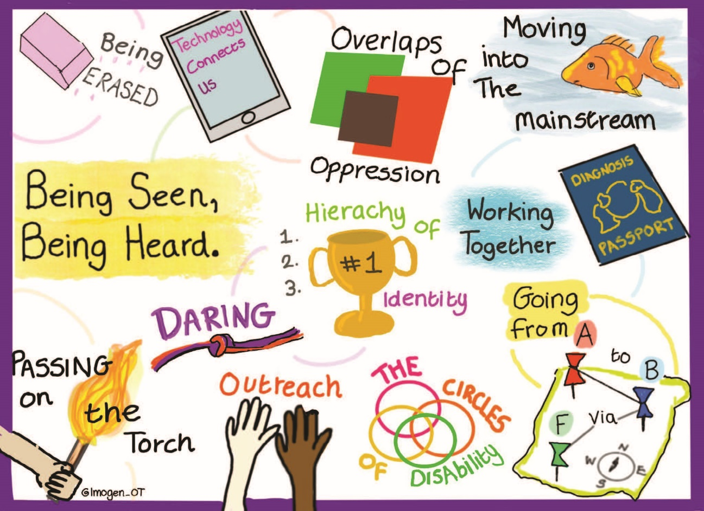

Disability Activism in Europe: Young Disabled Activist's Views and Experiences is a research project that forges new understandings of disability activism, politics, and the resistance practices of young disabled activists across Europe. The project runs from October 2020 until March 2024. the University of Leeds and the Leverhulme Trust. It is led by Dr Miro Griffiths. It is the first study to investigate the present position of young disabled activists engaged in activism and social movements across Europe.
It will offer insight into young disabled activist's contributions to disability politics, the barriers limiting their participation, and their vision for the future of disability activism. It is co-funded by It will make original contributions to the fields of Disability Studies, Social Movement Studies, Youth Studies, and the Sociology of Resistance. Of particular note, it provides a still rare investigation into disabled people's social activism.

.

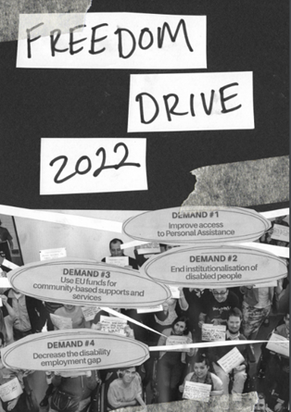
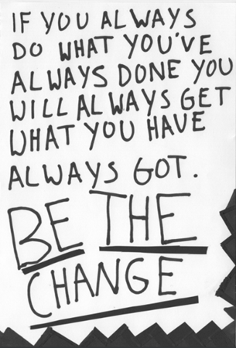

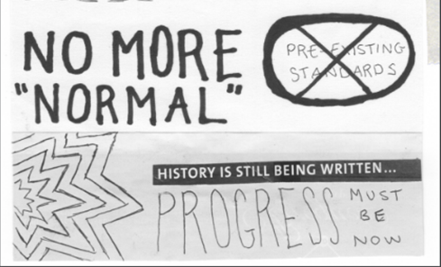
https://disabilityactivism.leeds.ac.uk/getting-involved-in-the-research-2/zine-disability-activism-in-europe/
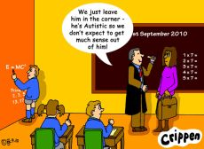

What is to be done?
Get rid of the normal. Value difference.
Remove all barriers. Full access and communication.
Enforce Disability Equality Law.
Challenge disability hate crime and bullying. Get rid of Disablism.
Fund Inclusive Education properly in nurseries, schools, colleges and universities.
Support our independent living, meaningful relationships and having fun.
Meaningful and adequate livelihood and/or employment for all.
Empower disabled children and young people and their peers to challenge the oppression they face.
Recruit parents, teachers, social workers, health workers etc. to be allies in our struggle for equality. Fully Implement the UNCRPD - Nothing About Us Without Us.
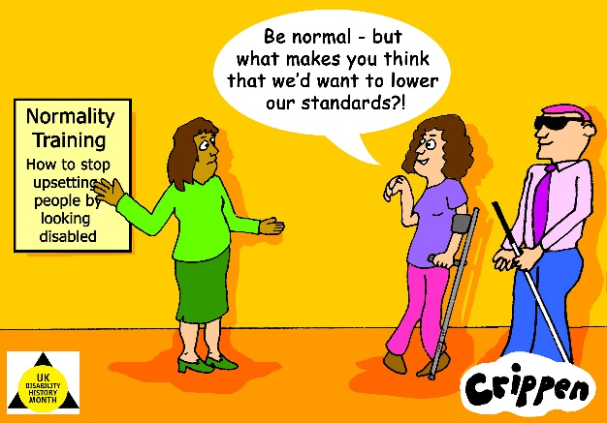

United Kingdom Disability History Month
Website https://ukdhm.org
Coordinator Richard Rieser rlrieser@ukdhm.org
0207 359 2855

