Disability Livelihood & Employment
14th Nov. to 20th Dec. 2024
Disability has been seen for many years as synonymous with non-employment or unemployment. This of course is not true. Disabled people have always sought a means of surviving whether in begging, employment or on welfare or charity. Recently the number of disabled people in the UK workforce has increased.
There were 5.1 million disabled people in employment in the UK in 2023. This is an increase of 320,000 on the year and an overall increase of 2.2 million since the same quarter in 2013. The duty of reasonable adjustment, improved employer attitudes, trade unions being more supportive and an expansion of the economy have all led to this. Though the pay gap remains high.
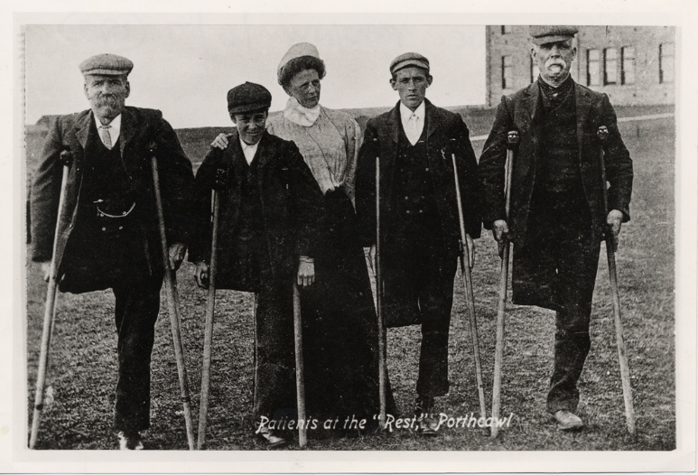
In times of war when non-disabled men have gone to fight, more disabled workers were recruited in 1914–18 and 1939–45. This has led to disabled workers being part of the reserve army of labour.

In the past, heavy industry like mining, steel-making and construction have had a high rate of accidents leading to more disabled workers. Depending on organised labour’s strength some have been able to accommodate these workers on light duties. This was particularly true in mining areas where the Unions and the local community facilitated the welfare of disabled miners and their families. Long before the Welfare State.
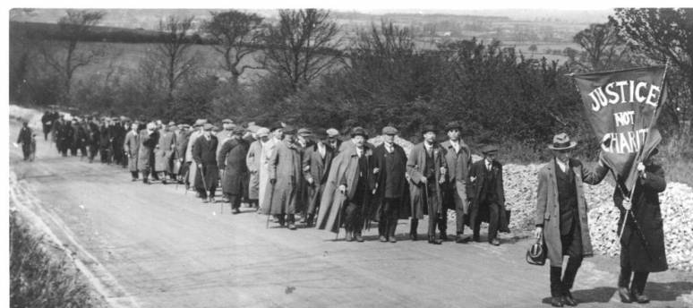
Many people know of the National League for the Blind 1920 three-way march on London for a decent wage and conditions for Blind workers. Far fewer know of the long history of their struggle with many local strikes over the previous 30 years.

After the First World War, disabled British veterans returned home to an uncertain future of work. In addition to voluntary efforts, the government’s response to the national employment crisis – the National Scheme for Disabled Ex-Servicemen (commonly known as the King’s Roll) – was established in 1919 to encourage employers to hire a five per cent quota of disabled ex-servicemen. Historians have recently revisited the scheme, noting that in many cases the process was slow and fraught, with many disabled veterans facing the prospect of unemployment, yet few have paid attention to soldiers’ pre-war working backgrounds and the specific requests of British industries.
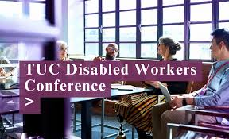
‘Disabled people have always been at the heart of British economic and labour history, but their contributions in the workplace often go unrecognised. Once the Industrial Revolution got underway in the late eighteenth century, the narrative that disabled people were unable to work and instead depended on the workhouse or on charity took hold; a myth that persists to this day. But this stereotype is not historically accurate,’ says Gill Crawshaw
In the last 35 years in the UK, in response to the Disability Movement the Trade Union Movement has completely transformed its response to disability in the workplace. Having disabled workers sections, conferences, places on the TUC General Council and promoting Disability Champions.
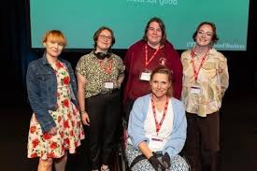
Modern high tech work can be carried out by a much wider range of employees as it does not require physical strength or stamina and modern patterns of flexible and home working allow a greater number of disabled people to work.
Stereotypes, barriers and prejudices still impact differentially on disabled people with different impairments. Those with Autism, Mental Health issues, Intellectual impairments and Visual impairments still have much higher rates of non-employment.
Chartered Physiotherapist TUCTUC
What can Trade Unionist do?
- Find out about a local struggle involving disabled workers,
- Schedule a branch meeting to celebrate disabled workers’ victories,
- Research our unknown struggles of the past. Write it up and send it in.

In 2024 UKDHM will collect together a variety of resources to demonstrate the above and develop a range of educational resources to inform students on the factors influencing the employment of disabled people now and in the past to illuminate a more equitable way forward.

UKDHM c/o World of Inclusion, 78 Mildmay Grove South ,London N12 4PJ. Richard Rieser, Coordinator rlrieser@gmail.com website https://ukdhm.org

