**Micheline Mason and the Struggle for Inclusive Education and Disability Rights**

**Micheline Mason died of a stroke on Saturday 7th September 2024.** Micheline was 74, a major leader in the Disability Movement and a brilliant thinker, taking our Movement forward, especially the struggle for Inclusive Education, in a series of quantum moves.

This will leave a great hole in the lives of those who loved, knew and worked with her, but also a strong feeling of loss across the thousands of people whose life Micheline changed directly and a diminishment of possibility in the lives of millions.

Micheline had been developing her thinking since she had been born with Osteogenesis Imperfecta (Brittle Bones) and although she felt like everyone else coming from a loving and supportive home, firstly Medical, then Educational and Social authority required her to be hospitalized, [isolated and educated at home and later sent to a segregated boarding school.](https://howwasschool.allfie.org.uk/people/micheline-mason/) Micheline has powerfully written about this formative process and how it strengthened her in her book she self-published in 2022 “[An A book cover of a baby
Ordinary Baby: Tales of Childhood Resistance](https://www.allfie.org.uk/news/inclusion-now/inclusion-now-65/review-essential-insights-from-a-leading-thinker-of-the-inclusion-movement/).’ Against the odds Micheline excelled academically and went to Art College where she began to liberate herself. After leaving Art College she rejected having a commercial art career in favour of activism. Micheline’s thinking developed further through the Re-Evaluation Counselling, the Women’s Movement and the burgeoning Disability Movement.

In the 1980s she played a key role in launching and running the ‘In From the Cold Collective’ [ [See this clip where with her long term friend Chrissy Wilson](https://youtu.be/w_lISzzOH1w) she describes this], which brought together many of the future leaders of the Movement particularly Women, as it took a more all embracing approach than Union of Physically Impaired against Segregation (UPIAS), who became the majority of the leadership of the newly formed British Council of Disabled People (BCODP, 1980).

‘[The Liberation Network of Disabled People (LNDP)](/https:/ukdhm.org/v3/wp-content/uploads/2019/10/Micheline-Mason-poster-2019.pdf) were influenced by the Women’s Movement. Following their initial meeting at Lower Shore farm outside Swindon in 1980, they focused on breaking down isolation by finding ways to communicate with each other whether deaf, blind or physically impaired. Many of the ideas were developed by Micheline Mason and others in their ‘In From the Cold’ magazine. “We brought together leaders of different fragments of a movement. We challenged the effects of ‘internalised oppression’, recognised by all marginalised groups as the major ‘tool’ of the oppressive society; we challenged the conditioned hatred of ourselves and each other as disabled people; we challenged the desire to assimilate; we challenged the denial of ‘hidden’ disabilities; we challenged the fierce competition between us; we challenged the inability to champion, appreciate and support each other's achievements or thinking (especially when it challenges our own); we challenged the lack of information & understanding about the issues of other oppressed peoples.’’ The LNDP were at the founding meeting of BCODP, leaving at lunchtime not happy with the male dominance and rigid approach. Many of these activists formed organisations that joined BCODP as it grew, but they always formed a different approach within the Disability Movement. The thinking of LNDP helped form the Alliance for Inclusive Education. The work on self-representation, social model and disability as an oppression was brought together to transform education.’

To earn a living Micheline had also become a Disability Equality Trainer and worked with the London Boroughs’ DET Team. Here she had learned and developed the thinking about the Social Model of disability, the need for self-representation and to challenge disability as a social oppression.

For Micheline “Friendship is key. I would argue for inclusive education as young people need to be facilitated to make friendships across the barriers that adults have created. That can’t happen unless they’re all together. All the rest of it is secondary. It was certainly the thing missing from my childhood. You never get over it, not really”.

Let me give some examples. I was introduced to Micheline, when I was put together with her by the Inner London Education Authority (ILEA) to write advice on Disability Equality to the 13 successor boroughs, after abolition in March 1990. As a disabled teacher who won my grievance against compulsory redeployment, I had been seconded to develop work on bringing disability into the curriculum. Margaret Thatcher had abolished ILEA for purely ideological reasons, even though it was highly effective and popular with parents. The parents of disabled children, through an advisory group in 1989, had demanded that such advice be produced, as unlike Race, Gender and Class none had come from the ILEA.

The core of that group of parents became Parents for Inclusion, who had worked with Micheline previously when she’d sought advice on how to ensure her daughter, Lucy, who had the same impairment as her mother, could be successfully included in mainstream primary school. They mainly had children with Learning Difficulty, mostly Downs Syndrome, and had been struggling to get their children included [though at that time we called it integration].

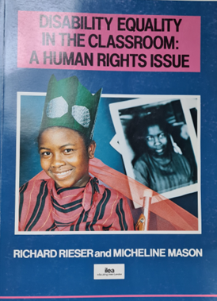I had come from a teacher trade union and socialist background and until this point had seen my impairments as a personal issue to be overcome. All this changed on the carpet of Micheline’s flat in Tooting as we argued and sought to find a way to reconcile our different views. I think I learned more from Micheline, but she also gained an understanding of the education system and wider social organisations. We met for the first time in September 1989 and what was meant to be a 80 page document grew and grew, as we agreed different experiences and thoughts had to be in ‘[Disability Equality in the Classroom : A Human Rights Issue’](http://worldofinclusion.com/res/deinclass/DEC1.PDF). Launched by the political leaders of the ILEA three weeks before its demise, copies of the 280 page handbook were sent to every school in Inner London, every English Education Authority. Largely due to Micheline’s thinking in bringing the social model into education to challenge the deficit thinking of the medical model (Special Education Needs view) a uniquely radical approach to the education of disabled people was presented, covering impairments, curriculum, disability equality, pedagogy and self-representation.

Several things arose from our collaboration. Micheline became a life-long friend and collaborator. The Alliance for Integration was formally formed following an initial conference. The 3000 remaindered books were delivered to me and Micheline. Disability Equality in Education was formed to deal with the distribution and training over the next 17 years. Founding the Alliance, Micheline worked with me to develop a constitution that would represent all our allies but have a majority of the Council as disabled people, so it could be part of the UK Disability Movement. This meant having places on the Council for disabled people with various descriptions, disabled school students, disabled teachers, disabled parents and allies being parents, teachers and headteachers, educational psychologists, non-disabled young people. It sounds cumbersome but as the first elected Chair for 12 years, it was very effective, following Micheline’s leadership. In the first 10 years Allfie supported many parent led local campaigns for inclusion, drafted an Integrated Education Bill for Parliament, adopted Inclusion rather than Integration and changed its name, worked closely with Parents for Inclusion, Education Psychologists for Inclusion, spoke at many education and training conferences and later set up Young and Powerful. We got grants from Platinum Trust and Barrow Cadbury. Micheline held, for the first time in her life, a regular paid appointment as Allfie Coordinator with an office.

In 1995, Save the Children approached the Alliance, concerned at the lack of portrayal of images of disabled children and to organise a conference of children’s image makers, both authors and programme makers. This was the highly successful [Invisible Children Conference](http://worldofinclusion.com/res/invisible/Invisible_Children.pdf). Out of this came the 1 in 8 Group which led to real changes both in books and children and adult programming.

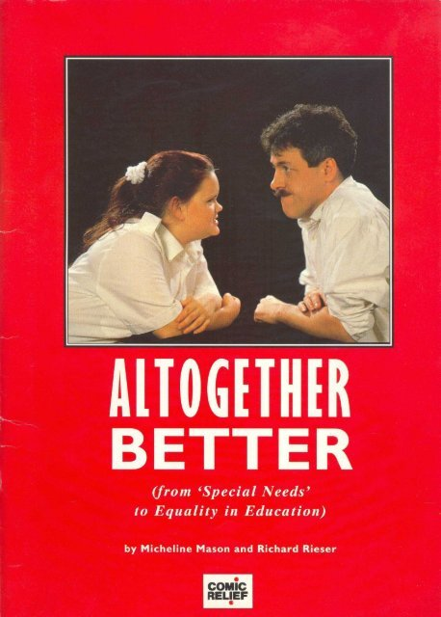Comic Relief were keen to work with us and Micheline became a member of their Board. The change in the images, their patronizing approach and their grant giving to DPOs is in no small way due to Micheline’s tenacity. Though they could not fund children they were able to commission a pack for training the adult workforce for inclusive education. ‘[Altogether Better](http://worldofinclusion.com/res/altogether/AltogetherBetter.pdf) from ‘Special Needs’ to Equality in Education’. This was another collaboration between Micheline and myself and gave us a valuable space to produce a more practical case for inclusive education. With a film from [Anthony Minghella - Break down the Wall](http://worldofinclusion.com/res/altogether/atb9.flv) and [Griff Rhys Jones in a head to head](http://worldofinclusion.com/res/altogether/atbShortPreview.flv) with an astute disabled student from Tottenham, linking film extracts chosen by Anne Pointon, Channel 4 disability advisor, this was a powerful salvo for inclusive education. It sold more than 10,000 copies and was used throughout the country for training education professionals.

Comic Relief funded the first national Disability Equality Trainers Training for Education at the Leicester Holiday Inn,1992. They gave an interest free loan for a second edition of a further 5,000 Disability Equality in the Classroom. In 2008, Comic Relief was able to fund children’s activities and they funded ‘Young and Powerful’, ‘The Alliance’’ and ‘Disability Equality in Education’ (DEE), a small charity based on the work of Micheline Mason & Richard Rieser. DEE has developed and trained a national network of 100 disabled Disability Equality Trainers in England and Wales. The trainers delivered high quality disability equality training for inclusion to schools and colleges. This was launched by Jacqui Smith MP, Minister at the DFE in 1999. Micheline and I worked on developing the materials and running the Training the Trainers. We thought the Alliance should be the campaigning organisation, which is why it was not a Charity, whereas DEE could be and it got funding. Its training was received by over 100,000 educationalists in the UK. 625 disabled people had received Training the Trainers training which developed a much more positive view of inclusive education in the Disability Movement, by the time it was wound up in 2008. This was because Labour had changed their mind and would no longer fund this important work.

Some of the other major achievements were getting a meeting with David Blunkett MP before the 1997 General Election. As the future Secretary of State for Education he committed to developing an inclusive education system. Amending the Disability Discrimination Act to bring all Education establishments under it and removing 2 of the caveats that prevented parents getting their wish for mainstream. We called this compulsory segregation. Micheline and I, along with Jo Cameron of PI on the Council for Disabled Children managed to get the support of all the Charities sitting there. Ministers, Estelle Morris MP and Jackie Smith MP also supported and brought in the 2001 Education Amendment Act. Support of the Disability Rights Commission, teachers’ unions and TUC helped. Things were not perfect but from 2002 to 2006 the range and number of disabled children successfully included in mainstream schools went up in England. The publication of the [Inclusion Assistant](http://www.allfie.org.uk/wp-content/uploads/2018/06/Inclusion-Assistant-Training-Pack.pdf)  which came out of a weekend workshop of young disabled people was another major achievement, later taken up by the Government (2007) for Learning Support Assistant training.

Further achievements were getting a Disability Equality Duty into the 2005 Act for all public bodies and UK Government support for the United Nations Convention on the Rights of Persons with Disabilities (UNCRPD), especially Article 24 on Inclusive Education.

However, as David Blunkett said to Lucy at a Young and Powerful meeting :‘Send Micheline and Richard a message. I could not do what I promised. The forces arrayed against us were too powerful.’ This was an unholy alliance of ‘SEN experts’, politicians led by David Cameron, special school headteachers, teachers who had not received adequate training, ill-informed parents, LA bureaucracy. [The Baroness Warnock, author of the report that led to the 1981 Act changing her mind about inclusion](http://worldofinclusion.com/res/warnock/Warnock_Ad.pdf) and a Government laisse faire approach, not requiring schools to admit disabled pupils. The Labour Government view by 2007 had shifted when Andrew Adonis , Schools’ Minister, told the Education Select Committee that Labour did not have a policy of Inclusive Education. Micheline joined in these public debates on TV.

In 2010, the Conservative /Liberal Democrat Government had a policy of countering the ‘Bias to Inclusion’ which was a nonsense, but together with austerity it led to an onslaught on the rights disabled people had gained.

In 2010, Rosa Branson launched her Portrait of the Inclusion Movement, painted 5 years earlier, which puts Micheline at the centre of multiple avenues of change. Launched after the first ever UK Disability History Month on the theme of Education at the Institute of Education, in November 2010, where the picture was hung.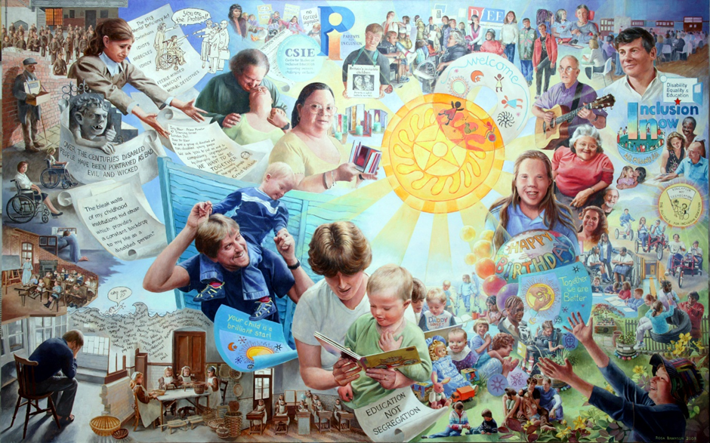

Speaking at that event Micheline said:-

“Inclusive education AND Disability Rights are here to stay. I have seen such an enormous change in this area in my life-time. When I was born in the 1950s to be disabled was a terrible tragedy. It was just seen as a life sentence. At the point a child got a diagnosis they would be called handicapped. The parents were told they would never achieve. The expectations for their life were extremely low. Certainly, for me it was never expected that I would leave home, that I would get married, have children, have a job or a voice in the world. None of those things were expected. There was no Disability Movement. Disability was seen as a God given tragedy and possibly a punishment for the past evil deeds of thew parents. Parents felt full of guilt and shame. As a disabled girl there was absolutely no place in this country where I could receive an education that would lead to taking public examinations.

There was no differentiation between people with different impairments. We were all handicapped, we were all the same and needed to be shouted at, patted on the head and treated as children for the whole of our lives. The best you could hope for was a job at Remploy. I can remember that word filling me with absolute horror. One of the reasons it is so important to say all this is because of how it makes you see yourself. Apart from the Rights you don’t actually have it makes you feel so insignificant as a human being. I think what happens is even when things change, because today disabled people have far more rights in the world and there is a growing understanding that we are an oppressed group. Like other oppressed groups it is the discrimination and mistreatment that makes our lives so difficult. Even with some of those improvements it doesn’t necessarily mean you feel any better about yourself, without actually learning the history, learning that we are part of a group that have resisted, that have come together and fought. It is disabled people who have brought about these changes and that is something that each generation needs to know. That they are part of that group of people who chain themselves to buses, who fought for the DDA, who did so many things to make lives better for ourselves and each other. That struggle and that history is not known. They still think the Government did it, kind souls, or parents did it.

It was disabled people who did it. We had to organise and do it. It’s a history we have to be immensely proud of. As Richard said if you look back at how we have been treated over the years, it’s amazing it did not work. We’re still here. We are coming out and getting stronger, louder and bigger all the time. So what does that say about human beings and what really matters to us? Something I have noticed we call it a struggle for inclusion. An awful lot of people are using that word and they know what it means. It has stirred something right in the core of our beings, which everybody wants. I don’t believe there is anyone on this planet who does not want inclusion in their hearts. It is only the fears and everything else that is stopping it. The bigger our voices and the more platforms we have to speak on the more we can move things forward and its not just for us but for a kinder world to live in.”

[2016 UKDHM Micheline read two of her poems](https://youtu.be/1B4C79h7-GY?t=31) Micheline’s poems are powerful and impactful. Not Dead Yet (2006) is as relevant now as then, with threats to introduce assisted dying.

**Not Dead Yet**

I have lived to see another spring

To breath in the blossom’s perfumed air

To feel again in the sun warming my skin

To wonder at the life we share

I have another chance to notice

Shining eyes meeting my own

Some with love, some with questions

The hope, fear, pain we have all shown

I can touch again those I care for

With my hands, my mind, my heart

They touch me as if for the first time

New thoughts, our dreams just start

Physical pain I have known plenty

Impairments hold little fear for me

But to feel unwanted, a burden, a weight

Is the intolerable pain I fear

The answer cannot lie in murder made easy

In fueling guilt, complicity and dread

It lies in the courage to create a kinder world

In which no one would choose to be dead

Happily, I am not dead yet

I have lived to see another spring

I will use every precious moment I have left

This welcome change to bring

**Micheline’s illustrations** of our inclusion message have often convinced people more than screeds of words.

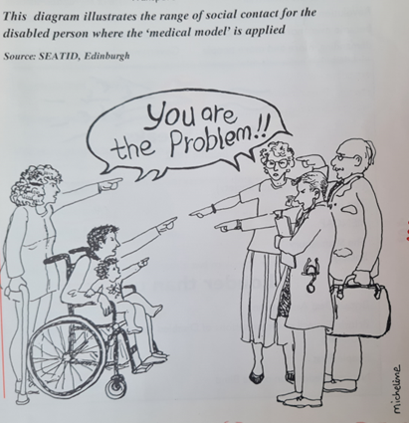

In 2019 for UKDHM Micheline and myself did a 2 handed interview on the [History of the Alliance for Inclusive Education](https://youtu.be/0XifUb3ng-0)

Going into retirement, Micheline was free to write and began to drill down into the origins of some of the thought barriers we had come up against that reversed the moves to inclusion. Micheline was always an optimist and strongly believed that much of what we had done by challenging the status quo of segregation and integration could not be put back in the box.

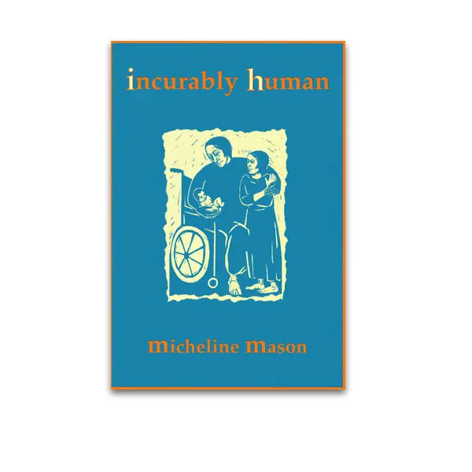So ‘Incurably Human’ and ‘Dear Parents’ published by Inclusive Solutions, bear witness to this deeper thinking and both still stand as invaluable templates for rekindling the Inclusive Education Movement.

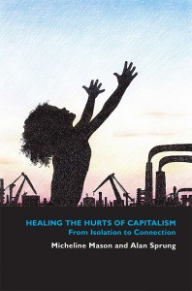

The Financial Crash of 2008 and Austerity led Micheline on a deeper investigation of Capitalism and its impact on the working class. Micheline was convinced that a process of healing in group meetings was necessary to empower working class people, including disabled people, to have the confidence to challenge the oppressive power of those in control.

Interview with Colin Newton [from Inclusive Solutions](https://youtu.be/Jwk59NA3BCQ?t=54)

Critique of the Conservative [Government SEN Green Paper and Plan](https://www.bing.com/videos/riverview/relatedvideo?q=Micheliune%20Mason&mid=F44A805E7C3E8382E042F44A805E7C3E8382E042&ajaxhist=0#:~:text=Micheline%20Mason%20%2740%20years%20SEND%20Framework%20campaigning%27%20%7C%20Inclusive%20Education%20Conference%2021%20%23ALLFIEAGM). Here Micheline says the Government has spoken to everyone but those who have grown up in the special segregated schools and can attest to their negative and long-lasting impact on their lives.

Those of us who worked closely with her will always venerate and be thankful for her insights and the challenge she provided which moulded the journey forward. In her memory we must continue. I will also never forget her joy and laughter.

As the American Socialist, Joe Hill said on his death by firing squad “ Don’t Mourn. Organise!”

**Richard Rieser friend, collaborator and comrade in the struggle for Inclusive Education and a better world. World of Inclusion and UK Disability History Month**