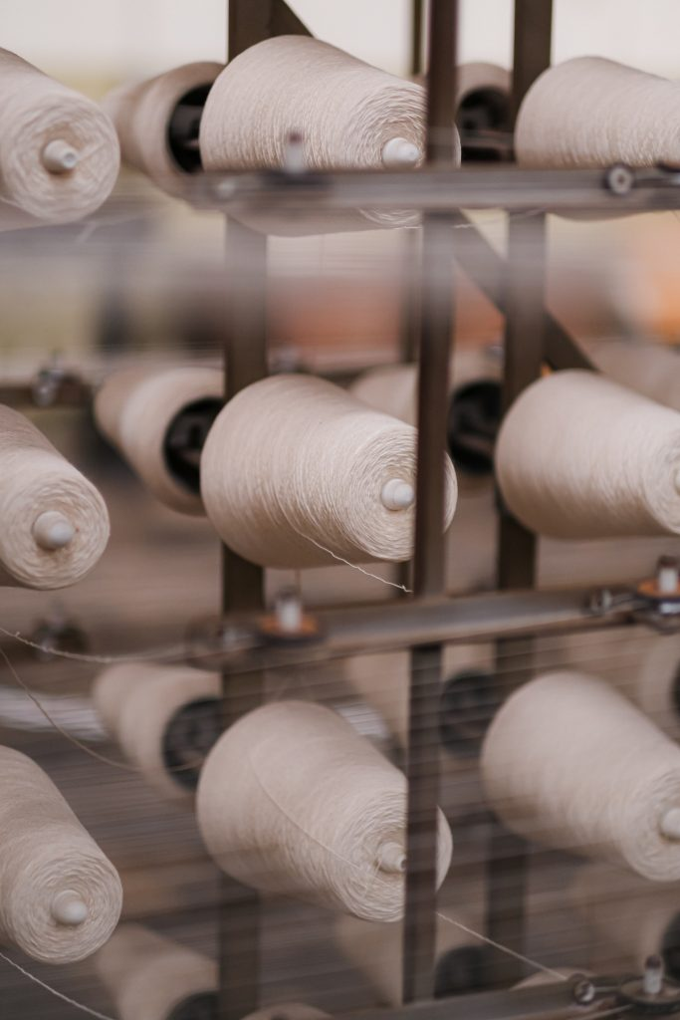
Download the full article here
Disabled people have always been part of the textile workforce of Lancashire, but their contributions have often gone unrecognised. Once the industrial revolution got underway, the narrative that disabled people were unable to work and had to depend on the workhouse or on charity took hold. This idea of disabled people as being dependent and needy continues to this day. But it’s not the whole picture.
The stories of Lancashire’s disabled cotton workers aren’t always easy to find. The mills didn’t keep any records of disabled workers, it wasn’t considered to be important. And few mill workers were able to read and write so didn’t record the details of their lives. However, local archives, censuses and other sources reveal some snippets of information that give us fresh insights into their lives. In this article, Gill Crawshaw shares some of her research into disabled mill workers in Lancashire.
These stories are valuable because they can help us to think differently about disabled people’s role in society – today and in the past – not as dependent or scroungers, but as active contributors to their communities. Disabled people were not bystanders, but played their part in Lancashire’s leading industry: cotton production.
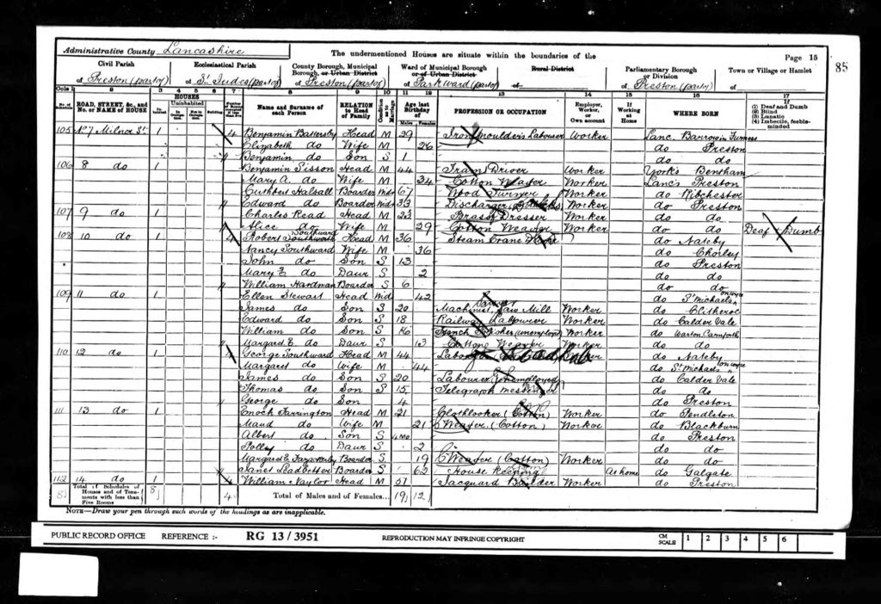In the census of 1901, Alice Read of 9 Milner Street, Preston is listed as a cotton weaver. In the far right column, she is listed in the category of the time as ‘Deaf and Dumb’. 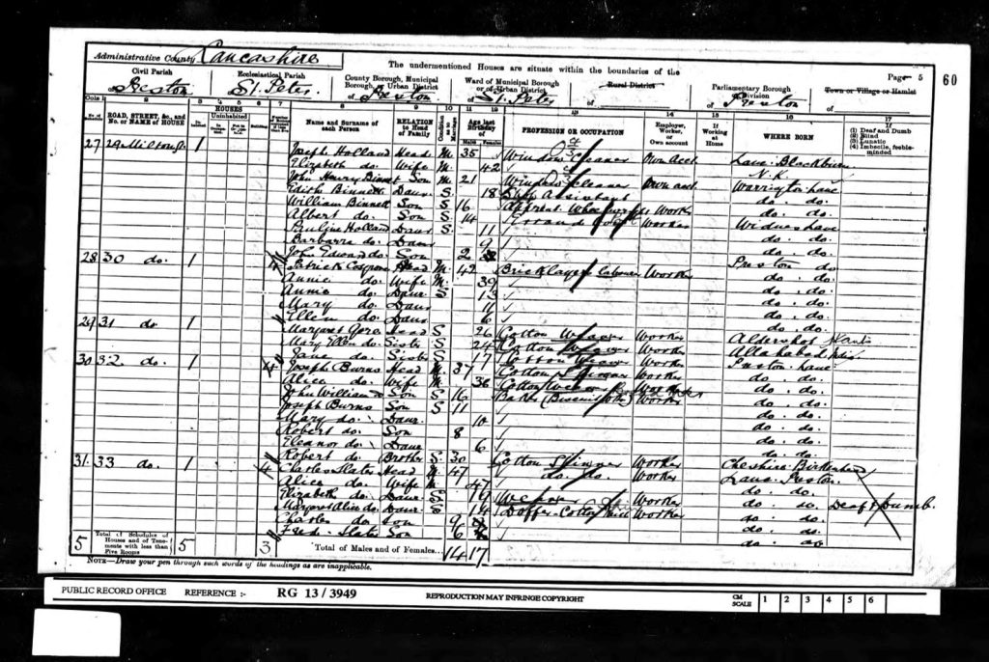Another census entry from 1901 shows Elizabeth Slater, a weaver, living with her family at 33 Milton Street, Preston.
Gill Crawshaw is a curator who draws on her experience of disability activism to organise art exhibitions and events which highlight issues affecting disabled people.
Gill has curated exhibitions which have addressed representation of disabled artists (Possible All Along, 2020), charity (Piss on Pity, 2019), cuts to welfare and public spending (Shoddy, 2016) and access (The Reality of Small Differences, 2014). Gill is interested in the intersection of disabled people’s lives with textile heritage in the north of England, as well as with contemporary textile arts. She is based in Leeds.
Gill gained an MA in Curation Practices from Leeds Arts University in 2018.
Email: gill.crawshaw@gmail.com
Website: https://shoddyexhibition.wordpress.com/

