Traces of disability amongst the Lost Workers
Posted on April 14, 2024 by gillcrawshaw2015
I trawled the records of the Lost Workers, available to browse at Dean Clough, looking for traces of disabled people and disability. The Lost Workers was originally an installation by Christian Boltanski, commemorating the workforce of Crossley Carpets, which was based at the mills at Dean Clough, Halifax until it closed down in 1982. Boltanski’s artwork had the appearance of an archive and was installed in a cellar room at Dean Clough, not long after the carpet mill had closed down.
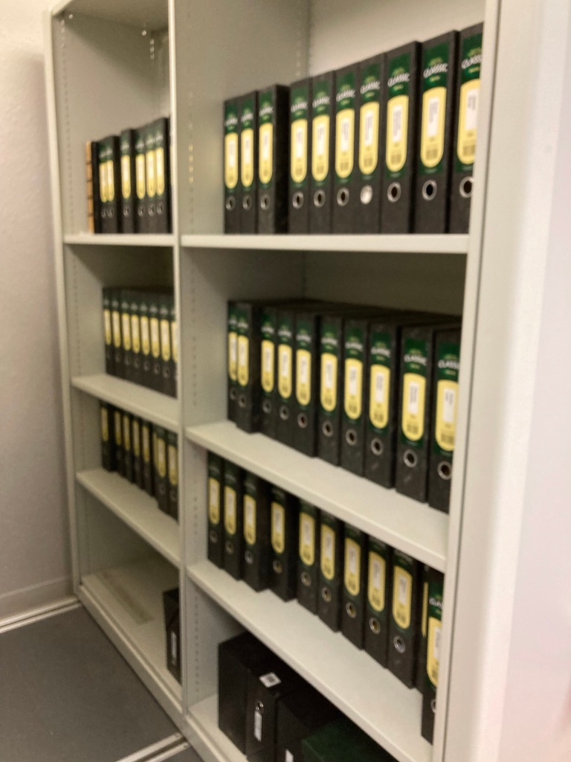The Lost Workers archive, Dean Clough
The installation no longer exists in its original form. Instead, there are several shelves of files with the names of workers from the 1960s, 70s and 80s. Many of the files contain just a photograph, but some have memorabilia, company newsletters, news cuttings, awards and so on, donated by workers or their relatives. I managed to find something to add to the story of disabled workers, although there wasn’t much beyond health and safety reminders.
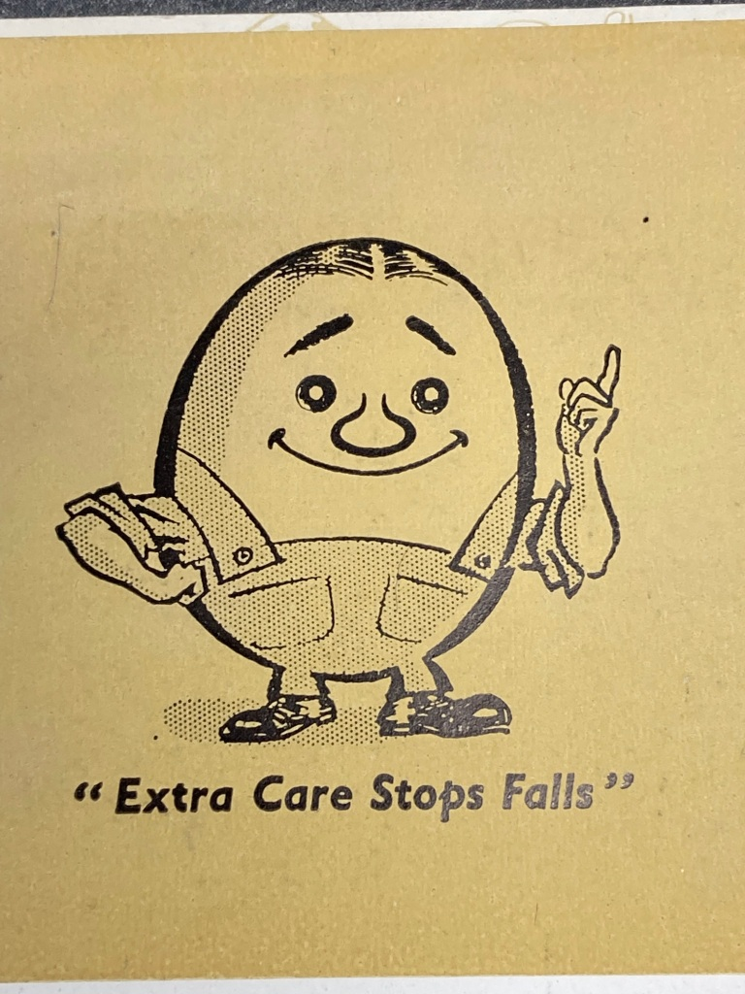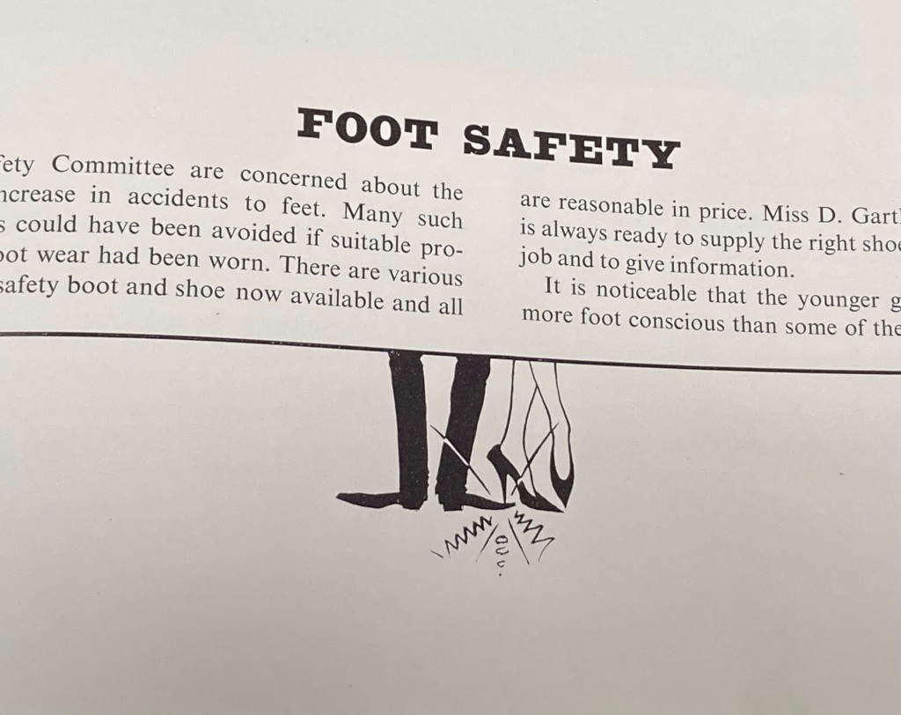
One box included a protective mask, clearly used. The stain on it suggests it saw heavier use than the ‘nuisance dust’ that it was made for. A stain suggests there may have been some injury or breathing problem.
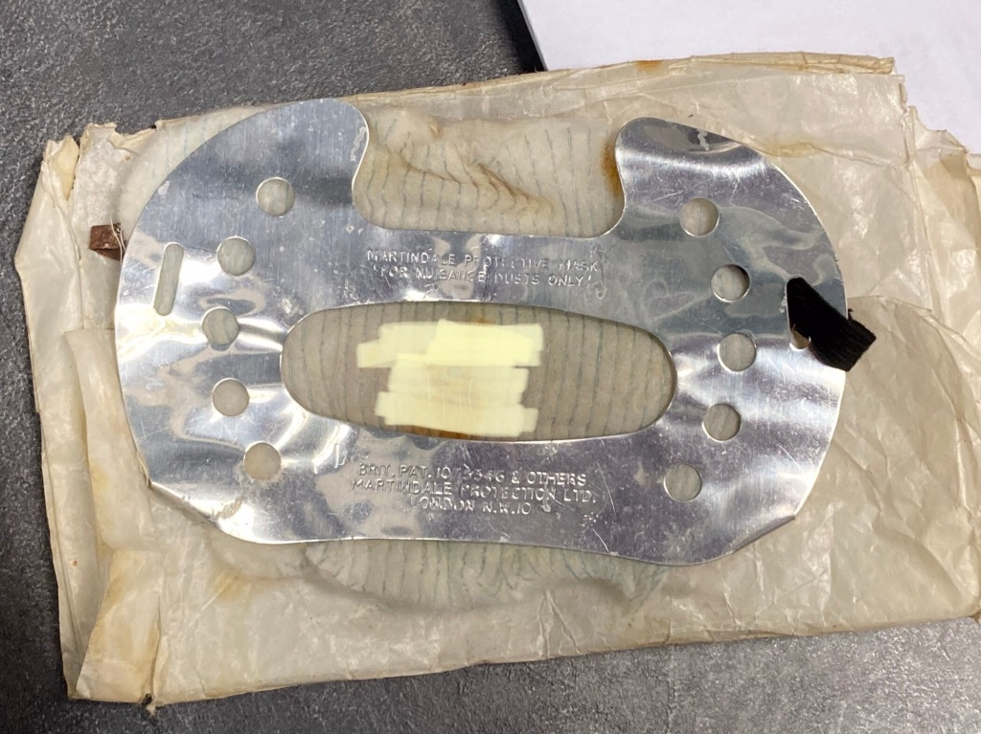A Martindale dust mask, well used
Another box included an audio screening device for carrying out hearing tests, with a couple of cards to record the level of hearing loss. This was a common industrial injury in textile mills right through to the 20th century. It was only in 1989 that the government brought in regulations around noise at work that made ear protection mandatory. Before this a 1972 code of practice advised employers to provide ear protection for workers in noisy environments, but many workers didn’t wear them.
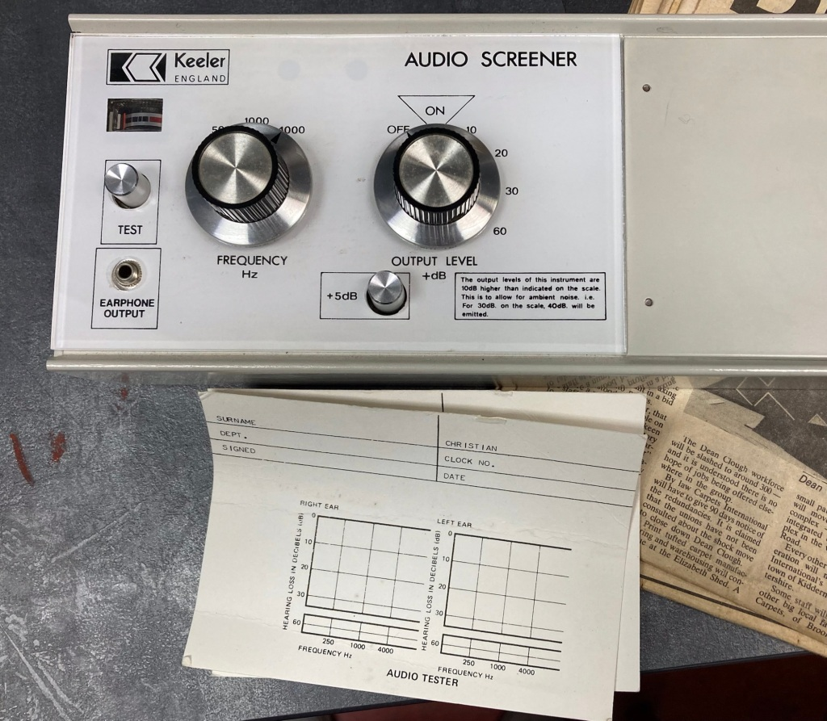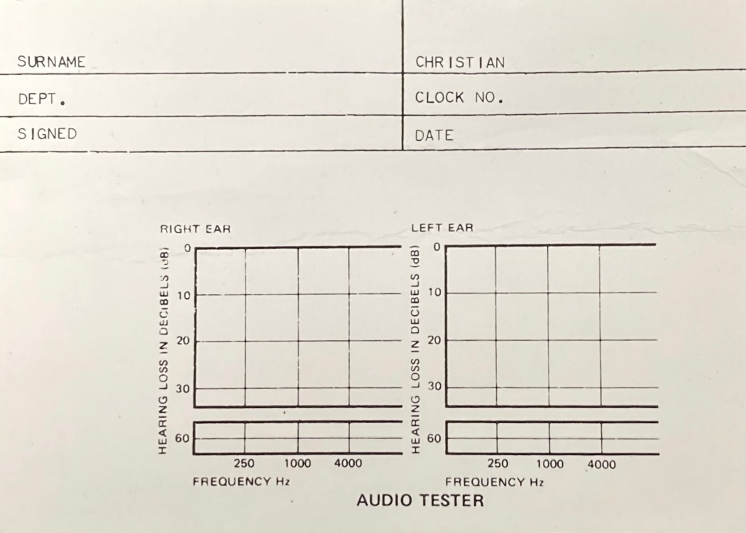
https://shoddyexhibition.wordpress.com/2024/04/14/traces-of-disability-amongst-the-lost-workers/

