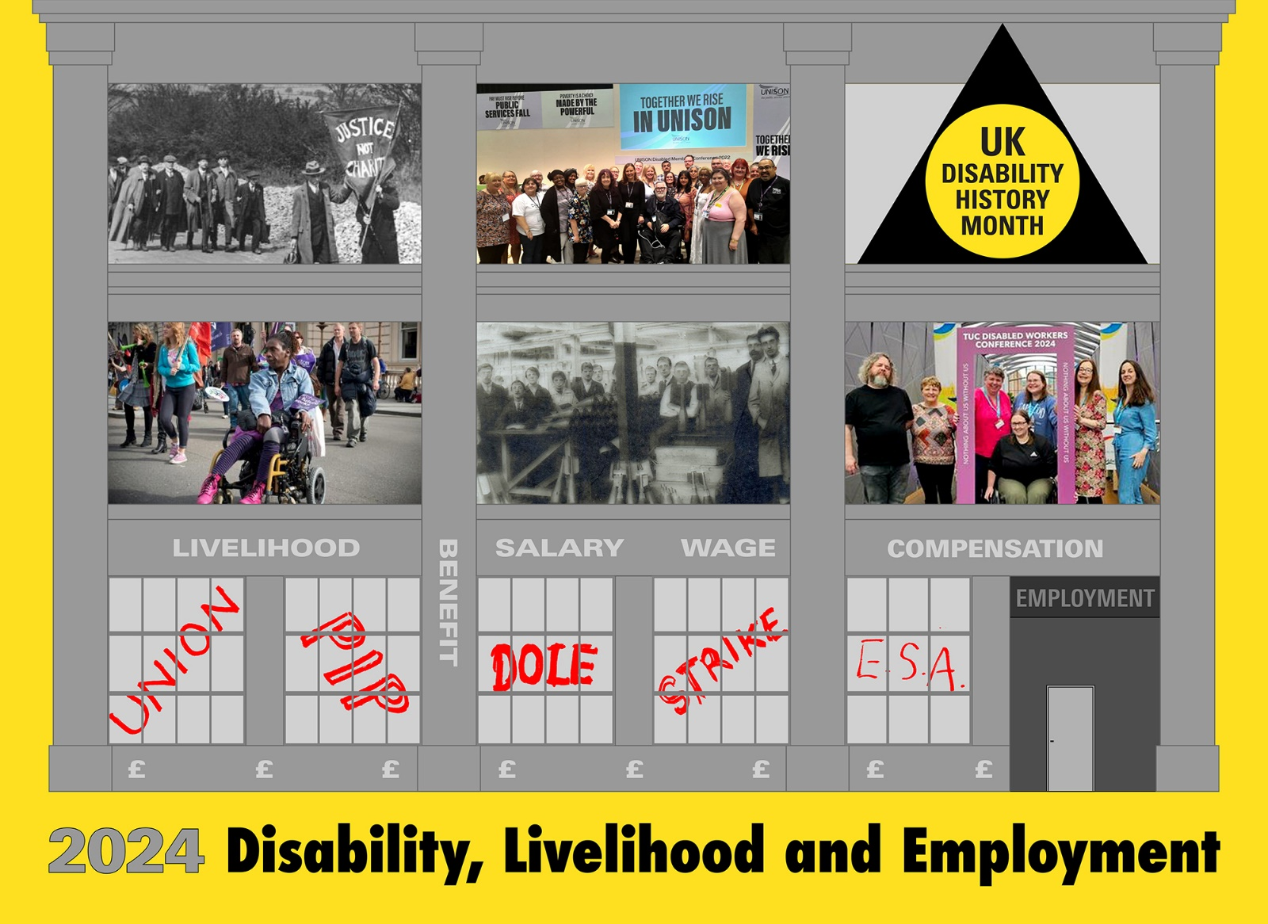

**[Description. A three-storey building-a workplace or factory. Grey with windows on a yellow background. Top floor 3 windows. Window 1. Men in hats, coats and suits marching along a road behind a banner ‘Justice not Charity’. National League of Blind marching to London 1920 for rights at work. Window 2. Diverse group mainly female with one wheelchair user holding a placard 'Together we are In UNISON' Disabled Members Meeting. Window 3. Logo UKDHM, Black triangle with yellow circle 'UK Disability History Month’. Middle floor, Window1. Black Woman in wheelchair on a protest for Right to Work. Window 2. Male Factory workers in Munitions Factory 1914-1918 all Deaf workers. Window 3. 1 man with beard and 5 women, one in a wheelchair. National Union of Journalists, Disabled Members at TUC Disabled Workers Conference 2024. Bottom Floor- 5 x 12 pane windows. Under Livelihood is Window 1 in red paint UNION, Window 2 PIP. Benefit written in-between. Window 3. Under Salary DOLE written in red, Window 4. Under Wage STRIKE written in red. Window 5. Under Compensation ESA is written in red. Next is a grey door with EMPLOYMENT written on it. Under the building against yellow background is written ‘2024 Disability, Livelihood and Employment’.]**

Disability has been seen for many years as synonymous with non-employment or unemployment. This is not true. Throughout most of history, disabled people have, wherever and whenever they can, sought a means of surviving largely without the state. **[Left: The Admiral’s Porter 1790. Wellcome. Disabled sailors with a job. A man with an amputated leg and crutch in C18th seaman’s outfit delivers a piece of paper to a servant in livery. He is accompanied by another man with his arm in a sling.**]

UKDHM use a social model/human rights approach to viewing disabled people and the disablism they were subjected to over time, even though this was not the thinking then. Impairment has always been part of the human experience, whether caused by accident, fighting and war, disease, genetics or malnutrition. It is the functional loss due to these causes that makes life harder and often more painful than for most people. Cultural and social explanations of the phenomena of impairment have generally been the biggest barrier to people with impairments.

These attitudinal, organisational and environmental barriers continually reoccur in different cultural manifestations, and it is these that disable us. Disablism expresses itself in discrimination and exclusion and is challenged by the human rights thinking of today. For thousands of years untrue stereotypes and stigma ruled our lives as disabled people. Then came notions of charity and the burgeoning medical sciences which created a new form of othering. At some periods these were more damaging than others, but for most times we got food, water, shelter and protection**. If we were not eliminated at birth or scapegoated, we survived through community and family support, survival subsistence, earning through self- employment or employment, begging, charity or later state organised welfare.**

Sometimes ideology such as Eugenics and prejudice have removed disabled people from the community by euthanasia, sterilisation or to long stay hospitals, asylums, workhouses or worse. At many times the community has supported us and all but those with the most significant impairments have found a livelihood. Today new threats are posed by Gene Therapy or Assisted Dying against a background of austerity, where disabled people have increasingly had the safety blanket of welfare and human rights removed.

**Let us look at some different examples from UK history**

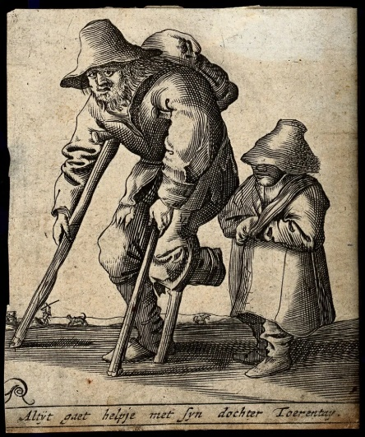[The Norwich ‘Census of the Poor’,](https://liverpooluniversitypress.blog/2023/12/11/a-history-of-disability-in-england/) “which took place in 1570, twelve years after Elizabeth I came to the throne. It provided a detailed analysis, based on door-to-door surveys, of the inhabitants of the poorest areas of this commercial second largest trading city, including its disabled residents. These were variously described as blind, deaf, ‘lame’, ‘crooked’ or lacking one or more limbs. The majority were married, usually to non-disabled partners, and most were working, including an 80-year-old yarn spinner and a 70-year-old blind baker**. [Right: C17th Disabled man with crutches walking with daughter.]** The picture is one of an integrated community of disabled people. They were poor and daily life was hard, as was the case for most of the population at this time. The hardship for this group was of course exacerbated by their impairments. However, there was no sign in the census of their being marginalised, forced out of mainstream society or seen as not belonging” says Simon Jarret. But tension was set up between non-disabled unemployed and disabled people by a series of Tudor [Poor Law](https://historicengland.org.uk/research/inclusive-heritage/disability-history/about-the-project/glossary/p/1418486/) Acts which viciously punished ['sturdy vagabonds'](https://historicengland.org.uk/research/inclusive-heritage/disability-history/about-the-project/glossary/s/1418532/) who were seen as idle by choice. They could be whipped and branded. But the ['impotent poor'](https://historicengland.org.uk/research/inclusive-heritage/disability-history/about-the-project/glossary/i/1418321/) were viewed differently. 'The person naturally disabled, either in wit or member, as an idiot, lunatic, blind, [lame](https://historicengland.org.uk/research/inclusive-heritage/disability-history/about-the-project/glossary/l/1418339/) etc., not being able to work…all these… are to be provided for by the overseers of necessary relief and are to have allowances … according to…their maladies and needs.’

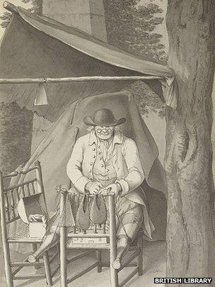Fear of the mob and fear of the different were both at work here. Economic hardship caused by the Plague, famine and wars led to increasingly the old feudal system breaking down and disabled and non-disabled people going ‘on the tramp’ to find work in the growing medieval cities.[**Disability historian David Turner**](https://www.bbc.co.uk/news/blogs-ouch-27975766) **says that although times may have been hard in centuries gone by, disabled workers sometimes enjoyed more equal rights than they do today.** Life was not easy prior to the Industrial Revolution, but the agricultural economy provided opportunities for disabled people to work in their own homes at their own pace - something we often hear disabled people calling for today, so they can contribute and not be entirely reliant on benefits**.**

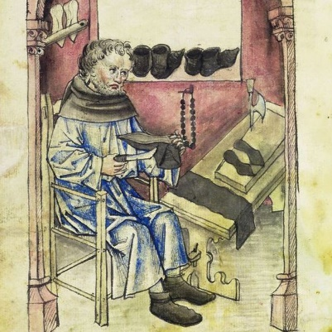

**[Left: medieval cobbler. Right: amputee cobbler Bath 1789.]**

Certain sedentary occupations such as tailors and shoemakers, had been seen as a suitable occupation for those with a physical impairment.

“An account of the Shropshire village of Myddle written around 1700 described one of its inhabitants, Anne Parkes, as being unable to walk until the age of 19, because of rickets. She supported herself by knitting gloves and stockings.

A hundred years later, a survey of the poor inhabitants of Cumwhitton near Carlisle described a 45-year-old man with a "lameness" who earned "a little money" by making baskets and beehives to support himself and his elderly mother. His status as a caregiver reminds us that not all work undertaken by disabled people, either now or in the past, is paid.

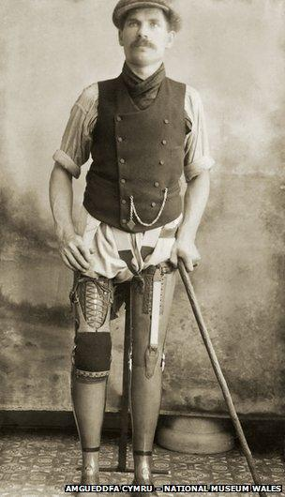The industrial revolution is often seen as a turning point for disabled workers. The coming of factories and heavy, mechanised industry, together with greater regulation of working hours and demands for increased productivity, meant that they were less able to compete in a labour market that was unresponsive to their needs.

But new research on Britain's coal industry challenges the extent to which disabled workers were excluded. Coal production expanded to meet the demands of Britain's industrial cities in the 19th Century, and it was a physically demanding industry with high rates of accident and death. A Victorian coal mine might be the last place one would expect to find disabled workers, yet there are accounts of miners with physical impairments working underground. **[Above: Man with flat cap and waist coat standing with a stick** **showing 2 prosthetic legs up to thigh. Disabled Miner George Preece 1909 after mining accident Abercynon Colliery.**]

In 1865 an explosion at the Upper Gethin Colliery, Merthyr Tydfil, claimed more than 30 lives, among them brothers David and Griffith Ellis. As the miners fled the suffocating firedamp (flammable gases) that followed the blast, David turned back to fetch his brother who had a prosthetic limb. Sadly, neither made it out alive.

In some areas miners worked in family groups. David Ellis had supported his brother, so they could both work at hewing coal.

One journalist described the lifeless body of the "poor lad with a wooden leg" as one of the most affecting sights of the disaster. But no reporter questioned the presence of disabled men working underground in a dangerous and demanding occupation, nor did they hail the amputee as "inspirational" in the way today's press might do.

Victorians differentiated between "total" disability that prevented a person from working - and thus made them liable for state support under the Poor Law - and "occupational" disability that prevented a person returning to their old job, but who was still able to work.

Men who were disabled in the mining industry may have been able to take lower-paid work on the surface, or even return underground as supervisors.

Thomas Haswell, killed in an underground explosion at Thornley Colliery near Sunderland in 1841, was an experienced coal hewer but had been working as an overman (supervisor) after breaking both legs in a rock fall the year before. Though newspaper reports of the disaster described him as a "cripple", Haswell's impairments may have marked him out as a survivor, earning the respect of the young crew who worked for him.

Since the late 19th Century, disabled people have faced greater obstacles in the workplace. The expansion of legislation to provide greater compensation for injured workers, beginning with the Employers' Liability Act of 1880, hardened attitudes towards risk and made it less likely that bosses would take disabled people on.

At times of national crisis such as the two world wars, demand for disabled workers increased due to the lack of available labour. But in times of economic difficulty - the depression of the 1930s for instance - unemployment was high and disabled people were less successful at competing for jobs.

There is no evidence that disabled people in history have been unable or unwilling to work. Their ability to do so has depended on the structure of working environments, availability of resources, supply and demand in the labour force, and on the support and the attitude of employers, particularly towards risk.” Turner

**Industrial Revolution, Coal Mining and Disability**

Early factories were powered by water that restricted them to areas of fast flowing water, such as in Derbyshire or burning wood for which there was heavy demand. The change to coal began in 1770 and in the following 100 years it spread as a magnate to industry, with many new collieries, some reached by the new canal network to power steam engines in factories nearer to raw materials, labour and growing cities such as Birmingham, Cardiff, Manchester, Leeds and Newcastle and numerous pit villages. The coal mining industry grew to be the largest employer of labour but also the most dangerous to work in, as mine workers were exposed to flammable gas, dust, rock falls and equipment failures. Having the greatest risk of death of any industrial workers, Muir estimated in 1800 to 1850 they were at significant risk of disablement with perhaps 100 non-fatal accidents to every fatal one. Benson for the second half of C19th says ’A miner was killed every 6 hours, seriously injured every two hours and injured badly enough to need a week off work every two or three minutes.’ On top of this as mining developed more safety regulations it became apparent that many miners developed occupational impairments, such as black lung or pneumoconiosis and significant sight problems.

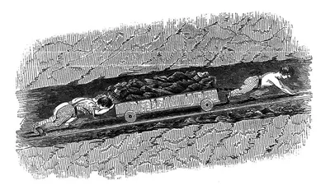The phenomenal growth of the industry is given by these figures of annual output

1700-under 3 million tons

1750- 5 million tons

1830-30 million tons

1870 -128 million tons

1914- 228 million tons peaked.

Employment grew rapidly as mining in C19th was intensively manual-pick and shove. The work force rose from 40,000 in 1800 to 485,000 in 1880 and progressed to over 1.19million in 2019. The shortage of labour was one reason why many disabled miners returned to the pit, going underground if they could manage or taking a lower paying surface job. **[Above: Children dragging and pushing coal underground.]**

As Turner and Blackie in their ground breaking study [Disability in the Industrial Revolution](https://pubmed.ncbi.nlm.nih.gov/30011158): Physical Impairment in British Coalmining, 1780-1880) show by studying three different important coalfields in North East England, South Wales and Central Scotland that significant geological variation not only affected rates, scale and method of extraction, but also the social organisation of the mining communities. This in turn leads to differences in working practice, risk of impairment, industrial relations welfare provision for sick and injured miners and shaped the experience of disabled people in mining communities in multiple ways. There was also variability across coalfields and from colliery to colliery of the level of accepting severely impaired colliers back to work.

What is clear from this study is the reasons why disability theorists such as Finklestein, Barnes and Oliver put forward disabled workers being rejected i.e. growing speed of production, stricter discipline, more stringent timekeeping and standardisation did not apply uniformly. The reasons seemed to be fear of destitution, the workhouse and community solidarity that motivated disabled miners to stay in work if they possibly could. The close-knit community, mine owners’ paternalism with strong solidarity from peers in local trade union branches and local friendly societies, looked after miners welfare when they could not return to work.

A second study [**Disability in Industrial Britain:**](https://www.manchesterhive.com/display/9781526124326/9781526124326.xml) **A cultural and literary history of impairment in the coal industry, 1880-1948 by Kirsti Bohata et al** showed that statutory compensation legislation did reduce chance of work for severely impaired miners. The book considers the coal industry at a time when it was one of Britain’s most important industries and follows it through a period of growth up to the First World War, through strikes, depression, wartime, and into an era of decline. During this time, the statutory provision for disabled people changed considerably, most notably with the first programme of state compensation for workplace injury. And yet disabled people remained a constant presence in the industry, as many disabled miners continued their jobs or took up ‘light work’. The burgeoning coalfields literature used images of disability on a frequent basis and disabled characters were used to represent the human toll of the industry. A diverse range of sources are used to examine the economic, social, political and cultural impact of disability in the coal industry, looking beyond formal coal company and union records to include autobiographies, novels and oral testimony.

**It argues that, far from being excluded entirely from British industry, disability and disabled people were central to its development.**

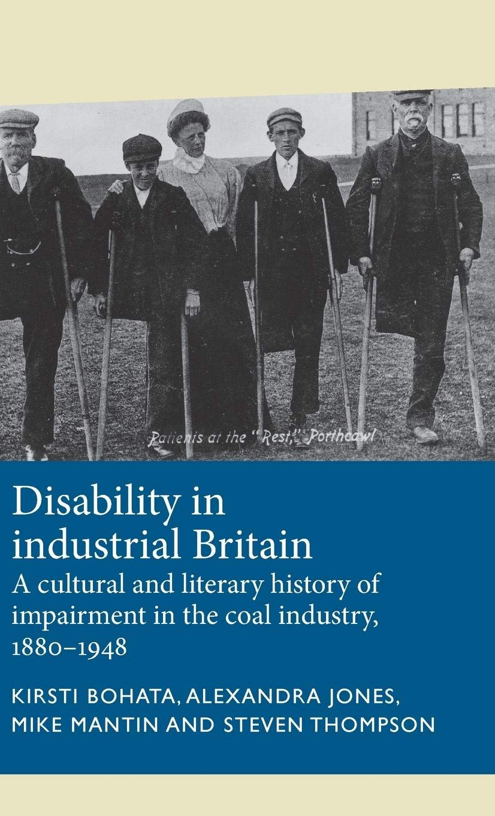

**[Above: 4 amputee miners with crutches with nurse, outside the “Rest” at Porthcowl funded by South Wales Miners Federation.]**

Mass gatherings of protest, not to mention community celebration and commemoration, have long and diverse histories which predate the organised London marches of the interwar period. In the literature and iconography of the coalfields, community solidarity and protest are evoked via a range of mass gatherings, from military procession to riot, funeral marches to carnival, and disability is an

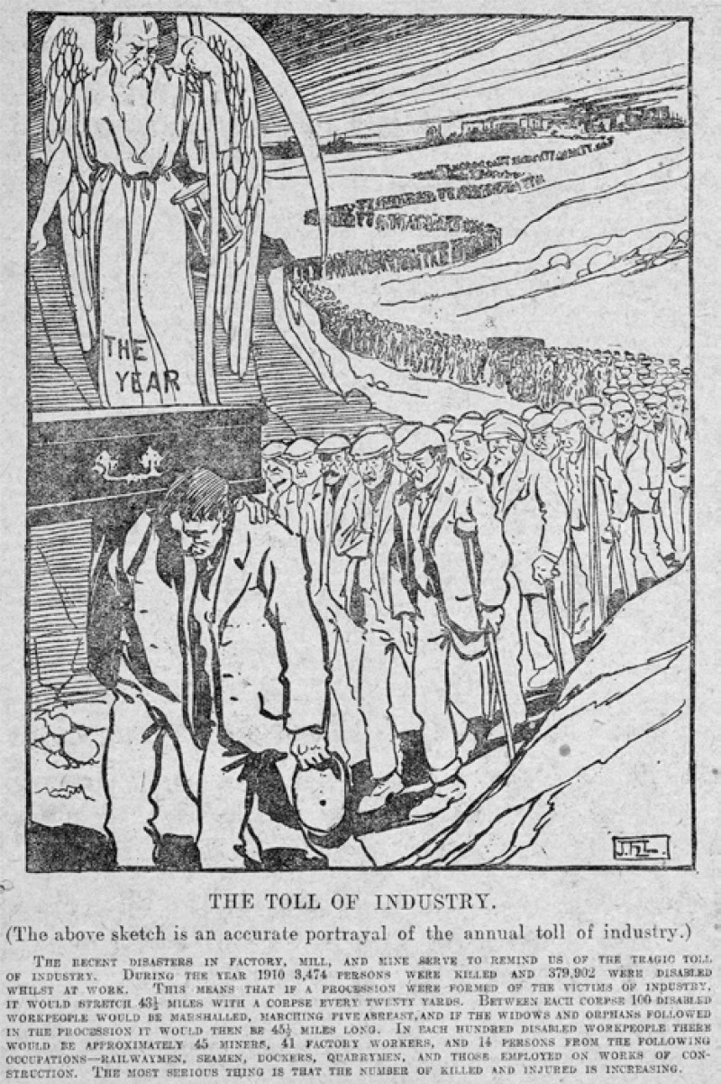important element in all of these. **[Below: *The Toll of Industry* a cartoon in Labour Leader, 1911. A long line of marching men, many with crutches carry, a coffin at the front on top of which is Father Time labelled The Year. The writing at the bottom says** ‘**During the year 1910, 3,474 persons were killed and 379,902 were disabled whilst at work. This means that if a procession were formed of the victims of industry, it would stretch 43½ miles with a corpse every twenty yards. Between each corpse 100 disabled workpeople would be marshalled, marching five abreast, and if the widows and orphans followed in the procession it would then be 45½ miles long. In each hundred disabled workpeople there would be approximately 45 miners, 41 factory workers, and**

**14 persons from the following occupations – railwaymen, seamen, dockers, quarrymen and those employed on works of construction.’]**

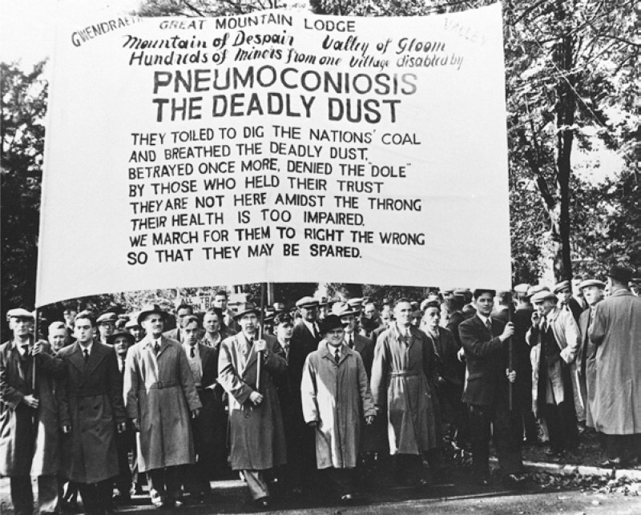The impetus for Health and Safety at work was laid by these experiences in Coal Mine Regulations 1860 /Factories Acts that finally came to fruition in the 1975 Health and Safety at Work Act. Not **Red Tape** but life saving and respecting employees’ interests.

**Nystagmus** was a condition of the eye that impacted on increasing numbers of underground miners and cleared up when they were no longer underground. As time went on the old rock falls and explosions became less as work became more safety conscious, largely due to the efforts of the unions, but as mechanisation was introduced more problems arose in the mines in C20th. **Pneumoconiosis** or Black Lung impaired more and more miners. **[Above:** **Pneumoconiosis banner and marchers in NUM march, 1952 Hundreds of Miners disabled by Pneumoconiosis the Deadly Dust. “They toiled to dig the Nations Coal and breathed the deadly dust. Betrayed once more denied the ‘Dole’ by those who held the trust. They are not here amongst the throng their health is too impaired. We march for them to right the wrong so they may be spared.”]**

**Textile Industry and Disabled Employees**

Gill Crawshaw a disability activist and archivist has been examining disability and workforce in C19th Lancashire cotton and Yorkshire woollen mills. Disabled people have always been part of the textile workforce of Lancashire, but their contributions have often gone unrecognised. Once the industrial revolution got underway, the narrative that disabled people were unable to work and had to depend on the workhouse or on charity took hold. This idea of disabled people as being dependent and needy continues to this day. But it’s not the whole picture.

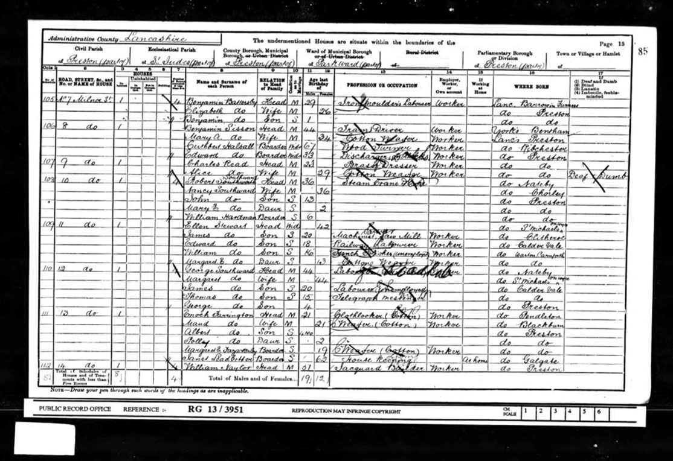The stories of Lancashire’s disabled cotton workers aren’t always easy to find. The mills didn’t keep any records of disabled workers, it wasn’t considered to be important. And few mill workers were able to read and write so didn’t record the details of their lives.

However, local archives, censuses and other sources reveal some snippets of information that give us fresh insights into their lives.

**[Above: The census of 1901. Alice Read of 9 Milner Street, Preston is listed as a cotton weaver. In the far right column, she is listed in the category of the time as ‘Deaf and xxxx’.]**

**John Dawson****,** a disabled Leeds man who gave evidence to the Factories Inquiry Commission, which led to the 1833 Factory Act. The evidence given by disabled mill workers like John, about the toll that factory work had taken on their bodies, was a crucial factor in bringing about factory reform. Subsequent legislation reduced the hours and raised the age at which children were allowed to work, and improved safety. In speaking up, often in the face of intimidation from mill owners, these disabled workers played their part in campaigns for better conditions. John was in his 20s when he went before the commissioners in Leeds. He was no longer working in a textile mill, but he recalled that he had done this for many years, as a child and a youth.

“I was between six and seven when I first began to work in Shaw and Tennant’s flax-mill in Leeds as a doffer” …The mills caused him to become disabled, his knees were affected significantly so that, years later, he still had great difficulty walking. Despite pain and deformity developing in his legs, he continued to work: “I was obliged to do it or go” (lose his job). As well as a doffer, removing full bobbins from the spinning machines, John also hugged bobbins, carrying full bobbins from room to room, making sure the thread didn’t unspool from them.

[**Sarah Hartley Bobbin winder**](https://shoddyexhibition.wordpress.com/2023/04/23/sarah-hartley-bobbin-winder/comment-page-1/#comment-1536)

Sarah Hartley was one of the ex-pupils of the Yorkshire Institution for the Deaf and Dumb (YIDD) who appears in their reports of 1844 and 1859 and who went on to work in a mill. Sarah is one of this group who I’ve been able to find out more about, with the aim of revealing hidden stories of disabled mill workers.

**[Above: Sarah Hartley, Leeds, report by Didkinson & Barraclough.]**

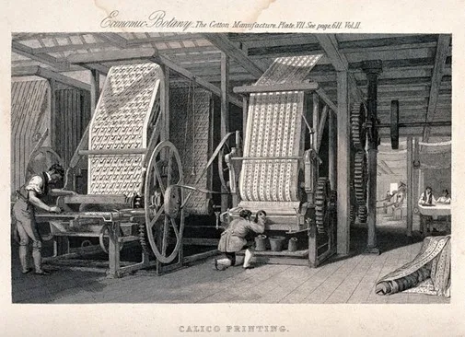Gill was intrigued by the statement from her employer in the YIDD report that Sarah “is not quite so even tempered as other girls in the same employment. This suggests to me that she was a spirited young woman who didn’t meekly put up with the frustrations of her job. As well as the hard conditions, I’m sure there would have been frustrations in communicating with colleagues, particularly the overlooker. While other workers might have begun to develop signs to aid communication, this didn’t necessarily extend to the overlookers and managers who saw themselves in a different class. Her classmate Jane Holmes was employed in the same role at the same worsted factory, so hopefully they were able to support each other.”

**[Above: Workers calico printing at looms in a Victorian cotton mill, 1855.]**

**Sarah’s education** The Yorkshire Institution for the Deaf and Dumb (YIDD) was established in 1829 as a school to educate young Deaf people so they would be able to support themselves as adults. Sarah and Jane started at YIDD just a year after it opened. In the first year the school only accepted boys, but in 1830 several girls began their education there. Sarah stayed for five years. Children lived in at the school.

* While Sarah was at the Yorkshire Institution in the 1830s, the children were taught using the ‘silent ‘or ‘manual’ method, where communication was based on signing and finger-spelling. There were a few Deaf teachers and assistants, some of whom had been pupils at the school. The institution’s annual reports and other publications included illustrations showing the finger-spelled alphabet to encourage their supporters to use it to communicate. So Sarah would have used sign language, at least at school. Later on, in the 1870s, the school started experimenting with oralism, based on using the voice and lip-reading. In 1880, the infamous Milan Conference, the Second International Congress on Education of the Deaf, declared that sign language was inferior to oralism, and should be banned. This led to the widespread suppression of sign language in Deaf schools throughout the world, stifling Deaf culture and many Deaf teachers were sacked.

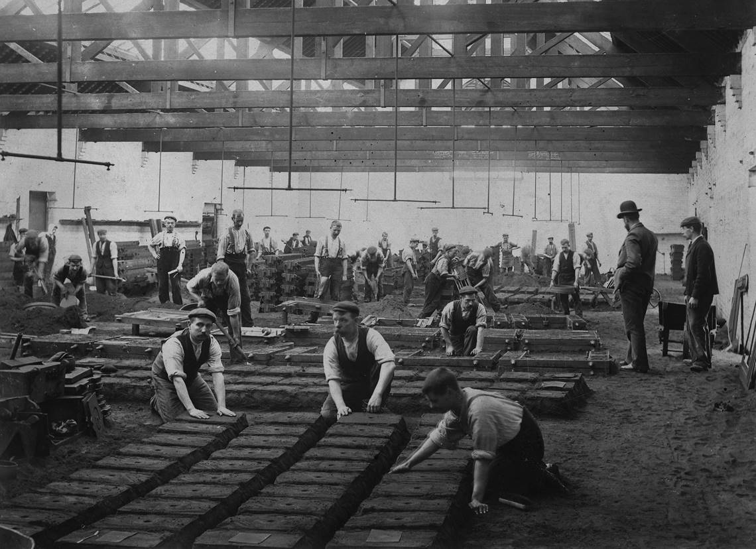[**Albert Marshall Cureton (1853-1912**](https://www.ironbridge.org.uk/learn/museum-collections/stories-from-the-collections/lives-of-disabled-workers/)**)** was an iron moulder who was Deaf. Born in Coalbrookdale to Joseph and Eliza, he was one of five siblings and grew up with his family at Bawdy Bank. When he was eight years old, Albert was sent to ‘The General Institution for the Instruction of Deaf and Dumb Children’ which had been founded in Edgbaston near Birmingham in 1812. During his time at the school, Albert was taught by Mr Hopper, the headmaster, two assistant masters, a matron and three female teachers, all of whom were Deaf, and former students of the school. A typical day at the school consisted of six-hours of teaching with the evenings free for recreation and chores. Sign language was the principal method of teaching and children were taught subjects that would prepare them for future employment. After 1880 the Deaf teachers would have lost their jobs. From 1871 until 1912 Albert worked as an iron moulder for the Coalbrookdale Company. It was a repetitive but dangerous job, with workers being paid by the piece to make moulds and pour molten iron into them to produce cast-iron goods. Pouring the iron required teamwork as it had to be carried in a heavy ladle by two workers before being poured into a mould.

**[Above: Iron moulders like Albert at work in the Coalbrookdale Company’s Severn Foundry, c. 1901.]**

Albert would not have been able to use sign language whilst carrying the ladle, so it is likely that he communicated through lip reading instead. Albert lived a relatively short life, dying at the age of 58. Iron moulding was a dangerous job; it caused conditions such as silicosis and anthrax infections and it was a very hot environment where burns were common. We don’t know much about the end of Albert’s life, but he was taken to Madeley Union Infirmary in December 1912 where he died.

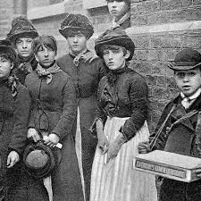**Mass Trade Unionism**. From 1880 to 1914 saw a big upsurge in mass trade unionism and many strikes to improve conditions, pay and hours. As there were many disabled people working in so called semi- skilled and unskilled jobs they would also have benefitted. This 'new unionism' brought organisation to large numbers of unskilled workers, encouraged by the successes of groups like the London gas workers in 1888, in their demands for a three-shift system (which meant an eight-hour day), the London dockers in their strike for a rate of six pence an hour (the "docker's tanner") and the match girls at Bryant and May. This was also the period when the first Trade Union for Blind and later disabled people, was founded.

**[Above: Match girls on strike 1888. Many had phossy jaw from working with sulphur.]**

****Justice not Charity. Ben Purse, born in 1874,** was a blind piano tuner who had trained at Henshaw’s Blind Asylum, Old Trafford. **[Right: black & white portrait photo of Ben Purse, wearing dark glasses.]** Purse had lost his sight completely by the age of 13. After failing to get work Purse decided to form a radical organisation of only blind and partially sighted people. Purse and the newly formed National League of the Blind (1899) argued the need for an entitlement to direct state aid and the abolition of all charities. Purse was a strong advocate of self-representation, using parliamentary and direct action, arguing a trade union was required in order to represent workers who were being exploited in private industry and in the charity sector. Ben stayed connected to NLB until 1920s, then moved away from the NLB’s radical aims, wishing to work with charities to improve the lot of blind people. Ben’s dream of a [minimum wage](https://www.gov.uk/hmrc-internal-manuals/national-minimum-wage-manual/nmwm01020#:~:text=The%20National%20Minimum%20Wage%20Bill,pay%20for%20virtually%20all%20workers) was only introduced 48 years after his death in 1997.

The **National League of the Blind** of Great Britain and Ireland (founded in 1894) joined the TUC (1902) and the Labour Party at its first Conference (1906), which endorsed the NLB policies, including education and training for blind students in mainstream institutions. Conditions in the charity workshops for blind workers were notorious for their excessively low wages. Workers often had to beg to augment their meagre incomes. They organised many strikes, one for 6 months in Bristol, 1912. Organisations such as the NLB and its influence in the TUC and Labour Party helped frame the Beveridge Report and the instigation of the Welfare State. As well as collective bargaining for workers in charitable foundation workshops, the League campaigned for the state to take over responsibility for employing blind people and for a decent pension for those who could not work. 74 blind workers from Scotland and north-east England travelled to Leeds, setting off on 5th April 1920. 60 workers from Ireland and the north-west left Manchester and 37 from the south west departed from Newport. They marched behind a banner reading ‘Justice not Charity’, the marchers reaching Trafalgar Square on 25 April, supported by London trade union branches. **[Above: photo of the march.]** They then waited five days to see Prime Minister Lloyd George. The Blind Persons’ Act became law (September 1920). Despite the huge propaganda success of the march, the law was less prescriptive than the League had wanted. A further march was organised in 1933.

**The First World War** [**https://ukdhm.org/2014-broadsheet/**](https://ukdhm.org/2014-broadsheet/)UKDHM has previously looked in detail at the 1st World War and what happened to the more than 2 million veterans who returned to a ‘Land fit for Heroes’ and were largely ignored. The Government pushed for a charity response for getting them back to work. The King’s Shilling and other such schemes. Only after a long struggle was a pension granted and this was inadequate. However, the demand for men to fight had led to advances in rehabilitation which were later offered to civilians as well.

The shortage of labour in the factories led to a huge boost in female employment and the recruiting of disabled

people who had in the pre-war period found it difficult to get a decent job.

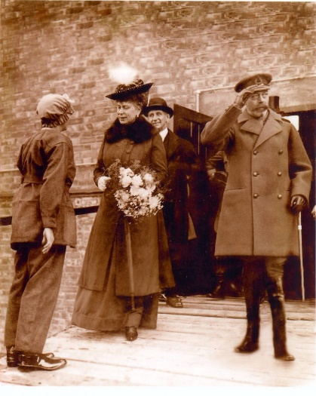**[ Above: a group of factory workers (male) with shell cases. Caption London Deaf on munitions work. Below right: Victoria as one of youngest workers HM Factory Gretna chosen to give bouquet to Queen Mary.]**

The Devil’s Porridge “Many who worked in munitions factories, such as HM Factory Gretna were also disabled. Some had arrived at the factory disabled or injured and were unable to do active service. [Eric De Clemont lost his eye and contracted miners phthisis](https://www.devilsporridge.org.uk/the-life-and-death-of-eric-de-clermont) before the outbreak of war. Considered unfit for active service, Eric spent the war working in the cordite section as a sub-section officer at Gretna. Others were disabled through their work at Gretna. Victoria May McIver lost the lower part of her arm in an accident at the factory[. In later life, one of her son’s friends was amazed at her skills at potato peeling, balancing the potato in the crook of her elbow](https://www.devilsporridge.org.uk/victoriamaymciver)”.

[Before the First World War](https://historicengland.org.uk/research/inclusive-heritage/disability-history/1914-1945/mental-deficiency-between-the-wars/), the 'mentally deficient' had been seen as incapable of work. But when thousands of employed people signed up to fight, disabled people were left behind and found to be useful members of the workforce for the first time.

As the war drew to a close, this was about to change. Ex-servicemen were coming home from the front, and they wanted their jobs back. The 'science' of [eugenics](https://historicengland.org.uk/research/inclusive-heritage/disability-history/about-the-project/glossary/e/1418145/) was in fashion at this time. Those who believed in eugenics argued that ['defective'](https://historicengland.org.uk/research/inclusive-heritage/disability-history/about-the-project/glossary/d/1418128/) members of the population would cause a general [degeneration](https://historicengland.org.uk/research/inclusive-heritage/disability-history/about-the-project/glossary/d/1418132/) of the country's racial stock unless they were kept strictly controlled and segregated, and if possible, [sterilised](https://historicengland.org.uk/research/inclusive-heritage/disability-history/about-the-project/glossary/s/1418530/). In line with this thinking, the 1913 Mental Deficiency Act set up a new ['Board of Control'](https://historicengland.org.uk/research/inclusive-heritage/disability-history/about-the-project/glossary/b/board-of-control/). It specified that 'mental defectives' should either be closely supervised in the community or kept in a new type of institution, the ['mental deficiency colony'](https://historicengland.org.uk/research/inclusive-heritage/disability-history/about-the-project/glossary/m/1418381/). **[Below: Photo of the main driveway at Harperbury 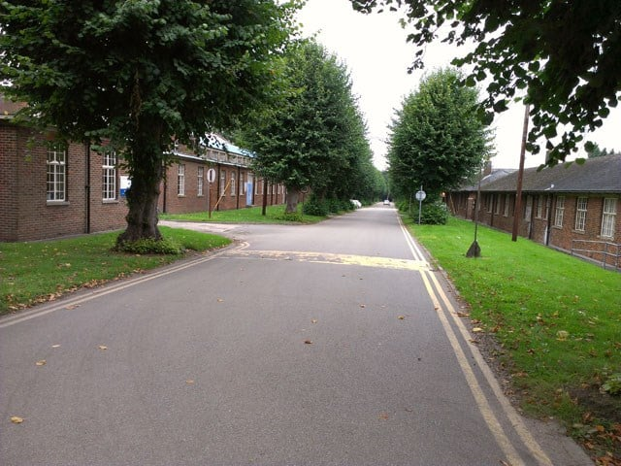hospital (formerly the Middlesex Colony).]**

As a result, a network of small, self-contained 'scattered villages' was established across the country to provide permanent settlements for children and adults. The inmates often stayed their whole lives and they were only closed in 1990s. They were adults, worked in the colony, but just got pocket money.

**2nd World War and after**

The Government learned some lessons and introduced the [**Disabled Persons Employment Act of 1944**](https://www.legislation.gov.uk/ukpga/Geo6/7-8/10/enacted) anticipating more unrest if it did not provide more for disabled veterans. This led to an ineffectual quota that many employers got round, a disability register, Remploy workshops, rehabilitation and vocational training. In 1950s and 1960s many disabled people worked but different impairment groups as today had differential employment rates. The Chronically Sick and Disabled People Act gave more support to disabled people from Service providers, but things did not seriously change until the 1995 Disability Discrimination Act incorporated into the 2010 Equality Act.

**Recent Developments**

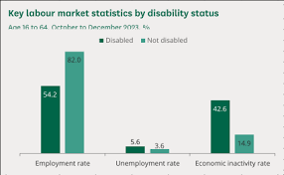It is now possible to challenge employers for Disability Discrimination at an Employment Tribunal and this includes failure to make reasonable adjustments. Using the definition of disability in the Act there were 10.21 million people of working age (16 to 64) who reported that they were disabled in October to December 2023, which is 24% of the working-age population.

**[Above: Bar chart showing these key labour market statistics by disability status.]** This is an increase of 459,000 from the year before. The economic inactivity rate for disabled people was 42.6%, which compared with a rate of 14.9% for those who were not disabled.

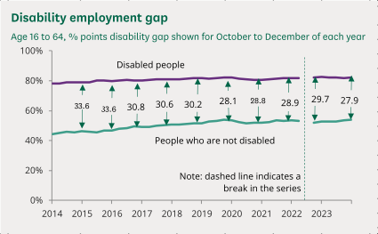The gap between disabled and non -disabled people’s employment has narrowed from 31.6% to 27.9% over the last 10 years**. [Left: Graph showing disability employment gap.]** While lowering, this remains a large gap that has an impact on disabled people’s lives. The inactive living on benefits and in poverty. Part of the issue is the much lower level of educational achievement of disabled people. But the biggest issue remains employer attitudes, with large numbers of disabled people wanting to work but not being offered jobs.

The legislation and various Government schemes have had a small impact. In the last 35 years in the UK, in response to the Disability Movement and Disability Legislation the Trade Union Movement has completely transformed its response to disability in the workplace. Having disabled workers sections, conferences, places on the TUC General Council and promoting Disability Champions are all significant changes.

Union representatives and shop stewards in the workplace are much more willing and have been trained to fight for disabled colleagues rights and seek to get employers to implement Reasonable Adjustments**.**

**[Above right: Unite the UNION circular logo – ‘Dignity & Justice’, ‘Disabled Workers’. Below: UNISON disabled workers AGM.]**

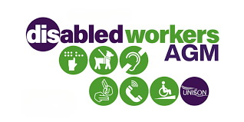

**Reasonable Adjustments** are important and to not consider them is effectively Disability Discrimination and can be a great support for disabled workers. They include :-

* Making changes to a disabled person’s working pattern. Allowing those who have become disabled to make a phased return to work.
  + Doing things another way, such as allowing someone with social anxiety disorder to have their own desk instead of hot-desking, or allowing someone with a wheelchair to work on the ground floor.
  + Providing training or mentoring. This will include training to non-disabled workers on how they can be more inclusive to disabled people.
  + Either employing a support worker to assist a disabled worker or arrange for a colleague to assist them with certain tasks.
  + Making alterations to premises, like installing a ramp for a wheelchair user or an audio-visual fire alarm for a deaf person.
  + Ensuring that information is provided in accessible formats, for example in braille or on audio tape.
  + Modifying or acquiring equipment, such as special keyboards for those with arthritis.
  + Changing the recruitment process. Modify procedures for testing or assessment to ensure they don’t disadvantage people with particular disabilities.
  + Allowing extra time during selection tests.

[Reasonable adjustments for workers with disabilities or health conditions - GOV.UK](https://www.gov.uk/reasonable-adjustments-for-disabled-workers)

<https://commonslibrary.parliament.uk/content/uploads/2023/04/The-Employment-Tribunal-Process-flowchart.png>

**Opportunities and barriers to young disabled people getting into work**

In 2021/22, 14% (47,500) of people starting apprenticeships had learning difficulties and/or disabilities. There is a problem with getting the level 2 requirement in English and Maths and although calls have been made for flexibility. no flexibility has yet been put forward. It remains a shocking fact that less than 5% of young people with severe learning difficulties or neuro-diversity are in gainful employment.

The House of Lords Public Services Committee's report, [***Think Work First***](https://publications.parliament.uk/pa/ld5901/ldselect/pubserv/12/1202.htm)***: the transition from education to work for young disabled people,****o*utlines challenges and recommendations for helping young disabled people transition from education to work:

* **Challenges**Young disabled people face challenges at every stage of the transition, from low expectations in school to discrimination in the workplace. The disability gap despite various Government initiatives has remained stubbornly around 30% for the last decade.
* **Recommendations**

The report includes recommendations for the government to:

* + Work with employers to create inclusive workplaces
  + Co-produce services with young disabled people and those who have already transitioned out of education
  + Make vocational profiling a standard part of careers guidance for young disabled people in schools
  + Work with local authorities to improve the availability of "ready to work" programs
  + Support internships to help people gain workplace experience.

We also heard of services that are offering the right support, delivered by specialists who could work with the young disabled person to account for their needs.

Tailored, specialist advice, accessible apprenticeships and work experience, and supported internships, all provide effective support.

**Disability and Livelihood**. UKDHM have covered the history of this detail in 2022 [Disability Health and Well Being](https://ukdhm.org/v3/wp-content/uploads/2022/10/Broadsheet-United-Kingdom-Disability-History-Month-2022.pdf), [2019 Leadership, Resistance and Culture,](https://ukdhm.org/v3/wp-content/uploads/2019/10/UKDHM-2019-Broadsheet-final-A4-1.pdf) [2013 Independent Living](https://ukdhm.org/2013-broadsheet/). It remains the case that successive Governments including the current one are continually attacking the security of disabled people who do not feel they can work.

****This is not about challenging employers’ attitudes and preparing young people for work, or the benefit of flexible working. Which due to COVID the whole country benefitted from. The attack on the 1.5 million disabled people debilitated by long term Covid is a good example. The [UNCRPD Article 28](https://social.desa.un.org/issues/disability/crpd/article-28-adequate-standard-of-living-and-social-protection) makes this a human rights issue. It does not look like the UK State is taking adequate steps to promote and protect these rights. **[Left: Crippen cartoon – Woman sitting at desk “I wonder what they’ll say if they ever find out we’re just recycling old Tory lies”, Man standing at microphone “Don’t start thinking Liz – just keep with the programme!”]**

**Conclusion**

**Disabled people have always worked, where they can and have been allowed to, including in the Medieval Period, through the Industrial Revolution and into the Modern Period. Towards the end of C19th Eugenics led to Deaf people losing their jobs and the incarceration of many with low level learning difficulty into colonies. The Statistics and IQ tests developed by proponents of Eugenics have shaped the development of our education system whether they be 11+ or SATS and Public Examinations, which exclude the potential of many from getting qualifications and employment.**

**The Disabled People’s Movement have achieved laws such as the Equality Act that make our employment easier. Trade Unions have become big allies in Disabled People’s struggle for the right to work. They only cover 20% of the workforce.**

**However, the culture of segregation and special education reinforced by recent Education Government reforms has let young disabled people down. Disablist attitudes persist. Lack of a properly planned, resourced and delivered inclusive education continues to blight the lives of many disabled people. With the wealth and technology at our disposal it is possible to enter a new era of inclusion and equality. But is the political will there?**

**United Kingdom Disability History Month**

[**https://ukdhm.org**](https://ukdhm.org)

**0207 359 2855**

**Coordinator email** [**rlrieser@gmail.com**](mailto:rlrieser@gmail.com)