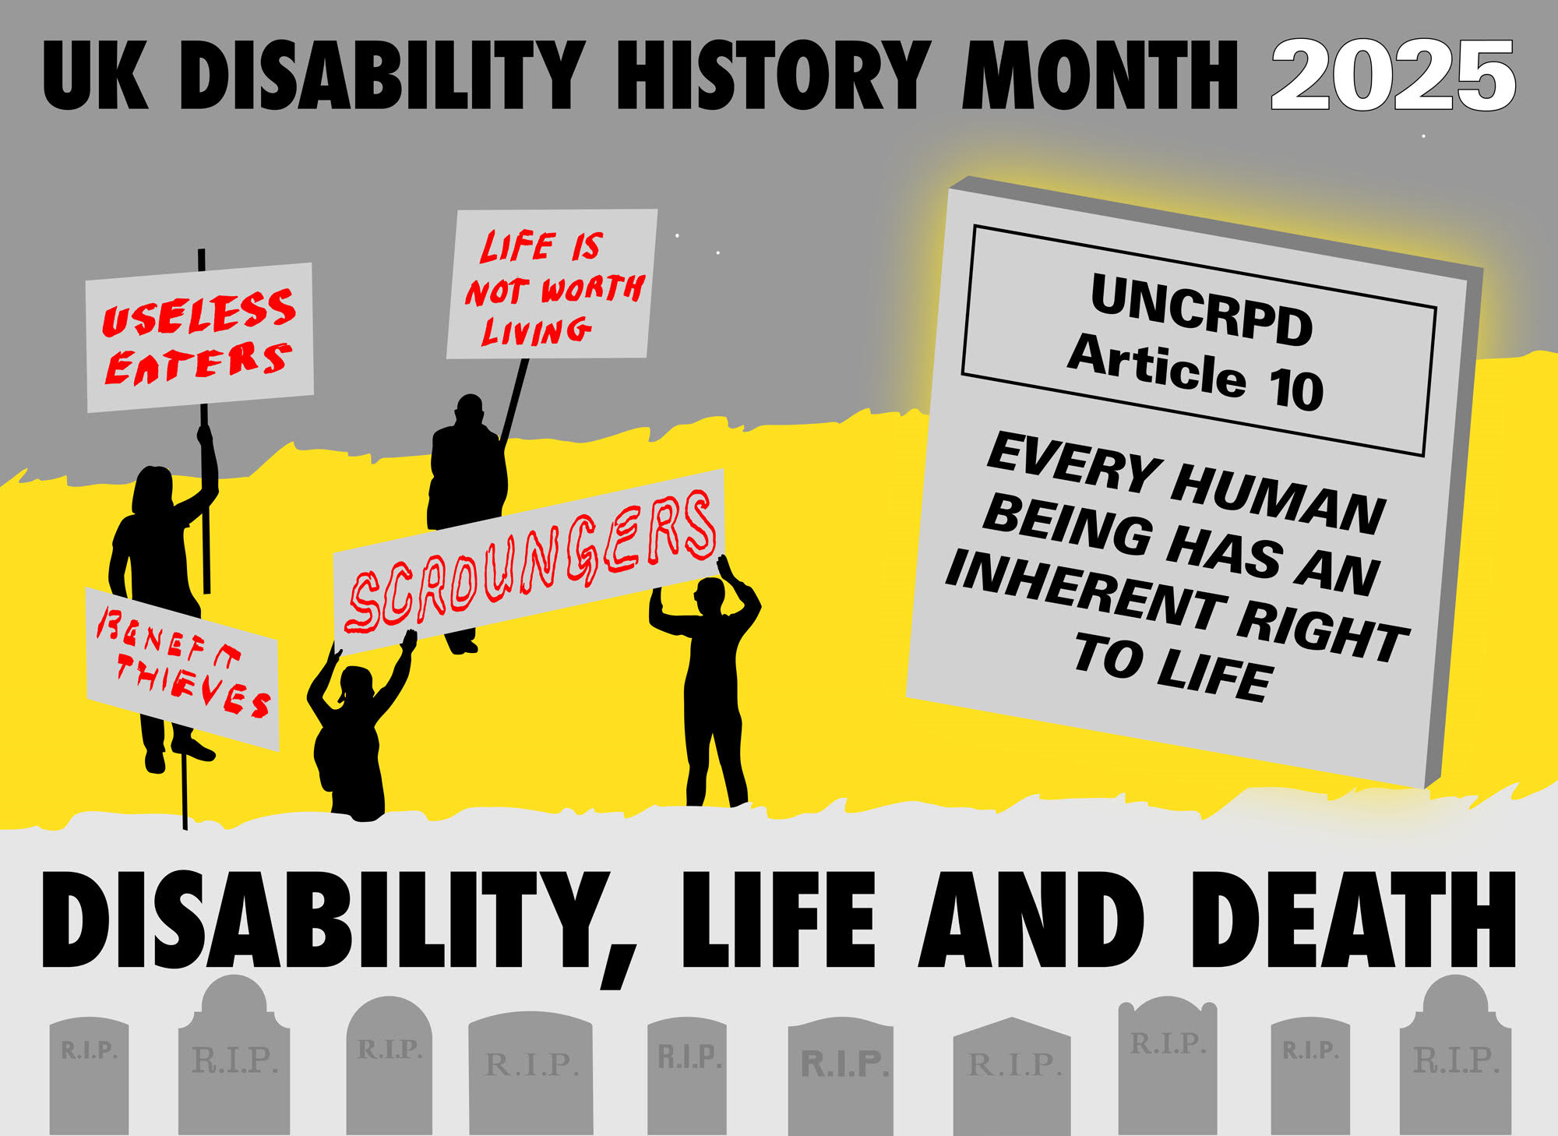
Human Beings are sociable, preferring fairness and justice, can be inclusive of disabled people but may need guidance to recognise their prejudice. Mostly the 16% of humanity who have long term physical or mental impairments are disabled by social barriers but accepted to a variable degree, if not granted equity.
“Optimism is the faith that leads to achievement. Nothing can be done without hope and confidence.” - Helen Keller
“My advice to other disabled people would be, concentrate on things your disability doesn’t prevent you doing well, and don’t regret the things it interferes with. Don’t be disabled in spirit as well as physically.” - Stephen Hawking
“Just because a man lacks the use of his eyes doesn’t mean he lacks vision.” – Stevie Wonder
““Part of the problem is that we tend to think that equality is about treating everyone the same, when it’s not. It’s about fairness. It’s about equity of access.’’ - Judy Heuman
"Everybody is a genius. But if you judge a fish by its ability to climb a tree, it will live its whole life believing that it is stupid"- Albert Einstein
"Always remember, you have within you the strength, the patience, and the passion to reach for the stars, to change the world.”- Harriet Tubman Slave liberator, feminist and disabled person
Under the Nazi Eugenics killing programmes, all of the above could have been eliminated because identified as disabled people or Jewish, but they all led successful lives.
Disablism is widespread and is discriminatory, oppressive, abusive behaviour arising from the belief that disabled people are inferior to others. Disablism refers to prejudice, stereotyping, individual and "institutional discrimination" against disabled people.
For thousands of years physical and mental impairment was not accepted as a part of the human condition, but was explained by magic, myth, superstition and religion leading to mistreatment, segregation, isolation, euthanasia and sometimes pity, charity and asylum.
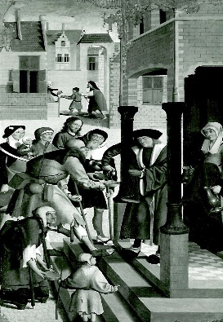
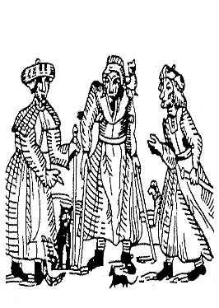
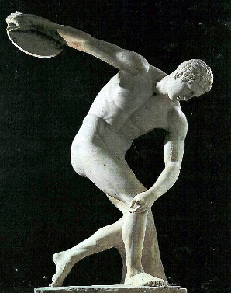
a) b) c)

a) Physical perfection, b) disabled women killed as witches, c) C16th Holland pity for lepers.
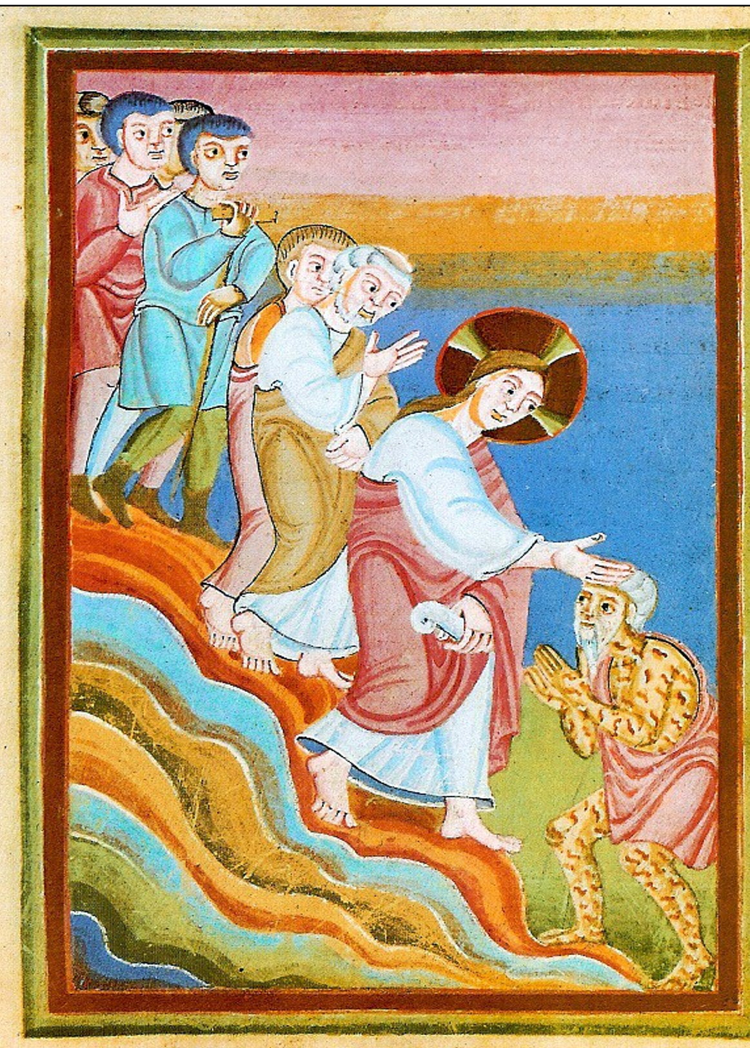
d) e)

d) Miracle cures penitent sinner, e) Rejected Hephaestus, God with club foot.
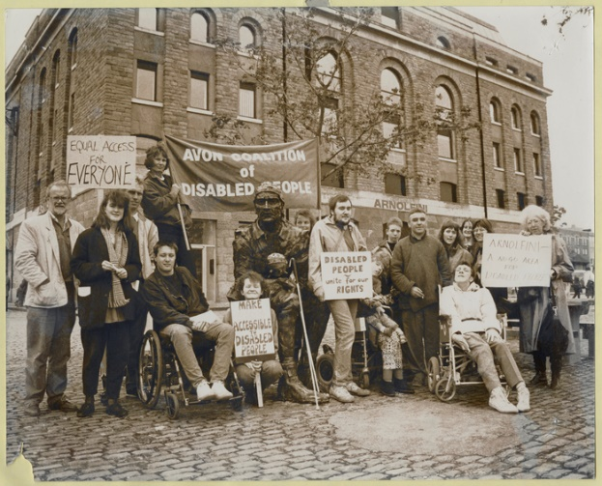
Only in recent years, through the efforts of the Disabled People’s Movement, has humanity learned that it is the barriers created by society of attitude,
environment and organisation that disable. Impairment is part of the human condition.
But all Disabled People have Human Rights including a Right to Life (Above: Avon Coalition of Disabled People 1980s).
The recent resurgence of the New Right and their attack on Diversity, Equity and Inclusion will challenge the rules-based international consensus that was a reaction to the horrors of the 2nd World War and Nazism. The precariousness of the Human Rights of Disabled People is demonstrated by the fact that it took from 1947 ‘Universal Declaration of Human Rights’ to 2006 ‘United Nations Convention on the Rights of Persons with Disabilities’ to establish parity of rights for disabled human beings.
For 1000 years, until the C20th, most people in Europe viewed life as fairly transitory, en route to a state of grace or purgatory after death. There were higher death rates & more causes of death such as tuberculosis or cholera that could not be controlled.
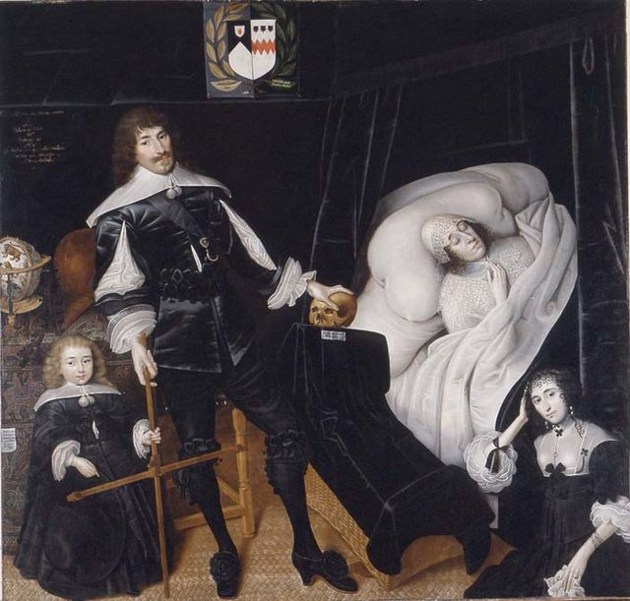
[Left: Ars Moriendi - A good death Christian C17th rituals]
As Christianity became a minority belief and materialism replaced it, we have experienced a number of attempts to regulate who lives, gives birth and procreates. Misguided and based on false science, these approaches mainly to disabled people, have not gone away but are just hidden, but feature eliminating impairment from the human condition such as in Eugenics and lately the Genome Project.
Euthanasia Societies and cultures throughout history, depending on their belief systems, have responded differently to disabled children.
The Greeks and Romans in particular, held very different views of self - the Romans as practical, disciplined, and straightforward, the Greeks as pretentious, vain, and clever. With their respective contributions to art, philosophy, literature, and science, they saw themselves as superior to everyone else. Both cultures were dependent on physical and military strength to prosper. Physical differences, such as race, ethnicity, or disability, were seen as marks of inferiority. Aristotle (384-222BC) believed, as did most others in ancient Greece, that man was the most highly evolved being and that woman was one great evolutionary step below, representing "the first step along the road to deformity". He also recommended that there should be a law "to prevent the rearing of deformed children," and wrote in his Politics that, "As to the exposure and rearing of children, let there be a law that no deformed child should live".

In Rome disabled children were treated as objects of scorn. Children who were blind, deaf, or mentally disabled, were publicly persecuted and reported to have been thrown in the Tiber River by their parents. Some disabled children were mutilated to increase their value as beggars, while others were left in the woods to die, their feet bound together to discourage anyone passing by from adopting them. In the military city of Sparta, the abandonment of "deformed and sickly" infants was a legal requirement. Babies who failed to meet the council of elders standards were taken to a chasm at the foot of Mount Taygetos, a place often referred to as the 'Apothetae' or 'place of rejection’. Here, they were left exposed to the elements. However, recent evidence suggests disabled babies were cared for and when infanticide occurred it was general and for economic reasons.

Across the Mediterranean in Ancient Egypt there is evidence of Blind and Short children and people being venerated and included. The Nile flooding each year was like a giant fertiliser factory and assured surplus that did not have to be fought for.
a) b)
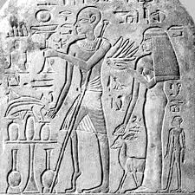
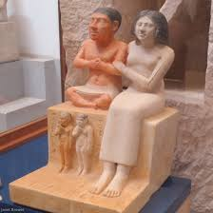
- Short King
- Ambulant Impaired - Egypt
- Elders decide if a baby should survive

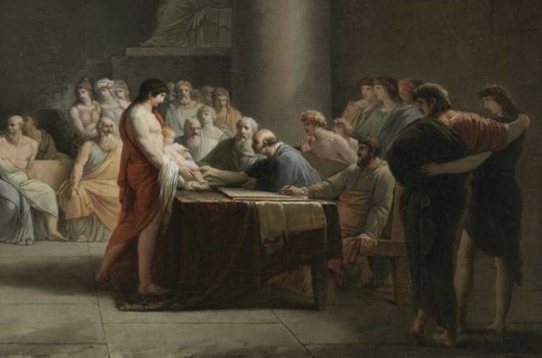
c) It is often thought that the more complex our human society the more humane we might be. This is not held out by anthropology which identifies for example a Hunter Gatherer band of Northern Australia
Aborigines who carried a disabled member of their family for 60 years.

For much of history disabled people have fitted in with their family groups and been cared for. At certain times of social crisis, disabled children are abandoned or taken into institutional care. In the last 60 years as self-advocacy has become more valued and old prejudices have been challenged, many institutions have closed and independent living and care in the community have become more accepted.

UK Disability History Month in the Autumn of 2025 has the theme Disability, Life and Death. This year, with over 300 UK Disabled People’s Organisations being opposed to the current draft legislation on Assisted Death, seems like a good time to look
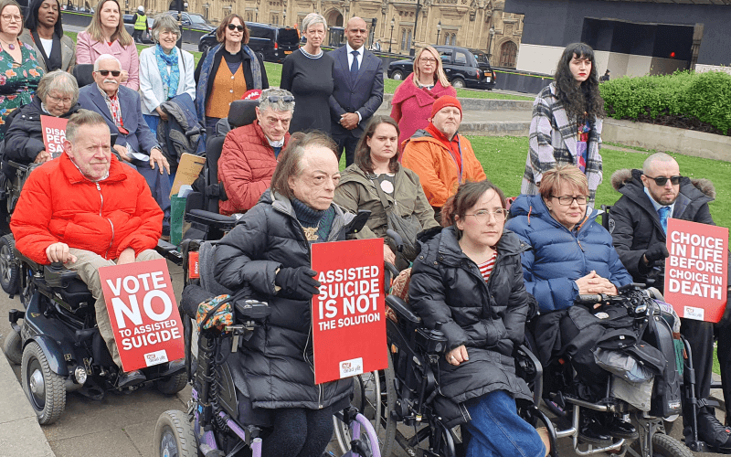
through the historical lens at why disabled people have learned to be suspicious of giving the State the power of life and death over us.
Not Dead Yet, UK main points against Assisted Suicide Legislation are :
1. Evidence of ‘legislation creep’, in countries where assisted death is legal suggests a similar risk if the law is changed here.
2. The restrictions society places on disabled people denies them true choice and control.
3. In the absence of choice and control, the role of physicians in assisting a disabled person to take their life cuts across the principle of informed consent.
4. Assisted suicide legislation conveys the message that living with a disability is a fate worse than death.
5. The Government’s role is to increase resources for palliative care, improve support for disabled people and uphold its commitment to enabling their full participation in society. The opposite of this is occurring with both cuts to welfare and reductions in access to palliative care.

Evidence from Canada is highlighted in Liz Carr’s BBC film ‘Better Off Dead’.
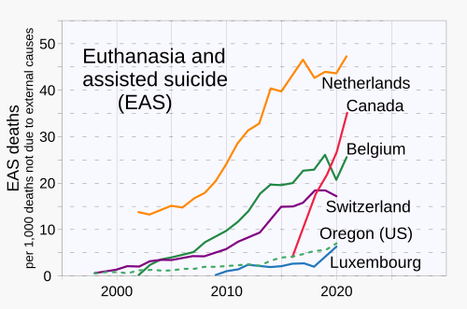
Campaigners for assisted suicide want a ‘good death’, not as with the Victorians suffering, but pain free and with relatives. But already there is evidence of death creep in Netherlands and Canada. 23-year-old Canadian Kiano Vafaeian, was depressed—he was diabetic and had lost his vision in one eye, and he didn’t have a job or girlfriend or much of a future. A doctor in Toronto under MAiD ‘Medical Assistance in Dying’ had approved killing him by lethal injection. His mother led a social media campaign against it and it was stopped. As of March 2023 there had been a total of 31,664 MAiD deaths and the large majority of those people were 65 to 80 when they died. In 2017, only 34 MAiD deaths were in the 18 to 45 year-old category. In 2018, that figure rose to at least 49. In 2019, it was 103; in 2020,118; and in 2021, 139.

The campaign for Assisted Death has been pushed by some key individuals and the media. But a representative survey in June 2025 found 67% agreed the UK Parliament should prioritise on improving access to care over introducing assisted dying. Only 13% disagreed. 6 in 10 agree disabled people could be coerced. The fact that this survey was carried out just after the Labour Government backdown on cuts to disabled people’s welfare, demonstrates that currently a majority support disabled people and their human rights. Our rights are precarious, as we demonstrate here abuses of our human rights are widespread and in the past some did not even think we were human.

Disabled people are often viewed as triumphing over tragedy for doing ordinary things in life, as there is an underlying perception from traditional, charity and medical model views. This so called ‘inspiration porn’ puts the focus on the individual disabled person against the odds ‘overcoming adversity’; rather than focussing on the collective struggles of the Disabled People’s Movement to enforce Disability Rights. These views fuel arguments for assisted dying. One disabled person’s life is seen as intolerable suffering by someone not used to living with an impairing condition, while seen as normal by someone who is.

That is why we need to reinforce and assert the UN Convention on the Rights of Persons with Disabilities including maintaining:-“States Parties reaffirm that every human being has the inherent right to life and shall take all necessary measures to ensure its effective enjoyment by persons with disabilities on an equal basis with others”. Article 10 United Nations Convention on the Rights of Persons with Disabilities,2006

“Eugenics is the ideology that human populations should be “improved” through social policies, such as selective breeding – encouraging people with “desirable” traits to have children while discouraging those with “undesirable” traits. It’s a coercive ideology. It involves people in positions of power making value judgements about which traits are desirable or not, and so who is deserving of reproduction or not, and it inevitably leads to human rights abuses”(Adam Rutherford). Developed by Francis Galton, Darwin’s cousin, it sought to apply Darwin’s ideas of evolution to living human beings. The Galton Laboratory and the first Professor of Eugenics were associated with University College London, which in the last few years thy have repudiated and countered their key role. At the time, strong Christian moralistic arguments based on the superiority of the white middle class saw the poor, disabled and labouring classes and ‘inferior races’ as the biggest threat, attributing things like their low test results on the newly invented Intelligence Tests to genetic inferiority, rather than the poverty and lack of education they experienced.

The eugenicist agitation and moral panic towards the ‘feeble minded’ (people with mild to moderate learning difficulties) who were living in the community, were viewed as sapping the national strength and power, leading to immorality and crime. This led to some of the worst crimes against humanity of the Twentieth Century. As many as 70,000 were incarcerated for life in the UK under the 1913 Mental Deficiency Act, forced sterilisation and racist immigration control in the USA and extermination of over 1 million disabled people in the empire of the Nazi 3rd Reich. Orchestrated in the UK by a few dozen influential scientists and social reformers Francis Galton, Ida Darwin, Mary Dendy, Dr. Alfred Tredgold, Cyril Burt and Reverend Harold Burden. They got a Royal Commission in 1908 and the Mental Deficiency Act through Parliament in 1913, with only 2 MPs opposing. Many people with learning diffficulties had their lives shaped by these events right up to the 1980s and 1990s when ‘Care in the Community’ became the vogue. The UK White Paper Valuing People (2001) with its principles of choice, independence, rights and inclusion could not be further removed from its early equivalent, the 1913 Mental Deficiency Act which is characterised by segregation, labelling and coercion. However, recently real gains in supported and independent living have been challenged by austerity measures.

In the early C20th Europe and USA was a time of Great Power competition and concerns about the undermining of the gene pool. It was also a period when there had been pressure to incarcerate disabled people especially with learning needs and mental health in asylums, hospitals and workhouses. The cheaper alternative that many Eugenicists argued for was compulsory sterilisation to stop the spread of ‘poor genes’. Big business such as Ford, Rockefeller, Kellogg in the USA poured money into supporting laboratories such as Cold Springs Harbour, Long Island where Harry Laughlin set up and brought about the first legislation for compulsory sterilisation in 1907 in Indiana.
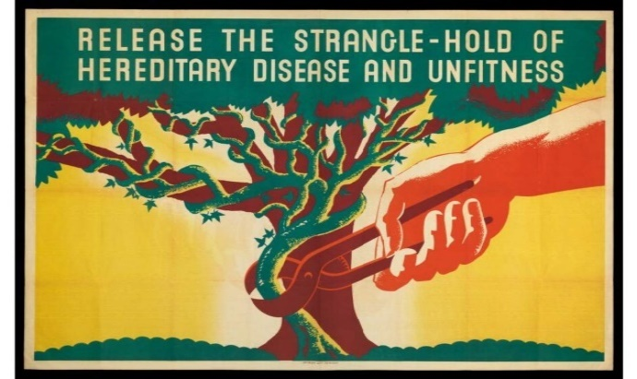

In 1922 Lauglin produced a Model Law which recommended compulsory sterilisation for those identified as Feeble Minded, Insane , Criminalistic, Epileptic, Inebriates, Diseased ( including tuberculous, the syphilitic, the leprous and chronic infectious and legally segregable diseases), Blind including seriously visually impaired, Deaf including seriously hearing impaired, Deformed Including cripple and Dependent including ‘ner-do-wells’, orphans, homeless tramps and paupers. This led to many states introducing these laws (up to 37 at maximum). Adolf Hitler in Mein Kampf praised these measures. In 1933 when he was German Chancellor, he introduced an almost identical law that led to more than 400,000 Germans being forcibly sterilised. Previously in the workhouse and asylums, conditions for disabled inmates were very harsh leading to high death rates.
After 1919 up to 200,000 incarcerated in long stay hospitals all over the UK
In the UK the movement for Eugenics was just as strong. Despite Winston Churchill as Home secretary supporting legislation to introduce compulsory sterilisation, it was defeated. Instead the Mental Deficiency Act was introduced in 1913 leading to many people with learning difficulties being incarcerated for life in colonies and long stay hospitals, until they closed towards the end of century. Intelligence Quotient was often used to segregate people, even though we know this to be culturally, racially and disability biased. For a pack with lots of class based activities go to https://university.open.ac.uk/health-and-social-care/research/shld/education-resources/guide-using-education-resources

The Eugenicists, Scientists and Medical Doctors made a number of serious scientific errors:

- Single trait. People with learning disabilities had a trait/gene of ‘feeble mindedness’ that could be identified with intelligence testing and by their appearance. These were not simple identifiable ‘traits’ such as eye colour, height and blood group, which are easy to define and measure. Eugenicists, however, were most interested in mental capacity and behavioural traits – such as epilepsy, intelligence, depression, feeblemindedness, alcoholism and criminality. Even today with our far greater understanding of genetics and the chemical messengers in the cell that make up DNA, scientists are still unable to find particular traits or genes for these human conditions.

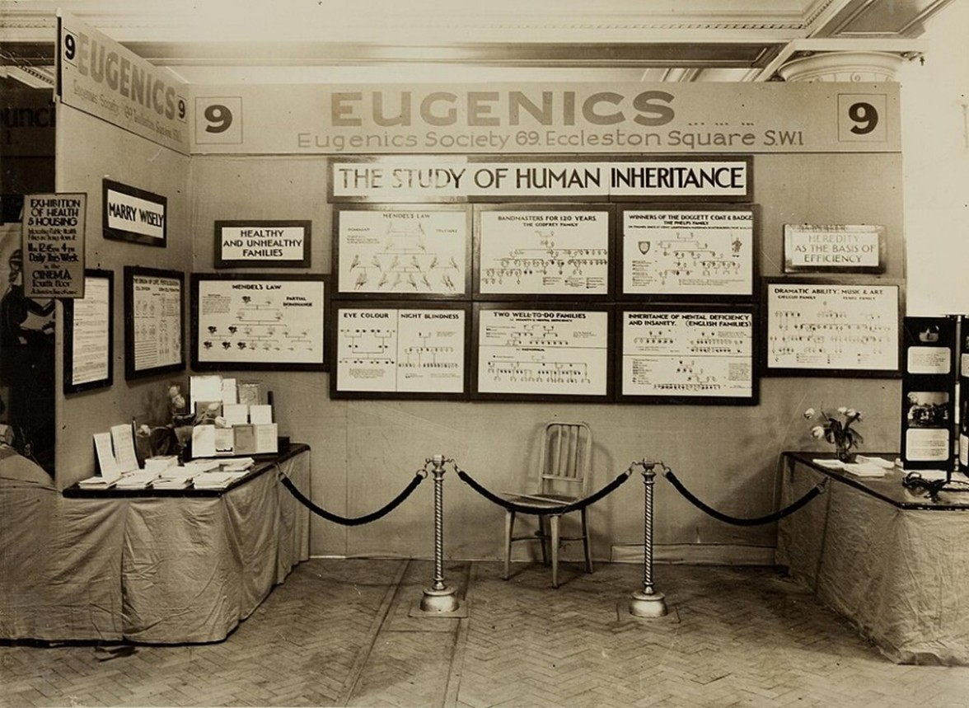

b) Reductionist simplifications. Eugenicists treated intelligence as if it were a general innate quality of the brain that could be represented by a single factor. Later experts recognized that there may be many "intelligences" – including mechanical, quantitative, visual/spatial, verbal, and abstract and these develop in a complex ongoing interaction of the individual, their genetic potential, and the environment.

c) Poor survey and statistical methods. Seldom was a eugenic researcher able to personally interview family members going back more than two or three generations. At the time, few doctors and hospitals kept systematic medical records, so ‘pedigree information’ was often obtained by second-hand reporting or hearsay. Interestingly, Goddard was of the strong opinion that a trained person could identify mentally deficient people on sight. This dubious method was used to select those who had the ‘bad gene’ in genealogical studies and to select subjects for testing.

d) False quantification. The assumption that if you can produce a numerical value (such as a score on an intelligence test) then it must be a valid measure. Tests were given under a wide variety of conditions, often by poorly trained administrators and sometimes even in pantomime when the subjects spoke no English. According to one set of IQ tests given to immigrants by Henry H. Goddard, 83% of Jews, 80% of Hungarians, 79% of Italians, 87% of Russians were classified as "feebleminded".

e) Intelligence was innate, fixed and could not be much improved by education and training. Now we think of the brain and its functions as plastic . Psychologists such as Jack Tizzard showed that intelligence was not fixed but could be developed and so there was no such thing as humans being ineducable.

f) Ignoring social and environmental influences. Eugenicists sought genetic explanations of complex human traits to the virtual exclusion of other explanations. However, family pedigrees are as much documents of social inheritance as they are of biological inheritance. In addition to genes, family members share customs, life-styles, and health practices (including diet) that can greatly affect the development of physical, intellectual and emotional traits.
To understand in more detail this false science and its implications listen to the recent Radio 4 series Bad Blood https://www.bbc.co.uk/programmes/m001g2yc Presented by Scientist Adam Rutherford or read his book Control : The Dark History and Troubling Present of Eugenics, 2023.

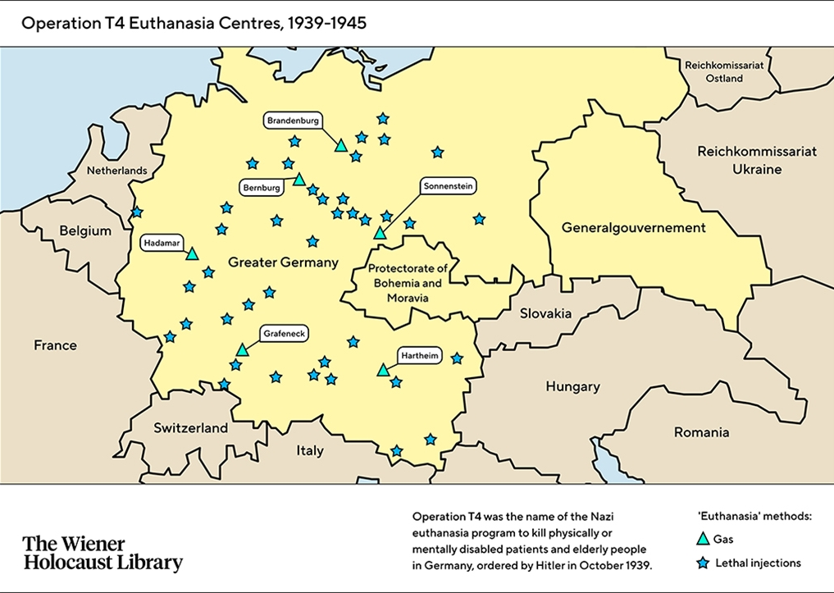
In Germany Hitler copied these ideas and took them further to eliminate all those unworthy of life-disabled people, Jews, Gypsies, Roma, homosexuals, and communists.
Disabled people nos. the German Government has acknowledged 275,000, but Black in War Against the Weak estimates more than 1 million across the occupied German Empire. Doctors carried out the killing of adults and children under the T4 programme and only 9 doctors were executed at Nuremberg.
Looking back before the Holocaust, it is hard to understand how popular and widespread the idea was of eliminating the Useless Eaters-today’s Burden or Benefit Street.

PROPONENTS
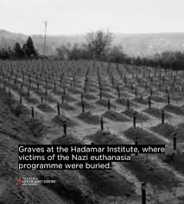
DH Lawrence “If I had my way, I would build a lethal chamber as big as the Crystal Palace, with a military band playing softly, and a cinomatograph working brightly; then I would go out into the back streets and bring them all in the sick the halt and the maimed: I would lead them gently, and they would smile me a weary thanks; and the brass band would softly bubble out the Hallelujah Chorus”1908.

Winston Churchill writing to Asquith Prime Minister in 1910 “The unnatural and increasingly rapid growth of the feeble-minded and insane classes, coupled as it is with a steady restriction among all the thrify, energetic and superior stocks, constitutes a national and race danger which is impossible to exaggerate…I feel that the source from which the stream of madness is fed should be cut off and sealed up before another year has passed’

HG Wells could not contain his enthusiasm, ‘hailing eugenics as the first step toward the removal “of detrimental types and characteristics” and the “fostering of desirable types” in their place’.

George Bernard Shaw wrote: “The only fundamental and possible socialism is the socialisation of the selective breeding of man”. Later he mused that “the overthrow of the aristocrat has created the necessity for the Superman”. Jonathan Freedland writing in the Guardian in 2019 highlighted how the British Left were fully invested in Eugenics.
Looking back, but also forward, to inaccurate and populist ideas we can see the present danger.

The answer is a form of full inclusive education, where children go to school together regardless of their need or impairment and the school, its staff and curriculum are adapted to remove all barriers. Children grow up respecting diversity and difference. The alternative is the rekindling of prejudice and hatred drawing on the oldest superstition, our fear of strangers and physical and mental difference, because they frighten us.


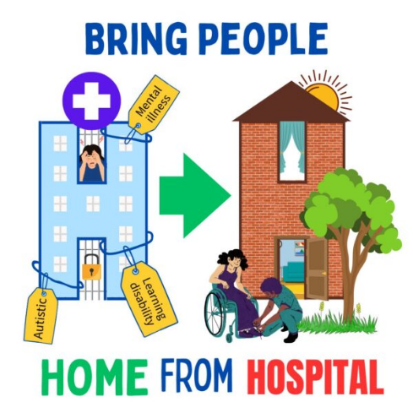
Free Our People Now! Over 2000 people are locked up in hospital on the grounds of having learning difficulties or being autistic. The UK government has failed to meet its own target of reducing the number of people in these hospitals by 50%. Things have got worse. The number of children with learning difficulties / or autism in inpatient hospitals has increased since the start of the Transforming Care Plan. The number of children in psychiatric hospitals has doubled. From 110 to 210 children between years of 2015 to 2024. People with learning difficulties and Autistic people who may see, be, feel and think about the world differently from others, must be treated as equals.

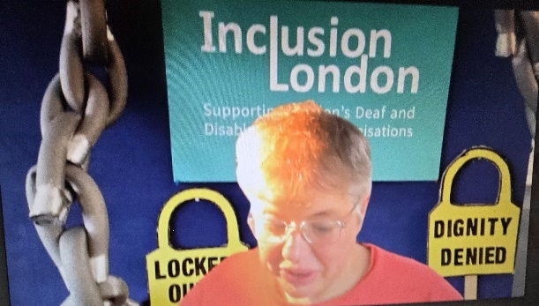
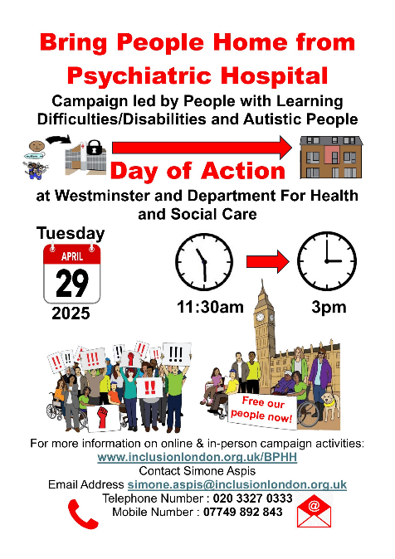
Under the Mental Health Act People with learning difficulties and Autistic people can be locked up in hospital on the grounds of disability alone. Only two doctors are needed to decide if we are at risk of harming ourselves or others needing mental health hospital treatment. We can be locked up and treated against our wishes because our minds and brains are different from non-disabled people. We can also be locked up without wrongdoing, independent trial and court hearing, unlike non-disabled people. Lots of reports since Winterbourne View scandal say we have been badly and cruelly treated in hospital. Government and services have failed to uphold our human rights. The Government, local authorities and integrated care boards could choose to fund kind and caring services aimed at us having good lives in the community. We must act now - Free Our People Now.
Simone Aspis, Free Our People Now campaigns’ manager. “We are calling for the end of locking people with learning difficulties and Autistic people up in psychiatric hospitals and the end of institutionalisation. We have three big government asks to end our institutionalisation.
Government ask number 1: We want a powerful say in how to keep us out of psychiatric hospitals. Our voice is important to having a good life.
Government ask number 2: Our right to live decent lives in our communities. Laws to be changed so that they uphold disabled people’s UNCRPD Human Rights to live in the community.
Government ask number 3: To be treated with respect and be protected from abuse everywhere. Tougher legal action by the Care Quality Commission including criminal prosecution against service staff who harm us. Solidarity! Free our people now!
The campaign raised concerns with the UNCRPD Committee in August 2025 over the Mental Health Bill Draft. The UK Government argued it was compliant. On 25th August the UNCRPD committee (charged with enforcement of the UNCRPD in 193 countries that have ratified the Convention) said that the UK government should:
- Work closely with Disabled people on the Mental Health Bill, to check whether it supports our human rights. This work should check whether the bill meets UN guidelines, which say no one should be locked up just because they are Disabled.
- They should also introduce comprehensive healthcare in the community for Disabled people, so that no one needs to be locked up to get help.
- The government should improve how it measures whether laws will impact negatively on Disabled people.
- It should work closely with Disabled people on the Universal Credit Bill, to check whether it supports our human rights. They should develop a plan with us, to make sure that Disabled people still have full and easy access to our right to a good life and good standard of living.

Dr Miro Griffiths of Leeds University “I support the bring people home from hospital campaign because it is imperative that disabled people have sufficient support to live the life that they want in places that they want to live, and belong to communities that value their participation and their existence. If we are going to achieve disabled people’s liberation and release accessible and inclusive societies, it is imperative that we move towards community based support which is sufficient, which is organised by disabled people through Disabled People’s Organisations and we ensure that support is funded to an equitable level, where disabled people have choice and control over their lives across their life course and are able to use support to pursue their own goals and interests. So we must support campaigns like this and ensure that we move away from the incarceration of disabled people in institutionalised and medicalised settings”.

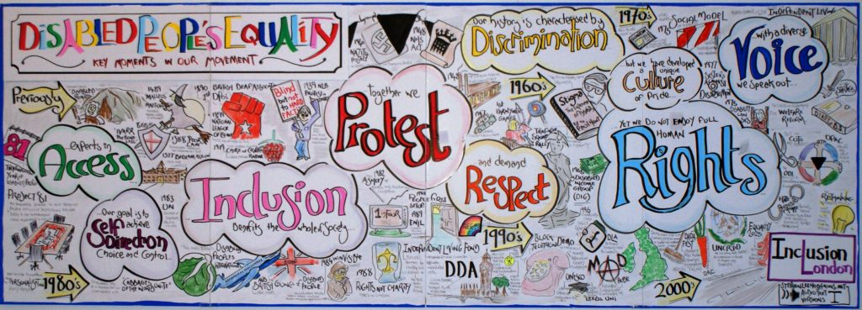

https://www.inclusionlondon.org.uk/wp-content/uploads/2015/05/FactSheets_TheSocialModel_Sept2015.doc
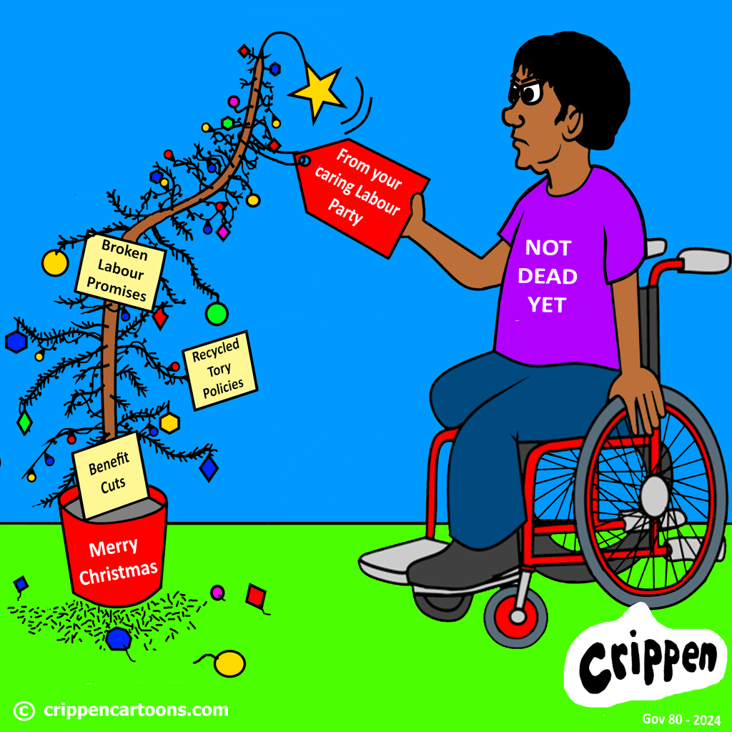

https://www.inclusionlondon.org.uk/wp-content/uploads/2015/05/FactSheets_TheSocialModel_Sept2015.doc

‘Our history is characterised by Discrimination. We have developed a unique Culture of pride. With a diverse Voice we speak out. Yet we don’t enjoy full human rights. Together we Protest. Experts in Access. Our goal is to achieve Self Direction, choice and control. Inclusion benefits the whole of society.’
Faced with Benefit cuts that have been delayed due to Disability Movement lobbying, Assisted Dying and a general failure to do what is in our interests, including cutting disability overseas aid in half, the Disability Movement will have to grow and fight on to preserve the quality of our lives! In this struggle we call on all our allies to support us!

UK Disability History Month ukdhm.org send events and info to rlrieser@gmail.com ukdhm coordinator.

