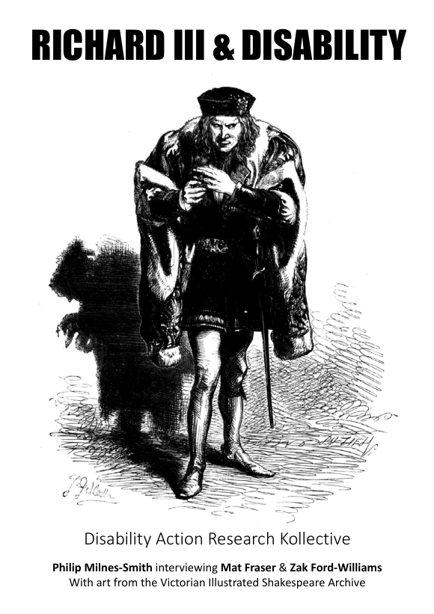

A zine about staging Richard III.
Author
Disability Action Research Kollective
Submitted by DisabilityARK on August 25, 2026
Richard III and Disability.pdf (2.79 MB)

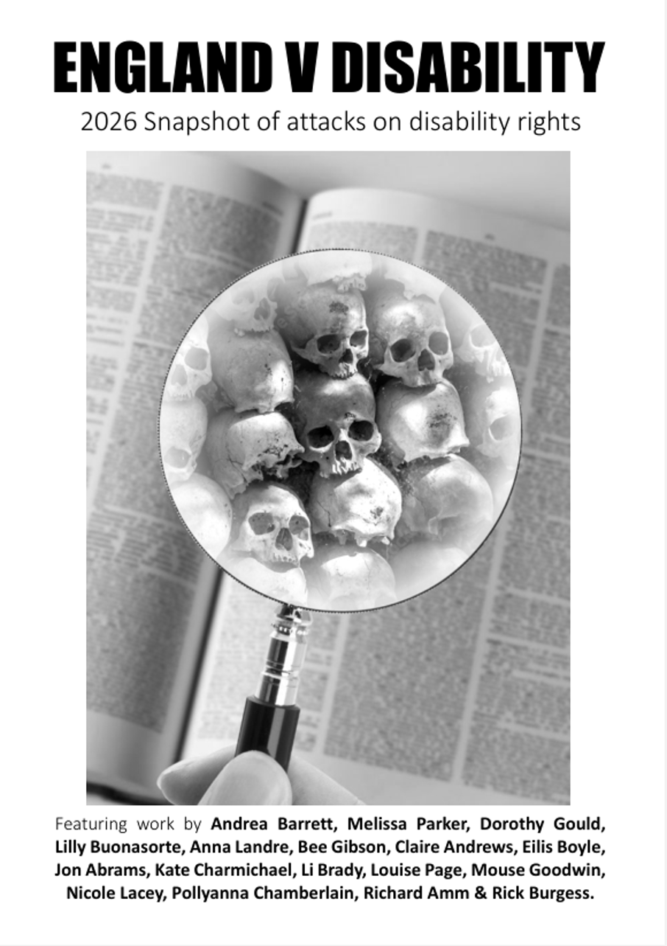
Disabled people in the United Kingdom (UK) have endured relentless attacks on their rights and opportunities on multiple fronts. Many hard-won freedoms have been steadily rolled back in recent years. This document summarises some of these policies that have either
been proposed or successfully enacted. Disabled people are often used as the testing ground for future policies, so being aware of what is happening to them has broader implications for the rights of other groups. During the Holocaust, many of the procedures developed on disabled people were later applied to wider populations. More recent examples include bank account surveillance systems, which are laying the groundwork for more extensive population-wide surveillance. Following the 2008 financial crash, attacks on disabled people’s rights intensified. In 2016, the United Nations (UN) found that the UK was engaged in “grave and systematic” violations of disabled people’srights, and linked these actions to a significant number of excess deaths. In 2024, the UN follow-up report to the inquiry declared that the UK made “no significant progress” on implementing the inquiry’s recommendations regarding independent living, social security, and an adequate standard of living. Now, in 2026, things have only gotten worse. This zine cannot adequately cover every front of attack or the rapid changes currently taking place, but it aims to provide a broad snapshot of the situation in England in the Summer of 2026.
Submitted by DisabilityARK on August 7, 2026
England V Disability by DARK 2.pdf (717.34 KB)

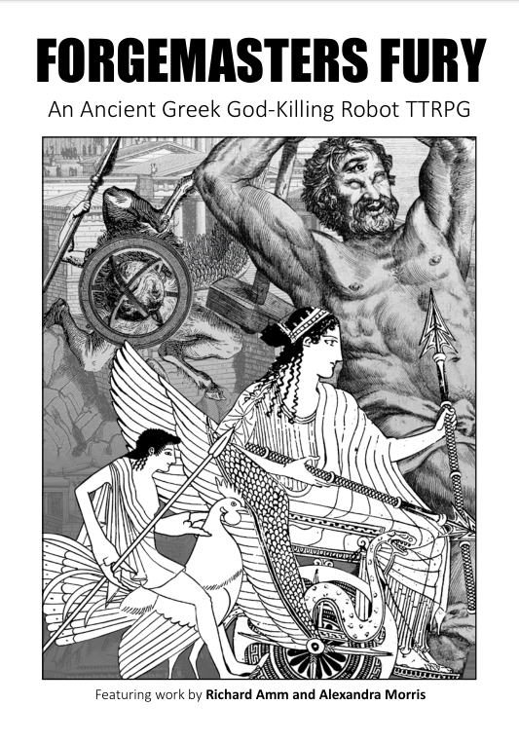
TTRPG for 2-4 players. Ancient Greek Mythology Setting.
Hephaestus was born with burning intelligence and bent and twisted legs. The gods of Olympus rejected him, flinging him into the sea to drown. But Hephaestus survived and swore an oath of vengeance. He crafted golden mechanical wonders, powered by ichor, the blood of gods and monsters. These living machines were to bring death and devastation to the gods themselves.
• Simple ruleset, based on Eat the Reich.
• Compact design, prints out onto 7 A4 pages double sided.
• 4 Playable Characters
• 21 Scenarios
• 7 Boss fights
• 36 Artefacts
Author
Disability Action Research Kollective
Submitted by DisabilityARK on August 3, 2026
Digital - Forgemasters Fury v2.1.pdf (6.49 MB)

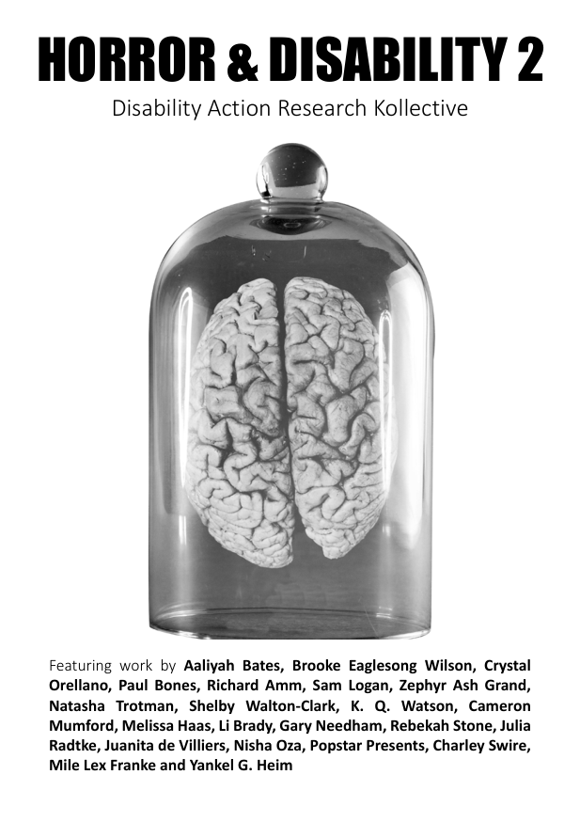

Continued from first zine but with more of a focus on the trope of associating evil with neurodivergence.
Author
Disability Action Research Kollective
Submitted by DisabilityARK on May 14, 2026
Horror & Disability 2 by DARK_3.pdf (1.04 MB)
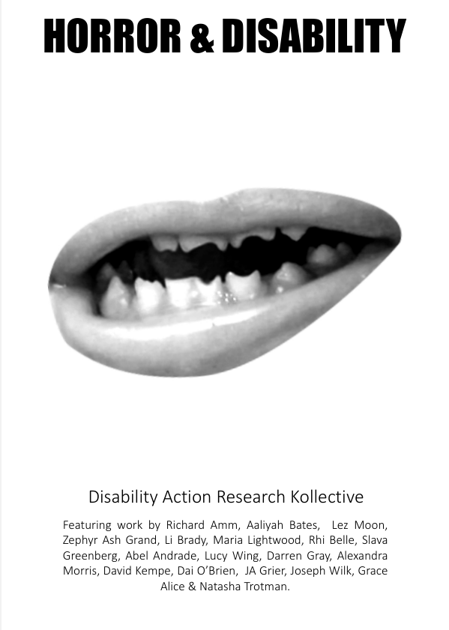
The horror genre has long grappled with its portrayal of disability,
often reflecting the societal prejudices of its time. Emerging alongside early cinema, many early horror works were influenced by eugenic ideology, rooted in Victorian advancements in science, technology, and pseudoscience like degeneration. These theories positioned
disabilities as markers of a “less evolved” human prone to immorality and criminality, promoting a constructed ideal of bodily “perfection.” As horror reflects societal anxieties, early films mirrored fears of the “monstrous other,” often emphasizing science and rationality to defeat such threats, aligning with eugenic thought. Historically, individuals with physical or mental impairments have been depicted as either weak and vulnerable or as archetypes of evil, chaos, and social disorder.
While these representations reflect entrenched prejudice, they are not unique to horror and unfortunately mirror broader societal biases
Author Disability Action Research Kollective
Submitted by DisabilityARK on September 9, 2025
Horror & Disability by DARK.pdf (389.25 KB)

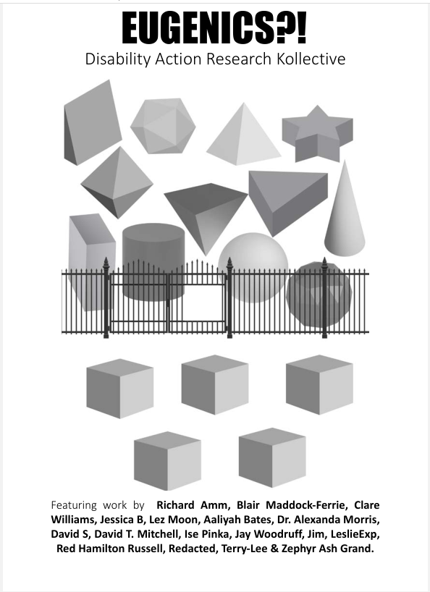
This zine is a collection of thoughts on eugenics by a variety of disabled people. Eugenics is a set of largely discredited beliefs and practices that supposedly aimed to improve the genetic quality of a human population. In practice this often involved mass murder & forced sterilisation of marginalised ethnic groups. While the actions of the Nazis are the ones that most people think of in relation to eugenics, many practices continue in the modern day. It shapes everything from our laws to how we think about our neighbors. This zine can only include a small number of topics but eugenics is far more widespread than can be adequately represented here.
Author
Disability Action Research Kollective
Submitted by DisabilityARK on July 16, 2025
Eugenics by DARK.pdf (245.51 KB)

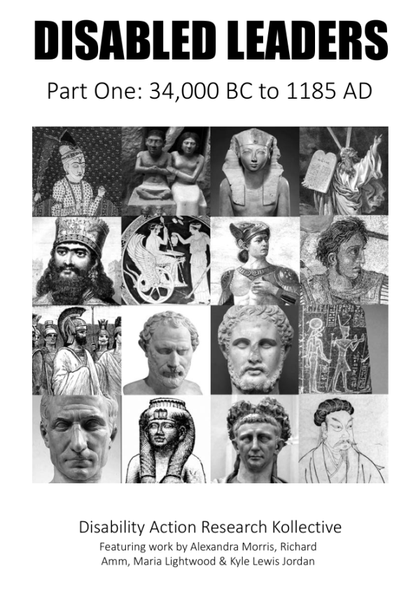
Disabled people have not always existed at the bottom of society.
When the histories of people with power are recounted, disability is
often excluded to avoid tarnishing their reputations. This widespread and harmful practice strips away the full humanity of these figures and reinforces disability as a stigmatising characteristic. Disability was a lot more widespread in the past but was likely significantly less stigmatising than it is under modern capitalism, where productive capacity is directly linked to individual personhood, belonging, inclusion, respect and value.
Author Disability Action Research Kollective
Submitted by DisabilityARK on April 19, 2025
Disabled Leaders 1 by DARK.pdf (8.48 MB)
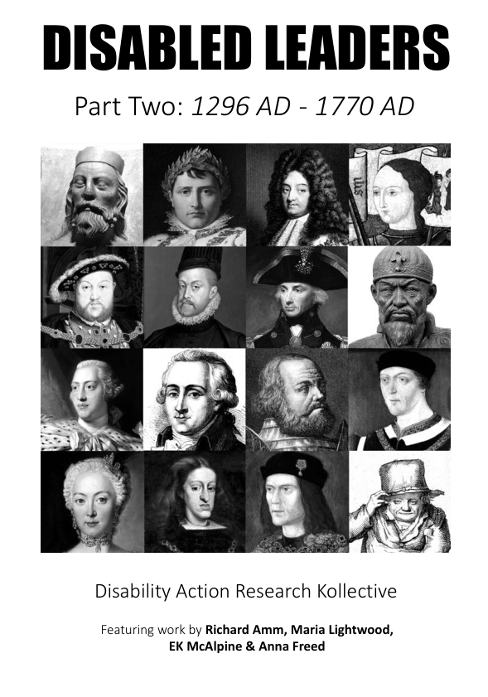
This zine continues from: Disabled Leaders Part One: 34,000 BC - 1185 AD
Author
Disability Action Research Kollective
Submitted by DisabilityARK on August 2, 2025
Disabled Leaders 2 by DARK_0.pdf (9.74 MB)

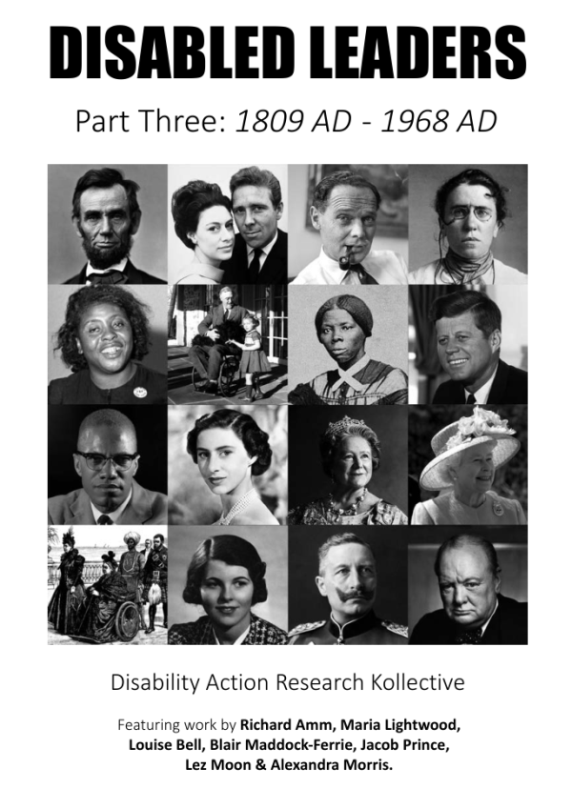Continued from Disabled Leaders 1 & 2
Author
Disability Action Research Kollective
Submitted by DisabilityARK on August 7, 2025
Disabled Leaders 3 by DARK.pdf (6.87 MB)

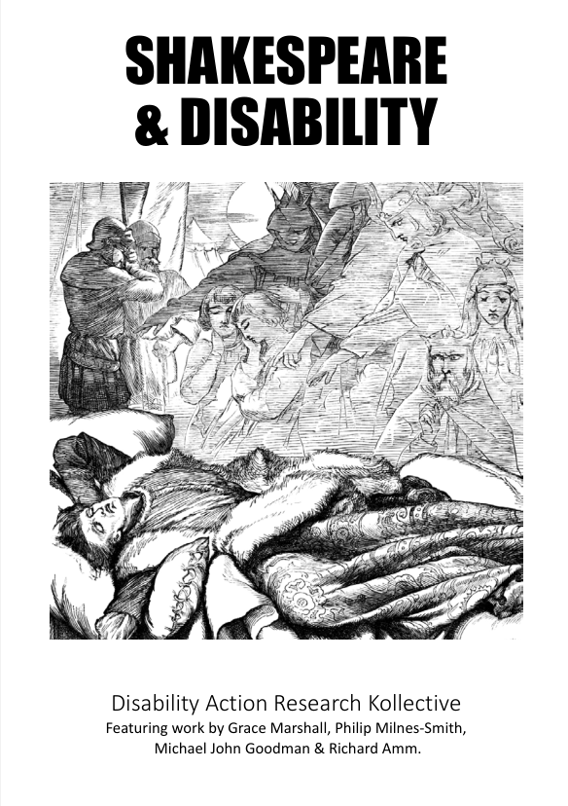
Shakespeare and his audiences understood their bodies within the
frameworks that were available to them, as we do now. The most
widely accepted way of understanding the body was as being made up of various liquid chemicals (the “humours”). These mingled with each other and responded to the external environment. In this sense, people thought of their bodies as being highly differentiated and constantlychanging. Bodily difference was a crucial aspect of human physiology.Author Disability Action Research Kollective
Submitted by DisabilityARK on October 28, 2025
Shakespeare and Disability.pdf (6.54 MB)
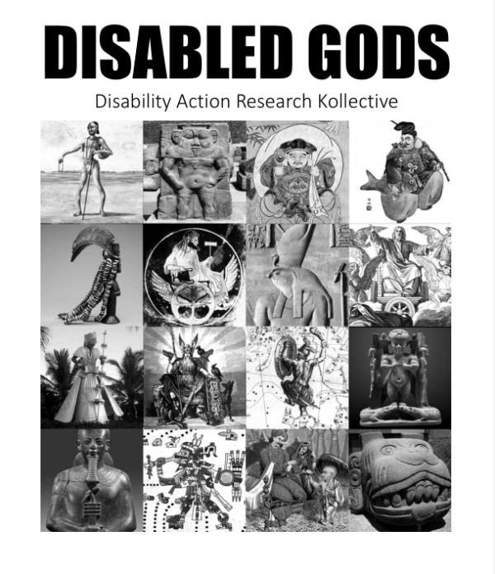
Disabled Gods offers a glimpse of how disability was thought of in the ancient past. This is not suitable for children, as it contains nudity, infanticide, human sacrifice, violence, murder, ableism, and infantilisation.
In a world where disability is often erased from histories, learning about disabled gods does at least remind us that disabled people have always existed and impacted the storytelling and culture in all the places they lived.
Author Disability Action Research Kollective
Submitted by DisabilityARK on July 14, 2024
Disabled Gods by DARK.pdf (7.98 MB)
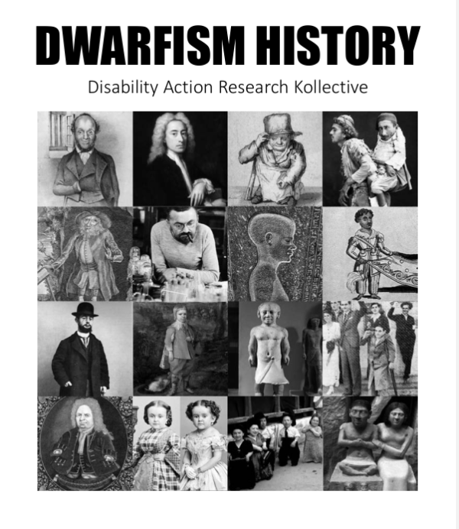
Many prominent people with dwarfism have existed throughout history. Some held high positions within the royal courts of ancient Egypt, while others were hidden away, enslaved or dismissed. The degree of exclusion and prejudice that people with dwarfism currently experience is neither natural nor universal, as inclusion and acceptance has varied greatly over time and between cultures.
Author Disability Action Research Kollective
Submitted by DisabilityARK on August 15, 2024
Dwarfism History by DARK.pdf (8.47 MB)

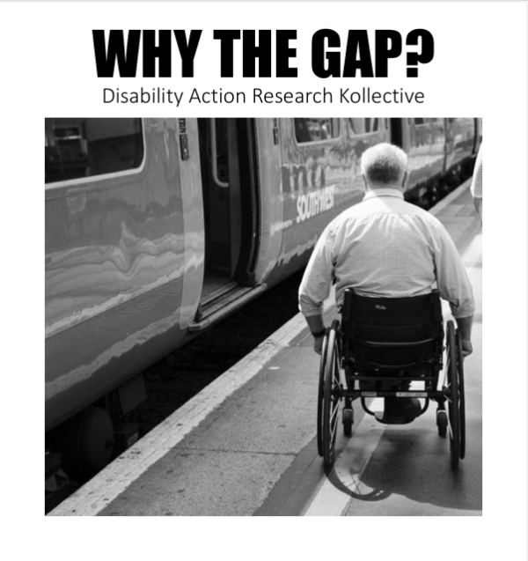
Disabled people were not a priority and were kept in workhouses and asylums when rail systems were built. The UK built some of the earliest rail systems, but they were never intended to be joined together and so there were no coherent standards. To this day different rail companies have monopolies of different areas and each have their own approach. There is still no enforcement for platform placement standards or of train floor heights. New trains and platforms are still being built and bought that are not compatible (e.g. Thameslink, Crossrail, Elisabeth Line, HS2 etc.
Author Disability Action Research Kollective
Submitted by DisabilityARK on August 15, 2024
Mend The Gap by DARK.pdf (582.19 KB)

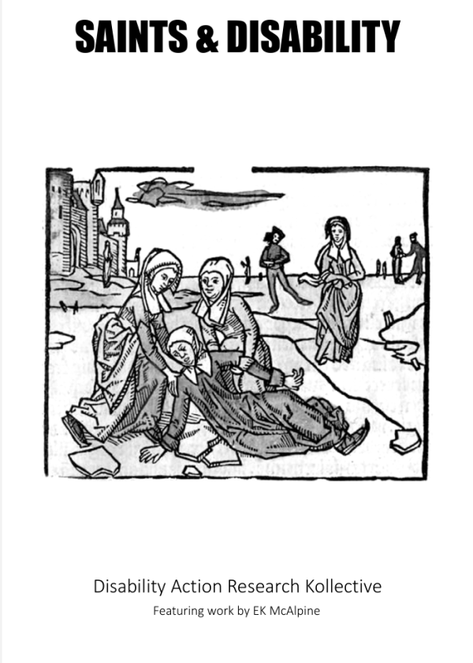
There is an assumption that in times before modern medicine, disabled people didn’t survive or live for very long, and that their lives were a lot worse than today. It’s true that before modern medicine, people had less effective treatment for conditions and injuries that people would probably survive today. But disabled people have still existed throughout human history.
Author Disability Action Research Kollective
Submitted by DisabilityARK on April 14, 2025
Saints & Disability by DARK.pdf (490.23 KB)

Ancient Egypt and Disability
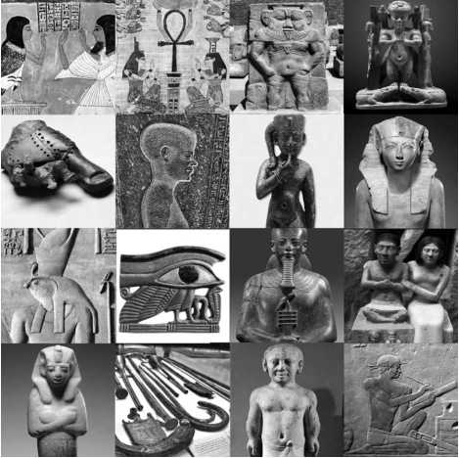
Ancient Egyptian society was more accepting and inclusive of disability than many contemporary societies. Disabled people were integrated into the community, working alongside non-disabled people as scribes, musicians, craftsmen, or labourers. They sometimes held titles as high as pharaoh (king) and were well represented in high positions within royal courts. Disabled people were also featured in art and texts and even within the pantheon of the gods. Including the god Ptah, who Egypt is named after, and Horus who represents the power of the pharaoh.
Author Disability Action Research Kollective

Ancient Egypt and Disability.pdf (6.87 MB)

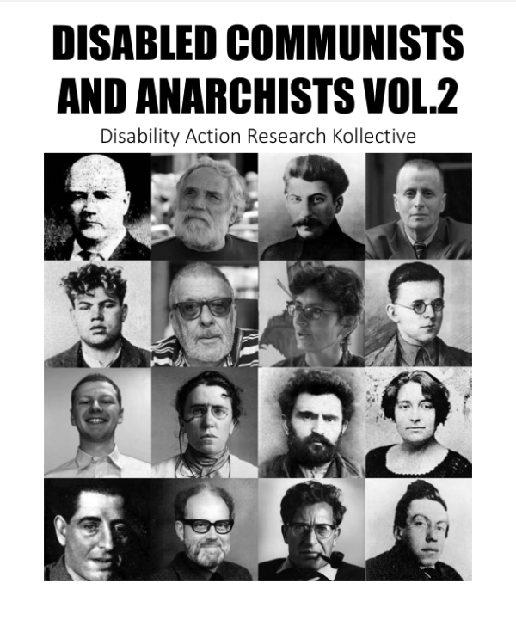
When communists and anarchists are remembered, their disabilities often go unacknowledged, even though they likely deeply impacted their lives and perspectives. Disabilities should not be seen as a shameful personal failure but as a neutral characteristic within the natural variation of humanity. Here is a brief biography of some of those revolutionaries.
AuthorDisability Action Research Kollective
Submitted by DisabilityARK on July 14, 2024
Disabled Communists and Anarchists Vol.2 by DARK.pdf (7.38 MB)
Like many people in history, when communists and anarchists
are remembered, their disabilities often go unacknowledged,
even though they likely deeply impacted their lives and
perspectives. Disabilities should not be seen as a shameful
personal failure but as a neutral characteristic within the
natural variation of humanity. Here is a brief biography of
some of those revolutionaries.
Author Disability Action Research Kollective
Submitted by DisabilityARK on July 14, 2024
Disabled Communists and Anarchists by DARK.pdf (2.67 MB)

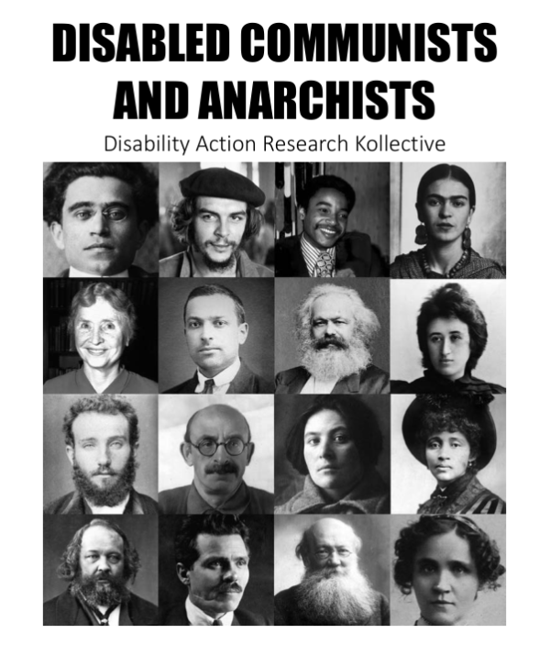

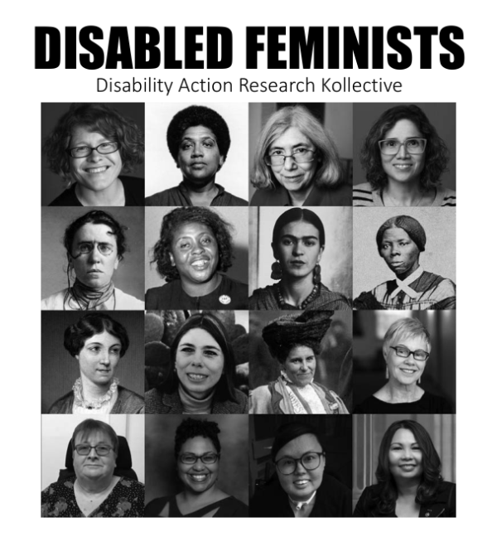
Feminist disability activism seeks to challenge intersecting forms
of oppression and create a more inclusive and accessible world for
all. This includes fighting for reproductive justice for disabled women, challenging the stereotype of disabled people as asexual or undesirable partners, and advocating for greater representation of disabled women in media and politics. By bringing together the insights of disability studies and feminism, we can work towards a more intersectional and inclusive vision of social justice that recognizes the full diversity of human experience.
Author Disability Action Research Kollective
Submitted by DisabilityARK on July 14, 2024
Disabled Feminists by DARK.pdf (8.2 MB)

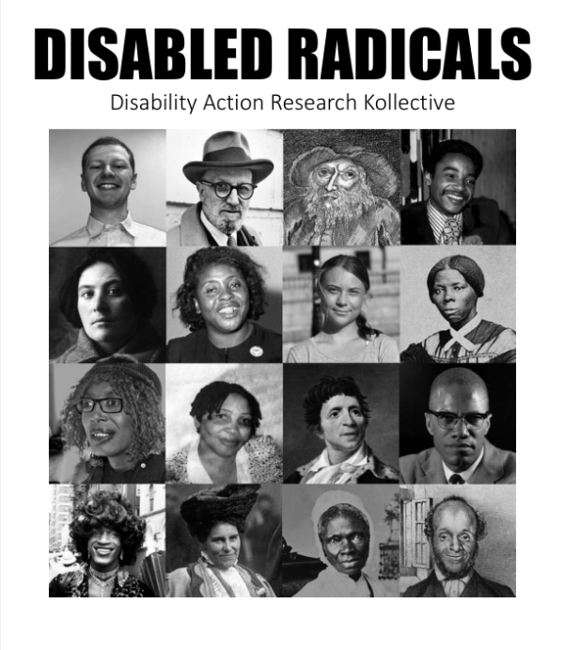
Disabled people have been active parts of every society and liberatory movement. Yet when history is written, disability is often erased or stigmatised. This zine aims to celebrate the lives of disabled radicals. To frame disability not as an individual shameful failure that undermines one’s agency, legitimacy and personhood, but as a neutral characteristic within the natural variation of humanity.
Author Disability Action Research Kollective
Submitted by DisabilityARK on July 14, 2024
Disabled Radicals by DARK.pdf (3.18 MB)
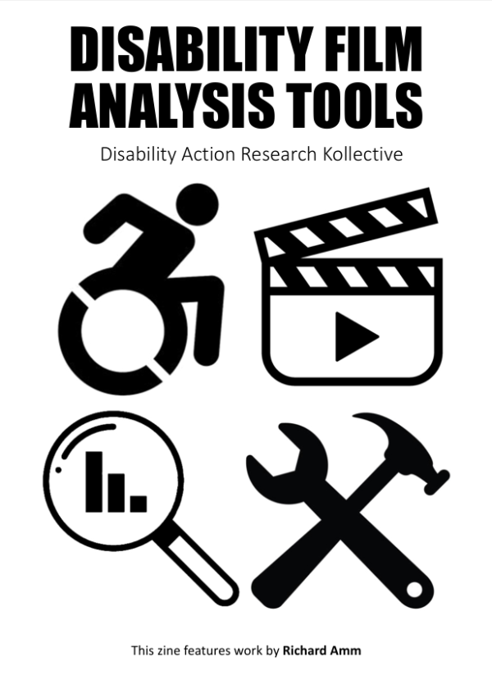
Representations of disabled people in media often perpetuate
stereotypes that can reinforce prejudice and lead to the marginalisation
and oppression of disabled people. Many conventions for representing disabled people in film were formed during the eugenics movement and continue to the modern era. This document provides a toolkit for assessing and improving portrayals of disabled people in film.
Author Disability Action Research Kollective
Submitted by DisabilityARK on July 14, 2024
Disability Film Analysis Tools by DARK 2.0.pdf (2.22 MB)
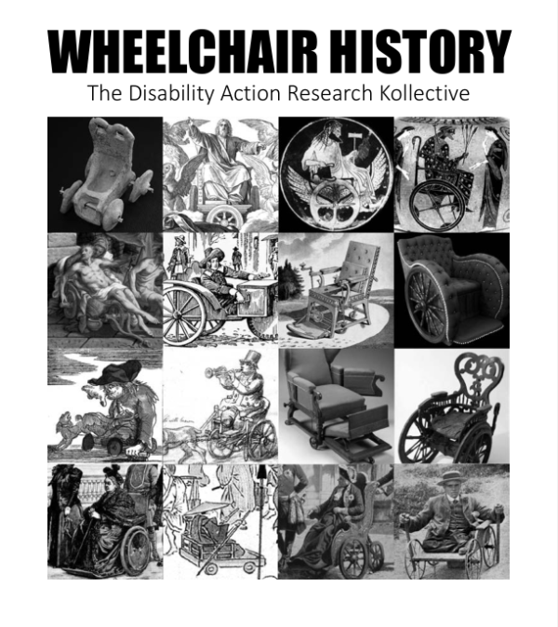
This zine is a chronological visual history of wheeled chairs dating back to ancient times. Disabled people have existed for as long as humanity, and for as long as there have been disabled people, we have crafted tools to make our lives easier. People who are new to being wheelchair users may not know the distinguished and fascinating history of their noble steeds. Wheelchairs predate many other wheeled chairs like bikes, cars or office chairs. They may go back to the invention of the
wheel itself.
Author Disability Action Research Kollective
Submitted by DisabilityARK on July 14, 2024
Wheelchair History by DARK.pdf (11.62 MB)

Star Trek and Disability - Vol 1

Infinite diversity in infinite combinations was not just an in-universe philosophy but it was something that Star Trek shows themselves strived to show. While it did have a diverse cast, there were many categories of humanity that went unrepresented. Trek’s representation of disabled people has been sparse and complex. Many tropes for representing disability in the media in general have been heavily influenced by eugenics and sadly Star Trek has not been able to be more progressive than the culture that produced it.
Author Disability Action Research Kollective
Submitted by DisabilityARK on November 7, 2024
Star Trek and Disability 1 by DARK.pdf (240.84 KB)

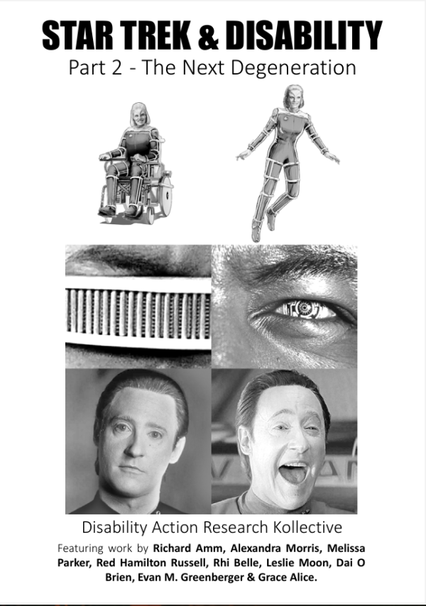
More examples, building on part 1
Author Disability Action Research Kollective
Submitted by DisabilityARK on July 5, 2025
Star Trek and Disability 2 by DARK.pdf (533.05 KB)

